Applicant: K.RAMAKRISHNAN COLLEGE OF ENGINEERING No. of Sheets: 1
Sheet No: 1 of 1
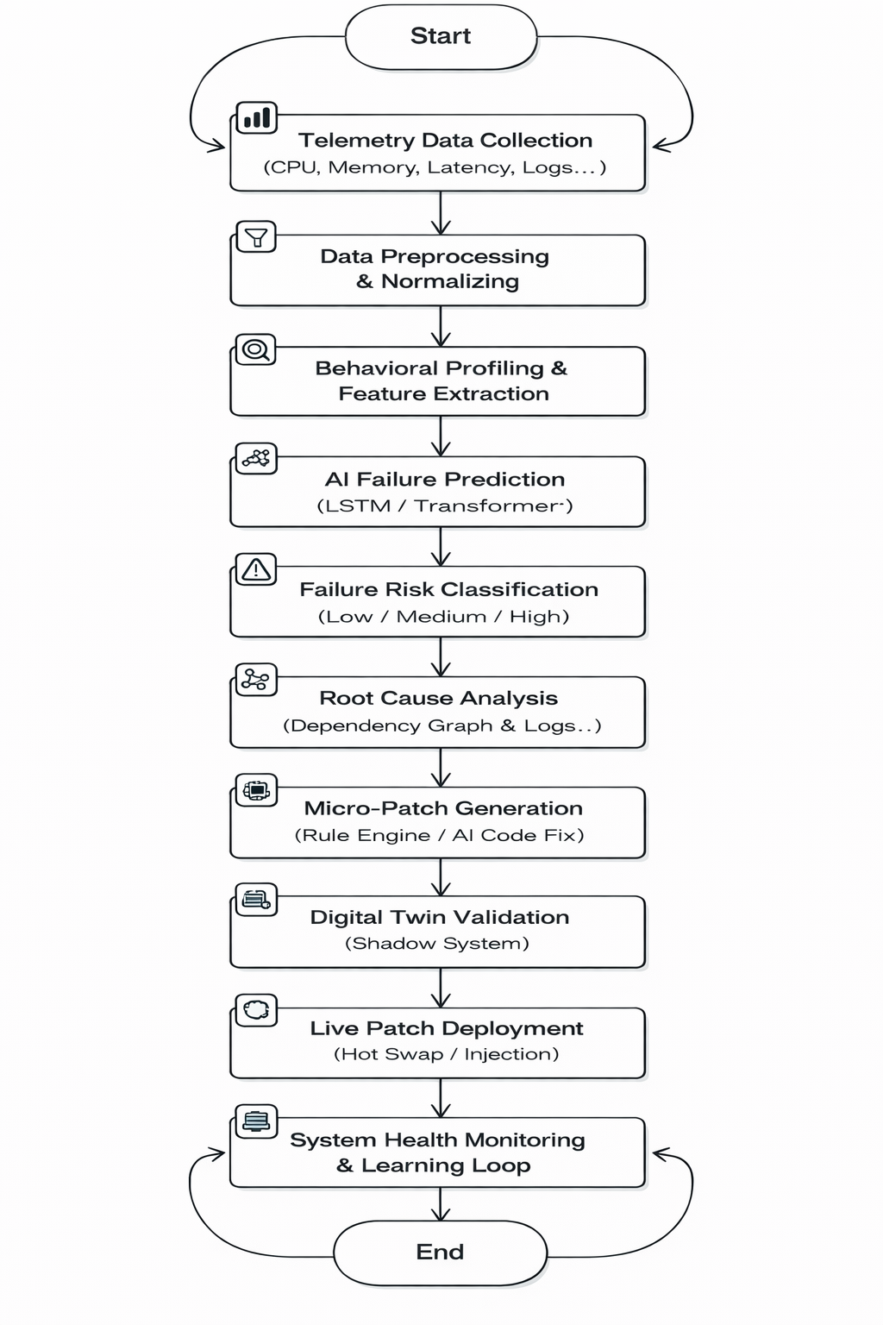
Fig 1

