Applicant: LKLSDFKLSDF No. of Sheets: 1
Sheet No: 1 of 1
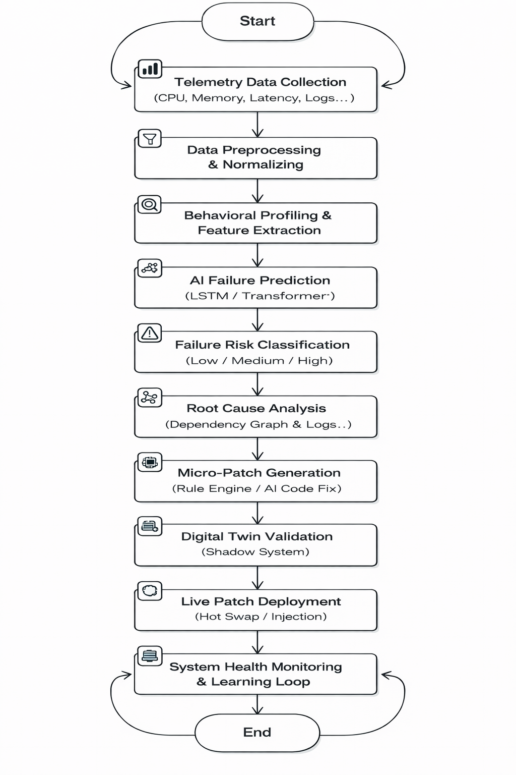
Fig 1

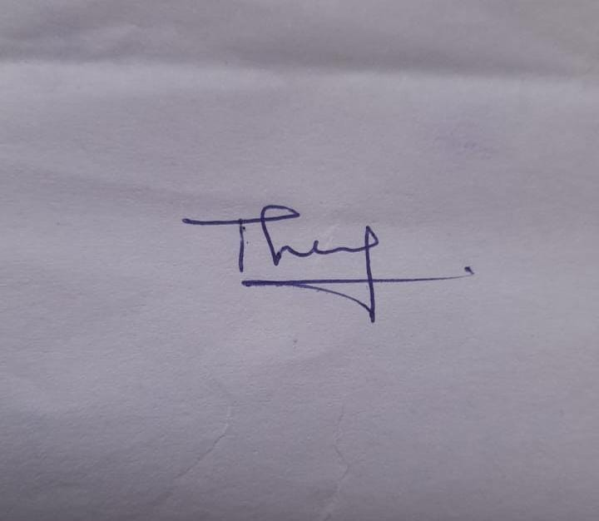
A. Albert Francis

