**Software Engineering Tools Lab**

**Assignment No-1**

**(Module 1- Introduction to FOSS) Due date-29/01/2023**

**1. Differentiate in between free software, Open source software and proprietary software with**

**respect to its properties.**

Ans:

Free software refers to software that is available for use, modification, and distribution without any charge. This means that users are free to download, use, and share the software with others. Examples of free software include Linux, Firefox, and LibreOffice.

Open source software refers to software that is available for use, modification, and distribution with a license that allows users to access the source code. This means that users are free to modify and distribute the software as they see fit, but they must also make the source code available to others. Examples of open source software include Apache, MySQL, and WordPress.

Proprietary software refers to software that is owned by a particular company or individual and is protected by copyright and patent laws. This means that users are only allowed to use the software according to the terms and conditions of the license agreement and are not allowed to access the source code or modify the software. Examples of proprietary software include Microsoft Windows, Adobe Photoshop, and Apple iOS.

In summary, free software is available without any charge, open source software is available with a license that allows users to access and modify the source code, and proprietary software is owned by a particular company or individual and protected by copyright and patent laws.

**2. Enlist some examples along with its purpose and properties (at least 10) of FOSS and**

**proprietary software with respect to database.**

1. MySQL (FOSS) - A popular open-source relational database management system used for web-based applications, data warehousing, and logging applications. It supports a wide range of platforms and can handle large amounts of data.
2. PostgreSQL (FOSS) - An open-source object-relational database management system that is known for its stability, performance, and compatibility with other databases. It supports advanced data types, such as arrays, and is often used in scientific and financial applications.
3. MongoDB (FOSS) - A popular open-source document-oriented database management system that is designed for storing and querying large amounts of unstructured data. It is commonly used in big data and real-time web applications.
4. SQLite (FOSS) - A small, lightweight, and self-contained relational database management system that is often embedded in other software applications. It is known for its simplicity and ease of use.
5. Oracle Database (Proprietary) - A powerful and widely-used commercial relational database management system that is designed for enterprise-level applications. It supports a wide range of platforms and offers advanced features, such as data warehousing and business intelligence.
6. Microsoft SQL Server (Proprietary) - A popular commercial relational database management system that is designed for Windows-based environments. It offers advanced features, such as business intelligence and data warehousing, and is often used in enterprise-level applications.
7. IBM DB2 (Proprietary) - A commercial relational database management system that is designed for enterprise-level applications. It offers advanced features, such as data warehousing, data mining, and business intelligence.
8. Sybase (Proprietary) - A commercial relational database management system that is designed for enterprise-level applications. It offers advanced features, such as data warehousing, data mining, and business intelligence.
9. Informix (Proprietary) - A commercial relational database management system that is designed for enterprise-level applications. It offers advanced features, such as data warehousing, data mining, and business intelligence.

**3. Enlist some examples of free open source exam software for online assessment.**

1. Moodle - An open-source learning management system that allows educators to create and administer online assessments, quizzes, and exams.
2. ExamSoft - A cloud-based assessment platform that allows educators to create, administer, and analyze assessments, quizzes, and exams.
3. OpenOLAT - An open-source learning management system that allows educators to create and administer online assessments, quizzes, and exams.
4. Ilias - An open-source learning management system that allows educators to create and administer online assessments, quizzes, and exams.
5. Canvas LMS - An open-source learning management system that allows educators to create and administer online assessments, quizzes, and exams.
6. TestLink - An open-source web-based test management system that allows educators to create, administer, and analyze assessments, quizzes, and exams.
7. ProProfs Quiz Maker - A cloud-based assessment platform that allows educators to create, administer, and analyze assessments, quizzes, and exams.

**4. Demonstrate any one exam software which is open source and freely available.**

One example of an open-source and freely available exam software is Moodle. Moodle is a learning management system that allows educators to create and administer online assessments, quizzes, and exams. Some of its features include:

A built-in quiz module that allows educators to create multiple-choice, true/false, short answer, and matching questions

* Support for multiple question types, including drag-and-drop, matching, and numerical questions
* Customizable settings for each quiz, including time limits, number of attempts, and feedback options
* Automatic grade calculation and reporting
* Integration with other tools, such as forums and calendars
* Support for multiple languages

Moodle is open-source software, which means that it is available for use, modification, and distribution without any charge. Educators can download the software, install it on their own servers, and customize it to meet their specific needs. Additionally, Moodle has a large community of users and developers who contribute to the development of the software and provide support to others.

**5. Demonstrate FOSS software related to database.**

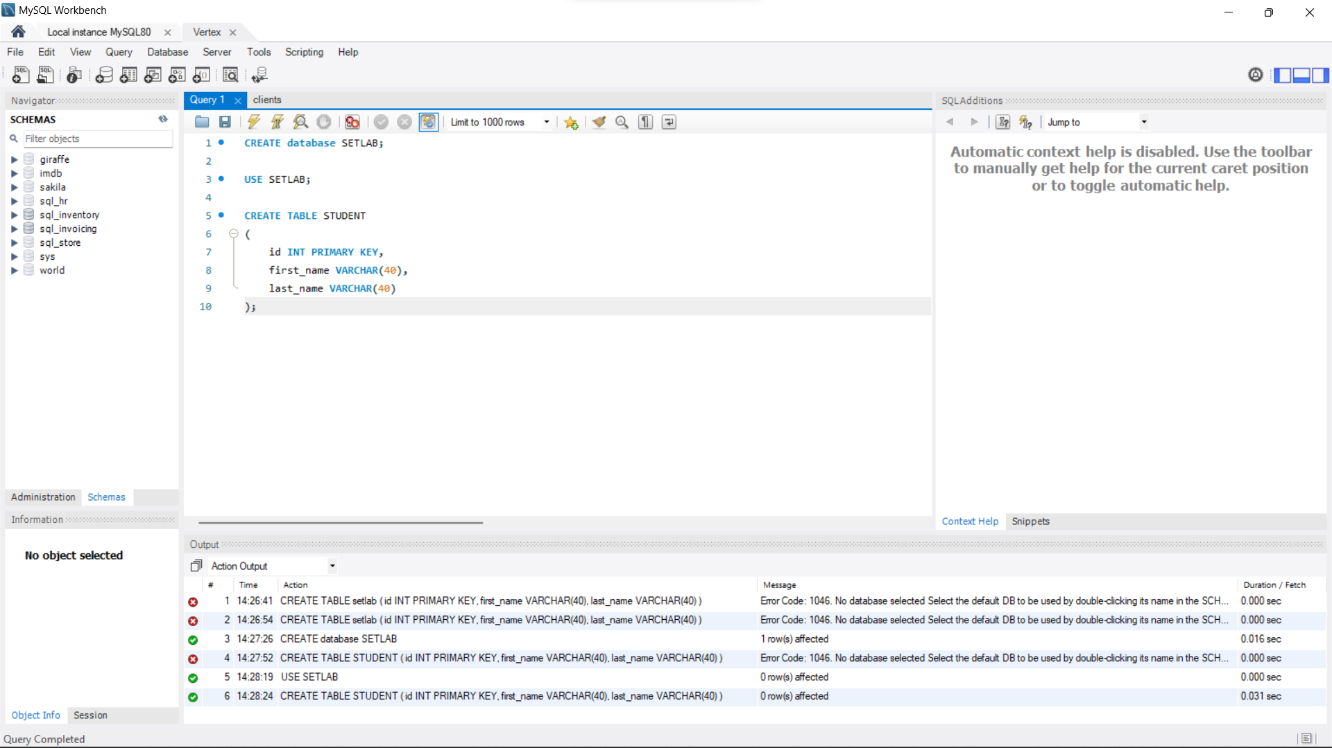

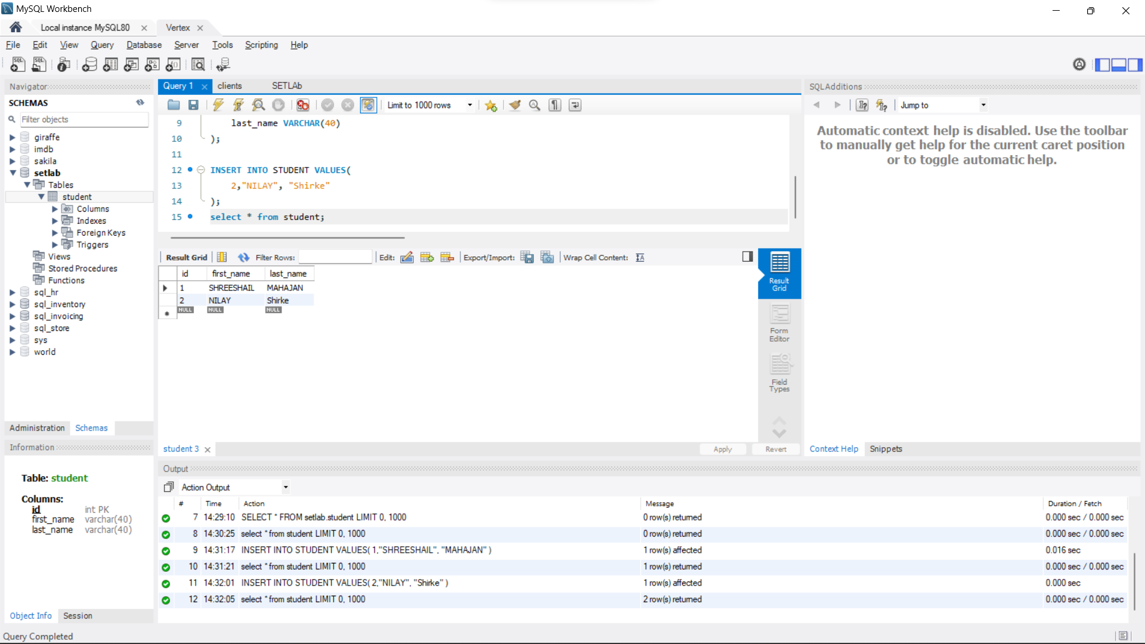

One example of a FOSS (Free and Open-Source Software) related to databases is MySQL. MySQL is a popular open-source relational database management system (RDBMS) that is widely used for web-based applications, data warehousing, and logging applications. Some of its features include:

* Support for multiple storage engines, including InnoDB, MyISAM, and Memory
* SQL (Structured Query Language) for querying and modifying data
* Support for multiple platforms, including Windows, Linux, and macOS
* Support for data replication and partitioning
* Support for multiple languages, including English, Chinese, and Russian
* Large community of users and developers who contribute to the development of the software and provide support to others

MySQL is open-source software, which means that it is available for use, modification, and distribution without any charge. Developers can download the software, install it on their own servers, and customize it to meet their specific needs. Additionally, MySQL has a large community of users and developers who contribute to the development of the software and provide support to others.

**6. How does the Exam software work?**

Exam software typically allows for the creation, administration, and grading of assessments. The software can be used to create test questions, organize them into exams, and set up the rules for taking the exam (such as time limits and allowed resources). The software can also be used to administer the exam, either in a proctored setting or online, and automatically grade the exam based on pre-determined rules. Some exam software also includes features such as analytics and reporting to help educators and administrators evaluate student performance.

