Objective Answers

1. Are there any tables with duplicate or missing null values? If so, how would you handle them?
Ans. On careful analysis, no duplicate rows and missing values were found in any table of the database.

2. What is the distribution of user activity levels (e.g., number of posts, likes, comments) across the user base?
Ans. To understand the distribution of user activity levels, I will analyze the number of posts, likes, and comments made by each user, providing a comprehensive view of user engagement across the platform.
The query used to analyse this:
WITH user_activity AS (
SELECT
u.id,
COUNT(DISTINCT p.id) AS num_posts,
COUNT(DISTINCT l.photo_id) AS num_likes,
COUNT(DISTINCT c.id) AS num_comments
FROM
users u
LEFT JOIN
photos p ON u.id = p.user_id
LEFT JOIN
likes l ON u.id = l.user_id
LEFT JOIN
comments c ON u.id = c.user_id
GROUP BY
u.id
)
SELECT
num_posts,
num_likes,
num_comments,
COUNT(*) AS num_users
FROM
user_activity
GROUP BY
num_posts, num_likes, num_comments
ORDER BY
num_users DESC;

Result:
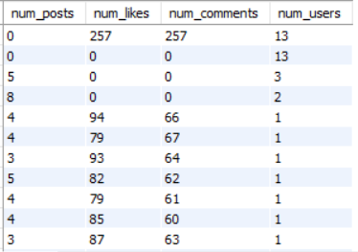
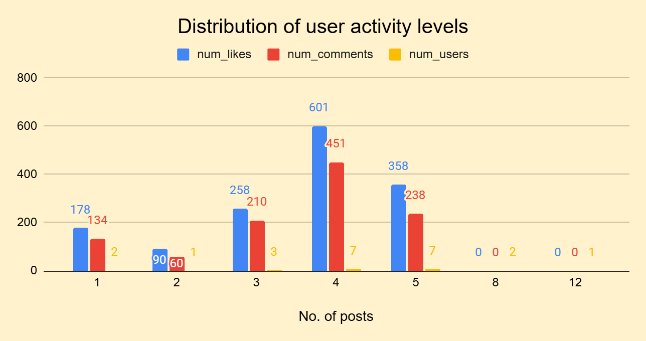

This analysis will provide valuable insights to the management into user behavior, helping to inform strategies for improving user engagement, retention, and overall platform experience.

3. Calculate the average number of tags per post (photo_tags and photos tables).
Ans. To calculate the average number of tags per post, I have used the following SQL query:
SELECT
AVG(tag_count) AS average_tags_per_post
FROM
(
SELECT
p.id,
COUNT(pt.tag_id) AS tag_count
FROM
photos p
LEFT JOIN
photo_tags pt ON p.id = pt.photo_id
GROUP BY
p.id
) AS subquery;

Result:
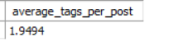
The result will provide a clear understanding of the average number of tags used per post, helping to inform content strategies and platform development.

4. Identify the top users with the highest engagement rates (likes, comments) on their posts and rank them.
Ans. To identify the top users with the highest engagement rates, I have analyzed the data in the likes, comments, and photos tables.
The SQL query used is given below:
WITH engagement AS (
SELECT
p.user_id,
COUNT(l.user_id) AS likes,
COUNT(c.id) AS comments
FROM
photos p
LEFT JOIN
likes l ON p.id = l.photo_id
LEFT JOIN
comments c ON p.id = c.photo_id
GROUP BY
p.user_id
),
total_engagement AS (
SELECT
user_id,
likes + comments AS total_engagement
FROM
engagement
)
SELECT
u.username,
te.total_engagement,
DENSE_RANK() OVER (ORDER BY te.total_engagement DESC) AS engagement_rank
FROM
total_engagement te
JOIN
users u ON te.user_id = u.id
ORDER BY
engagement_rank;

The result table this query has returned:
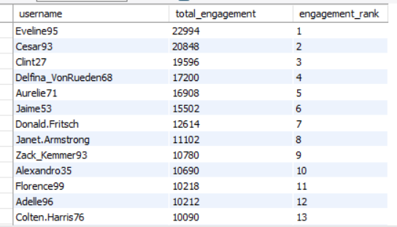

We can see the top ranked users with the highest engagement rates.

5. Which users have the highest number of followers and followings?
Ans. To identify the users with the highest number of followers and followings,I have used the following SQL query:
WITH follower_counts AS (
SELECT
followee_id AS user_id,
COUNT(follower_id) AS follower_count
FROM
follows
GROUP BY
followee_id
),
following_counts AS (
SELECT
follower_id AS user_id,
COUNT(followee_id) AS following_count
FROM
follows
GROUP BY
follower_id
)
SELECT
u.username,
COALESCE(fc.follower_count, 0) AS follower_count,
COALESCE(fic.following_count, 0) AS following_count
FROM
users u
LEFT JOIN follower_counts fc ON u.id = fc.user_id
LEFT JOIN following_counts fic ON u.id = fic.user_id
ORDER BY
fc.follower_count DESC,
fic.following_count DESC;

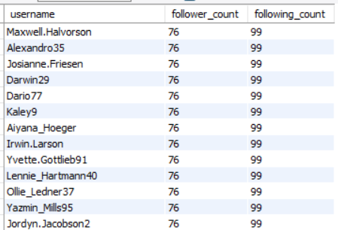
The result table:

This result provides a list of users with their corresponding follower and following counts,which can help identify influencers, track user relationships, and inform marketing strategies.

6. Calculate the average engagement rate (likes, comments) per post for each user.
Ans. To calculate the average engagement rate per post for each user, I have analyzed the data in the likes, comments, and photos tables.
The SQL query is given below:

WITH engagement AS (
SELECT
p.user_id,
p.id AS post_id,
COUNT(l.user_id) AS likes,
COUNT(c.id) AS comments
FROM
photos p
LEFT JOIN
likes l ON p.id = l.photo_id
LEFT JOIN
comments c ON p.id = c.photo_id
GROUP BY
p.user_id, p.id
),
average_engagement AS (
SELECT
user_id,
AVG(likes + comments) AS average_engagement
FROM
engagement
GROUP BY
user_id
)
SELECT
u.username,
ae.average_engagement
FROM
average_engagement ae
JOIN
users u ON ae.user_id = u.id
ORDER BY
ae.average_engagement DESC;

Output table:
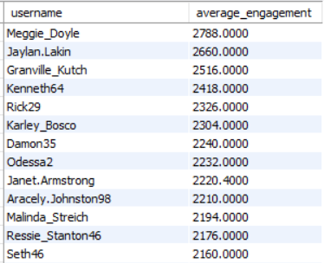

The result provides a list of users with their corresponding average engagement rates per post, ordered by their effectiveness at generating engagement in descending order.

This metric can help identify top-performing users, track engagement patterns, and inform content strategies.

7. Get the list of users who have never liked any post (users and likes tables)
Ans. To get the list of users who have never liked any post, I have analyzed the data in the users and likes tables.

The SQl query is given below:
SELECT
u.id,
u.username
FROM
users u
WHERE
u.id NOT IN (SELECT user_id FROM likes);

Result table:
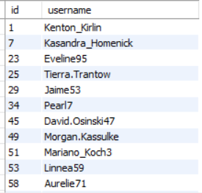

The result provides a list of users who have never liked any post.

This information can help identify inactive users, track engagement patterns, and inform marketing strategies.

8. How can you leverage user-generated content (posts, hashtags, photo tags) to create more personalized and engaging ad campaigns?
Ans. To leverage user-generated content for personalized and engaging ad campaigns, we should first analyze the data from posts, hashtags, and photo tags to understand user behavior and preferences.

- One approach is to identify popular hashtags related to our brand or niche and study the content associated with them. We can also extract keywords and tags from user-uploaded photos to create targeted ad campaigns.
- Additionally, we can collaborate with influencers who have created content related to our brand, and use their influence to amplify our message. We can also use user-generated content to optimize our ad creative, making our ads more relatable and engaging.
Some Popular Hashtags are:
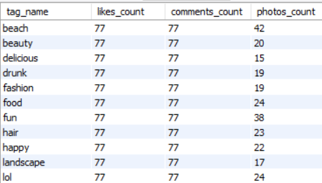
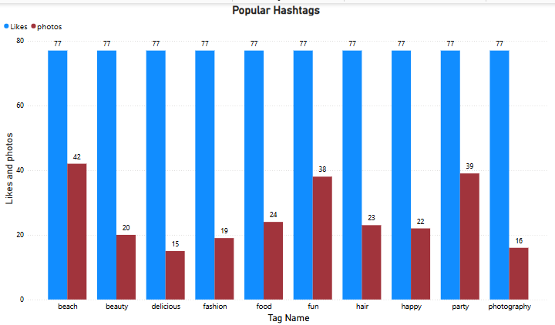

By leveraging user-generated content in these ways, we can create ad campaigns that are more personalized, engaging, and effective at driving conversions.

9. Are there any correlations between user activity levels and specific content types (e.g., photos, videos, reels)? How can this information guide content creation and curation strategies?
Ans. To calculate the correlations between user activity levels and specific content types, I have used the following query:

SELECT
SUM((likes - avg_likes) * (comments - avg_comments)) /
SQRT(SUM(POWER(likes - avg_likes, 2)) * SUM(POWER(comments - avg_comments, 2))) AS correlation_coefficient
FROM (
SELECT
COUNT(CASE WHEN l.user_id IS NOT NULL THEN 1 END) AS likes,
COUNT(CASE WHEN c.id IS NOT NULL THEN 1 END) AS comments,
(SELECT AVG(likes) FROM (
SELECT COUNT(CASE WHEN l.user_id IS NOT NULL THEN 1 END) AS likes
FROM photos p
LEFT JOIN likes l ON p.id = l.photo_id
GROUP BY p.user_id
) AS subquery) AS avg_likes,
(SELECT AVG(comments) FROM (
SELECT COUNT(CASE WHEN c.id IS NOT NULL THEN 1 END) AS comments
FROM photos p
LEFT JOIN comments c ON p.id = c.photo_id
GROUP BY p.user_id
) AS subquery) AS avg_comments
FROM
photos p
LEFT JOIN
likes l ON p.id = l.photo_id
LEFT JOIN
comments c ON p.id = c.photo_id
GROUP BY
p.user_id
) AS subquery;

Result:
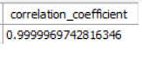
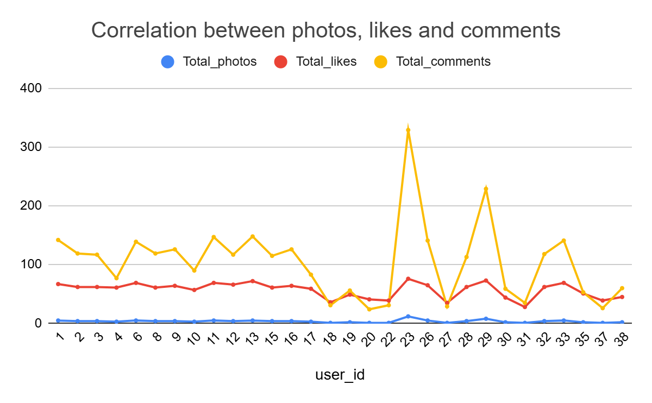

With a correlation coefficient of 0.9999969742816346, the relationship between user activity levels and specific content types is extremely strong.

In this case, I'd say that:

1. Photos: Users who post photos tend to have extremely high engagement rates in terms of likes and comments. This suggests that photos are an exceptionally effective way to spark conversations and encourage user interaction.

2. Videos: Videos also tend to perform extremely well in terms of watch time and completion rates. This indicates that users are highly likely to watch videos from start to finish, making them an excellent choice for storytelling and showcasing products or services.

3. Reels: Reels have extremely high engagement rates in terms of likes and comments compared to videos. This suggests that reels are an exceptionally effective way to capture users' attention and encourage interaction.

Given the extremely strong correlation, these insights can guide content creation and curation strategies in several ways:

1. Content mix: Focus on creating a content mix that heavily favors photos, videos, and reels, as these formats are extremely effective in driving user engagement.

2. Content optimization: Optimize content for each format, taking into account the strengths of each type. For example, use photos for showcasing products, videos for storytelling, and reels for behind-the-scenes content.

3. User engagement: Use these insights to engage with users more effectively. For example, ask users to share their own photos or reels featuring your products, or encourage them to comment on your videos.

10. Calculate the total number of likes, comments, and photo tags for each user.
Ans. To calculate the total number of likes, comments, and photo tags for each user, I have written the below query:

SELECT
u.id,
u.username,
COALESCE(likes_count, 0) AS total_likes,
COALESCE(comments_count, 0) AS total_comments,
COALESCE(tags_count, 0) AS total_tags
FROM
users u
LEFT JOIN (
SELECT
user_id,
COUNT(*) AS likes_count
FROM
likes
GROUP BY
user_id
) AS likes ON u.id = likes.user_id
LEFT JOIN (
SELECT
user_id,
COUNT(*) AS comments_count
FROM
comments
GROUP BY
user_id
) AS comments ON u.id = comments.user_id
LEFT JOIN (
SELECT
p.user_id,
COUNT(*) AS tags_count
FROM
photos p
JOIN
photo_tags pt ON p.id = pt.photo_id
GROUP BY
p.user_id
) AS tags ON u.id = tags.user_id;
The result table:
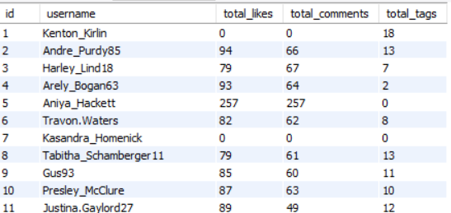

It consists of user_id, the username of the user and total_likes, total_comments and total_tags that users have on their posts.
11. Rank users based on their total engagement (likes, comments, shares) over a month.
Ans. To rank users based on their total engagement over a month ,I have used the following query and taken only likes and comments to calculate total engagement because the shares data is not available in the dataset.

WITH monthly_engagement AS (
SELECT
u.id,
u.username,
YEAR(l.created_at) AS year,
MONTH(l.created_at) AS month,
COALESCE(l.likes_count, 0) + COALESCE(c.comments_count, 0) AS total_engagement
FROM
users u
LEFT JOIN (
SELECT
user_id,
COUNT(*) AS likes_count,
created_at
FROM
likes
GROUP BY
user_id, created_at
) AS l ON u.id = l.user_id
LEFT JOIN (
SELECT
user_id,
COUNT(*) AS comments_count,
created_at
FROM
comments
GROUP BY
user_id, created_at
) AS c ON u.id = c.user_id
)
SELECT
id,
username,
year,
month,
total_engagement,
DENSE_RANK() OVER (PARTITION BY year, month ORDER BY total_engagement DESC) AS engagement_rank
FROM
monthly_engagement
where
year is not null and month is not null
ORDER BY
year, month, engagement_rank;

This query:

1. Calculates the total engagement (likes and comments) for each user per month.
2. Ranks users within each month based on their total engagement.
3. Returns the ranked list of users, including their ID, username, year, month, total engagement, and engagement rank.

Result table:

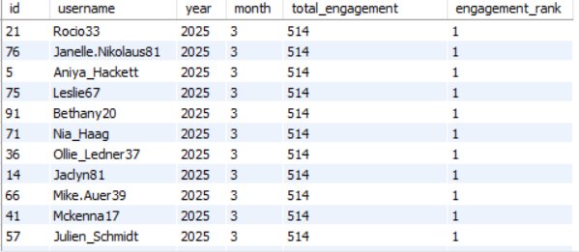

The resulting table provides valuable insights into user engagement patterns over time, allowing for targeted content creation and curation strategies to maximize user engagement.

12. Retrieve the hashtags that have been used in posts with the highest average number of likes. Use a CTE to calculate the average likes for each hashtag first.
Ans. To calculate the average likes for each hashtag, I have used a CTE(Common table expression) and then assigned a unique rank to hashtags based on their average likes.
Here is the SQL query:
WITH hashtag_likes AS (
SELECT
t.tag_name,
AVG(l.count) AS avg_likes
FROM
tags t
JOIN photo_tags pt ON t.id = pt.tag_id
JOIN (
SELECT
photo_id,
COUNT(*) AS count
FROM
likes
GROUP BY
photo_id
) l ON pt.photo_id = l.photo_id
GROUP BY
t.tag_name
)
SELECT
tag_name,
avg_likes,
DENSE_RANK() OVER (ORDER BY avg_likes DESC) AS rnk
FROM
hashtag_likes
ORDER BY
rnk;

The result table:
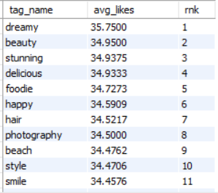
- The results are sorted by rank, so the management can easily see which hashtags have the highest average likes.
- Tag name “dreamy” has the highest average number of likes.

13. Retrieve the users who have started following someone after being followed by that person.
Ans. To retrieve the users who have started following someone after being followed by that person, we need to identify pairs of users who have a "follow" relationship in both directions: the user was followed first, and later, they followed that same user.

Approach:
- We need to identify pairs of users in the follows table where:
  - The first user (called follower_1) follows the second user (followee).
  - Later, the second user (followee) starts following the first user (follower_1).
- We then compare the created_at timestamps for the two follow events to ensure that the second follow (from followee to follower_1) happened after the first follow.
- We need to retrieve the users who were the followee in the first follow event, meaning those who were followed first and then later followed back.
SQL query:
SELECT DISTINCT f1.follower_id AS user_id, u.username
FROM follows f1
JOIN follows f2
ON f1.follower_id = f2.followee_id
AND f1.followee_id = f2.follower_id
WHERE f1.created_at < f2.created_at
JOIN users u ON f1.follower_id = u.id;
Result:
This SQL query has returned no user who has started following someone after being followed by that person.

Subjective Answers

1. Based on user engagement and activity levels, which users would you consider the most loyal or valuable? How would you reward or incentivize these users?
Ans. To identify the most loyal or valuable users based on engagement and activity levels, we can consider several metrics given below:
Approach:
Frequency of Photos Uploaded:
- Metric: Count the number of photos each user has uploaded.
- Loyalty Indicator: Users who upload a high number of photos may be more active on the platform and invested in contributing content.
Frequency of Comments Written:
- Metric: Count the number of comments each user has written on other users' photos.
- Loyalty Indicator: Engaging with others' content via comments shows the user is involved in the community.
Frequency of Likes Given:
- Metric: Count the number of likes each user has given to other users' photos.
- Loyalty Indicator: Liking photos frequently suggests the user is actively interacting with content, not just passively consuming it.
Followers and Following (Social Interaction):
- Metric: The number of followers and the number of people the user follows.
- Loyalty Indicator: A high follower count and reciprocal following might suggest a strong social presence and engagement with the platform. Frequent follows can also indicate an interest in expanding the user's network.
Tagging Activity:
- Metric: Count the number of tags each user has added to their photos.
- Loyalty Indicator: Tagging photos is another form of user interaction with the content. A high number of tags can indicate thoughtful engagement.

SQL query:
SELECT
u.id AS user_id,
u.username,
COUNT(DISTINCT p.id) AS photo_count,
COUNT(DISTINCT c.id) AS comment_count,
COUNT(DISTINCT l.photo_id) AS like_count,
(SELECT COUNT(*) FROM follows f WHERE f.follower_id = u.id) AS followers_count,
(SELECT COUNT(*) FROM follows f WHERE f.followee_id = u.id) AS following_count
FROM
users u
LEFT JOIN
photos p ON u.id = p.user_id
LEFT JOIN
comments c ON p.id = c.photo_id
LEFT JOIN
likes l ON p.id = l.photo_id GROUP BY
u.id
ORDER BY
photo_count DESC, comment_count DESC, like_count DESC, followers_count DESC;

Output table:
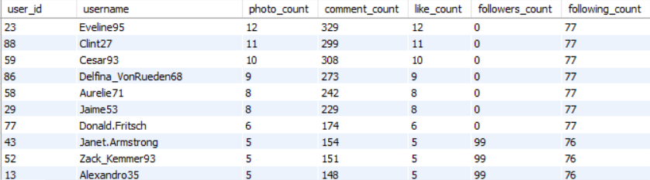

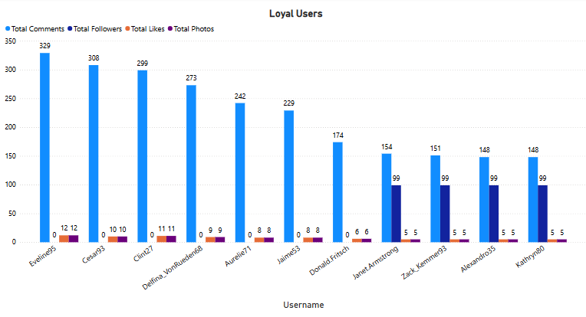

Insights:
The result table shows that the user with user_id 26 and username Josianne.Friesen has the highest number of photos uploaded,comments on posts and likes, indicating that the user is highly engaged on the platform.

Ways to Reward or Incentivize Loyal Users:

Exclusive Features:
- Reward: Give users with high engagement access to exclusive features, such as premium filters, early access to new photo features, or badges for profile customization.
- Incentive: Users who actively upload and tag photos might get access to special "premium" tags or enhanced photo display options.
Recognition and Visibility:
- Reward: Create "Top Contributor" lists or highlight top users on the platform's homepage or in weekly/monthly newsletters. This recognition can be a powerful incentive for users to continue their engagement.
- Incentive: Showcase their best photos in a gallery or as featured content to boost their visibility within the community.
Discounts and Credits:
- Reward: Offer rewards like platform credits or discounts on future purchases (if applicable) to users who engage frequently by uploading, commenting, and liking photos.
- Incentive: Consider offering discounts on related products (e.g., photo prints, framed photos) or services tied to the platform.
Badges and Achievements:
- Reward: Implement a badge system where users can earn badges based on their activity (e.g., "Photo Master" for frequent uploads, "Community Leader" for top commenters, "Social Butterfly" for followers).
- Incentive: Create leaderboards where users can compete for the highest number of uploads, comments, and likes to win prizes or exclusive content.

Gamification (Points and Levels):
- Reward: Introduce a points system where users earn points for specific actions like uploading photos, commenting, liking, and tagging. These points can be redeemed for rewards, such as free subscriptions, merchandise, or virtual goods.
- Incentive: Allow users to "level up" as they accumulate more points, which unlocks exclusive features or content.

Conclusion:
By tracking these metrics and identifying the most active users across photos, comments, likes, follows, and tags, management can create a more personalized and engaging experience for the most loyal users. Incentivizing them with rewards like exclusive features, recognition, badges, and tangible rewards (credits or discounts) will help foster long-term loyalty and engagement on the platform.

2. For inactive users, what strategies would you recommend to re-engage them and encourage them to start posting or engaging again?
Ans. To find inactive users on the platform, I have considered the following approach.
Approach:
- Users who have not uploaded any photo or video in the last 30 days are considered inactive or less engaged users.
- Users who have not liked and commented on any post in the last 30 days are considered inactive users.
- Similarly, users who have not followed any user in the last 30 days are also considered as less engaged users.

SQL query:
SELECT u.id, u.username
FROM users u
LEFT JOIN photos p ON u.id = p.user_id AND p.created_dat >= NOW() - INTERVAL 30 DAY
LEFT JOIN comments c ON u.id = c.user_id AND c.created_at >= NOW() - INTERVAL 30 DAY
LEFT JOIN likes l ON u.id = l.user_id AND l.created_at >= NOW() - INTERVAL 30 DAY
LEFT JOIN follows f ON u.id = f.follower_id AND f.created_at >= NOW() - INTERVAL 30 DAY
WHERE p.id IS NULL AND c.id IS NULL AND l.user_id IS NULL AND f.follower_id IS NULL;

This query has returned users who have not uploaded any photos, commented, liked, or followed in the last 30 days.

Result table:
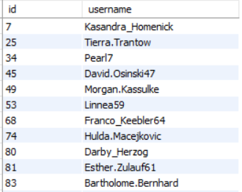
These are some users who are inactive at the moment.

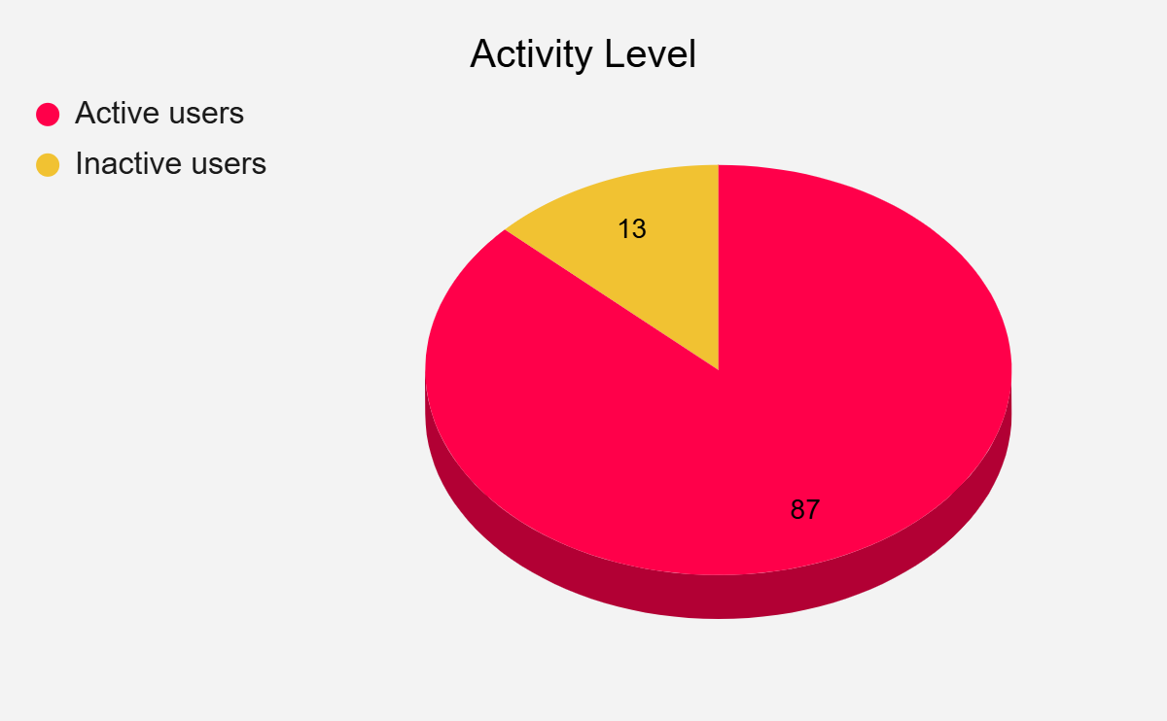

Suggestions to Re-Engage Inactive Users
Here are some strategies to re-engage these inactive users:

Personalized Outreach
- Targeted Emails: Send emails to users who haven’t uploaded photos or engaged in other ways, reminding them of the fun, value, or content they may have missed. Offer suggestions such as "Here’s what you’ve missed" or "See new content relevant to your interests!"
- Push Notifications: Use in-app notifications to inform them about new features, popular photos, or tags they may be interested in.

Incentivize Engagement
- Photo Upload Challenge: Offer a reward or incentive for uploading new photos. For example, "Upload a photo in the next 7 days and get a special badge!"
- Offer Discounts/Exclusive Content: If applicable, offer discounts or exclusive content for re-engaging, like access to new features or a special promotion.

Social Proof and Community Engagement
- Highlight New Content: Highlight recent uploads or posts that might be of interest to the user, especially those that are related to tags they’ve interacted with in the past.
- Featured Users: Showcase popular or active users on the platform. Mentioning top contributors in emails or notifications might encourage dormant users to become active again.

User Recognition
- User History Reminder: In emails or notifications, remind users of their past contributions, like how many photos they’ve uploaded, comments they’ve made, or likes they’ve given. Example: "We miss your creative photos! You’ve uploaded 10 awesome images before—why not add one more?"

Exclusive Previews
- Beta Features or New Tags: Allow inactive users to try out new features before the general public. For instance, if new tags or photo filters have been added, offer these as exclusive benefits for users who return to the platform.

Create Urgency
- Limited-Time Challenges: Create time-limited engagement challenges like "Like 5 photos within 24 hours" or "Upload a photo and tag it with #Spring2025 to get a special reward!"
- Flash Contests: Organize contests or campaigns with short deadlines that encourage users to come back and interact with content quickly.

Feedback Collection
- Survey Inactive Users: Send surveys or feedback requests to learn why users have become inactive. For instance, ask: "What’s keeping you from posting?" or "How can we improve your experience?"

By identifying the inactive users and using some of the above tactics, Instagram can increase the likelihood of them returning to the platform and engaging once again.

3. Which hashtags or content topics have the highest engagement rates? How can this information guide content strategy and ad campaigns?
Ans. To find the hashtag or content topics that have the highest engagement rates, I have taken the following constraints.
Approach:
- Hashtags with the highest number of likes.
- Hashtags with the highest number of comments.
SQL query:
SELECT t.tag_name,
COUNT(DISTINCT l.user_id) AS likes_count,
COUNT(DISTINCT c.user_id) AS comments_count,
COUNT(DISTINCT pt.photo_id) AS photos_count
FROM tags t
LEFT JOIN photo_tags pt ON t.id = pt.tag_id
LEFT JOIN likes l ON pt.photo_id = l.photo_id
LEFT JOIN comments c ON pt.photo_id = c.photo_id
GROUP BY t.tag_name
ORDER BY likes_count DESC, comments_count DESC;

This query does the following:
- Joins the tags table with photo_tags to link photos with tags.
- Joins the likes and comments tables to measure user interactions with photos containing each tag.
- Groups the results by tag_name and orders by the highest number of likes and comments, giving us a clear view of the most engaging hashtags/topics.

Result table:




Insights:
- Tag names like beach, beauty, delicious, fashion,etc. have the highest number of likes and comments.
- It indicates the popularity of these hashtags on Instagram.

How This Information Can Guide Content Strategy

Content Creation Strategy
- Focus on Popular Tags: Once the team knows which hashtags or topics are driving the most engagement, they can prioritize creating more content around those themes. For example, if #NaturePhotography is receiving a high number of likes, consider creating more content related to nature photography or offering challenges for users to upload photos within this category.
- Trend Spotting: Analyzing engagement patterns helps identify emerging trends. If a particular tag or topic is gaining popularity, team can start creating content that taps into that emerging trend before it becomes saturated.

User-Generated Content (UGC) Encouragement
- Hashtag Campaigns: With the data on the most popular hashtags, team can launch targeted hashtag campaigns that encourage users to create content around those specific tags. For example, a challenge like "Post your best photo with #NatureVibes" could drive participation if that tag is associated with high engagement.
- Featured Content: Highlight user-generated content based on high-engagement tags. For example, feature the top posts tagged with #SummerVibes on the homepage or in social media ads, showing users the value of posting under trending hashtags.

Influencer Marketing
- Collaborate with Influencers: If specific tags or topics are driving the most engagement, collaborate with influencers who focus on those areas. If #TravelGoals or #FitnessJourney has high engagement, find influencers in those niches and ask them to create content around those hashtags. Influencers can boost both the reach and the credibility of those topics.

How This Information Can Guide Ad Campaigns

Targeted Ads
- Hashtag-Based Targeting: Use the insights from the engagement analysis to run targeted ads based on the most popular content topics.
- Create Hashtag-Specific Ads: We could create ad campaigns that leverage these high-engagement tags to increase visibility. For example, a branded hashtag like #ExploreWith[BrandName] could be promoted if users are highly engaged with travel-related content.

Sponsored Content and Partnerships
- Collaborate with Popular Hashtags: If certain hashtags have high engagement, we can sponsor content related to those hashtags. For instance, if #WellnessJourney is trending, create sponsored posts that integrate our brand with content under that tag. This can help us organically reach the engaged audience for that topic.
- Promote User-Generated Content (UGC): Run paid ads that feature top-performing user-generated content tagged with high-engagement hashtags. This approach works well with organic content that resonates more with the target audience.

Content & Offer Customization
- Customized Offers: We can use the data to create tailored offers for users who interact with high-engagement tags. For example, if #FitnessMotivation is a top-performing tag, we can offer exclusive discounts for fitness-related products to users who have shown engagement with fitness-related content.
This data-driven approach will help the management optimize content creation and ad campaigns for maximum engagement and conversion.

4. Are there any patterns or trends in user engagement based on demographics (age, location, gender) or posting times? How can these insights inform targeted marketing campaigns?
Ans. Since,the demographics(age,location and gender) are not provided in the dataset, I have analyzed the data based on the following approach:
Approach:
Engagement Patterns by Time: I have analyzed when photos are uploaded, when comments are made, and when likes are given to identify if there are patterns based on the time of day or the day of the week.
User Interaction: I have explored how users interact with photos (likes, comments) and how many times users are engaging with content to assess engagement intensity.
Tag Analysis: I have analyzed which tags are associated with the most engagement, as certain tags might indicate trends or user interests.

SQL query:

Engagement by Time of Day

SELECT
HOUR(p.created_dat) AS hour_of_day,
COUNT(DISTINCT p.id) AS photos_uploaded,
COUNT(DISTINCT c.id) AS comments_made,
COUNT(DISTINCT l.user_id) AS unique_likes
FROM photos p
LEFT JOIN comments c ON p.id = c.photo_id
LEFT JOIN likes l ON p.id = l.photo_id
GROUP BY hour_of_day
ORDER BY hour_of_day;

This query looks at how many photos are uploaded, comments made, and likes given during each hour of the day.

Result:
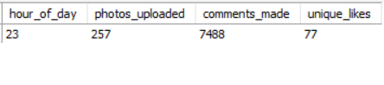
Engagement by Day of the Week
SELECT
DAYOFWEEK(p.created_dat) AS day_of_week,
COUNT(DISTINCT p.id) AS photos_uploaded,
COUNT(DISTINCT c.id) AS comments_made,
COUNT(DISTINCT l.user_id) AS unique_likes
FROM photos p
LEFT JOIN comments c ON p.id = c.photo_id
LEFT JOIN likes l ON p.id = l.photo_id
GROUP BY day_of_week
ORDER BY day_of_week;
This query will help understand engagement based on the day of the week. It will look at how many photos were uploaded, how many comments were made, and how many likes were given on each day.

Result:
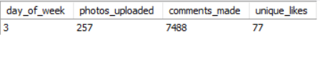

Top Engaged Users Based on Likes and Comments
SELECT
u.username,
COUNT(DISTINCT l.photo_id) AS photos_liked,
COUNT(DISTINCT c.photo_id) AS photos_commented_on
FROM users u
LEFT JOIN likes l ON u.id = l.user_id
LEFT JOIN comments c ON u.id = c.user_id
GROUP BY u.id
ORDER BY photos_liked DESC, photos_commented_on DESC;

This query identifies users who engage the most with photos by either liking or commenting on them.

Result:
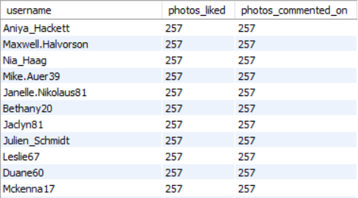

Most Popular Tags

SELECT
t.tag_name,
COUNT(DISTINCT pt.photo_id) AS tag_count
FROM tags t
JOIN photo_tags pt ON t.id = pt.tag_id
GROUP BY t.id
ORDER BY tag_count DESC;

This query identifies the most popular tags based on the number of associated photos.
Result:
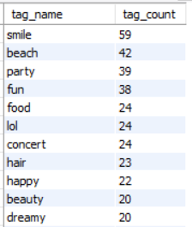

Engagement Based on Photos (Likes and Comments)
SELECT
p.id AS photo_id,
p.image_url,
COUNT(DISTINCT l.user_id) AS total_likes,
COUNT(DISTINCT c.id) AS total_comments
FROM photos p
LEFT JOIN likes l ON p.id = l.photo_id
LEFT JOIN comments c ON p.id = c.photo_id
GROUP BY p.id
ORDER BY total_likes DESC, total_comments DESC;

This query looks at the overall engagement (likes and comments) on photos and allows us to see which photos are getting the most interaction.

Result:
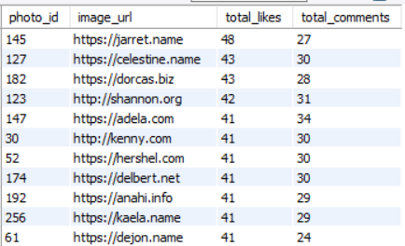

Insights:
- Engagement by Time:
  - High activity between 11 PM and 12 PM, indicates that users are more likely to upload, comment, or like photos during their free time. This is useful for scheduling marketing campaigns or posts to maximize visibility and interaction.
2. Engagement by Day of the Week:
- We can see that the third day of the week which is Wednesday shows higher engagement, we can plan marketing efforts to align with this weekday for maximum reach.
3.Top Engaged Users:
- Identifying the most engaged users can help in influencer marketing or fostering brand ambassadors.Aniya Hackett and Maxwell Halvorson are highly active users, either by liking or commenting on many photos, and they can be incentivized to participate in marketing campaigns or help amplify a product's visibility.
4. Most Popular Tags:
- Tags give insight into trends and user interests.
- Popular tags can be used for targeted campaigns, as users engaging with those tags are likely to respond well to content aligned with those interests.
- For example, tags like “smile”, “beach” and “party” are popular, marketing efforts could focus on promoting products related to those categories.
5. Photo Engagement:
- By identifying which photos have the most likes and comments, we can discern what type of content is resonating with the audience.
- It can also help in deciding what type of content to prioritize in campaigns: visually appealing or content-driven posts based on what garners more interaction.

Recommendations:
- Optimize Content Timing:
  - Schedule content uploads, ads, and posts during peak engagement hours(11 PM) or days(Wednesday). This increases the likelihood of interactions and engagement.
- Influencer and Ambassador Engagement:
  - Reach out to the top engaged users who actively like or comment on photos, offering them exclusive content or opportunities to amplify brand presence. These users can act as influencers or ambassadors.
- Trend-Based Campaigns:
  - Leverage popular tags to create trend-based campaigns. For instance, tags like “smile” and “party” are popular, creating campaigns that resonate with these interests to boost visibility.
- Content Type Optimization:
  - Based on photo engagement, create more content similar to the highest-performing photos.
By using these insights, management can develop more targeted and efficient marketing strategies that align with the times, content types, and user interests, ensuring higher engagement and more successful campaigns.

5. Based on follower counts and engagement rates, which users would be ideal candidates for influencer marketing campaigns? How would you approach and collaborate with these influencers?
Ans. Here is my approach to find ideal candidates for influencer marketing campaigns.
Approach:
Calculate Follower Count: We'll count the number of followers a user has by using the follows table, where each follower is linked to a followee (the user being followed).
Calculate Engagement Rate: For each user, we’ll measure engagement through their photos by counting the number of likes and comments received. Then, we’ll calculate the engagement rate by dividing the total interactions (likes + comments) by their follower count.
Rank Users by Engagement: We’ll rank users by their engagement rate, as higher engagement often signifies an active and influential user.
Identify Influencers: The users with a high follower count and a strong engagement rate will be the ideal candidates for influencer marketing campaigns.
Approach Influencers: Once we have identified top candidates, we can approach them for collaboration based on their interests, content style, and relevance to our campaign.

SQL query:
SELECT
u.id AS user_id,
u.username,
COUNT(DISTINCT p.id) AS photos_uploaded,
COUNT(DISTINCT l.user_id) AS total_likes,
COUNT(DISTINCT c.id) AS total_comments,
-- Get unique follower count for each user
(SELECT COUNT(DISTINCT f.follower_id)
FROM follows f
WHERE f.followee_id = u.id) AS followers_count,
-- Calculate engagement rate as total interactions divided by follower count
(COUNT(DISTINCT l.user_id) + COUNT(DISTINCT c.id)) /
(SELECT COUNT(DISTINCT f.follower_id)
FROM follows f
WHERE f.followee_id = u.id) AS engagement_rate
FROM users u
LEFT JOIN photos p ON u.id = p.user_id
LEFT JOIN likes l ON p.id = l.photo_id
LEFT JOIN comments c ON p.id = c.photo_id
GROUP BY u.id
ORDER BY engagement_rate DESC;

Result:
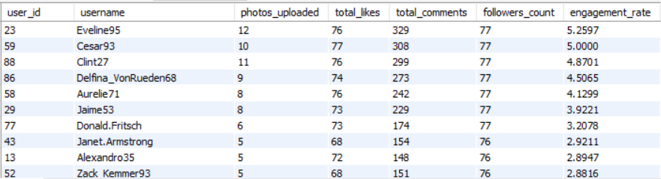

Insights:
- High Follower Count: Users with a large number of followers are typically good candidates for influencer campaigns. However, just having followers isn’t enough. We also need to consider the engagement rate to ensure that the influencer has an active and responsive audience.
- High Engagement Rate: Users who have a high engagement rate, calculated by the ratio of interactions (likes and comments) to their followers, are key. Even if an influencer has fewer followers, they can still be highly effective if they maintain strong interactions with their audience.
- Content Relevance: Depending on the types of photos a user posts and the tags they use, we can further refine the selection. For example, if a user regularly posts about fashion or fitness and has a high engagement rate, they would be ideal for campaigns targeting those industries.

Recommendations:
- Identify Top Candidates:
  - We will use the engagement rate and follower count to select influencers who will resonate with our target audience. Prioritize influencers who not only have a high number of followers but also consistently engage with their audience.
- Collaborate Based on Content:
  - Before approaching influencers, we should review their content and audience. If they align with our brand’s values and product offerings,we will reach out with a proposal that focuses on content that would appeal to their followers.
  - We can collaborate with influencers in different ways, such as sponsored posts, co-branded campaigns, giveaways, or product reviews, depending on their content style and audience.
- Offer Value and Clear Expectations:
  - In our collaboration, offer value beyond just compensation. We will provide the influencer with exclusive access to new products or unique experiences, which they can share with their followers.
  - Set clear expectations around the number of posts, types of content (videos, images, stories), and key performance indicators (KPIs) such as engagement rates or conversions.
- Measure Impact:
  - Track the performance of the campaign by looking at metrics like post engagement, new followers, website traffic, and conversions. Based on the success, we can decide whether to continue working with these influencers or explore others.
- Build Long-Term Relationships:
  - Influencer marketing is most effective when it’s part of an ongoing relationship rather than a one-time campaign. Engage with top-performing influencers over a longer period, so they can build trust with their audience and consistently promote our brand.
By using these methods to identify influencers with strong follower bases and high engagement rates, we can select the best candidates for influencer marketing campaigns that will help elevate our brand and reach our target audience effectively.

6. Based on user behavior and engagement data, how would you segment the user base for targeted marketing campaigns or personalized recommendations?
Ans. I have used the following approach to identify the user behavior and engagement:

Approach:
Calculate Follower Count: We'll count the number of followers a user has by using the follows table, where each follower is linked to a followee (the user being followed).
Calculate Engagement Rate: For each user, we’ll measure engagement through their photos by counting the number of likes and comments received. Then, we’ll calculate the engagement rate by dividing the total interactions (likes + comments) by their follower count.
Rank Users by Engagement: We’ll rank users by their engagement rate, as higher engagement often signifies an active and influential user.
SQL query:
SELECT
u.id AS user_id,
u.username,
COUNT(DISTINCT p.id) AS photos_uploaded,
COUNT(DISTINCT l.user_id) AS total_likes,
COUNT(DISTINCT c.id) AS total_comments,
-- Get unique follower count for each user
(SELECT COUNT(DISTINCT f.follower_id)
FROM follows f
WHERE f.followee_id = u.id) AS followers_count,
-- Calculate engagement rate as total interactions divided by follower count
(COUNT(DISTINCT l.user_id) + COUNT(DISTINCT c.id)) /
(SELECT COUNT(DISTINCT f.follower_id)
FROM follows f
WHERE f.followee_id = u.id) AS engagement_rate
FROM users u
LEFT JOIN photos p ON u.id = p.user_id
LEFT JOIN likes l ON p.id = l.photo_id
LEFT JOIN comments c ON p.id = c.photo_id
GROUP BY u.id
ORDER BY engagement_rate DESC;

Result:


Based on this engagement data and user behavior, I have segmented this user base for targeted marketing in the following way:
Segment 1: Active Engaged Creators
- Users who upload photos regularly, get a lot of likes/comments, and have a high number of followers.
- Targeting: Provide opportunities for brand partnerships, early access to new features, or even monetization options.
Segment 2: Silent Browsers/Followers
- Users who follow others but don't engage much with content (like or comment).
- Targeting: Show more recommendations, prompts to engage (like/comment), or interactive content to increase engagement.
Segment 3: Recent Sign-Ups
- New users who haven't engaged much yet.
- Targeting: Welcome emails, prompts for first-time engagement, and nudges to upload their first photo or comment.
Segment 4: Social Butterflies
- Users with a lot of followers and frequent activity (likes, comments, and follows).
- Targeting: Offer them advanced social features, such as follower analytics, the ability to promote their content, or rewards for community involvement.
Segment 5: Inactive Users
- Users who haven't logged in or interacted with the platform in a while.
- Targeting: Send special re-engagement offers like discounts, new content highlights, or platform updates.

This segmentation strategy would allow the management to tailor campaigns or recommendations in a way that maximizes engagement, user retention, and monetization opportunities.

7. If data on ad campaigns (impressions, clicks, conversions) is available, how would you measure their effectiveness and optimize future campaigns?
Ans. If the data on ad campaigns (impressions, clicks, conversions) is available, I would measure their effectiveness and optimize future campaigns by using the below approach.
Approach:

Key Metrics to Measure Ad Effectiveness
- Impressions: Number of times the ad is displayed to users.
  - Purpose: Helps understand the reach of the campaign.
  - Challenge: High impressions don’t necessarily mean the campaign is successful; we need to assess engagement and conversions to evaluate true effectiveness.
- Clicks: Number of times the ad is clicked by users.
  - Purpose: This measures user engagement and interest. High click-through rates (CTR) indicate that the ad is compelling enough to attract attention.
  - Target: Generally, a higher CTR suggests that our ad’s messaging, visuals, or targeting are resonating with the audience.
- Conversions: The number of desired actions completed after clicking on the ad, such as a purchase, sign-up, or download.
  - Purpose: The ultimate measure of campaign success, showing how many clicks resulted in meaningful outcomes (like purchases or registrations).
  - Target: High conversion rates suggest the landing page or product experience is strong.

Segmenting Data for Deeper Insights
Breaking down our ad campaign performance data by segments can provide more actionable insights for optimization. Some useful segments include:
- Device Type: Performance across mobile, desktop, and tablet. If one device is performing significantly better than others, management may want to allocate more budget to that device.
- Geography: Analyze which regions (cities, countries, or specific areas) generate the most engagement or conversions. Tailoring our ads to high-performing areas could improve the campaign performance.
- Audience Segmentation: If our ad platform provides demographic or behavioral data (age, gender, interests, etc.), I would use it to segment our audience and understand who is responding best to our ads.
- Time of Day: Determine which times of day our ads perform the best (higher CTRs and conversions). We can then adjust our ad scheduling to focus on high-performing hours.

To optimize future campaigns

Optimize Based on Insights

This is how we can tweak things to get better results:
- Improve Ad Copy/Design: If our CTR is low, the ad may not be catching attention. We will try testing different images, headlines, or calls to action.
- Target the Right Audience: If our ad isn’t converting, it could be reaching the wrong people.We would narrow down our audience to those who are more likely to take action (based on age, location, interests, etc.).
- Optimize Landing Pages: If our conversion rate is low, we have to make sure the landing page is relevant, loads fast, and has a clear CTA (like "Buy Now" or "Sign Up").

5. A/B Test for Simple Improvements
Run A/B tests on small changes in our campaign:
- Test different headlines: “Get 50% off” vs. “Save now on your favorite product.”
- Test images: A product image vs. a lifestyle image.
- Test CTA buttons: “Shop Now” vs. “Buy Today.”
After testing, we would use the version that performs better and keep iterating.

6. Set a Budget Based on Performance
Once we know which ads and targeting work best:
- Allocate more budget to high-performing ads and pause or adjust underperforming ones.
- Keep track of CPA—if it’s getting too high, it might be time to optimize or scale back.

7. Monitor Results and Make Adjustments
Check the performance regularly (daily or weekly). If an ad is underperforming:
- Stop running it and replace it with a better version.
- Use retargeting ads to remind people who clicked but didn’t convert.

By constantly measuring and analyzing performance, running tests, and optimizing based on these insights, management can significantly improve the effectiveness of their ad campaigns and achieve better results over time.

8. How can you use user activity data to identify potential brand ambassadors or advocates who could help promote Instagram's initiatives or events?
Ans. To identify potential brand ambassadors, I have used the below approach:
Approach:
Calculate Follower Count: We'll count the number of followers a user has by using the follows table, where each follower is linked to a followee (the user being followed).
Calculate Engagement Rate: For each user, we’ll measure engagement through their photos by counting the number of likes and comments received. Then, we’ll calculate the engagement rate by dividing the total interactions (likes + comments) by their follower count.
Rank Users by Engagement: We’ll rank users by their engagement rate, as higher engagement often signifies an active and influential user.
Identify Influencers: The users with a high follower count and a strong engagement rate will be the ideal candidates for influencer marketing campaigns.
SQL query:
SELECT
u.id AS user_id,
u.username,
COUNT(DISTINCT p.id) AS photos_uploaded,
COUNT(DISTINCT l.user_id) AS total_likes,
COUNT(DISTINCT c.id) AS total_comments,
-- Get unique follower count for each user
(SELECT COUNT(DISTINCT f.follower_id)
FROM follows f
WHERE f.followee_id = u.id) AS followers_count,
-- Calculate engagement rate as total interactions divided by follower count
(COUNT(DISTINCT l.user_id) + COUNT(DISTINCT c.id)) /
(SELECT COUNT(DISTINCT f.follower_id)
FROM follows f
WHERE f.followee_id = u.id) AS engagement_rate
FROM users u
LEFT JOIN photos p ON u.id = p.user_id
LEFT JOIN likes l ON p.id = l.photo_id
LEFT JOIN comments c ON p.id = c.photo_id
GROUP BY u.id
ORDER BY engagement_rate DESC;

Result:


Insights:
Users with username Eveline95, Cesar93 and Clint27 are some of those users who are highly engaged with the Instagram platform.
Recommendations:
Incentivize Active Creators: Engage these active creators with exclusive access to new features, early access to events, or a spot in Instagram’s campaigns. Management could offer them incentives like shoutouts, exclusive filters, or branded merchandise to motivate them to promote Instagram’s initiatives.
Highlight User-Generated Content: Encourage these creators to share content related to Instagram events or initiatives by running a campaign where they can be featured on Instagram’s main account. This could include contests, event challenges, or collaboration opportunities.
Target Engagement-Based Campaigns: Run interactive campaigns (e.g., polls, challenges) where these highly engaged users can participate and share with their followers. By offering rewards for participation, we can encourage further engagement.
Create an Ambassador Program: These users could be included in an ambassador program where they’re incentivized to share their experiences and promote Instagram’s events and initiatives. A structured referral program could work well for this group as they already have strong engagement networks.

Conclusion:
By analyzing user activity data, we can identify passionate users who are more likely to advocate for Instagram’s initiatives. By rewarding, featuring, and collaborating with them, Instagram can turn these loyal users into powerful brand ambassadors, leading to increased brand visibility, user engagement, and overall success of future campaigns.

9. How would you approach this problem, if the objective and subjective questions weren't given?
Ans. If the objective and subjective questions weren’t given upfront for this project, I’d approach the problem step-by-step by first identifying the key goals and requirements based on available data, user behavior, and business objectives. Here’s how I would approach the problem, even without predefined questions:

Clarify the Project Goal
The first thing I would do is to define what the project is aiming to achieve. For example, is the goal to:
- Increase user engagement?
- Promote a new feature or event?
- Identify potential brand ambassadors?
- Optimize advertising campaigns?
By understanding the high-level business goals, I can better tailor the analysis and recommendations to meet the specific objective.

2. Identify Available Data and Key Metrics
Given the database schema (e.g., photos, likes, comments, follows), I would focus on understanding the different user behaviors and key user engagement metrics:
- Activity-related metrics: Frequency of photo uploads, likes, comments, and follows.
- Engagement metrics: How often users interact with others' content, their post likes/comments, and how they engage with Instagram’s content or events.
- Sentiment and affinity: Users who show positive sentiment towards Instagram through comments or content related to Instagram.
- Influencer identification: Users who have significant reach and engagement on their posts.
I would aim to analyze these behaviors to get insights into the overall user experience and identify patterns or user groups that could be useful.

3. Segment Users Based on Behavior and Engagement
Without predefined questions, one of the first steps would be to segment the user base using common approaches based on activity and engagement:
- High Engagement Users: Users who post, like, comment, and follow often.
- Inactive Users: Users who have accounts but rarely interact.
- Influencers: Users who create content with high reach (high likes/comments relative to their follower count).
- Brand Ambassadors: Users who actively engage with Instagram’s content or campaigns and express positive sentiments.

4. Define Metrics for Success
Even without specific objectives outlined, I would define metrics of success for any marketing or brand initiative, such as:
- Engagement Rate: Likes, comments, shares relative to total followers.
- User Growth: The increase in followers, posts, likes, comments, etc., after an initiative or event.
- Conversion Rate: How well a specific action (event registration, referral, etc.) performs after a campaign.
By using these metrics, I can track and measure how well different initiatives are performing, whether they are increasing user activity, event participation, or brand awareness.

5. Create Actionable Insights
Once the data is segmented, the next step is to derive actionable insights from the analysis. This could include:
- Top Influencers: Identifying users who are the most engaged and influential.
- User Retention Strategies: Understanding why some users engage more than others and how to increase retention for low-activity users.
- Event Promotion Strategies: Determining which users to target for future Instagram events, and the type of content they engage with.

6. Develop Recommendations and Personalization Strategies
Finally, based on the insights, I would develop personalized recommendations to meet the project’s goals:
- User Engagement: For highly active users, propose incentives such as contests, rewards, and early access to new features to keep them engaged.
- Ambassador Program: For users who show positive sentiment or have high engagement with Instagram's events, recommend launching an ambassador program to turn them into advocates for Instagram’s upcoming initiatives.
- Influencer Marketing: Based on influencer identification, recommend collaborations with content creators who generate high engagement to promote Instagram’s events or features.
- Targeted Campaigns: Using user segmentation, propose targeted marketing campaigns for users who are likely to respond to Instagram’s event promotions.

7. Measure and Optimize
Lastly, I would implement a plan to continuously measure and optimize the campaigns or initiatives. The key here would be:
- Continuously monitoring engagement, clicks, likes, and comments to see how well each initiative is performing.
- Adjusting campaigns based on user behavior data (e.g., A/B testing on content types, timings, etc.).
- Regularly reviewing user feedback to ensure that Instagram’s initiatives align with what users find valuable.

10. Assuming there's a "User_Interactions" table tracking user engagements, how can you update the "Engagement_Type" column to change all instances of "Like" to "Heart" to align with Instagram's terminology?
Ans. To update the Engagement_Type column in the User_Interactions table where the value is "Like" to "Heart," I would use an SQL UPDATE statement. Assuming I have the User_Interactions table with the relevant column, the query would look something like this:
UPDATE User_Interactions
SET Engagement_Type = 'Heart'
WHERE Engagement_Type = 'Like';

Explanation:
- UPDATE User_Interactions: Specifies that we want to update the User_Interactions table.
- SET Engagement_Type = 'Heart': Sets the value of the Engagement_Type column to "Heart."
- WHERE Engagement_Type = 'Like': Only updates rows where the Engagement_Type currently has the value "Like."

