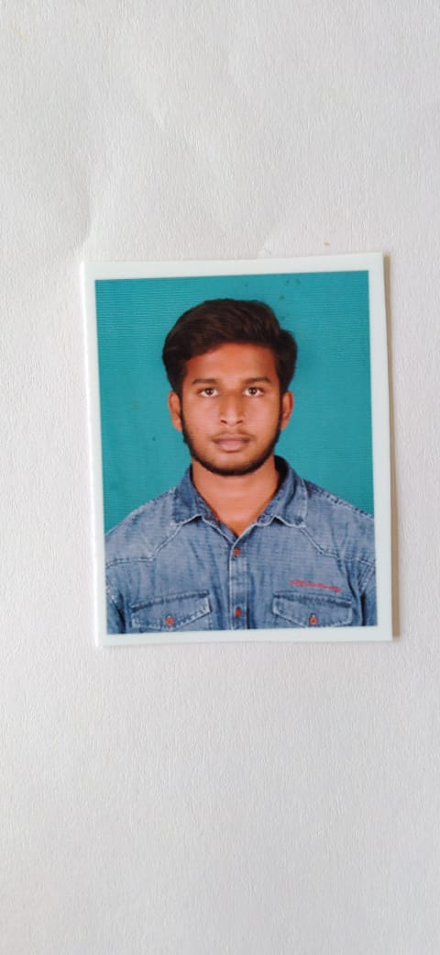

**Kiran Kumar D R**

Email:kirankumar799649843@gmail.comContact No: 9148269164

CAREER OBJECTIVE:

Seeking excellence in the professional field through positive attitude, hard work and commitment towards the organization where knowledge has always been the top priority to cope up with the future challenges, skills are suitably rewarded and given chances to constantly add value to the company at large by working at the cutting edge of technology.

# TECHNICAL SKILLS AND SUMMARY:

1. CORE JAVA
   * Create classes and objects and add methods to a class..
   * Excellent in Inheritance and Polymorhism.
   * Strong in Type Casting and Encapsulation.
   * Sound knowledge in Abstraction.
   * Very good in Collection Frameworks.
   * Implement error handling techniques using Exception Handling.
   * Learnt and implemented java Threads.
   * Very good in programming/coding in edit plus and Eclipse.
   * Knowledge of java Bean and Singleton class.
2. SQL
   * Knowledge on SQL Programming in Oracle 10g.
   * Written SQL queries for DML,DDL and TCL operations.
   * Knowledge on DQL,DCL operations.
   * Good knowledge of SQL Sub-queries,Joins and Predefined Functions.
   * Good in Normalization.
3. JDBC
   * Knowledge on jdbc driver.
   * Knowledge on jdbc connection steps.
   * Knowledge on jdbc transaction.

**SOFTWARE EXPOSER:** JDK 1.8, EDIT plus, Eclipse, Oracle 10g,

# CERTIFICATES:

* + - I have completed my Java Training of course at “**Jspider**” Rajajinagar Bangaluru.

# EDUCATION DETAILS:

* BE in Sri Siddhartha institute of Technology in Tumakuru in 2022.
* PU in SBG PU College in TB Cross,Mayasandra in 2018.
* S.S.L.C in GJC Turuvekere in 2016.

# EXTRA CURRICULAR ACTIVITIES:

I will done the survey in Melukote.

# PERSONAL DETAILS:

Date of Birth : 07-May-2000

Languages : English, Kannada.

Hobbies : Reading,Swimming,Running.