METHOD FOR NETWORK ASSISTED ASSET PROTECTION

Concept Paper

Analysis Work Carried Out At

<>, Bangalore

December 2021

ABSTRACT:

The idea proposes a new method for mobile and immobile asset protection and life cycle management using network assisted and network provided events.
The method to
- Generate mobility and communication context events
- Store communication context event data
- Generate a Hash Tag based on stored event data
- Authorize group users to acquire hash tags for multiuser authentication
- Induced/Virtual roaming for relative events

Events can be location events or device state events specific to device or relative to device.
Are specific to these domain

- IoT: Smart City
- General Public: Protecting/Monitoring the assets
- Government/Private Body: Protecting/Monitoring the assets
- Context Based Resource Authorization and Authentication
- Context Based Identity Management.

ACKNOWLEDGEMENTS:

I am highly grateful to <…> providing me such opportunity to write a first concept paper

I am obliged to <…> for providing such opportunity.

Kiran CS.

Table of Contents

Chapter No. | Title |  | Page No.
1 | INTRODUCTION  - Brief Introduction to Concept  - Problem being solved |  | 1  1  1
2 | Brief Description  2.1 Analysis |  | 4  6  7  7  7  9  11
3 | Further Enhancements |  | 12

List of Figures

Figure No. | Title | Page No.

List of Table

Table No. | Title | Page No.

GLOSSARY:

SSP: Security Service Provider
IoT: Internet of Things
HSS: Home Subscriber Server
GUI: Graphical User interface
CCEM: Communication Context & Event Management
AF: Application Function
SBI: Service based interface
LDAP:Lightweight directory Access protocol
UDR: User data repository
UDSF: Unstructured Data Storage Function
UDM: Unified Data Management

Implementation Plan.

Sr.No. | Description of work | Start Date | End date | Status
1
2
3
4
5
6

Execution Plan.

Sr.No. | Description of work | Start Date | End date | Status
1
2
3
4
5

1.INTRODUCTION

  - Brief Introduction to Concept

The invention provides a method as algorithm to prove authorization of resource via strong and recursive challenge factors using Network Provided information via security contexts.
The algorithm is adaptive, and network controlled by a security domain.
The method is hosted inside an AF called Communication Context & Event Management Function.
This method is responsible for producing the Authorization events related to the resource under monitoring.

1.2 Problem being solved

The method proposed facilitates the network driven authorization along with life cycle management of self-asset in safer and secured way to prevent fraud, mafia access.
The method uses network assisted procedures to build the trust data and challenge the fraud user based on communication contexts events the trusted user and trusted network have created over time. The method provides enhanced social security.

2. Brief Description

The method of generating the events, inducing it and maintaining the records of events for UE and group of UEs, is hosted inside an AF called Communication Context & Event Management Function.
This AF is responsible for producing the Authorization events and creating challenge factors for fraud user using time stamp or any related events as a question.
Some of the concepts of induced virtual roaming with AR-VR facilitation to create mobile communication context events that are encoded in 5G Data stores like UDR/UDSF. The new application function CCEM (communication context and event Management) is used to trigger mobility events related to asset protection and formulating Event data stored in granular time series DB in compact method with context data chains. The Fraud user will be challenged to prove the Mobility Context Events and its relative events, at specified granular time or chain of times that becomes NP hard problem to solve. Block chain method will be one implementation idea to realize this concept. Google APIs can be used as an example for Location based Authentication and Authorization apart from 3GPP defined procedures.

2.1 Analysis

Figure1: General Deployment Model

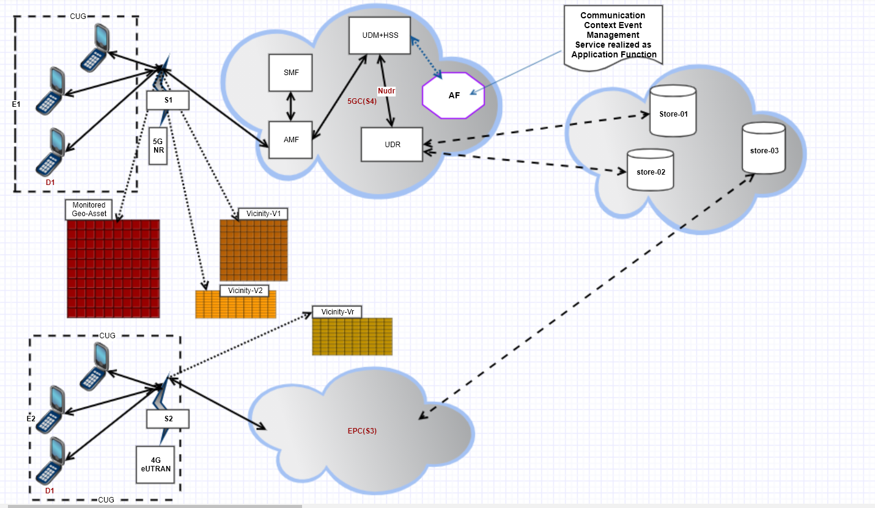

E1, E2: Location Events generated by Devices
S1, S2: Location Events generated by RANs w.r.t source.
S3, S4: Location Event Generation control by cloud core
S5: Event store with specific pattern.

Vicinity-Vr is the case of roaming by the same device D1 of the CUG.

Example Case considering Location context,

1.
The Location events are generated by E1, E2 and S1, S2
This usually comprises of Network Assisted Device Provided Location information along with meta data injected by the algorithm running in cloud securely triggered by device.
Also, the Network Provided Location information with Source (RAN) induced information like these location Events comprises of below for EPS case

MME-Location-Information:: = <AVP header: 1600 10415>
[E-UTRAN-Cell-Global-Identity]
[Tracking-Area-Identity]
[Geographical-Information]
[Geodetic-Information]
[Current-Location-Retrieved]
[Age-Of-Location-Information]
[User-CSG-Information]
[ eNodeB-ID ]
[ Extended-eNodeB-ID ]

For 5G Access please ( Refer 23.502 and 23.501 and 29.503 3GPPs)

Along with PLMN-ID and RAN induced information and roaming information (based on 3GPP specifications 29 series ..)
The time stamp the location information requested by Serving node.

2.
Geo Asset is the actual asset that needs to be monitored / protected.
The vicinity boxes are nearby assets (Example Actual Geo-Asset can be a building, or a site/land and vicinity can be nearby land or a hill or new layout)
The vicinity-r is also the vicinity but due to roaming conditions may induced via micro roaming.
The colour of the Main Assets and Vicinity example spectral/chromatic mapping that is generated by algorithm (which is a graph polynomial) that creates a NP-Hard problem.

3.
The location Event is generated above by device or network controlled by CN along with CUG that forms a strategy
These events are stored in time series DB and a Geo-Hash is generated for each event or for group of events in such a way that the members of CUG receives the Geo-Hashes generated differently
Mapping to same event happens over secured network slice.
This Event correlation data serves a challenge to Fraud user to prove the Location events based on Geo-Hashes.
If somebody hacks the Hash, they cannot hack the Location Event mapping to the hash because its securely stored in the subscriber repository that needs real user access only.
The fraud cannot prove all the mobility events (location events) on the random time series.

4.
Hovering over the asset is as feature where the device owner/ or a machine can turn on the function and just walk randomly over the Geo-Asset or vicinity to create events.
The algorithm takes that input and maps to the Network Assisted Device Provided Location information (Since this is network assisted there is no fake medium here, with the network assist a controlled recursive authentication of Geo-Hash/Hashes is executed)
Parallelly the network provided information will be invoked by the Core network based on existing, immediate/deferred / concurrent location requests
Or trigger via Application function scheduled strategy.

5.
The CUG can produce such Events against the Group subscription which can produce a mutual authentication using different access types and supplementary services.
The CUG can be formed by same SIM with different user identities or with different SIMs
6
Induced roaming can be done by user using the Virtual Reality methods
like owner can roam with device virtually and start creating roaming scenarios/criteria whose events can be recorded by CCEM AF via UDM/HSS

Figure 2: Authentication, Authorization and Registration to Network

The Authentication, authorization and Registration to Network follows existing 3GPP mechanisms a capability / supported feature for AF needs a direct programmable API using existing SBI mechanisms.
Even Vendor specific realizations with custom APIs are possible.
The N71 interface of eIMS can be utilized for realizing the CCEM AF.
The programmable API is authorized to fetch any event data / transaction state for mobility/charging events and subscribe and notify possible.

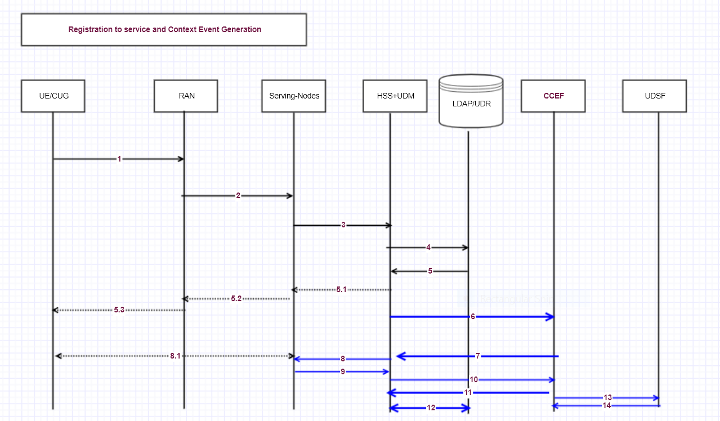

- UE/CUG performs authentication and attach subscribing for this new monitoring service.
- RAN forwards this request to Serving Nodes (MME, AMF.)
- Serving node asks HSS+UDM to perform authentication authorization
- HSS+UDM reads the subscriber profile in DB
- HSS+UDM gets the subscriber profile response from DB
5.1,5.2,5.3 The UE/CUG is authenticated and attached and acknowledged by network.
6. HSS trigger CCEF to perform the service execution for this UE/CUG
7. CCEF asks HSS to generate the location events, or any other events mentioned in (Type of Events)

HSS queries the serving node to get the event data
- HSS gets event data from serving nodes
- HSS forwards the event data to CCEF.
- CCEF acknowledges the HSS with permutation data
At this step the CCEF implicitly subscribes for permutation data movement from UDR to UDSF based on time stamp.
- HSS updates the permutation data into the subscriber profile/CUG.
- The CCEF Executed the Algorithm A1 and stores the output into UDSF in time series DB.
- The UDSF acknowledges the data.

Based on user query or periodicity the CCEF can produce the Geo Hash with Algorithm A2
And supply to user that can be used as challenge against fraud.

Figure 3: Context Event Generation

The new AF CCEM has connectivity with UDM or HSS over SBI interface.

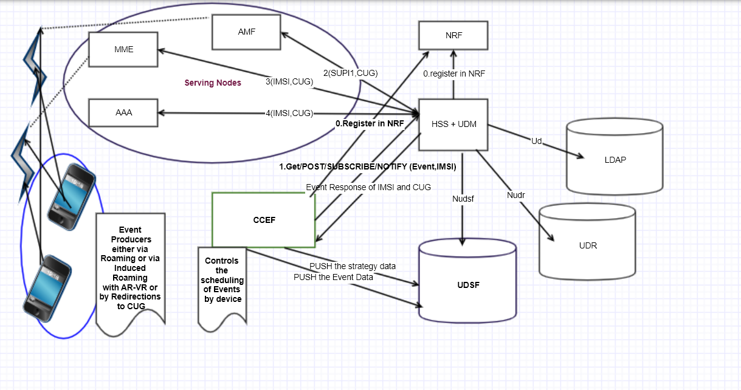

The Databases UDR and LDAP storing the subscriber profile data and its associated CUG data
Uses standardized interfaces from HSS+UDM for profile access.

The CCEF has access to these databases via HSS+UDM (using N71 or Sh interfaces)

The CCEF stores the Event data into UDSF retrieved from HSS+UDM who in turn queries serving nodes to get the event data.
Please note serving nodes mentioned are not limited, the concept can be used for OAM
aspects to account the registration, deregistration’s, subscriptions, and notifications event generation time, push and pull of CM/PM/FM events and as an event performed as correlation event.
These are valid for control plane signaling and the data access
The CCEF uses many intelligence services like SMS or MMS or email to make the application inside the UE that can produce the events as part of control and schedule strategy.
The application inside the UE is controlled by network operator and subscriber via service portal with secured interfaces.

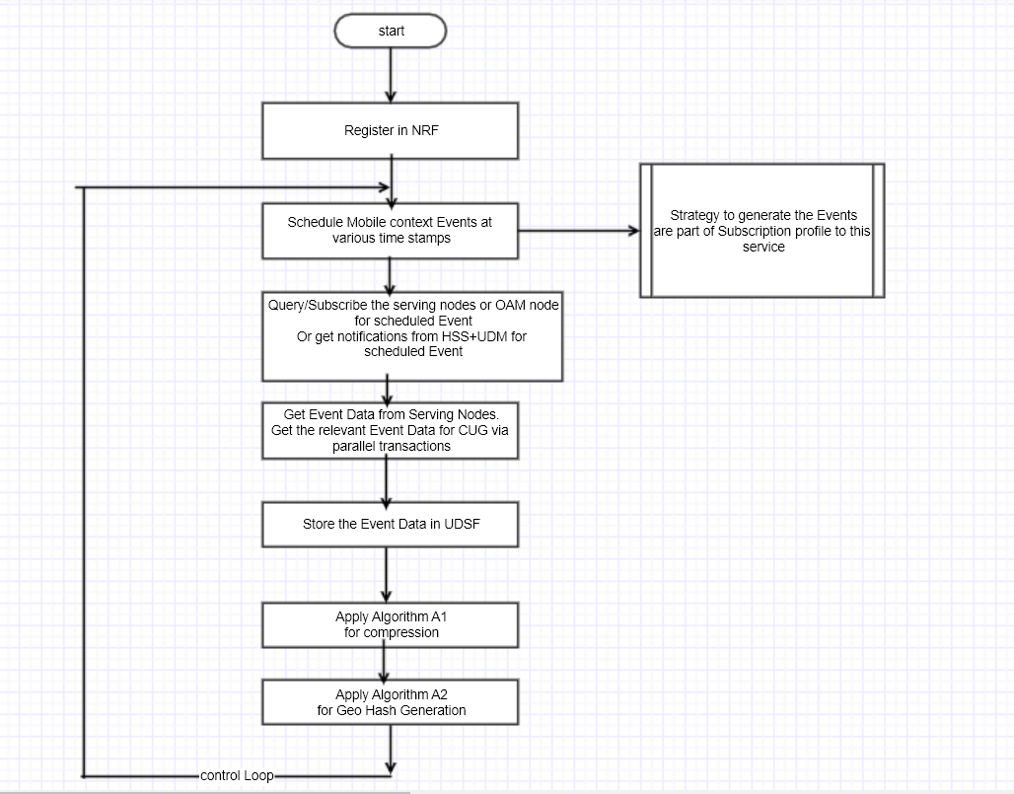

Types of Events:
- Location Events (Real, Induced)
- User state Event (Real, Induced)
- Roaming Events (Real, Induced)
- Re-Attach Event (Real, Induced)
- Detach Event (Induced)
- Relative Attach Event (Real)
- OAM events
- Charging Events
- Attach from type of network event
- Attach from specified Device event
- Receive SMS event
- Send SMS event
- Subscribe for SMS event.
- Generate email event
- Get Charging event.
- Handover from RAT (inter/intra) events
- Handover from different access events
- Using multiple SIMs from multi-vendor operator related events
- Events due to OTT
…
May more communication context event.
And these events are strategized by network operator either based on rule-based machine learning to detect the new events or static feed from operator service excellence.

Figure 4: Compression Geo-Hash Generation and Management

Algorithm A1:
The compression uses encoding methods internally with below strategy.
- Uses the profile reference from UDR / LDAP (basically UID of the user/CUG)
- Maps the event and the correlation events with unique numbers
- Uses the dictionary methods to compress the Event data received from serving nodes
Or OAM
- Uses multi part ZIPs based on the random number generated from time stamp, size of data, ascii value at specific index chosen inside the event data
- Assemble the ZIP with a strategy based on permutation sequence
The permutation sequence is stored in subscriber profile for configured time
And based on acknowledgement from user it will be moved to UDSF with documentation.

Algorithm A2.
Geo-Hash Generation:
There is assembler function F (D1, D2, D3, metadata) that uses the below input.
    - The public identity
    - permutation sequence,
    - then the random parts of multi part ZIP
to generate the current Geo-Hash.

Note: The detail implementation of A1 and A2 will be furnished based on request.
In one aspect the implementation can be realized with Block chain method with challenges taken from timeseries DB to answer the event details at time which is computationally hard.

Example case how the UE can produce the data:
A high-level call flow is depicted above is defined below the CCEF can be modeled as NEF or Management Entity in the below figure.

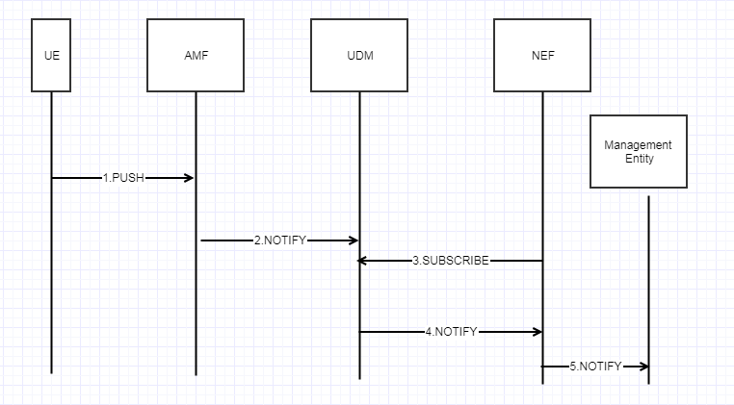

- Device PUSH: The android UE has an application software installed that calculates the device power consumption at periodic instance and transmits to AMF via NAS a control signal, after doing
a background data transmission to shared storage (like UDR) which any NE can access asynchronously
- NOTIFY: AMF notifies the UDM that there is a power pattern data change
- SUBSCRIBE: NEF had subscribed for power pattern change notification
- NOTIFY: UDM sends notification to NEF about the change in power pattern
- NOTIFY: NEF access the shared data and the trained data from UDR and applies ML (like k-means, Bayes) and decides the pattern match. If the current real time estimated pattern doesn’t satisfy the expected estimate, then NEF sends notification to Management Entity

The below diagram summarized the application logic via deep learning

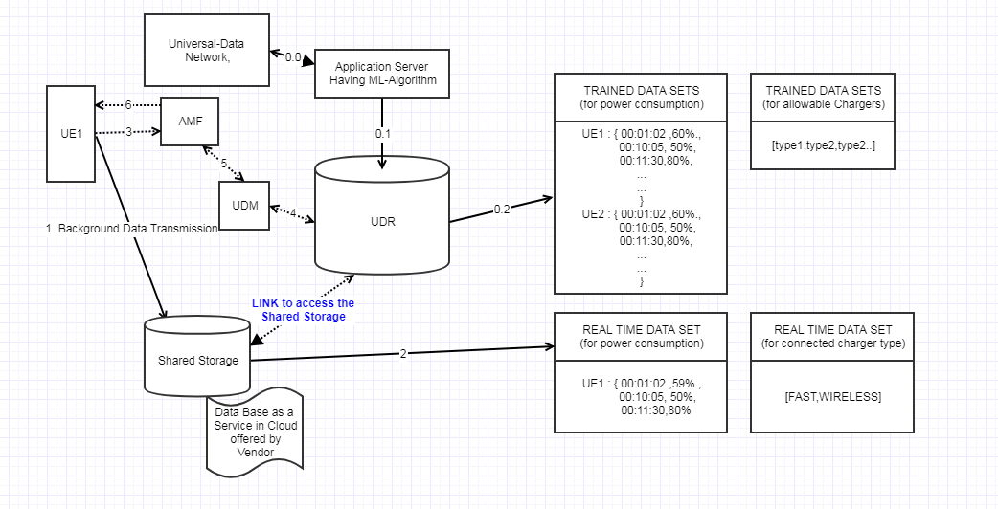

- : The Application Server gets the input from external data network(controlled) and learns the subject matter,
extracts the data related to allowable chargers/power patterns for a UE and builds the DATA sets.
It can use search engine or any trusted websites.
0.1: The Application Server can also get input from UDR where UE is pushing the data to shared storage (1,2) that is offered by vendor and UDR has a link to access such data (this is new idea that can be disruptive w.r.t keeping SBI of 5G not impacted)
Like: UE has access to third party cloud service providers and upload this data
The UDR can access this securely when Application Severs needs to fetch this data.
0.2: The UDR also has initial set of trained data done from provisioning.

Application Server applies ML algorithm for decision making when it gets notification from UDM.

Control Signals:
(4,5,6): The background data transmission rate for deep learning can be controlled by the signals
(3): UE intimates to AMF that background transmission of UE-Specific application data is completed
Asynchronously or the UE application can do some more transmission cycles and send this control signal to AMF.

How to select the Monitor/Announcer of Events to network in case of trusted CUG:
The below diagram depicts a sample use case where the sensory system like seismic sensor communicating with devices using CUG
Device-02 and Device-01 to feed the critical data
The ProSe-APP inside the device has the intelligence to frame the Message [ data/voice] to broadcast to group
Acting as Announcer/Monitor

Assume that the device Device-02 and Device-01 are in inactive mode
Either due t less battery or in PSM [power saving mode] or not available, then the critical event is missed.

To address this situation the devices in proximity can pushes the DeviceStatus, ex. UserState information as depicted in figure to proseFunction over PC3 interface. [ Alternatively, network can sense the user state and get this notification]

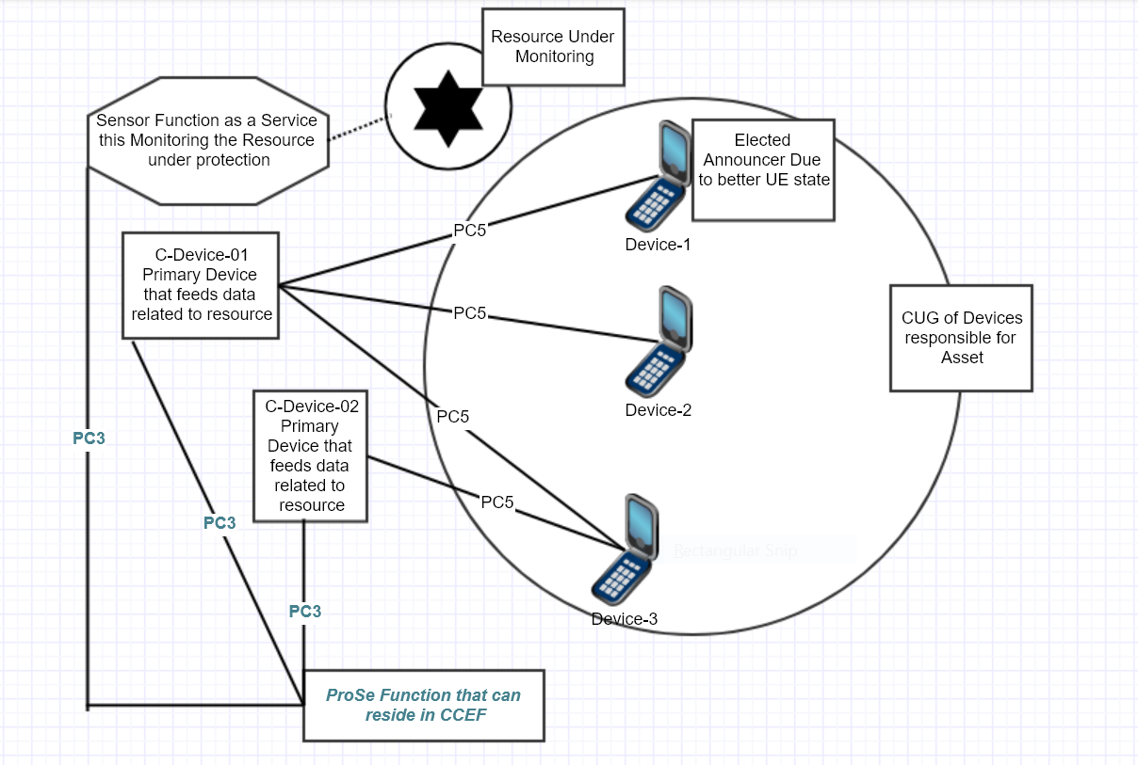

The below information set is propagated to ProSe Function embedded in the CCEF

DeviceStatusSet [
{"DeviceId":"0x001","BatteryStatus":"80%charged","MemoryStatus":"80%Free"},
{"DeviceId":"0x002","BatteryStatus":"50%charged","MemoryStatus":"50%Free"},
{"DeviceId":"0x004","BatteryStatus":"60%charged","MemoryStatus":"90%Free"},
]

UserStatusSet [
{"DeviceId":"0x001","userState":"IDLE"},
{"DeviceId":"0x002","userState":"BUSY"},
{"DeviceId":"0x004","userState":"NOT_REACHABLE"}

]

The ProSe function performs Best fit algorithm like below
- Parse the DeviceStatusSet, UserStatusSet
- Select device with Better Batter Condition and Memory condition
- Select device with UserState=IDLE satisfying condition 2
- Send notification to Best Fit Device to become the monitor.

In this above example of

BestFitDevice=0x001
BestFit (DeviceStatusSet, UserStatusSet) ➔
{
Do
{
BestFitDevice=DeviceStatusSet.sort(BestFitDevice, pair(BatteryStatus, MemoryStatus))

If(UserStatusSet.select(BestFitDevice). UserState == BUSY)
{
Wait for few nano seconds.
}
Else if(UserStatusSet.select(BestFitDevice). UserState == IDLE)
{
Return BestFitDevice
}
} while(true);
}

In this example we get
{"DeviceId":"0x001","BatteryStatus":"80%charged","MemoryStatus":"80%Free"}
{"DeviceId":"0x001","userState":"IDLE"},

{"DeviceId":"0x001"} becomes monitor.

Extraction and Mining of data:

Following components are part of data mining that will be used as a one method.
Each element in the set is a topic.
New elements to this set are added by controller for evolution on the topics.
The maturity time Tm depends on number of items in the set Pi (1, p)
The data corresponding to the element of Pi forms knowledge base.

The system shown in Figure 1 suffers to provide better service when the elements of the set Pi increase.

Following new method is devised to solve the problem.

Data Description Protocol for Knowledge Extraction:
This request-response protocol that tells if the piece of data subjected to the context is classified as knowledge / knowledge topic which is essential to build the context knowledge base.
This is application layer protocol the payload can be represented in any format with negotiation.
This protocol is self-communicating implies it generates the payload when the contents of set Pi changes.
Short Representation Below

DDP (Request | Answer, Operation, Payload […])

Extractor(EXT): A device or method or technique used to extract the data pointed by the element of set Pi to a shared storage (Ks)
Ks = KB (1, P)
It contains the Knowledge base of all the Topics as a hierarchy

Injector(INJ): A device or method or technique used to inject the Ks to Node-n subjected to scale out

Controller(CNTRL): Hosts Extractors and Injectors and facilitates building of Ks to mine and update the DDP payloads generated by Node(s)

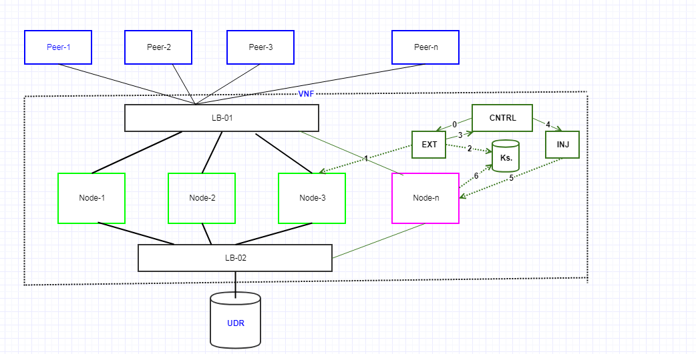

Figure 2.
0,3,4 are internal messages between CNTRL and its components
1,2,3,6 are the external messages using DDP
Note Ks is dynamic.
Node-n has got knowledge attached which was extracted from Node-3.
The attachment will be present until the intelligent copy is performed when Node-3 CPU is idle
Or subjected to conditions like low traffic or based on time like mid night etc.,

The same Ks can be attached to any scaled-out node if its not evolved until the new Ks is formed.
And the Node-n has detached the Ks after intelligent copy.

Descriptions:

DDP Packet Format looks like below

<payload Type>: JSON|DIAMETER|CBOR|…
<payload>: <KB-DATA>
<operation>:C|R|U|D|S|N|I|E|F|A
C: Create S: Subscribe F: Fast-Copy
R: Read N: Notify A: Attach-Storage
U: Update I: INJection
D: Delete E: EXTraction

KB-DATA is Knowledge Base Data corresponding to Pi (1, p)

If we use JSON payload the KB-DATA must conform to below schema
The schema is subjected to enhancement.
{
"$schema": "http://json-schema.org/draft-07/schema#",
"$id": "http://<vendor>.com/kb-data.schema.json",
"title": "KB-Data",
"description": "Knowledge Base Data Representation in VNFc",
"type": "object",
"properties": {

"kbTopic": {
"type": "string"
},

"kbSource": {
"type":"string"
},

"kbConsumers": {
"type":"array",
"items": {
"type": "string"
},
"minItems": 1,
"uniqueItems": true
},

"kbStore": {
"type": "string"
},

"detachStrategy":{
"type":"object",
"properties":{
}
},

"topicPriority":{
"type":"integer"
} } }

Schema element | Description | Consumers
kbTopic | These are various topics that forms he element of set Pi | Node, CNTRL, EXT, INJ
kbSource | Location URI, memory, port, service where knowledge base data is present and mined sophisticated. | CNTRL, EXT
kbConsumers | End points where knowledge to be injected | CNTRL, INJ
kbStore | Location URI, memory, port, service where knowledge base data is extracted to. Example can be distributed shared memory | CNTRL, EXT, Node
detachStrategy | Rules when the Node must detach from kbStore | Node, CNTRL
topicPriority | Integer from 0 to 100 that tells the priority of topic for node maturity in increasing order  0 means high priority topic to have that knowledge imbibed. | CNTRL, OAM

DDP response:

Format looks like below

<payload Type>: JSON|DIAMETER|CBOR|…
<payload>: <KB-DATA>
<resultCode>:<integer>

resultCode: User can have defined result code and error handling specific to his deployment.

Example interaction between components described below.

- Automatic building of Knowledge Base by existing Nodes (1, n-1)

The controller sends a periodic message to Nodes (1, n-1) based on distribution logic
Round robin or weighted or based on load factor (CPU, Memory consumption) the message
To each node is to prepare the mine of data corresponding to the items of set Pi
Set Pi {T1, T2, T3, T4, T5 …….}
Controller can send below payload to Node1 on pre-negotiated JSON formats
<payload Type>: JSON
<operation>: CSN
<payload>:
{
"kbTopic": "T1",
"kbSource":"Node1",
"topicPriority":1
}

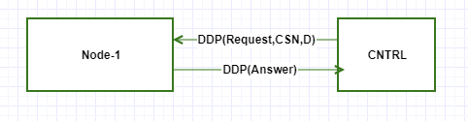

When the above DDP (Request) is received by Node-1 for Topic T1 it implicitly creates the resource
(a ticket, a pointer etc.,) by self mining.
The Mine in Node-m can be a memory map that has KB specific to Tm m<n called MN1
if the self mining is successful it responds in DDP(Answer) if the resource doesn’t exist a
subscription is created for this topic in Node-1 and will be self notified when the event pertaining to
T1 happens in Node-1.

Similarly, the CNTRL distributes the other Topics to other Nodes like
T2 to Node2, T3 to Node 3 etc.,
Or T2, T3 to Node2 and T4 to Node 3 based on the distribution strategy.

- Extraction of MNm from Node-m to Ks

Step 0,1,2 in Figure 2 corresponds to CNTRL sending DDP(Request) to EXT to extract MN1 to Ks

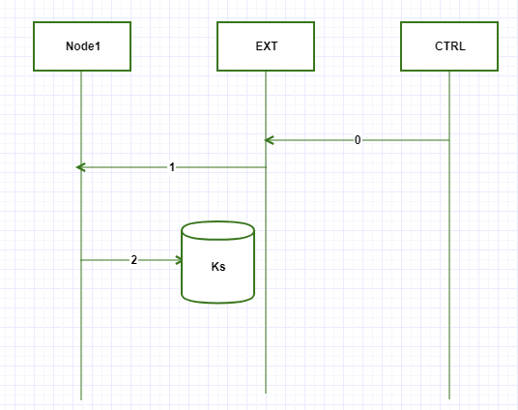

0: DDP (Request, Extraction, Payload [T1, Node1,1])
1: DDP (Request, Fast-Copy, Payload [T1, Node1,1])
2: Copy MN1 to Shared Storage Ks.

- VNFm scaled a new Node-n and CNTRL called INJ to attach Ks to Node-n

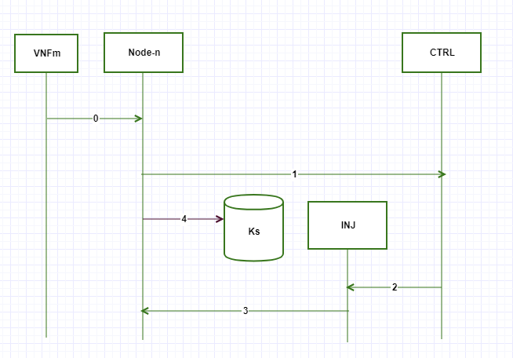

0: VNFm scaled out new Node-n (auto scaling)
1: Node-n checks the CNTRL for Knowledge about the current environment with below message
DDP (Request, Read, Payload [Pi (1, p)]
2: CNTRL calls INJ to attach the Ks to Node-n with below message
DDP (Request, INJ, Payload [Pi (1, p)]]
3.INJ sends below message to Node-n
DDP (Request, ATTACH, Payload [kbStore=Ks, detachStrategy=[D1]])
Here the Node-n has got all prerequisite to process the traffic
The detachStrategy =[D1] tells the Node-n must detach from Ks when D1 is met.
Here D1 tells to Node1 to copy the Ks to its in memory during off-peak load as example
After Node-n Attaches to Ks successfully it finally attaches to VNF so receive the traffic and provide service.

The below flow chart summarizes the Extraction concept driven by CNTRL.
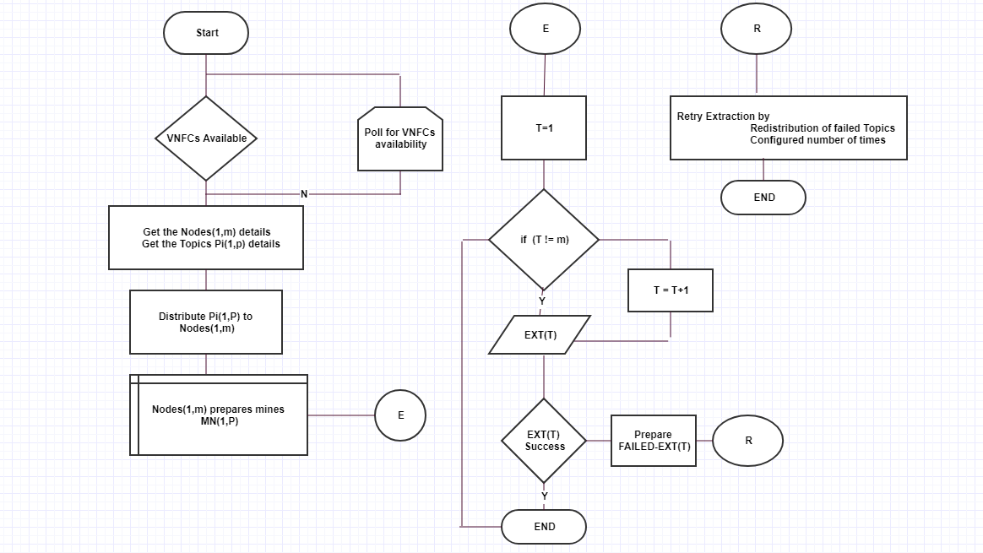
The below Flow chart summarizes the Injection Technique on Node-n scale out by VNFm

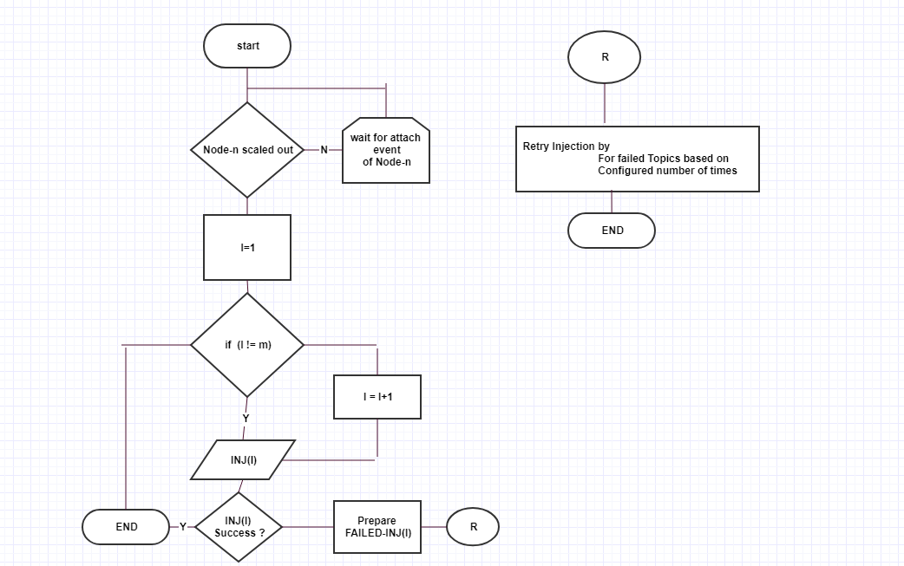

- New Topic Evolution and Subscription

The OAM interface can supply the new Topics using DDP to CNTRL with Update Operation.
And the CNTRL will update the set Pi (1, m)

The existing data will be evolved by using ML algorithms by sensing the size of the Mined data MN (1, m)
Or by explicit notification form Node (1, m) to CNTRL

Analysis of the KB Injection:

Assume that without KB injection technique the Node-n must perform below tasks to serve the real time traffic
- Contact UDR to get general data over TCP connection (max LAN delay = 50 ms) = T1
- Contact NRF to discover peers = T2
- Contact local process to load the configurations from Database = T3

Pi = [ T1, T2, T3]

Tmwokb ~ = (T1 + T2 + T3)

With KB injection technique

Node-n contacts controller and gets the KB = Tmwkb

Tmwkb far less than Tmwokb

Advantages of this solution:

- Improved quality of service.
- Adaptive and dynamic and systematic classification of knowledge-based data using DDP
DDP provides an agent that facilitates self mining of system to prepare KB
- Performance can be guaranteed as the Topic extraction are distributed to Nodes.
- The Ks can be plugged to any new Node of this VNF or in multi-VNF deployment to have faster maturity
- The Ks alone can be scaled based on strategy like mandatory basic prerequisite can be just scaled and attached for load sharing or can be flashed to other storage medium and attached.

Sample Case Study:

The CCEF instructs the user to perform induced roaming using Virtual reality method.
The user uses Virtual reality headsets and viewers and tries to roam from source (either chosen by network or by user) and moves to the destination (Geo Asset) using a route map.

This virtually creates a roaming scenario.
In this roaming scenario the specific events can be induced
by CCEF to get the location information, user state, the user specific contexts for impacted user or for CUG.
The other relative events from control plane elements are recorded as event data stored in UDSF.
The event can be fully constructed based on the induced roaming.
A hash code is generated for this with input as Event data and stored against the time stamp.

REFERENCES

- https://www.3gpp.org/
- https://en.wikipedia.org/wiki/Blockchain

Check List:

