LINEA.TC.VISA--20090101

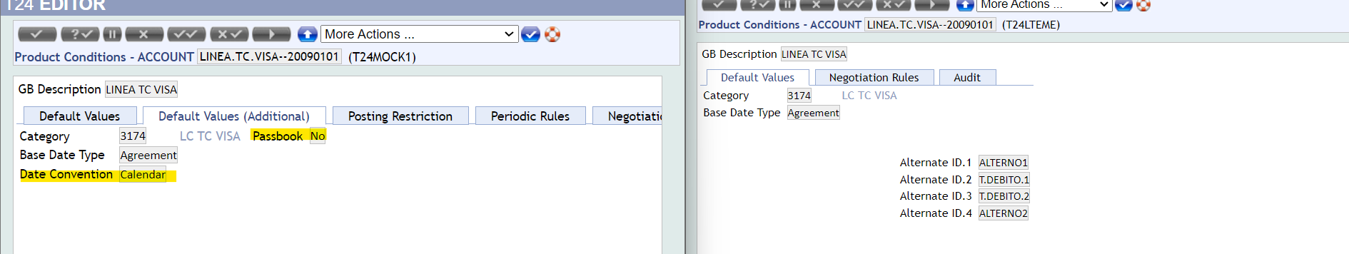

TC-20090101

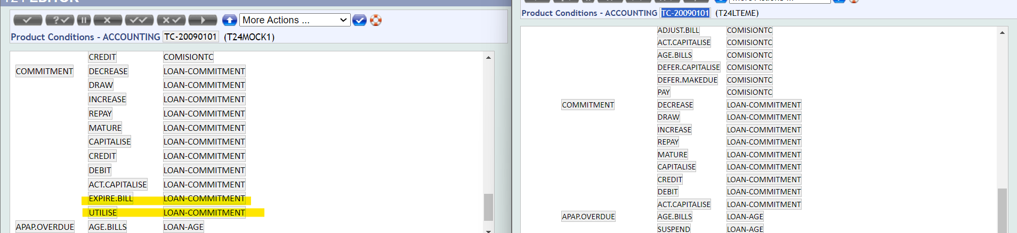

CONSUMO-20090101

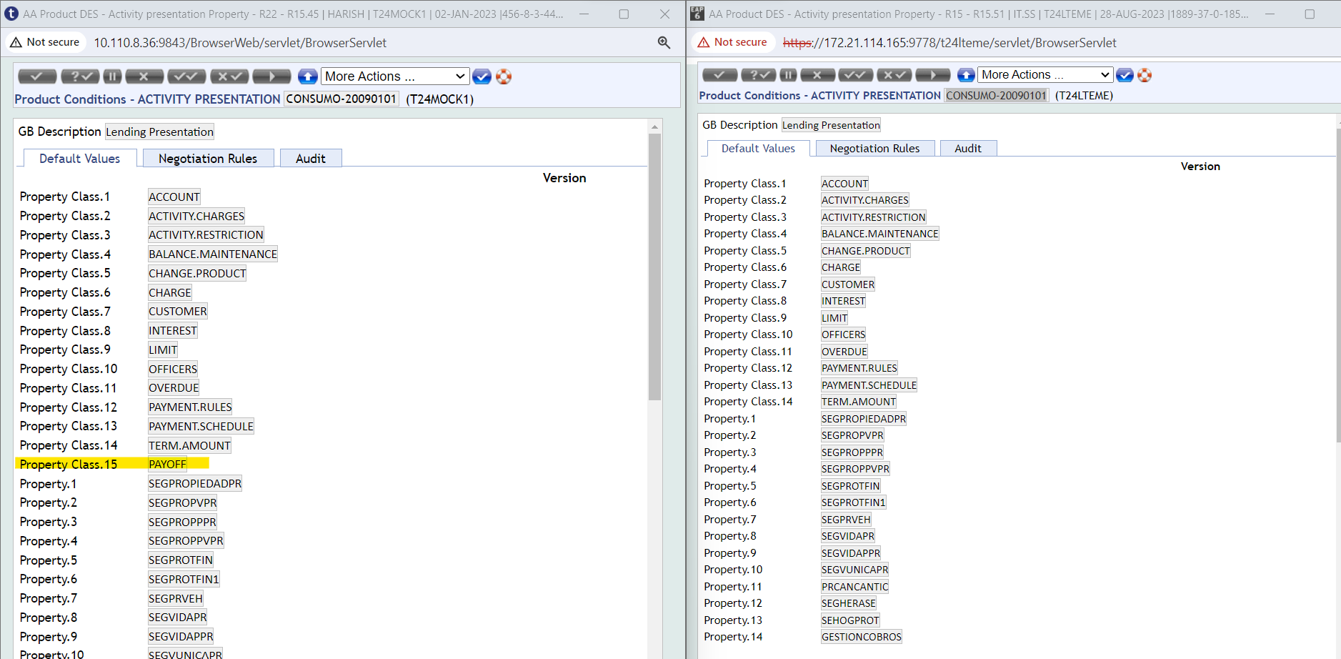

LINEA.CREDITO.TC-DOP--20090101

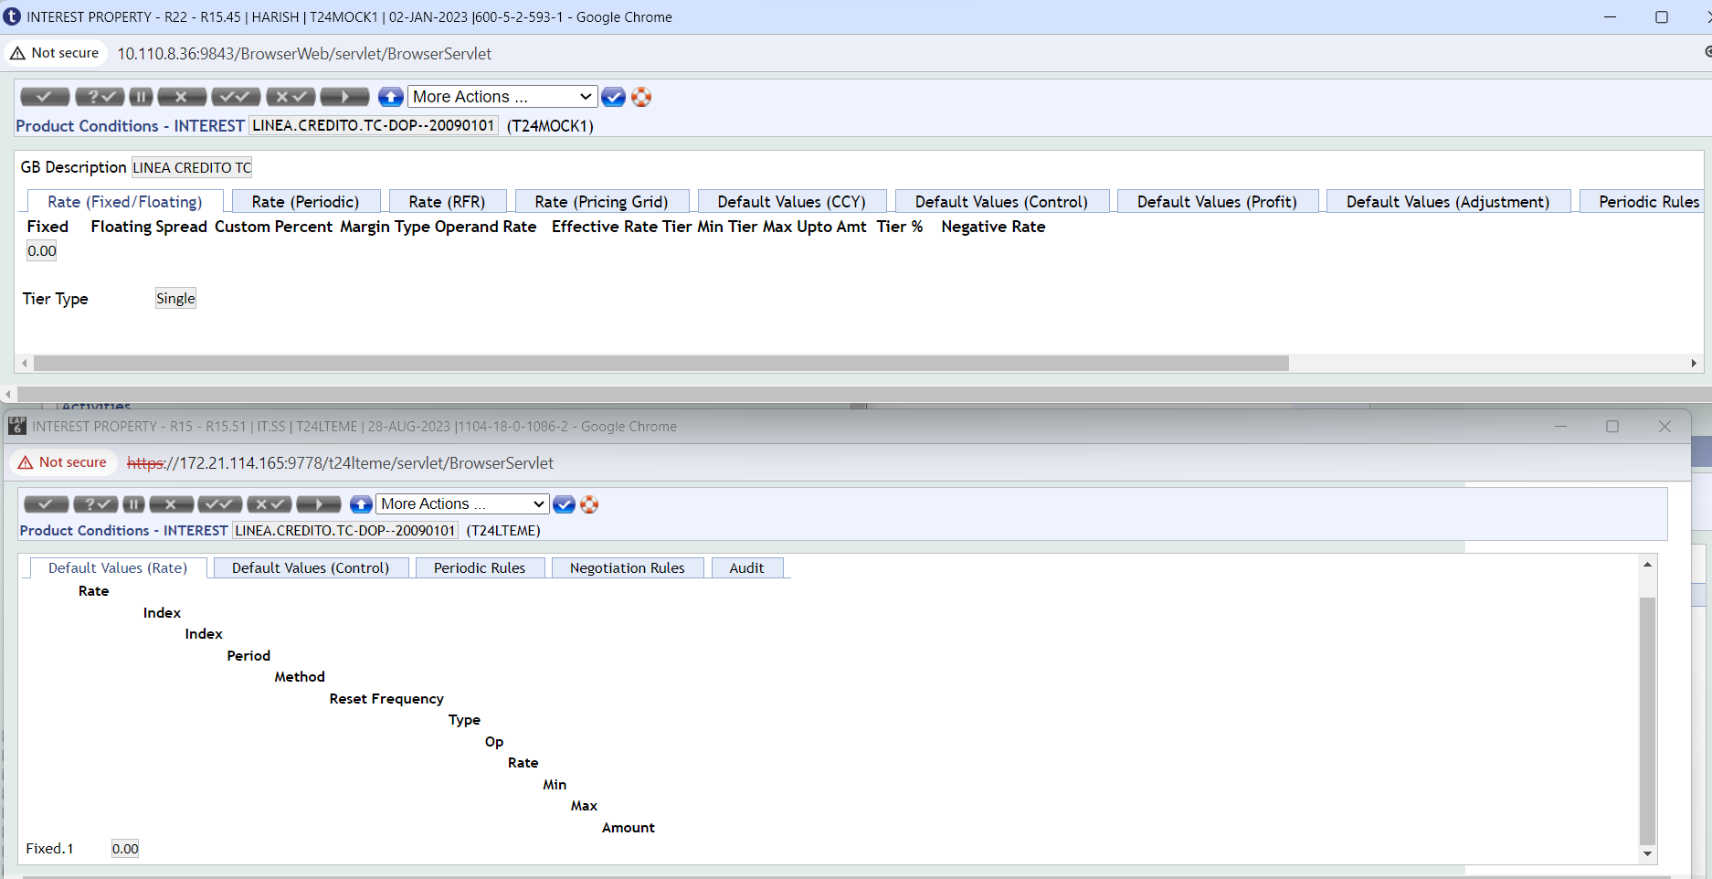

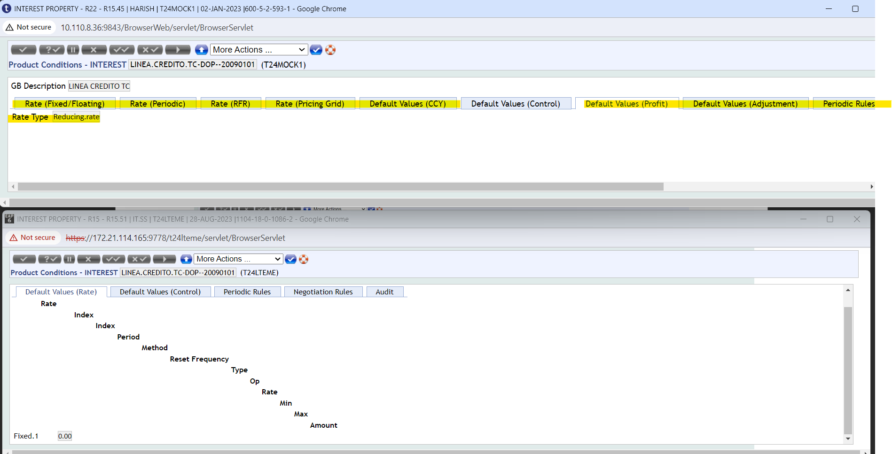

ATRASOS.TC-20090101

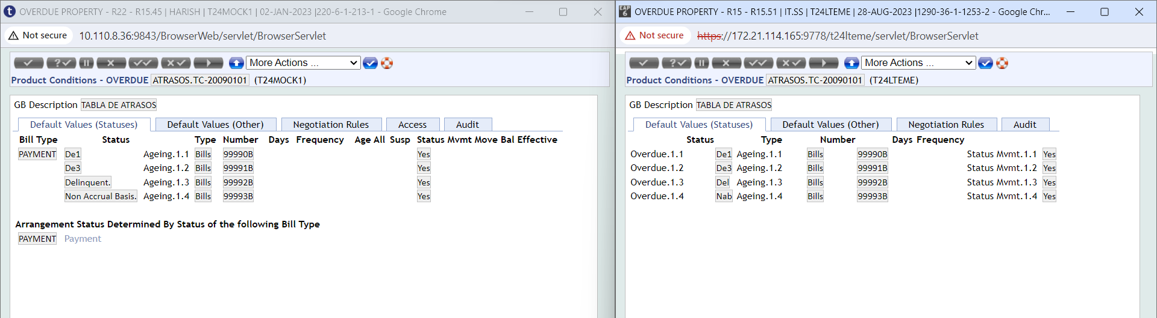

CUOTA.NIVELADA.TC-DOP-20090101

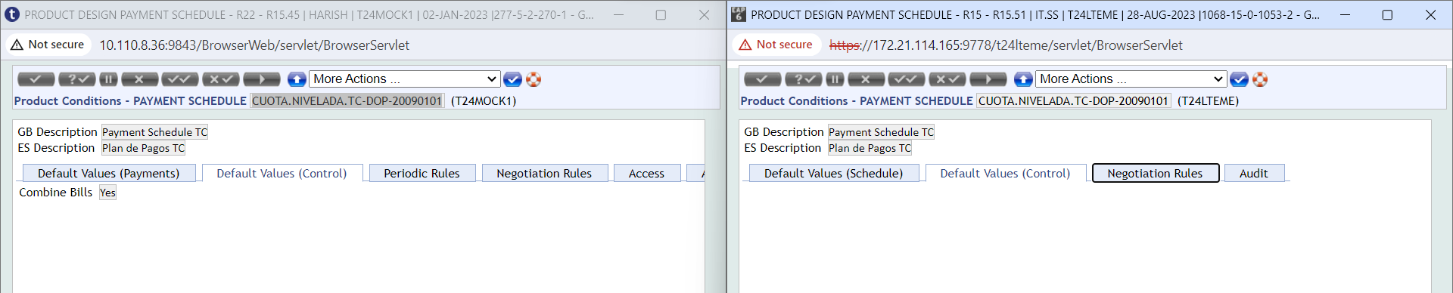

PAYOFF-20090101

