**Step 1:**

**Please make sure below DMD and DSC records are available in the environment.**

**DMD>AA.VISON.PLUS:**

**AA.VISON.PLUS.CUOTA:**

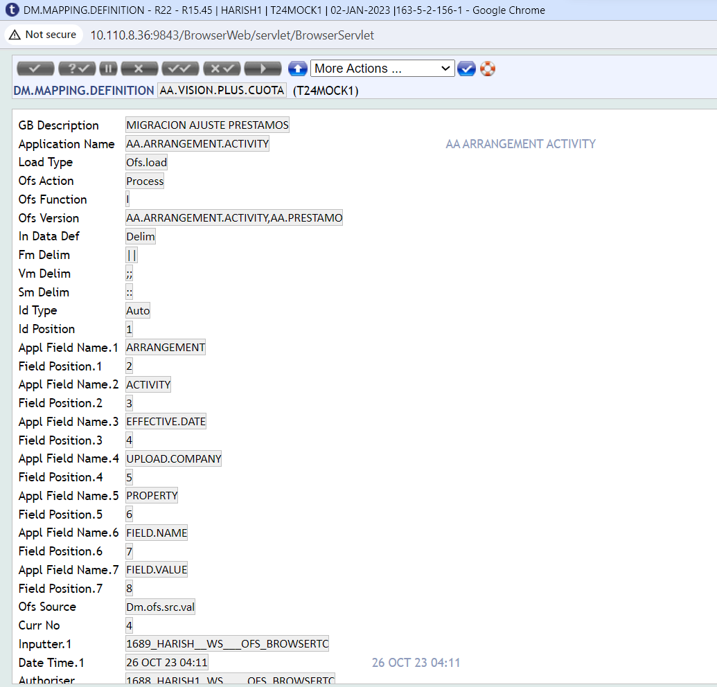

**AA.VISON.PLUS.MONTO:**

**Step 2:**

**Place all DM input files (AA.VISION.PUS, AA.VISION.PLUS.MONTO and AA.VISION.PLUS.CUATO)**

**Under required path and define the same in corresponding DSC records.**

**Step 3:**

**Once DSC is updated, pls verify the same to launch the DM loading process.**

**After above setup, below are the steps to process files.**

* AA.VISION.PLUS Service:

Below AA.VISION.PLUS.txt file file uploaded and services proccessed

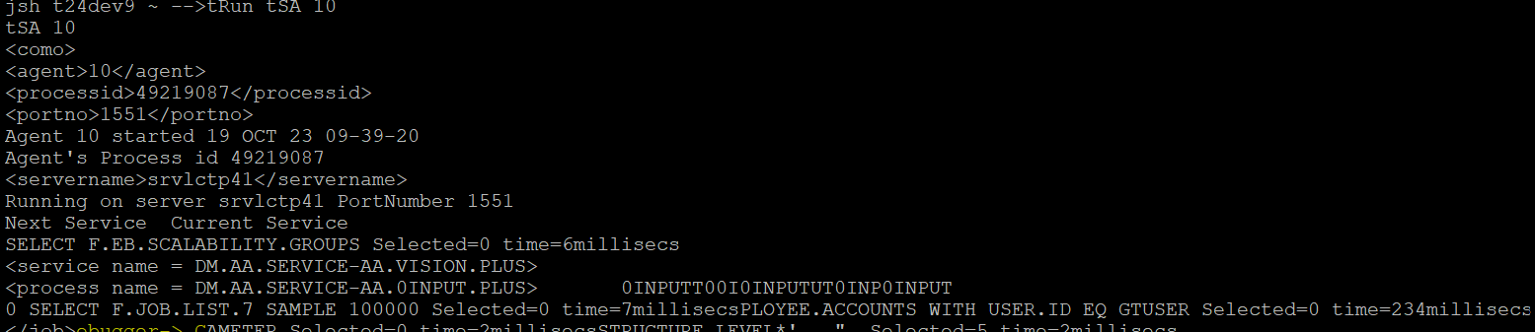

After processed above file generated blank error file.



* AA.VISION.PLUS.CUOTA Service:

Below AA.VISION.PLUS.CUOTA.txt file file uploaded and services proccessed

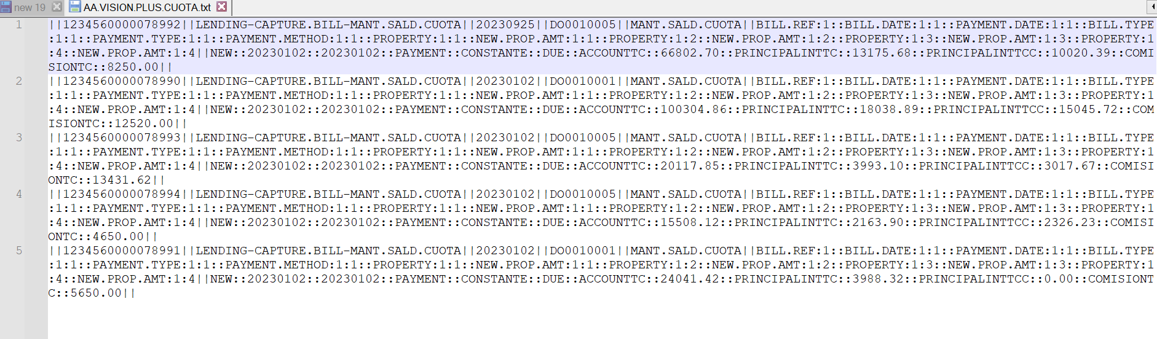

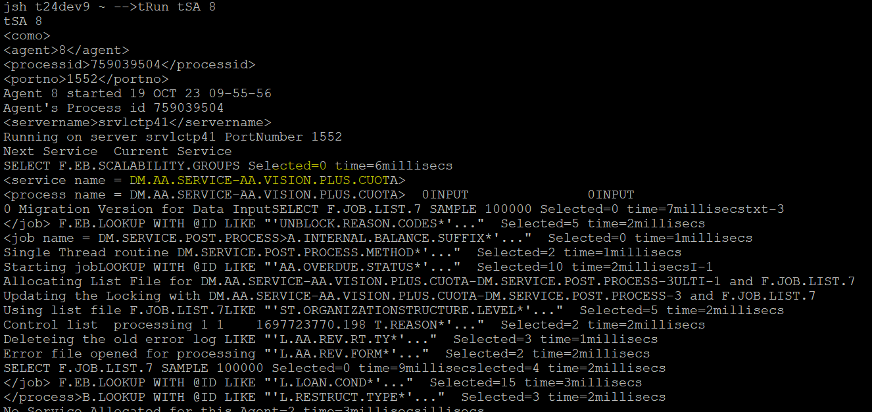

After processed above file generated blank error file.



* AA.VISION.PLUS.MONTO Service:

Below AA.VISION.PLUS.MONTO.txt file file uploaded and services proccessed

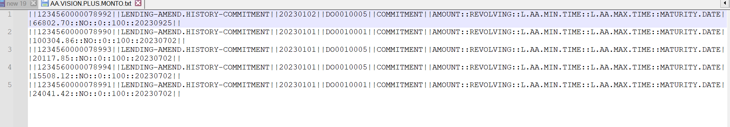

After processed above file generated error file with one error contract.



* AA.VISION.PLUS Negative Test:

Below AA.VISION.PLUS.MONTO.txt file file uploaded and services proccessed



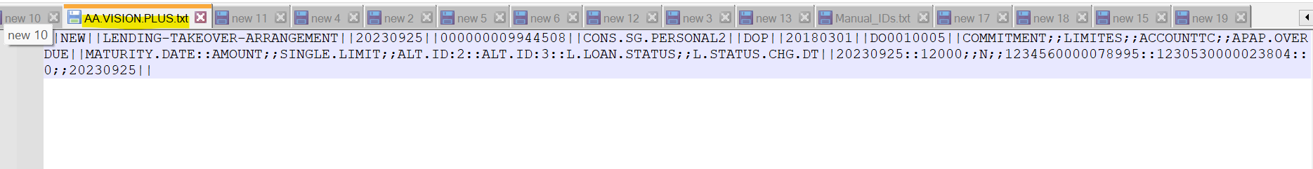

After processed above file generated error file with error contract.



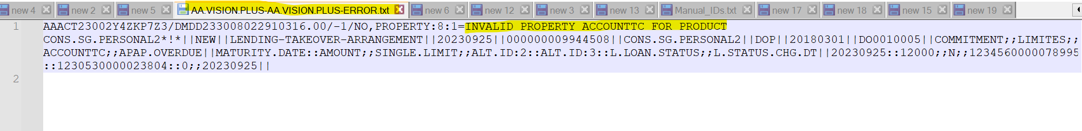

**Step 4:**

Place the LOGO file under required path and start below mentioned service.

* DM LOGO and REG.REPORT Service:

1. Service BNK/REDO.APAP.CREDIT.CARD.UPD, we have processed this file and records uploaded successfully.

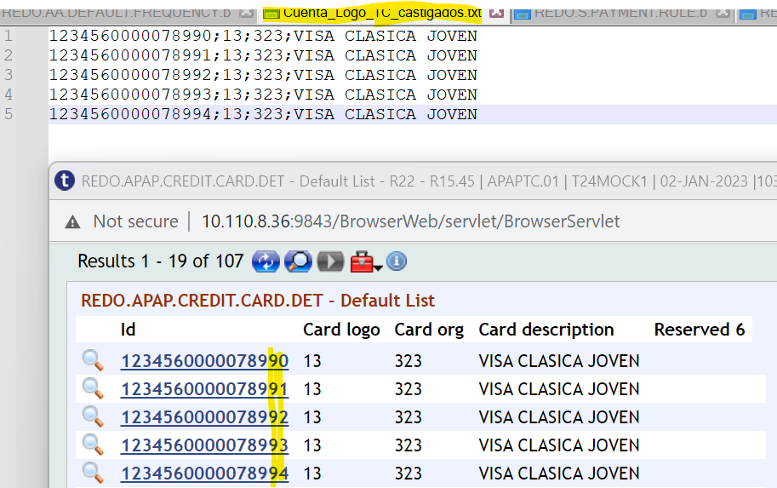

1. BNK/L.APAP.AA.TC.MIG.DREPORT, **we** run this service and records deported and file generated.



