**APAP**

**APAP-IVRInterfaceTWS**

**INSTALLATION GUIDE**

Document History

|  |  |  |  |  |
| --- | --- | --- | --- | --- |
| Version | Date | Author / Changed By | Status | Change Description |
| 0.1 | 07-11-2023 | Harishvikram Chinnasamy | Initial | Pack Release document |
|  |  |  |  |  |

Table of Contents

1. System Requirements 4

2. General Considerations 4

3. Contents of the Package 4

3.1. Components Included 4

3.2. Package Location 6

3.3. Package Content 6

4. Steps for Installing the Package 6

4.1. Pre-Installation steps 6

a. Installation steps 7

b. Post-Installation step 8

5. Special Instructions 8

1. System Requirements

The following are the pre-requisites for installing this package.

* TAFJ R22
* T24 R22 Release
* Build Control Package

# General Considerations

NA

# Contents of the Package

## Components Included

Routines:

|  |  |  |
| --- | --- | --- |
| S.NO | Directroy | Routine name |
| 1. | APAP.REDOCHNLS | REDO.IVR.PROCESS |
| 2. | APAP.REDOCHNLS | REDO.IVR.ENQ.REQ.RESP |
| 3. | APAP.REDOCHNLS | REDO.IVR.ENQ.REQ.RESP.FIELDS |
| 4. | APAP.REDOCHNLS | REDO.B.IVR.ENQ.REQUEST |
| 5. | APAP.REDOCHNLS | REDO.B.IVR.ENQ.REQUEST.LOAD |
| 6. | APAP.REDOCHNLS | REDO.B.IVR.ENQ.REQUEST.SELECT |

**INSERT FILE**

I_F.REDO.IVR.ENQ.REQ.RESP

I_REDO.B.IVR.ENQ.REQUEST.COMMON

PACK1

|  |  |  |
| --- | --- | --- |
| **S.NO** | **T24 TABLE** | **T24 RECORD** |
| 1. | PGM.FILE | REDO.B.IVR.ENQ.REQUEST |
| 2. | BATCH | BNK/REDO.B.IVR.ENQ.REQUEST |
| 3. | TSA.WORKLOAD.PROFILE | BNK/REDO.B.IVR.ENQ.REQUEST |
| 4. | TSA.SERVICE | BNK/REDO.B.IVR.ENQ.REQUEST |
| 5. | PGM.FILE | REDO.IVR.ENQ.REQ.RESP |
| 6. | FILE.CONTROL | REDO.IVR.ENQ.REQ.RESP |
| 7. | STANDARD.SELECTION | REDO.IVR.ENQ.REQ.RESP |

## Package Location

NA

## Package Content

* + APAP001-IVRInterfaceTWS.tar

# Steps for Installing the Package

## Pre-Installation steps

1. Please move the attached APAP_REDOCHNLS.jar to the path /T24/areas/t24dev9/bnk/bnk.run/lib as per area configuration.

## Installation steps

1. Copy the BUILD.CONTROL packs into ..\T24\BNK\UD\F.BCON.DATA\RELEASE directory
2. Release the packages using BUILD.CONTROL tool

* Login to **BNK company (DO0010001) and Release pack**

**APAP001-IVRInterfaceTWS.tar**

* Open a new record in BUILD.CONTROL table, in input mode. Enter ‘RELEASE’ in ACTION Field
* Enter the path where the package has been placed i.e. ./F.BCON.DATA/RELEASE
* Enter “BUILD.CONTROL” in OFS.SOURCE field.
* Commit the record
* Open the record in Verify mode and verify it.
* Sign Off from T24 and Log out

1. Log back in, Sign into T24(BNK company) and view the same BUILD.CONTROL record. Upon authorisation failure, authorise manually.

## Post-Installation step

1. Login to **BNK company (DO0010001)**
2. Give the **SERVICE.CONTROL as “Auto”** and **Review time as “5”**
3. Start the TSM in phantom mode.
4. Launch ENQ REDO.IVR.PROCESS.

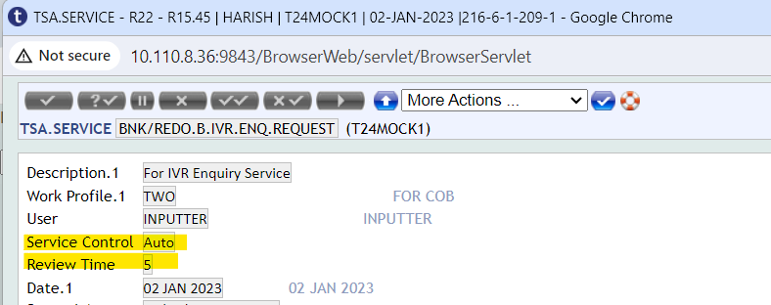



# Special Instructions

* Rebuild the STANDARD.SELECTION> REDO.IVR.ENQ.REQ.RESP 