Windows Server Tool

Hi all ,

This is a GUI tool for most common windows Administrations.This tool is presently a Powershell GUI which will eventually be made available as part of Automation Tribes Self Service Portal.  
  
You might find many tasks simplifies using this tool.Please feel free to give your feedbacks to [citadelforsomerefuge@gmail.com](mailto:citadelforsomerefuge@gmail.com) to add features or to correct bugs.

# Prerequisites

* **All multiple servers List are fetched from c:\temp of the server from which you are running**
* **Make sure all the servers you are trying to access has Windows Remoting enabled from the Server you are running the script from**
* **The results can be copied directly from the grid output to a text file or an Excel**

# Tabs

## Serverinfo

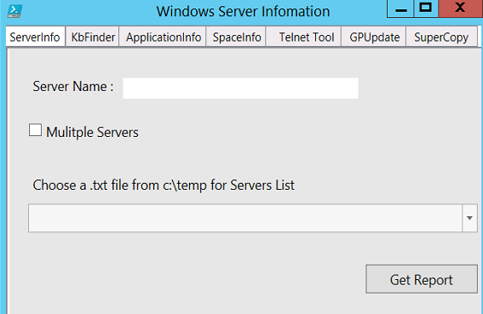

## KbFinder

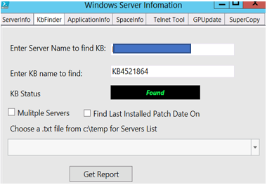

## Application

### Single Server

If a Single Server is used It gives all the applications on the server

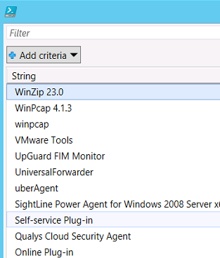

### Multiserver

If Multiserver is used it checks it if the application mentioned is found on the serverlist.

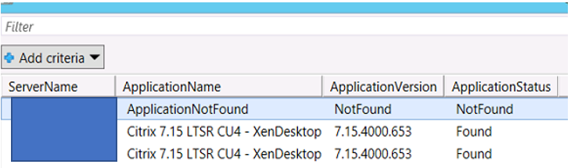

## SpaceInfo

### SingleServer

### MultiServer

### Choose Drive and ServerList

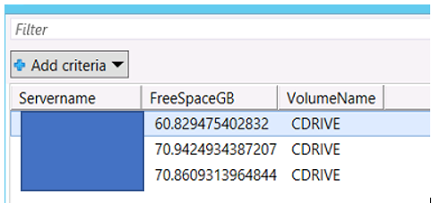

## Telnet Tool

This tool is really helpful to make Network Port queries to multiple computer in two ways

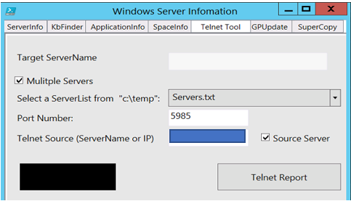

### One To Many

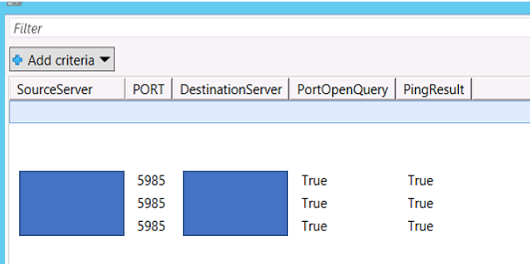

### Many To One – You could check Network connection for Many different source to a single destination too

## GPUpdate

Used to remotely force Gpupdate for both Computer and User Policy

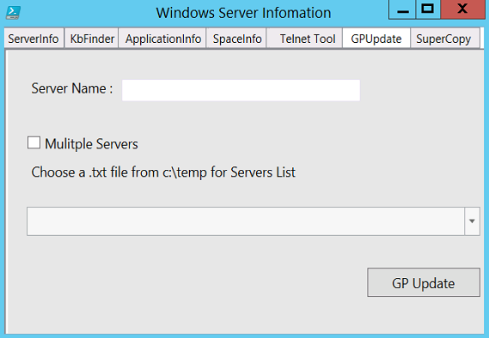

### SingleServer

### MultipleServer

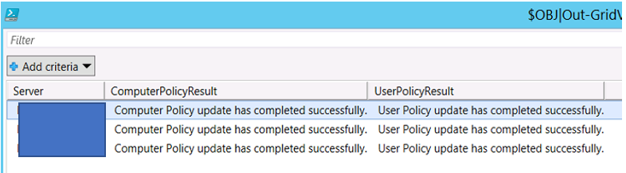

## SuperCopy

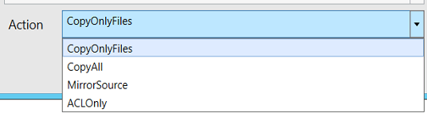

### CopyOnlyFiles

Does not copy any Directories or child Directories.Only the Parent Files.

### CopyAll

Copies all files and Directories including Child

### MirrorSource

This will sync with the Source Directory and its Structure. Any extra files in the Destination will be purged and deleted.

### ACLOnly

This will copy only the file securities as the Souce.No data will be changed in files but only the securities

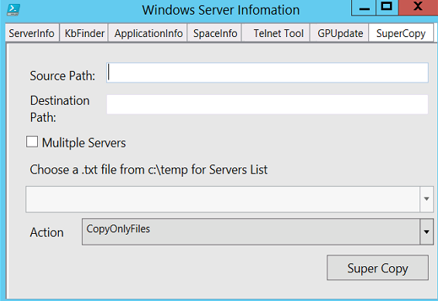

# Thank You