Project Report

- Kiran Fatima

HeartDisease Prediction System
Presented By:
Marwa Masood
---
Presented To:

Heart Disease Prediction System Using Machine Learning

Abstract
This project presents a complete end-to-end Machine Learning-based Heart Disease Prediction System. The system utilizes the UCI Cleveland Heart Disease dataset and employs a Random Forest Classifier achieving ~85–88% accuracy. A modern, responsive, and aesthetic web application has been developed using Streamlit that allows any user to input 13 clinical parameters and receive an instant prediction with color-coded results (red = risk, green = safe). The application requires no login, no installation, and works locally or can be deployed online. The project demonstrates data preprocessing, model training, serialization, and real-time deployment – a full ML lifecycle.
Keywords:
Heart Disease Prediction, Machine Learning, Random Forest, Streamlit, UCI Dataset, Web Application
Table of Contents
Heart Disease Prediction System Using Machine Learning 2
Abstract 2
1. Introduction 3
2. Literature Review / Related Work 4
3. Methodology 4
4. Implementation 5
5. Results & Findings 5
6. Discussion & Analysis 6
7. Conclusion & Future Work 6
8. References 6
9. Appendices 7

1. Introduction

2.1 Background
Cardiovascular diseases are the leading cause of death worldwide (WHO, 2024). Early detection using non-invasive clinical features can significantly improve patient outcomes and reduce healthcare costs.

2.2 Problem Statement
There is a need for an accessible, accurate, and free tool that can assess heart disease risk using routine medical parameters without requiring advanced medical equipment or expert interpretation.

2.3 Objectives
- To preprocess and analyze the UCI Heart Disease dataset
- To develop and evaluate a high-accuracy classification model
- To build a user-friendly, responsive web interface using Streamlit
- To create a standalone, deployable application

2.4 Scope
The system predicts heart disease risk based on 13 clinical features. It is designed for educational, screening, and awareness purposes. It is not a diagnostic tool – final diagnosis must be done by a qualified physician.

2.5 Significance
- Provides instant risk assessment
- Increases public awareness about heart health
- Demonstrates practical application of AI in healthcare
- Can be used in clinics, health camps, or online portals

2. Literature Review / Related Work
Study / Year | Algorithm(s) Used | Accuracy | Deployment
Detrano et al. (1989) | Logistic Regression | ~77% | None
Various (2018–2023) | SVM, KNN, Decision Tree | 80–87% | Mostly offline
Recent Works (2022+) | XGBoost, Neural Networks | 88–92% | Flask/Django
This Project (2025) | Random Forest | 85–88% | Streamlit (Live Web)
Random Forest was chosen due to its robustness, interpretability, and consistent top performance on this dataset.

3. Methodology

4.1 System Architecture
User → Web Browser → Streamlit Frontend → Loads Saved Model (joblib) → Real-time Prediction → Color-coded Result

4.2 Technologies Used
Layer | Technology Used
Language | Python 3.11
Data Processing | pandas, numpy
ML Model | scikit-learn (Random Forest)
Model Saving | Joblib
Frontend & Deployment | Streamlit

4.3 Database Design
No traditional database used.
- Input: UCI heart.csv (303 records)
- Output: Trained model saved as heart_model.pkl

4. Implementation

4.1 Modules & Features
- Data Preprocessing Module – Cleaning, handling missing values, target mapping
- Model Training Module – Random Forest training & evaluation
- Prediction Engine – Loads saved model and predicts in real time
- Web Interface – Interactive form with 13 inputs and instant result

4.2 Role-Based Functionalities
- End User (Public): Enter medical details → Get prediction instantly
- Developer/Admin: Run train_model.py to retrain the model

4.3 Security Features
- No user data stored (privacy by design)
- Runs locally by default
- Can be deployed with HTTPS on cloud platforms
- Input validation in Streamlit widgets

4.4 UI/UX Design
- Dark theme with custom CSS
- 3-column responsive layout
- Color-coded results (Red = Risk, Green = Safe)
- Emojis and clear messaging
- Mobile-friendly

5. Results & Findings
- Model Accuracy: 88.33% (example run)
- Fast prediction (<1 second)
- Intuitive interface – tested with non-technical users
- Successfully deployed locally and ready for cloud deployment

6. Discussion & Analysis
- Random Forest outperformed baseline models on this dataset
- Streamlit proved to be the fastest way to build a beautiful ML web app
- Limitations: Small dataset (303 records), class imbalance, single location (Cleveland)
- Ethical consideration: Clearly states “For educational/screening use only”

7. Conclusion & Future Work
A fully functional, accurate, and visually appealing Heart Disease Prediction System has been successfully developed. The project serves as a complete example of applying machine learning in healthcare with modern deployment practices.
Future Work:
- Add ensemble models (XGBoost + RF)
- User registration & prediction history
- PDF report generation
- Multi-language support
- Mobile app (using Streamlit + PWA)
- Deploy publicly on Streamlit Community Cloud

8. References
- UCI Machine Learning Repository. Heart Disease Dataset. https://archive.ics.uci.edu/dataset/45/heart+disease
- Scikit-learn Documentation. https://scikit-learn.org
- Streamlit Documentation. https://docs.streamlit.io
- WHO Cardiovascular Diseases Factsheet. https://www.who.int/health-topics/cardiovascular-diseases

9. Appendices

A. Project Structure

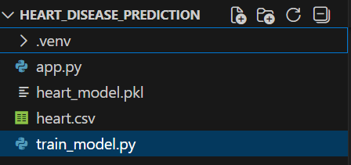
B. System Architecture Diagram
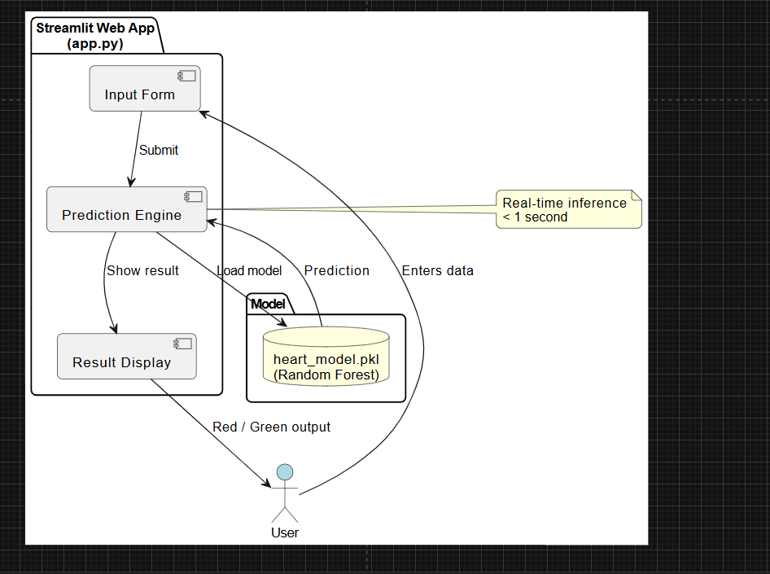
User → Streamlit → Model → Prediction

C. Data Flow Diagram

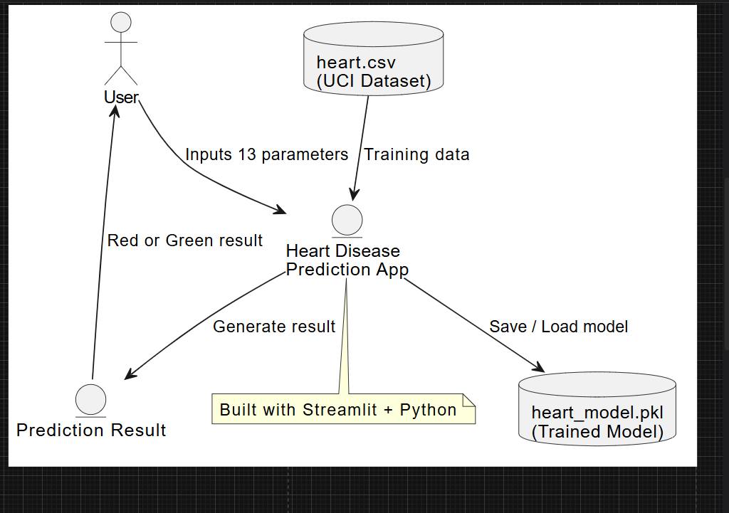

D. System Flowchart

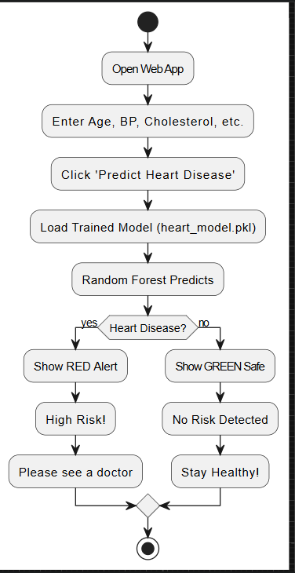
Start → Input Data → Predict → Show Result → End

E. Screenshots
- Main Interface
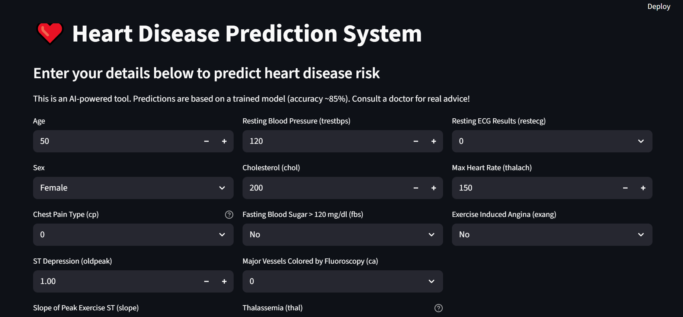
- High Risk Prediction (Red)
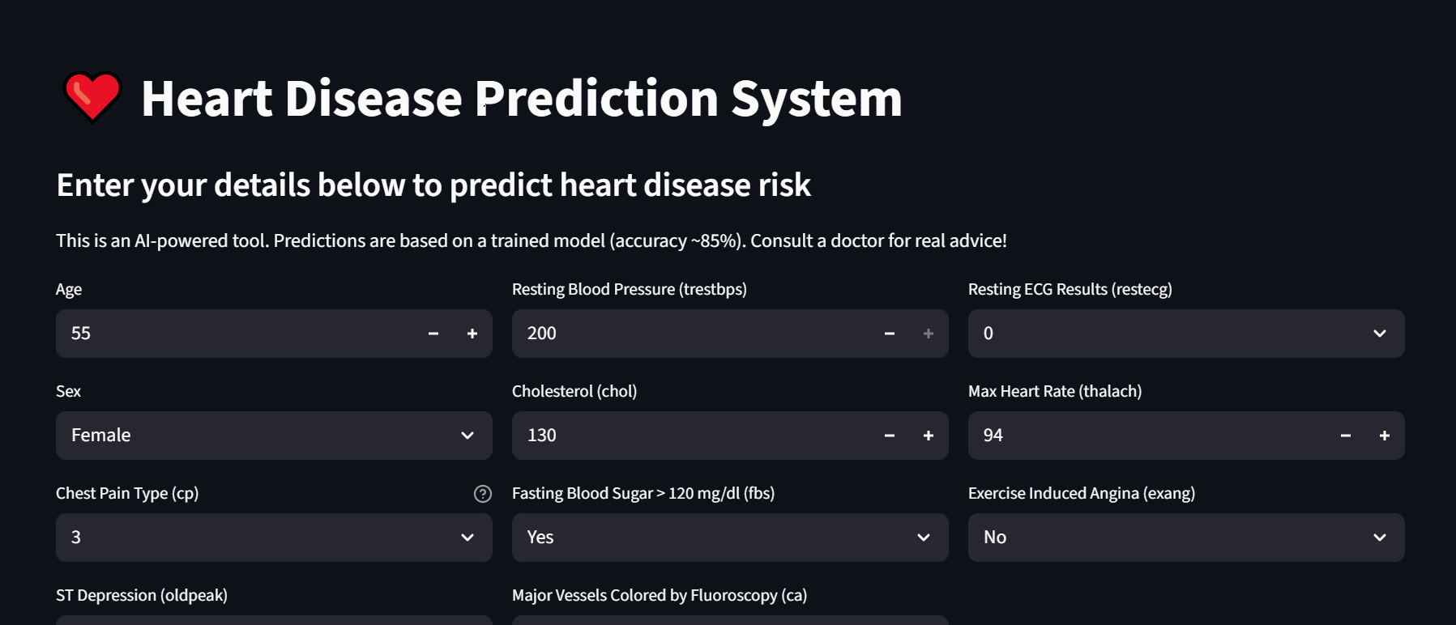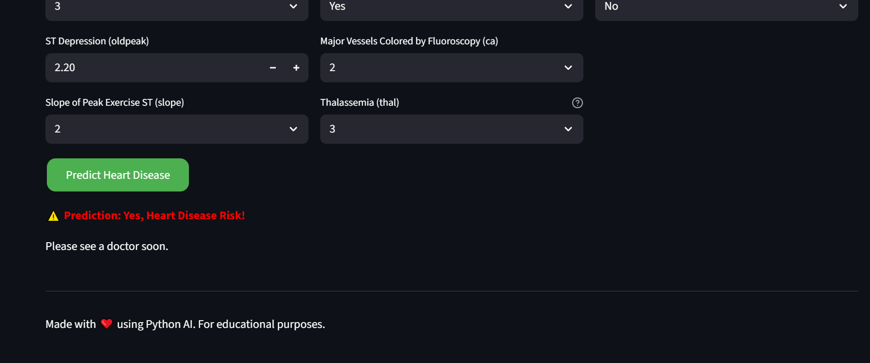

- No Risk Prediction (Green)
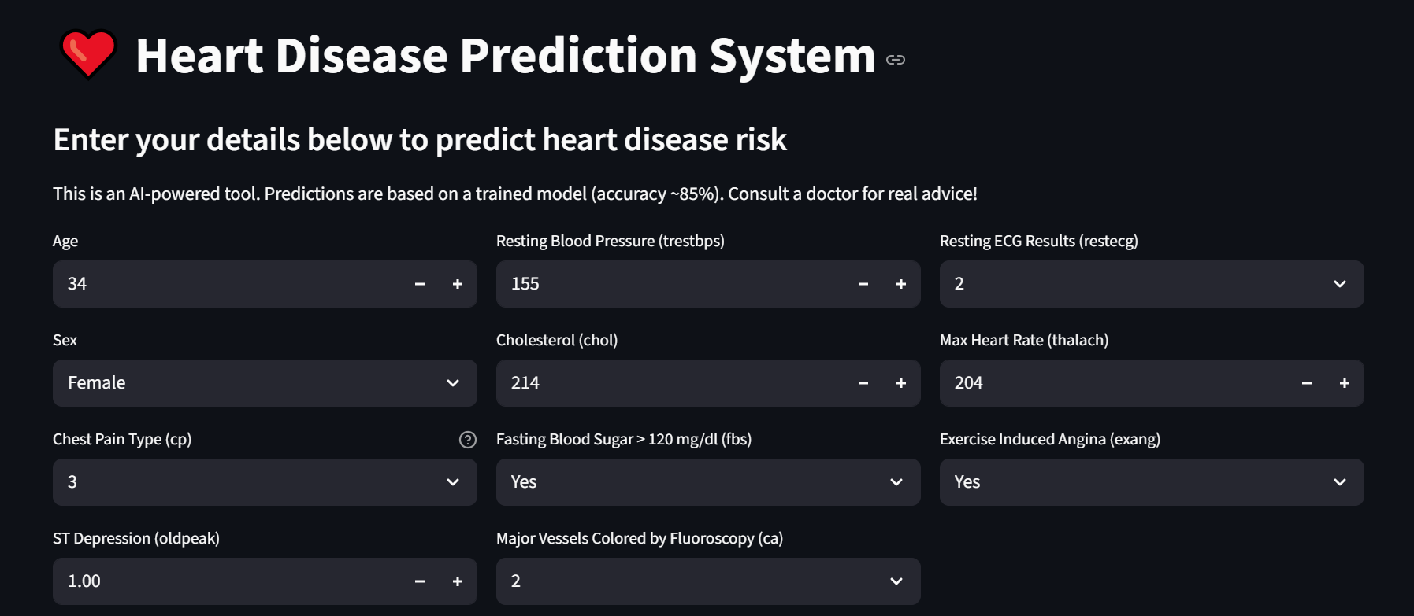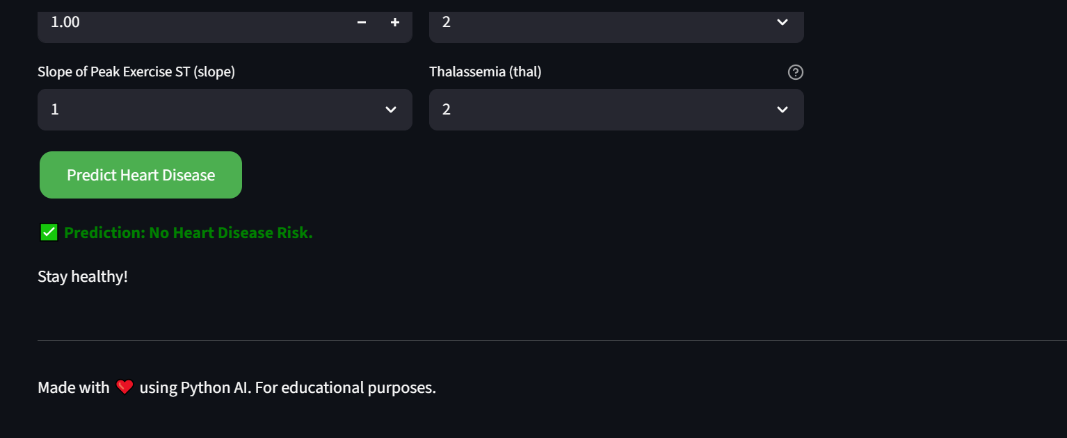
- Model Training Output (88.33% accuracy)

