**Data:**

Data given consisted of 8 sub-parts. Each sub-part had 3 divisions namely “Data”, “Stages”& “srate”. The 8 sub-parts is the sleep data from 4 subjects, where data is collected after Baseline night (after well rested night) and recovery night (after a sleep deprived night) [One sub-part for each]. The Baseline night data has data pertaining to 10 - 11 hours of sleep and Recovery night data had 16 - 18 hours of sleep data. Each ‘data’ presented has 9 arrays and each array pertains to a channel, the electrode in the brain. The ‘data’ is expressed in voltages. The ‘stages’ part of the data gives the stage subject is in for next 30 seconds of the time. Each thirty second interval is called an epoch. Stages assume values from 0 to 7. ‘Stages’: 7 - Unscored (typically before lights out or after lights on, not analyzed), 0 – Awake, 1 - NREM Stage 1, 2 - NREM Stage 2, 3 - NREM Stage 3, 4 - NREM Stage 4, 5 - REM Sleep, 6 - Movement Time. ‘Srate’ states the sampling rate and is 128 for all the datasets. (NREM- Non-Rapid Eye Movement)

**Exploration questions:**

From the given data, I tried to answer the following questions:

1. How much amount of time is spent in each sleep stage throughout the night?
2. What is the percentage of time-spent in NREM and REM sleep?
3. How does the amount of time spent in each sleep stage change between the well-rested night and the sleep-deprived night?
4. How does early hourly data vary between baseline sleep and Recovery night sleep?

**Findings:**

As per the findings, time spent in stage 2 is far more compared to any other stage. The next leading one is stage 5 along with the stage 4 in the close proximity. It is observed that stage two is frequently followed by stage four and stage five by stage one. The detailed table of time spent is given in the next page.

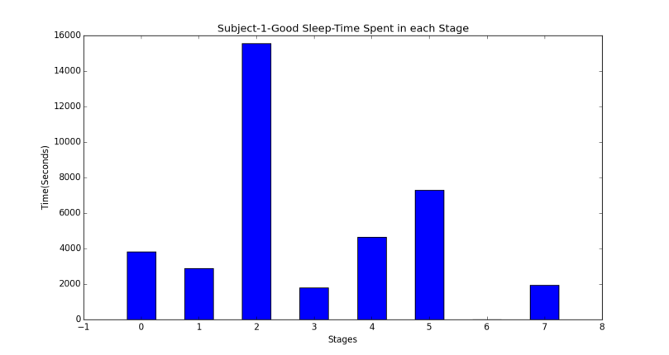

Good Sleep in the title meant Baseline sleep. It can be clearly seen that subject has spent highest amount of time in stage 2. The amount of time spent is 4.35 hours out of 10.5 hours.

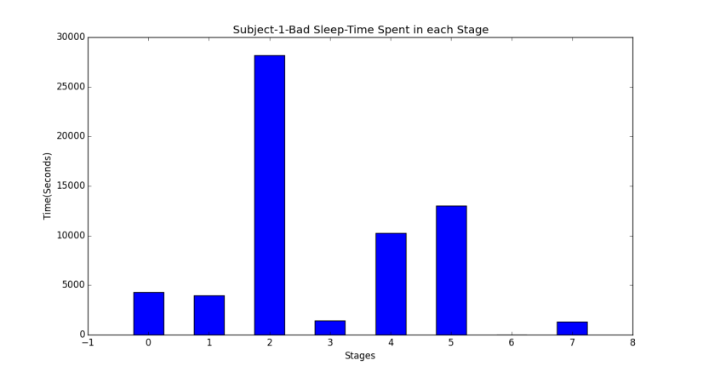

Bad sleep in the title meant Recovery night to the sleep deprived night. It can be clearly seen that the highest amount of time spent is in stage 2. The time spent is around 7.83 hours out of 17.35 hours.

**Table 1: Time spent (seconds) in each Stage of sleep**

|  |  |  |  |  |  |  |  |  |
| --- | --- | --- | --- | --- | --- | --- | --- | --- |
| **Subj**  **Stage** | Sub1(BSL) | Sub1(REC) | Sub2(BSL) | Sub2(REC) | Sub3(BSL) | Sub3(REC) | Sub4(BSL) | Sub4(REC) |
| 0 | 3810 | 4290 | 3210 | 10050 | 3300 | 3600 | 2280 | 2460 |
| 1 | 2880 | 3990 | 3510 | 1680 | 3960 | 4710 | 1890 | 1260 |
| 2 | 15570 | 28200 | 18300 | 32400 | 15540 | 29010 | 20370 | 28830 |
| 3 | 1800 | 1440 | 690 | 630 | 1830 | 2250 | 390 | 1320 |
| 4 | 4650 | 10230 | 3870 | 7500 | 4590 | 10230 | 6060 | 9840 |
| 5 | 7290 | 12990 | 6240 | 10830 | 6690 | 14970 | 4680 | 5490 |
| 6 | 0 | 0 | 0 | 0 | 150 | 120 | 0 | 0 |
| 7 | 1950 | 1350 | 1650 | 1560 | 2010 | 1680 | 1860 | 2610 |

As per findings, 11-25% of the sleep time is spent in REM stage and rest in NREM Stages.

Baseline night REM/NREM Split up

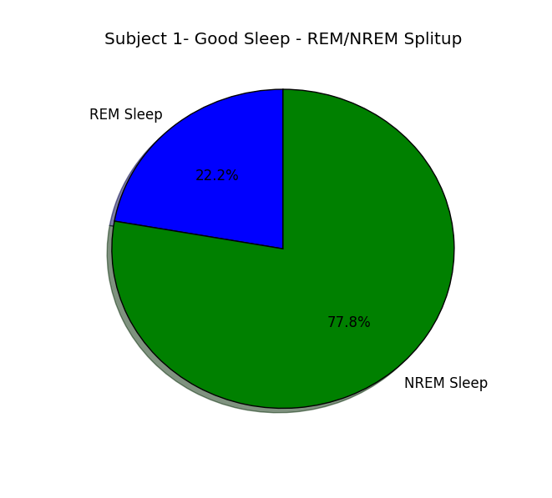 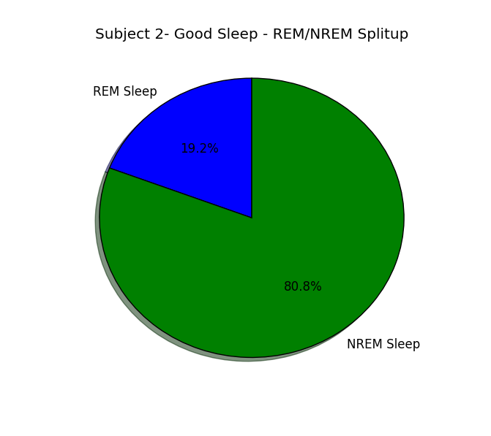

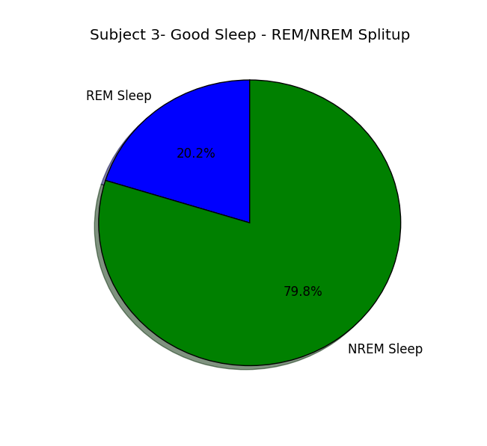 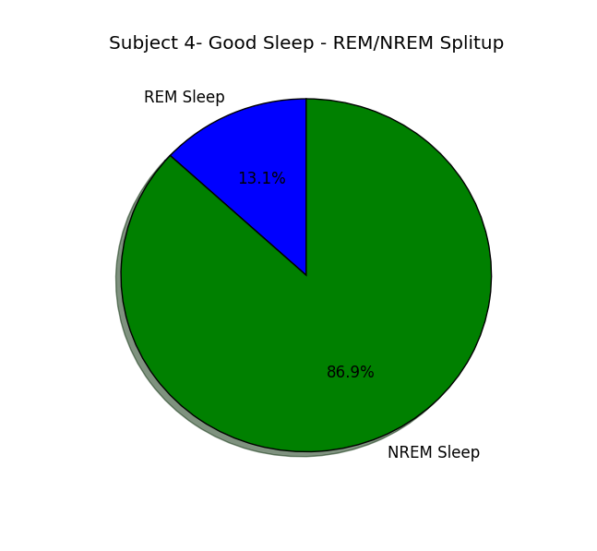

Recovery night REM/NREM Split up

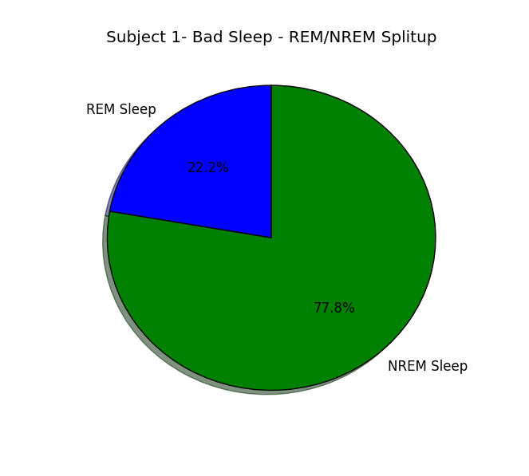 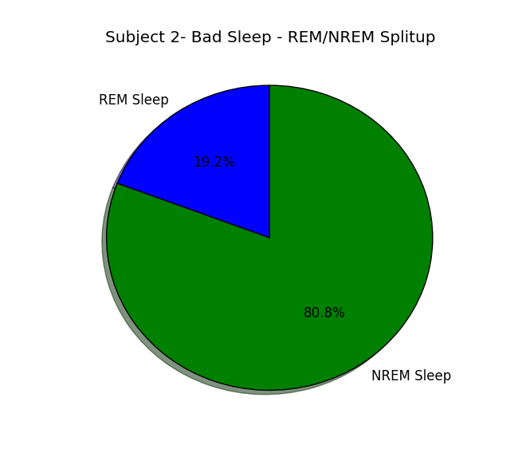

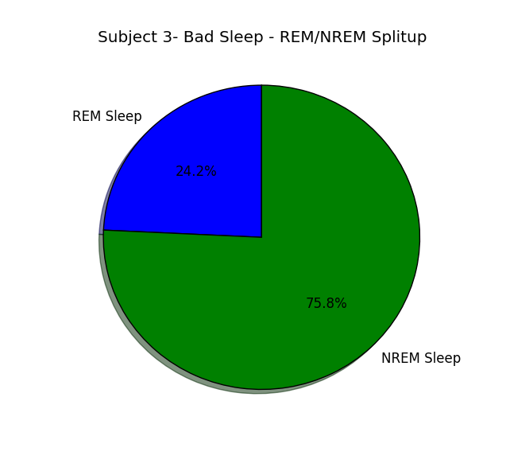 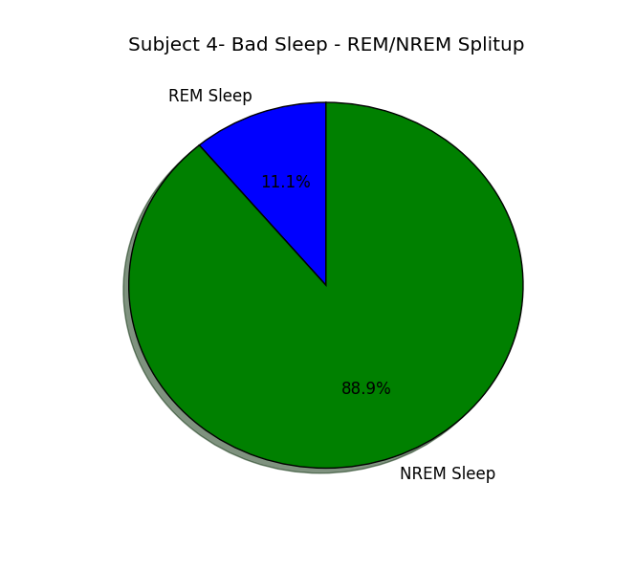

Comparisons between the amounts of sleep spent in different stages of baseline and recovery nights are given below. The data represented on Y-axis are percentages. It is observed that amount of time spent in stage 2 increases proportionately in the recovery night sleeps compared to baseline sleeps. Small increase in the amount of time spent in the stage 4 in the recovery night sleeps is also observed. It can also be stated that amount of time spent in stage 1 and stage 3 are decreased in recovery night sleeps. Stages 0 and 7 do not seem to follow any regular trends.

Subject 1 BSL and REC time spent percentages

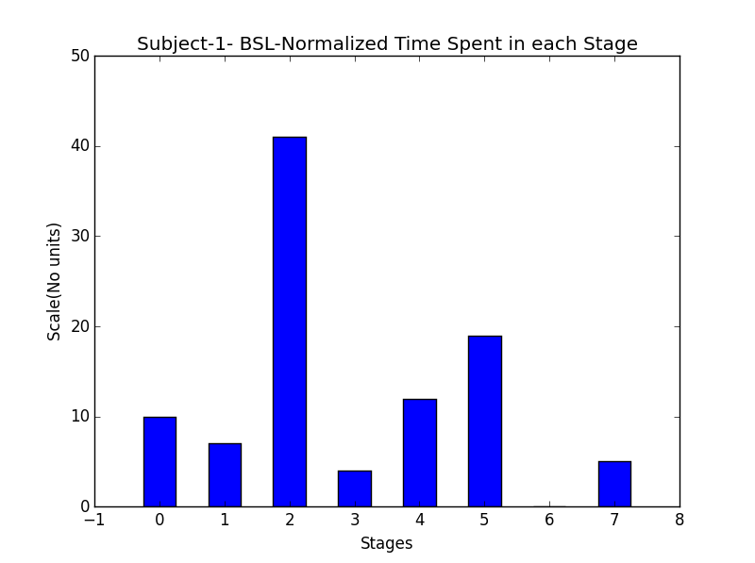 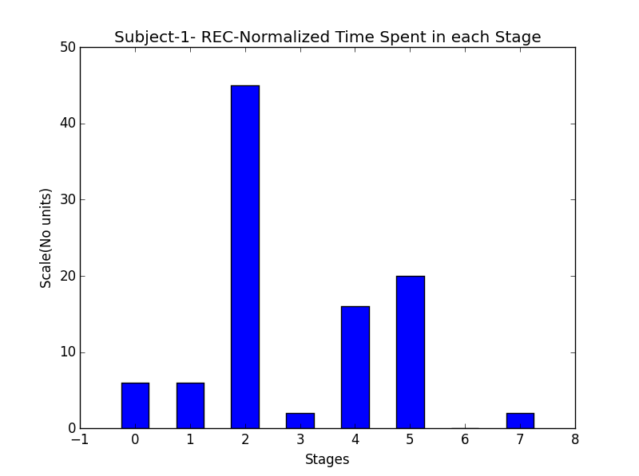

Subject 2 BSL and REC time spent percentages

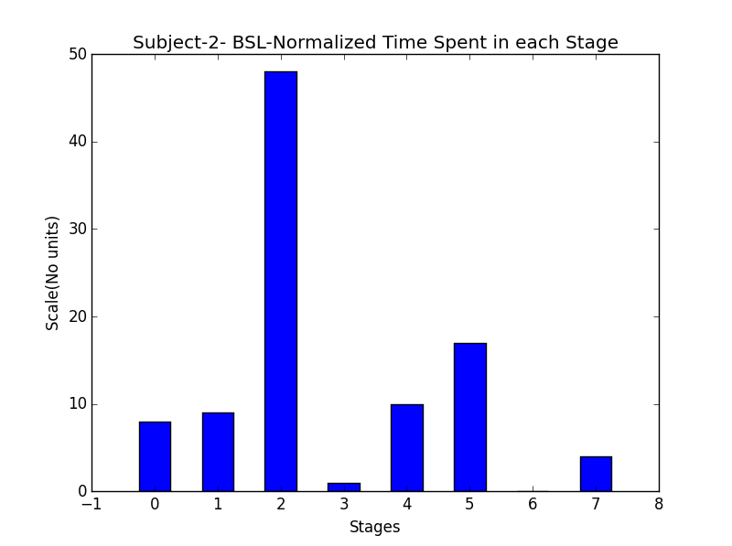 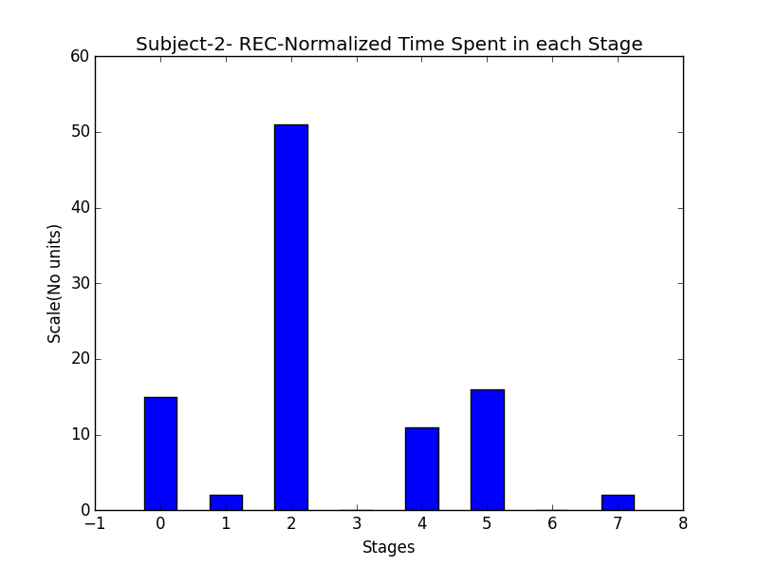

Subject 3 BSL and REC time spent percentages

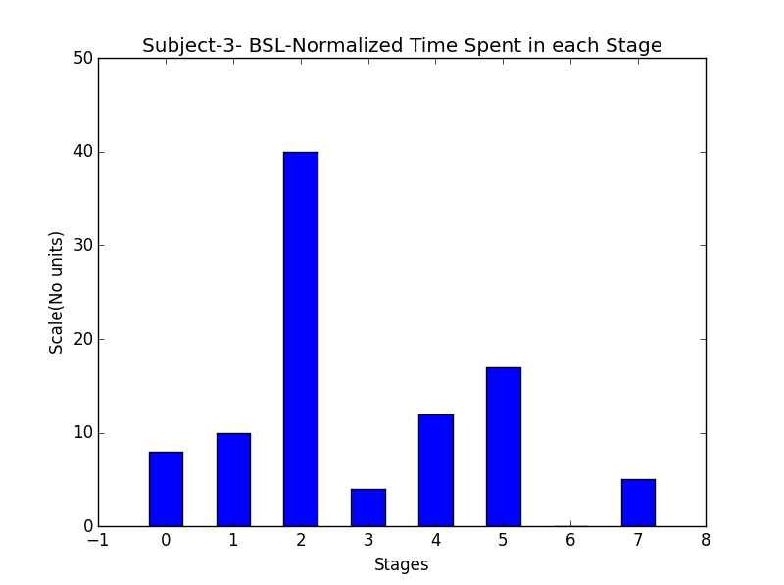 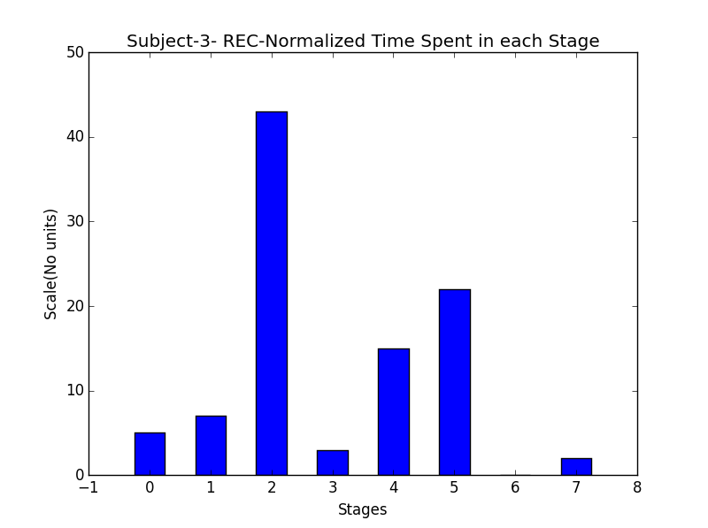

Subject 4 BSL and REC time spent percentages

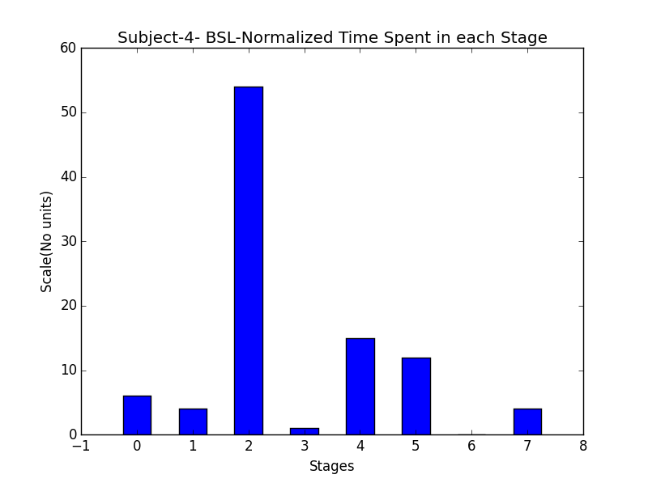 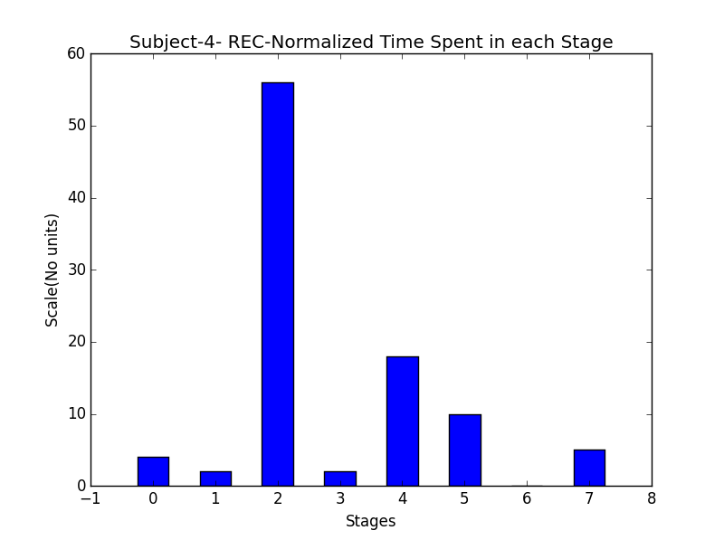

Given below are the constructed graphs of baseline and recovery nights for first two hours of sleep. It is observed that in baseline sleep, all the subjects follow a pattern. All the subjects move from stage 0 to 1 to 2 to 3 and then to 4 and the transition happens within 30 epochs i.e. around 15 minutes. Similar pattern is found during recovery night as well, but the transition is much faster in this case. It is around 20 epochs which is 10 minutes. When looked at both the comparisons simultaneously the pattern is subtle, but on careful investigation it can be pointed out that, if the time spans for which they are compared are on a common ground it is possible to observe the patterns.

Baseline sleeps – First two hours

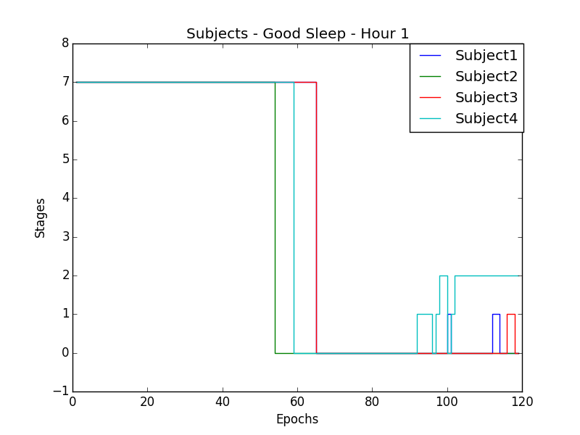 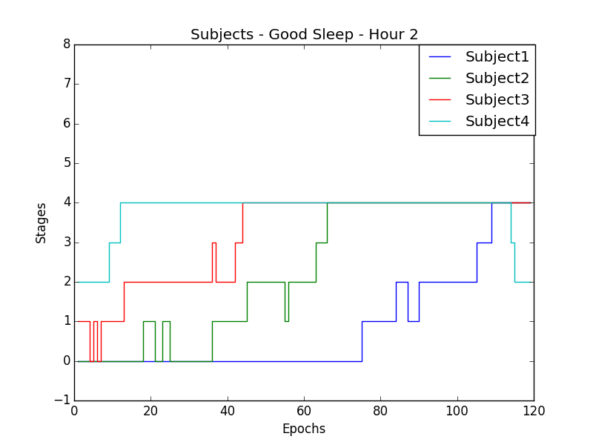

Recovery Night Sleeps – First two hours

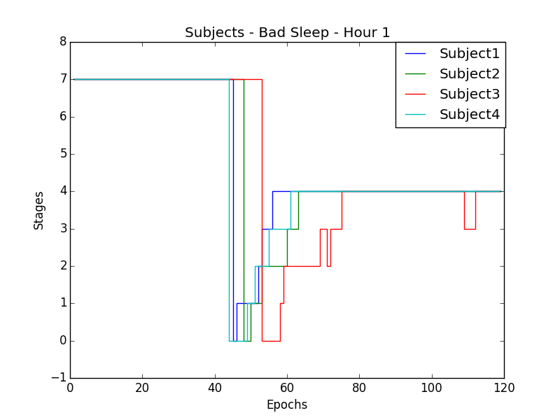 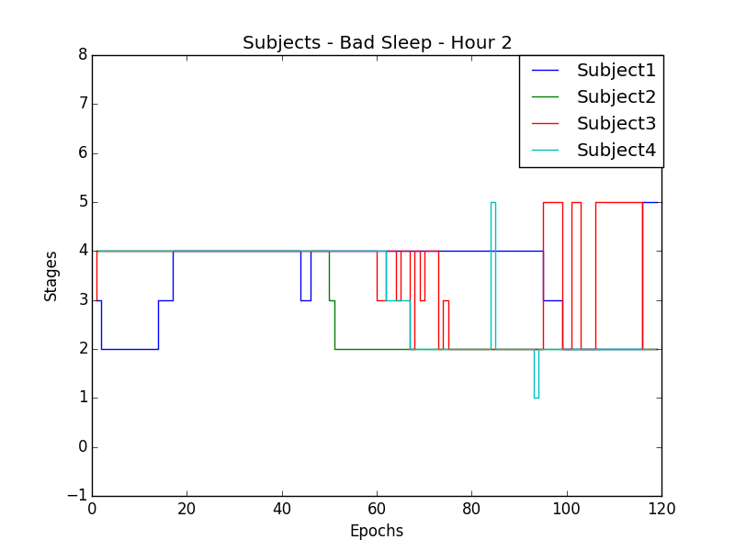

Subject 1 – BSL (Good) and REC (Bad) sleeps – First two hours

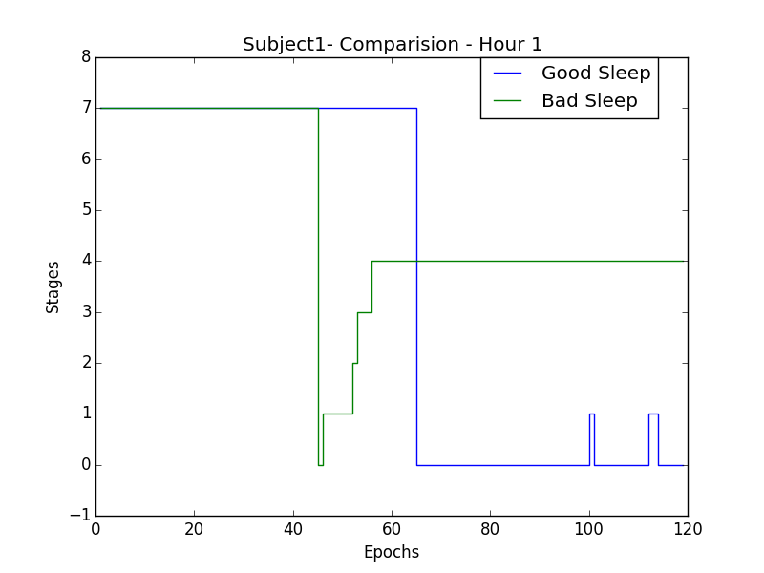 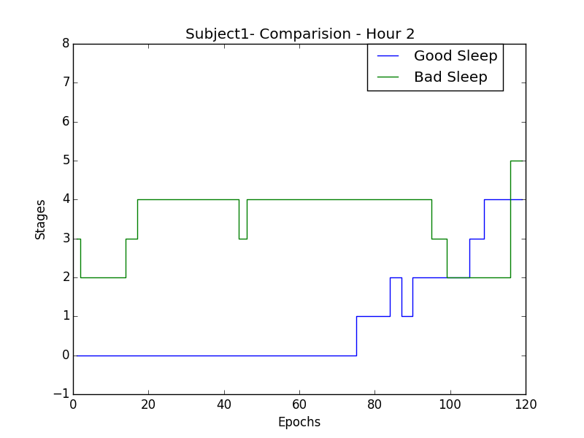

Subject 2 – BSL (Good) and REC (Bad) Sleeps – First two hours

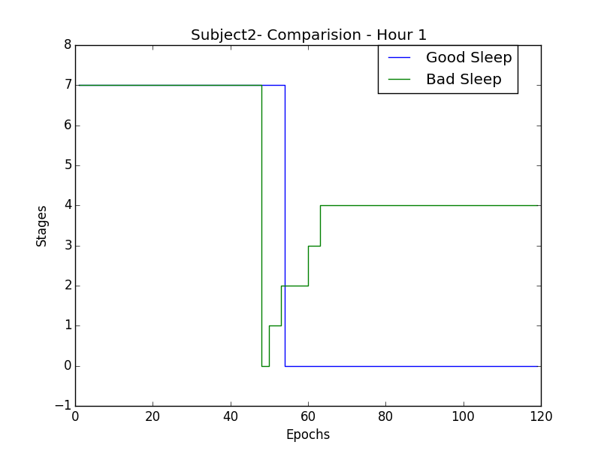 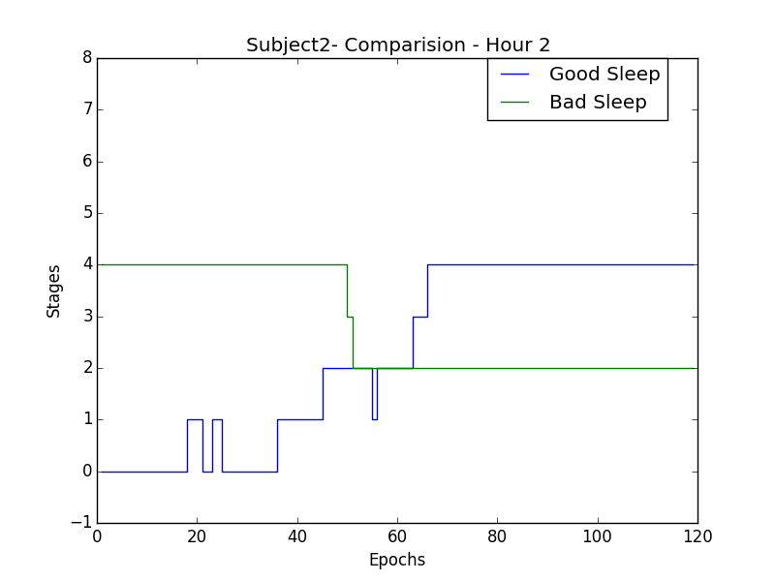

Subject 3 – BSL (Good) and REC (Bad) Sleeps – First two hours

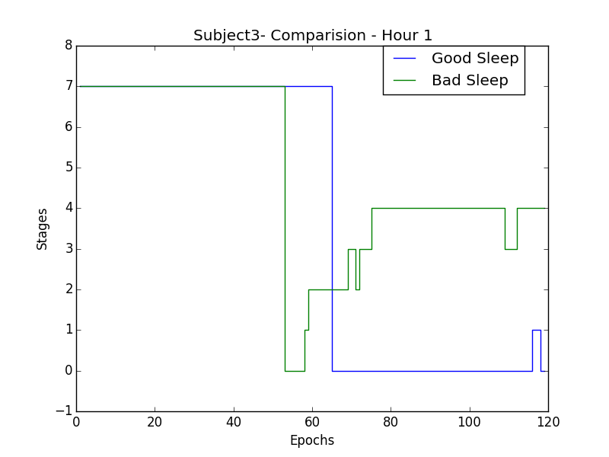 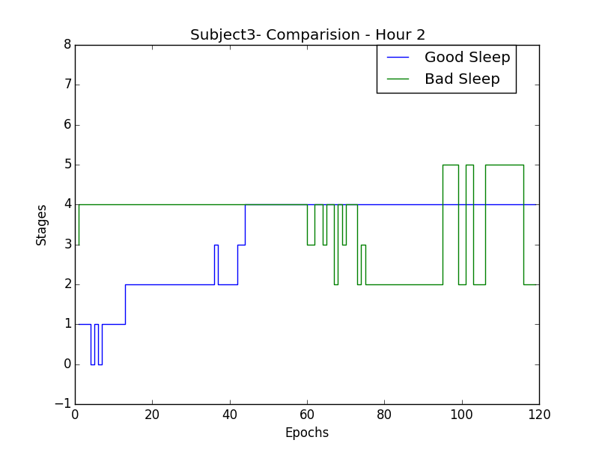

Subject 4 – BSL (Good) and REC (Bad) Sleeps – First two hours

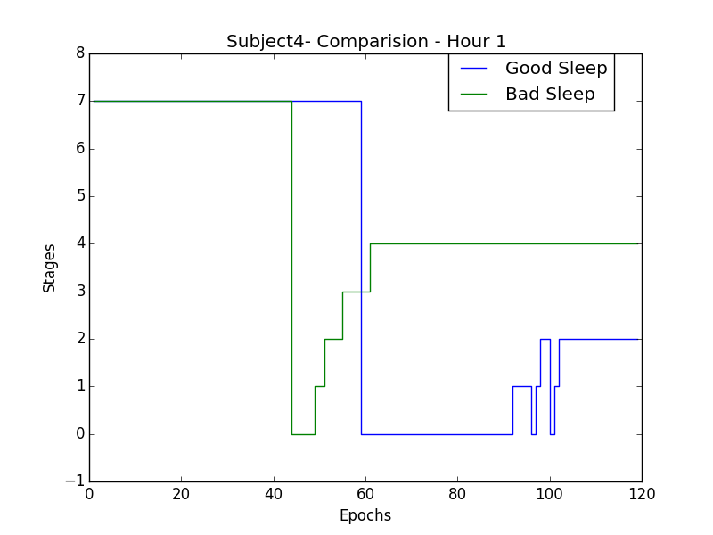 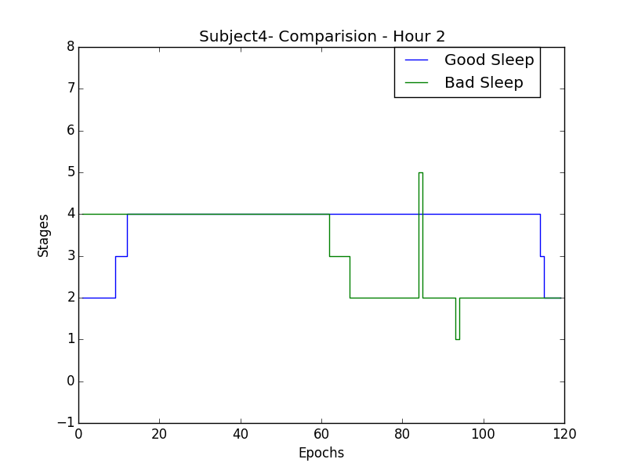

**New programming tricks used:**

In constructing the hourly graphs of the sleep stages, I used ‘for’ loop to iterate for each hour, construct the graph, title the graph accordingly and save it to the local computer with the name of the hour.

Pie-charts were constructed using python using the library matlibplot.

**Challenges faced:**

One particular thing which I wanted to do but couldn’t was when I wanted to observe all the stages on a similar hour span. I expected a pattern to arise when two are subjects are compared on the similar time scale. Subject had a different time scale in sleep i.e. Baseline sleep is for 10.5 hours and Recovery night sleep is for 17.35 hours. So putting them on common ground, makes 1 hour of baseline sleep equal to 1.65 hours of Recovery night sleep. So, I wanted to squeeze 1.65 hours of sleep and represent it as 1 hour time span so that I could actually compare the trends and patterns in the equivalent index.

**Future follow ups:**

I would like to follow up with the current project by constructing the equivalent time span and measuring both the types of sleep on common grounds to observe the patterns. Then I would like to connect the patterns, analogies and anomalies to the brain voltage data and pinpointing what exactly are the differences between various channels or within the channels when a particular pattern or an analogy or an anomaly takes place.

The patterns mentioned above, for example, might refer to continuous existence in the stage two or stage four and analogies might refer to similar fluctuations in the sleep.