- What is SSRS - SQL Server Reporting Services(SSRS
SSRS stands for SQL Server Reporting Services which is server-based report generation software from Microsoft. To work with SSRS , there are different tools(components) provided so we can develop report, deploy reports,manage permissions and view reports.
- What is Shared Data Source in SSRS

What is Data Source?
Data Source is a set of data source connection properties. When we create data source, we need to provide below information
Name: Name for the Data Source
Description: Optional, Good idea to provide
Connection Type: Such as Microsoft SQL Server, Oracle, OLE DB and ODBC etc.
Connection String: Provide the Connection String for Data Provider
Credential Type: Specifies how the credentials are obtained for connection

What is Shared Data Source?
A Data Source that can be used by multiple reports is called Shared Data Source. If your reports are accessing the same data source, it is good idea to create Shared Data Source. It really helps and reduce work when we deploy reports to Report Server. If you need to point reports to different data source, you only need to make change in Share Data Source Connection String and all reports will be able to use it.
If you have used the embedded Data Source in each of the report. You have to make change to each report to point to new data source.
- What is Shared Dataset in SSRS
Dataset represents the data returns by running query on Data Source in SSRS Report. For query you can have simple Select statement or you can use Stored Procedure. Report definition does not contain data but it contains query command,fields collection, parameters,filters and data options that include case sensitivity and collation.
There are two types of DataSets

Shared DataSet:
Shared Dataset is dataset which is created by using Shared Data Source and deployed to Report Server. Shared Dataset can be used by multiple reports.
Think about a view or stored procedure that can be used to create multiple reports. For those we can create Share DataSet. For example, we need to use Month Name parameter in multiple reports.We can create shared Dataset for MonthName( that will return us all month names in a year) and can use in multiple reports.

Embedded DataSet:
A Dataset that is created inside a report and only used in single report is called embedded DataSet.
- What is the difference between Data Source and DataSet in SSRS

Data Source
is a set of data source connection properties. When we create data source, we need to provide below information
Name: Name for the Data Source
Description: Optional, Good idea to provide
Connection Type: Such as Microsoft SQL Server, Oracle, OLE DB and ODBC etc.
Connection String: Provide the Connection String for Data Provider
Credential Type: Specifies how the credentials are obtained for connection

But DataSet
represents the data returns by running query on Data Source in SSRS Report. For query you can have simple Select statement or you can use Stored Procedure. Report definition does not contain data but it contains query command,fields collection, parameters,filters and data options that include case sensitivity and collation.
- When SSRS was introduced in Market and What Versions are available?
SQL Server Reporting Services is part of suite of SQL Server Services same as SQL Server analysis Services and SQL Server Integration Services.

SQL Server 2000
When in 2000, SQL Server was released. SQL Server Reporting Services was not part of it and it was release later in 2004.

SQL Server 2005
When SQL Server 2005 was released in November, 2005, SQL Server Reporting Services was release as part of SQL Server Services.

SQL Server 2008 R2
Third version of SQL Server Reporting Services was released as part of SQL Server 2008 R2 in April 2010.

SQL Server 2012
The fourth version of SQL Server Reporting Services was related as part of SQL Server 2012 in March 2012.

SQL Server 2014
The fifth and current version of SSRS was released as part of SQL Server 2014 in March 2014.

Future Versions ( SQL Server 2016)
The new version is added to SQL Server 2016. This is going to be the sixth version of SSRS. As of today ( 1/5/2016), SQL Server Community Technology Preview 3.2) is available to download.
- What is the difference between Shared Data Source and Embedded Data Source in SSRS

What is Data Source?
Data Source is a set of data source connection properties. When we create data source, we need to provide below information
Name: Name for the Data Source
Description: Optional, Good idea to provide
Connection Type: Such as Microsoft SQL Server, Oracle, OLE DB and ODBC etc.
Connection String: Provide the Connection String for Data Provider
Credential Type: Specifies how the credentials are obtained for connection

What is Shared Data Source?
A Data Source that can be used by multiple reports is called Shared Data Source.

What is Embedded Data Source?
The Data Source which is created in a report and can only be used for that report is called embedded Data Source. If non of other report/s need to connect to the data source, it is Ok to create embedded data source but if there is any possibility in future other report/s might use that data source, If yes then it is good idea to create Shared Data Source
- What type of SSRS Reports Can and Can't be created by using Report Wizard?

What type of SSRS Reports Can be created by using Report Wizard?
By using Report Wizard in SSDT you will be able to create below type of reports
- Tabular Report
- Matrix Report
When it comes to choose the layout for Table you have below options
- Stepped
- Block
Also you can Include Subtotals and if you like you can make your report drilldown.
Parameters can be added to report as well. You have to write the Query with Parameters.

What Type of SSRS Reports Can't Be Created By using Report Wizard?
You can not create Chart,Indicator,Gauge, List and Map Reports.
You can not create Cascading Parameter Report Directly by using Report Wizard
Note: Report Wizard is quick way to create simple reports. You can always create a quick report by using Wizard and then add the rest of the parts to it. As I have mentioned above you can't create Cascading Parameters report by using Report Wizard, but you can create report with multi parameters by using Report Wizard. Once you are done with that you can add additional DataSets and Map parameters to work your report as Cascading Parameter report.
- Can you create parameter reports by using SSRS Report Wizard?
Yes, Reports with parameters can be created by using SSRS Report Wizard. You have to write your Query with parameters or use a Stored Procedure that accepts Parameter.
In below example I have create a query with Region as single value parameter and Country as Multi value parameter.
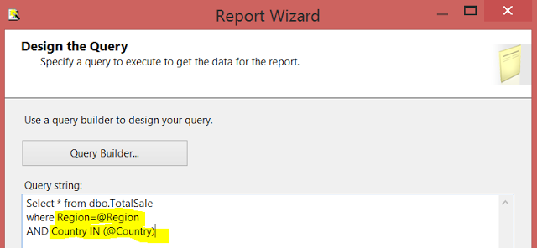
Just remember that once report is created, You have to go to Parameter properties and Define if Parameter can accept Multi values. Also you have to configure available values or default values to parameter if you like.
Here is how you will use the Stored Procedure with Parameter in SSRS Report Wizard, I have a below definition of a Stored Procedure that accepts Region as Parameter.
Create Procedure dbo.sp_SaleByRegion
@Region VARCHAR(100)
AS
BEGIN
Select * From dbo.TotalSale
where Region=@Region
END
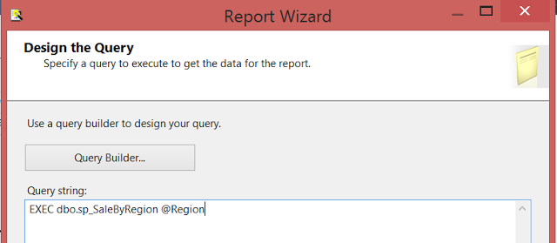
Once again, after the report is created you have to set the properties of Parameter.

- What are the stages of SSRS Report Processing?
Below are the steps/stages for SSRS Report Processining

Report Definition:
Reports are deployed to the Report Server. We can access report/s on demand or run them on schedule. Once accessing action is performed, the next step is Compile.

Compile :
In this step, All expressions, parameters and parameter properties are evaluated and saved as intermediate format.

Snapshot or Report History:
In this step, A snapshot is created which is set of report data at specific point in time plus intermediate format that contains report layout information.

Processed Report:
In this step/Stage we will have a fully processed report with data and layout information.

Rendering:
In this step/stage, A fully processed report is send to report renderer to display on each page in chosen rendering format.

Export Report:
In this step the report is exported to chosen format such as Excel,Word,PDF,TIFF and CSV.
- How would you Edit already deployed SSRS Report?
As developers we create different type of scripts, Reports and SSIS Packages etc. The best practice is to check in all the scripts, reports, SSIS Packages or any other code in version control software.
Different companies use different version control software to save the scripts and other objects. Team Foundation Server is example of Microsoft version control software.

Scenario 1: When Report is checked in Version Control Software
If you or other developer has checked in the report in TFS or any other version control software, Checkout to your local folder and follow below steps
- Open Report by using SSDT (SQL Server Data Tools)
- Make all required changes to report
- Save the Report and Check-in to TFS or other version control software you are using
- Provide the location of Report to DBA so he can deploy to Report Server. If you have Permission to deploy, go ahead and deploy from SSDT.

Scenario 2: When Report is not checked in Version Control Software
In case you have not saved the report definition in TFS or any other version control software but report is available on report Server only. You have two options
1) Click on drop down arrow next to report, go to Edit with Report Builder. It will open your report with Report Builder. You can make changes and save back to Report Server if have permissions. I will suggest to save report definition file in TFS as well so next time you can use from there.
2) Click on drop down arrow next to report, Go to Download. Download the report to your local folder. Create a new SSRS Project in SSDT (SQL Server Data Tools) and add report to Project.
Now you can make any changes and then save. From SSDT you have the option to deploy report to Report Server if you have permissions. At this point it is good idea to save the report to TFS or any version control software and provide the location path to DBA so he/she can take report from there and deploy to Report Server.
Important Note:
In case your company is not using any version control software, then make sure you take the backups of Report Server database regularly.
- What is Report Manager, Explain the function of Report Manager
Report Manager is Web based interface that can be used to perform different tasks such as
Adminster the Report Server,View the Reports and Manager the Report etc.
You need to have the URL to access the Report Server by using Report Manager interface. If Reporting Services is installed on the machine, Login to the machine and open SQL Server Reporting Services Configuration Manager. Once you open the SQL Server Reporting Services Configuration Manager and connect with Report Server, you will see the Report Manager URL as shown below.
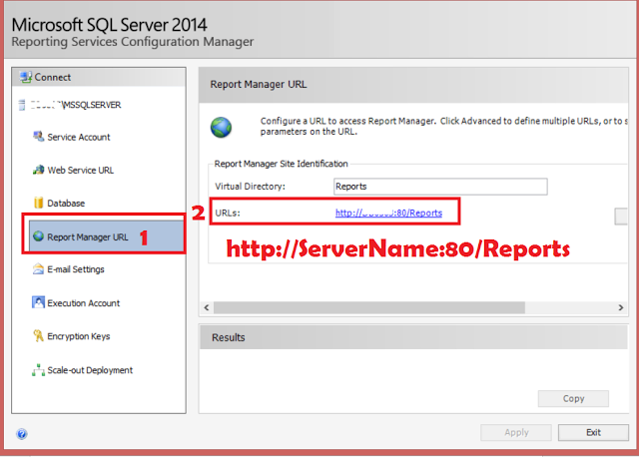
How to get Report Manager URL by using SQL Server Reporting Services Configuration Manager

Once you open the Report Manager URL, You will see all the folder available on Report Server. By using Report Manager Interface we can perform different Tasks, few are mentioned below

- We can create new folders so we can deploy reports to them
- We can create Data Sources
- We can run Report Builder from Report Manager
- We can provide permissions on different items ( reports,data sources,data-sets etc.) to Groups or to single users
- By using Upload File option, we can deploy new reports to Report Server
- We can move the reports between different folders
- We can delete different items such as Folders, Reports, Data Sources and Data-Sets etc.
- We can create Subscription for Report by using Report Manager
- We can download reports to our local folder by using report Manager
- We can configure plan to Cache SSRS Report

Which tool can be used by the Business Users to create their own reports

Report Builder is the tool that can be used by the Business Users or even by developers to create reports.
You can download the Report Builder by using This Link. Once Report Builder is installed on your computer, you can Search Report Builder by using Search option from Start Button or you can open Report Manager and start Report Builder from there.
After opening Reporting Builder, you need to connect to Report Server so you can use existing Data Sources or Share Data Sets in your reports. You can create embedded Data Sources as well if you like.
By using Report Builder, user can create different type of reports such as Tablix, Chart, Matrix and Map etc.
If user has publishing permission, he/she can save the report to report server from Report Builder.
User can also open existing reports and make changes and save to report server as well.

In which formats can we export SSRS Reports
SSRS Reports can be exported to below formats
- XML file with report Data
- CSV ( Comma delimited)
- PDF
- MHTML (web Archive)
- Excel
- Tiff file ( Tags Image file format)
- Word ( MS Word document)
I would suggest to watch the video so you can understand which type of report should be exported to which format and what are benefits of doing that.

How To Display All Records On One Page in SSRS

Scenario :
We have created our SSRS Report that consist of multiple pages. Our users do not want to click on next page to see the data instead of that they want to display all the records on one page.

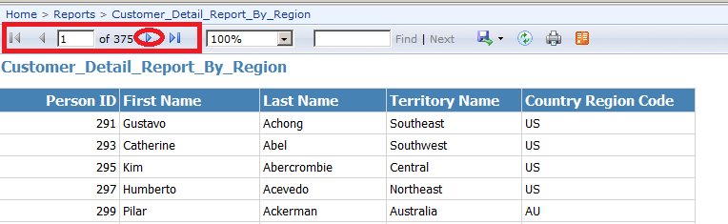

Solution :
The default Interactive size is set to 11 inches and whatever records can fit into it that is what SSRS display to us.
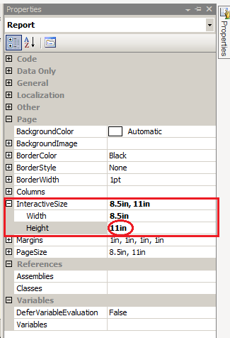

Let's change the Height to 0 Under InteractiveSize Property under Report properties and deploy our report and see if it is showing all records on one page.
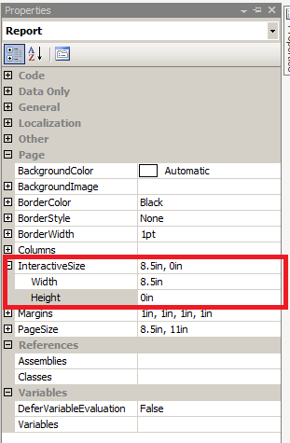
Report display
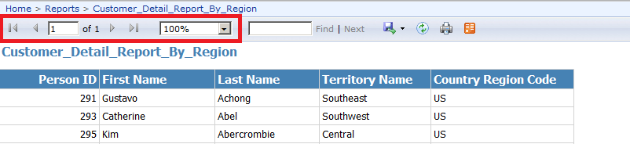

As we can see that the next page button is not available as all the records are shown on one page.

Note:
Displaying all the records on one page can take long time to display. You want to make sure you do not have millions of records to shown on a page. In those cases the explorer can crash or can take forever to display. Instead of displaying all the records on one page you might want to increase Height from 11 inches to another number to display more records on each page.

What are the different ways to sort your report data? What is interactive sort
here are three different ways to sort your data in ssrs report

1) Sort Data in DataSet Query
You can sort the data in your query that you are using for DataSet definition. Let's say we would like to sort the data by Region, we can use below query in our DataSet. If you are using Stored Procedure you can use Order by clause in your Select query inside Stored Procedure.
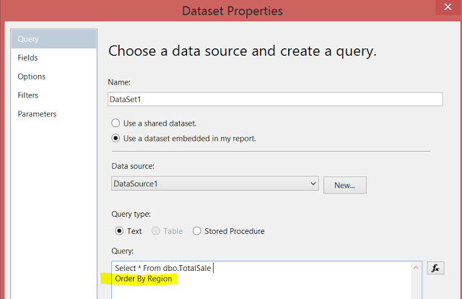

2) Sorting Data with Expressions
You can sort the data in report after retrieved from data source. You can enabling sorting on Tablix,group or detail group. Sorting can be enable on Tablix, Matrix,List, Chart,Gauge etc. Click the properties of Report Item and if you see Sorting listed in properties you can enable sorting on those report items.
Here is example how you can enable sorting on tablix
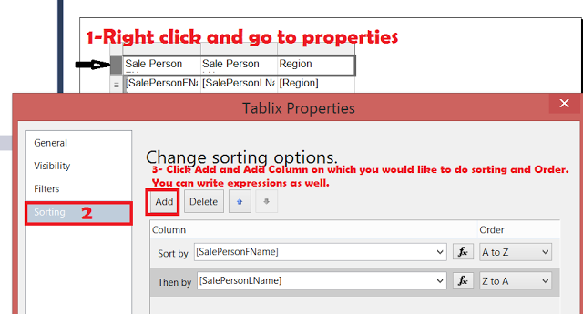
Enable Sorting on Tablix in SSRS Report - SSRS Interview Questions and Answers

3) Interactive Sorting :
you provide button on columns for the users to choose the sort order.
here are the steps to enable Interactive Sorting in SSRS Report
  - Right Click on Column and go to Text Box Properties as shown below
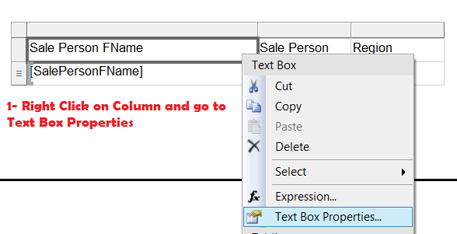
Enable Interactive Sorting in SSRS Report Column- SSRS Interview Questions & Answers

ii) In Text Box Properties go to Interactive Sorting Tab. Click on Enable interactive sorting on the text box. In next step you can choose either you would like to sort details or on Group. Finally you have to choose the Column which you would like to sort. You have option to write expressions.
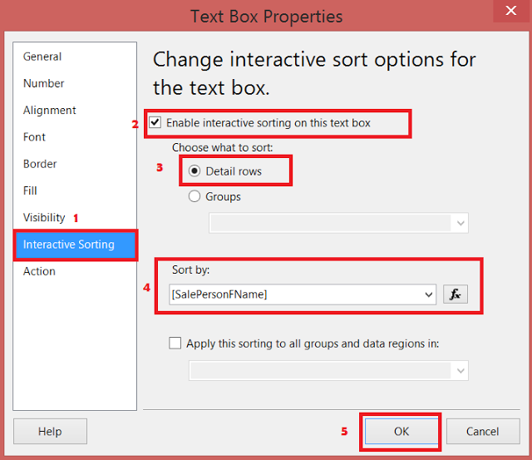
How to Enable Interactive Sorting in SSRS Report - SSRS Interview Questions and Answers

Hit Ok. Now once you preview report you will see a Interactive Sorting Button in Column as shown below.


How to display data on single tablix from two datasets in ssrs report by joining on Multiple Columns
Lookup Function can be used in SSRS to join two datasets. Let's say we have two datasets
Dataset1 has column FName and LName.
DataSet2 has FirstName,LastName and Region
We would like to Join FName--FirstName and LName--LastName and would like to display
FName,LName( from Dataset1) and Region from Dataset2, if values of columns match.
Here is syntax for Lookup Function.
LookupSet(source_expression, destination_expression, result_expression, dataset)
As we need to join on 2 columns from each Dataset. We need to concatenate the columns and then use in lookup.
Let's drag FName and LName from DataSet1 to Talix as shown and go to expressions for third column.
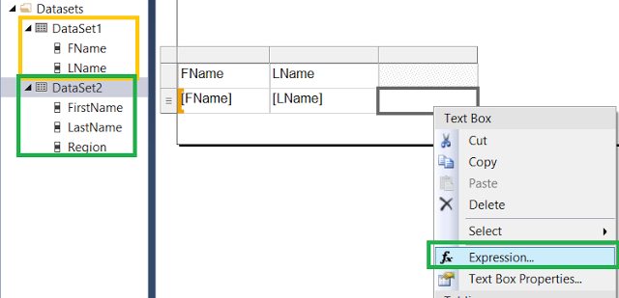

How to use Lookup Function with Multiple Columns in SSRS Report
Our expressions will be like that
=Lookup(Fields!FName.Value+Fields!LName.Value,
Fields!FirstName.Value+Fields!LastName.Value,Fields!Region.Value,"DataSet2")
If you don't like to concatenate columns in expressions. You could have create FullName1 calculate field in both datasets by using below expressions
DataSet1:
Right click on DataSet2--> Click Add Calculate Field and then write expression like shown below
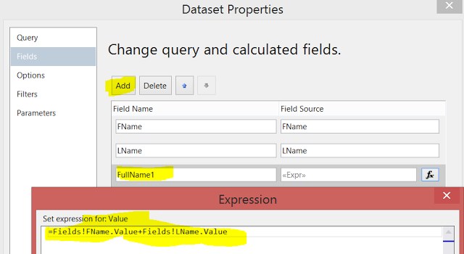
DataSet2:
Right Click on DataSet2 and go to Add Calculate Field and then Add FullName2 same way we did above. The expressions will be like below
=Fields!FirstName.Value+Fields!LastName.Value
Now you don't have to use concatenate the columns inside expressions for Lookup Function.
You can use calculate fields in Lookup Function to get the Region from DataSet2.
=Lookup(Fields!FullName1.Value,Fields!FullName2.Value,Fields!Region.Value,"DataSet2")

How to display data on single tablix from two datasets in ssrs report by joining on single column
We can use the Lookup Function in SSRS Report to join the data from two datasets. There should be at-least one matching column on which we will join the datasets.
Let's say we have DataSet1 with column FName,LName and DataSet2 with columns FirstName and Region.
If we would like to display FName,LName (from DataSet1) along with Region Column from DataSet2. We can use Lookup Function and write our expressions as shown below.
Lookup Function with Parameters
LookupSet(source_expression, destination_expression, result_expression, dataset)
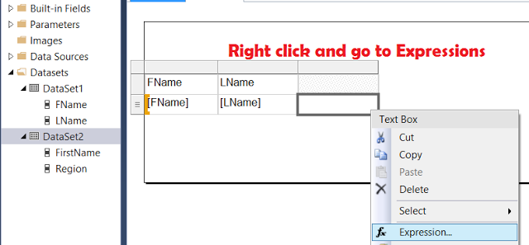

How to use Lookup Function in SSRS Report to Join Data from two datasets

Now let's write our expressions by using Lookup Functions and use FName as source_expression, FirstName as destination_expression,Region as result_expressions and "DataSet2" as Dataset.
=Lookup(Fields!FName.Value,Fields!FirstName.Value,Fields!Region.Value,"DataSet2")
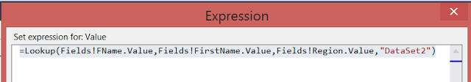
Lookup Function in SSRS Report - Display Multiple DataSets fields in Single Tablix

Our final Report will look like ( FName and LName coming from Dataset1), Region column values are coming from Dataset2 where DataSet1.FName matches with DataSet2.FirstName. We will see blank Region if there is no match.
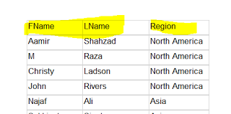

Display Header Row on Each Page

Scenario :
We have created a simple detail report. When we preview report it shows header on first page but after that it does not show Header Row. We want to see the Header Row on each page.

Solution :
Here are the steps we need to perform to shown Header Row on each page.
Step 1 : Click on Drop down arrow next to Column Groups as shown below
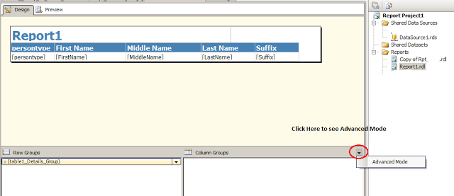
Step 2:
Click on Static under Row Groups and Press F4 to go to properties as shown below
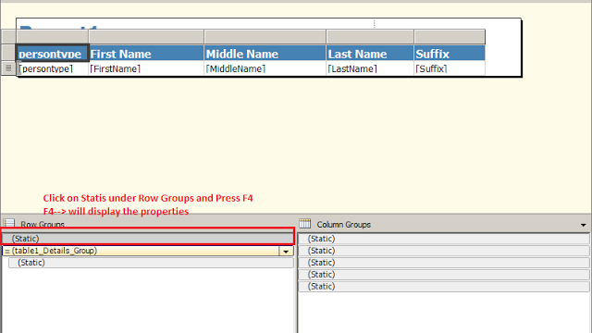
Step 3:
Set KeepTogether=True
and KeepWithGroup=After
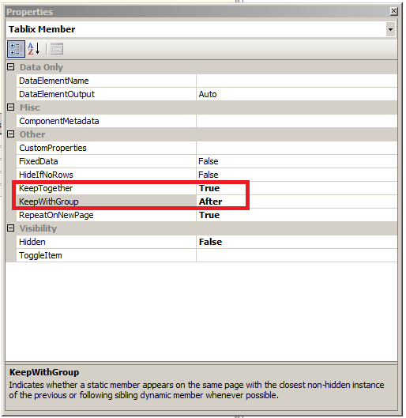
With above changes you should be able to see the Header Row on each of the page.

What are seven rendering extensions available in SSRS?
Rendering Extension is part/component of Report Server that transforms report data and layout to device specific format.
There are seven rendering extensions are available in SQL Server Reporting Services.
- HTML
- Excel
- Word
- CSV or Text
- Image
- PDF
- XML
By default Report Server will render the report in HTML. You don't have to specify the format in url.
http://ComputerName/ReportServer/Pages/ReportViewer.aspx?%2fReport&rs:Command=Render

rs:format
rs:format can be used in url to define in which format we would like to render our report. if I have a report with name Report and I would like to render in Excel, My URL will be like below

http://ComputerName/ReportServer/Pages/ReportViewer.aspx?%2fReport&rs:Command=Render&rs:format=Excel

for PDF

http://ComputerName/ReportServer/Pages/ReportViewer.aspx?%2fReport&rs:Command=Render&rs:format=PDF

if you would like to render in any above, you can change the rs:format=YourExtension

Passing Parameter values in URL
You can also pass the parameter in url if required. If my Report Name is SaleReport and it is using Param_Isactive ( Boolean type), I can use below url to render my report to TIF with parameter value =true.

http://ComputerName/ReportServer/Pages/ReportViewer.aspx?%2fSaleReport&rs:Command=Render&rs:format=Image&Param_IsActive=true

What is Page Break in SSRS Report
Page break is the way to control the contents on each of the page. We can introduce the page break between Data Regions, Rectangles and also between the Groups created in the Data Regions.
To Enable Page Break, we need to click on the Tablix, Matrix, and Rectangle properties and then go to Page Break and then choose you would like to put Page Break after the Item or before the Item.
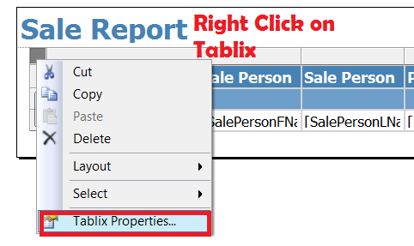
How to add page break in SSRS Report for different items - SSRS Interview Questions.

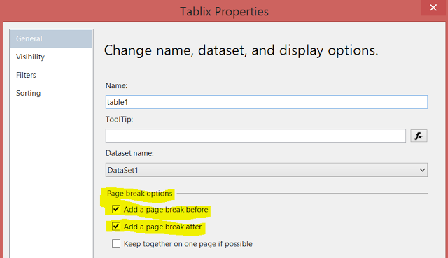
Choose If you would like to add Page Break before or After Report Item(Tablix,Matrix,Rectangle)

We can also add Page Break between Groups. Here is the link How to Add Page Break Between Groups in SSRS Report.

