Setting Python environment and IDE Set up ARC 2.0

- Install Anaconda from Software Center
  - If installation fails restart laptop and try again(It take more than 1 hour for installation, Make sure you laptop is active and doesn’t go into sleep mode)
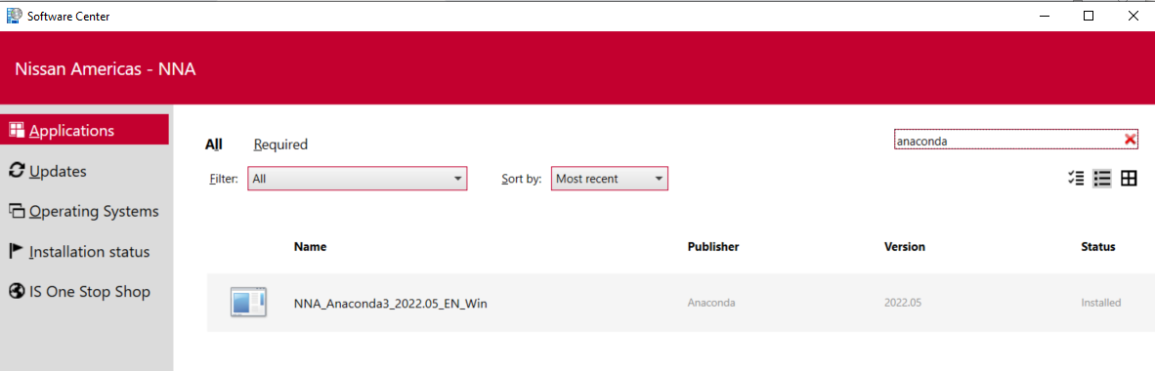
- After successful installation, In windows search bar search for Anaconda you will find two options.
  - Anaconda Navigator
  - Anaconda Prompt(CLI)
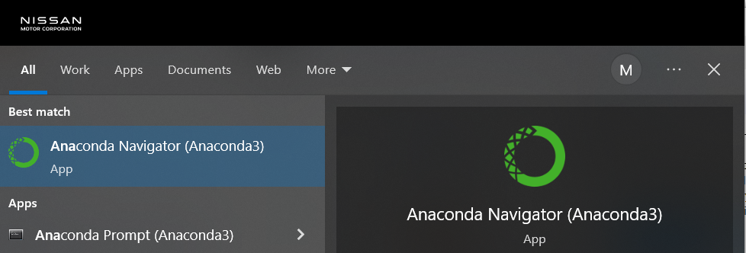
- Setting up Anaconda Python installation path in your IDE.
  - In my laptop PyCharm is installed(Even without admin permissions was able to install PyCharm)
  - Open Anaconda Prompt(CLI) and type below command to get the Anaconda python environment path

conda env list 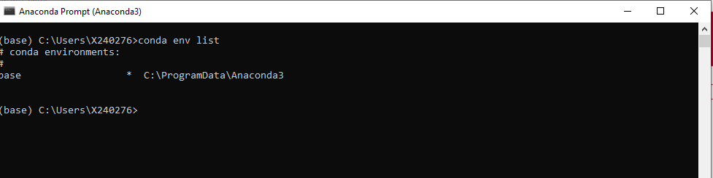

  - Please copy the base path from the output of above command from conda cli.
  - Open Pycharm, Click on New Project

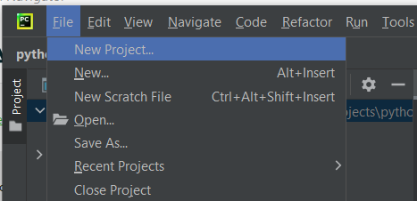

  - In “Create Project” window you have configure python environment in Python interpreter.
  - Choose “Previously Configured interpreter” and add your conda python.exe path from Anaconda environment.
For me it is in this location C:\ProgramData\Anaconda3\python.exe
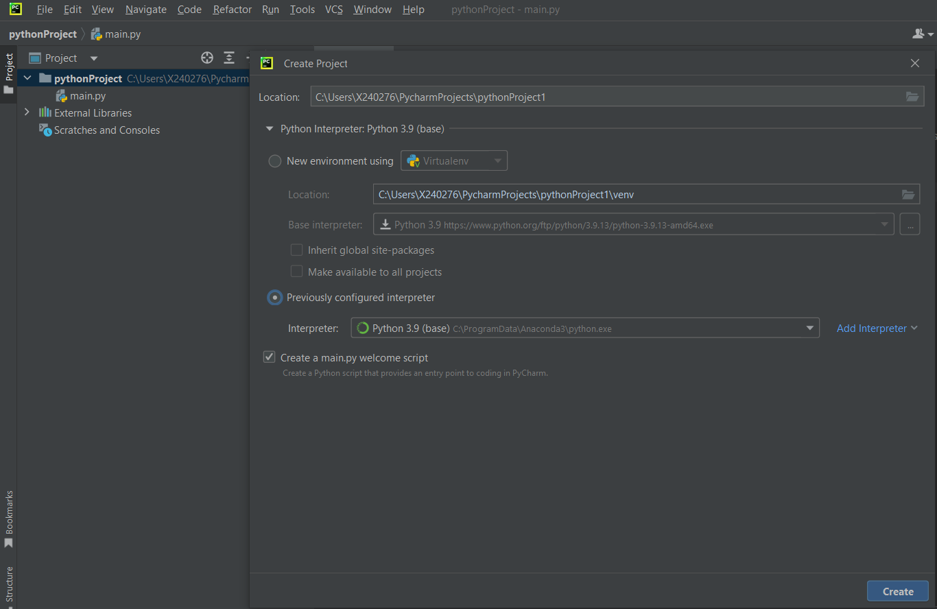
  - After successfully creation of Project.
  - Click on File > Settings
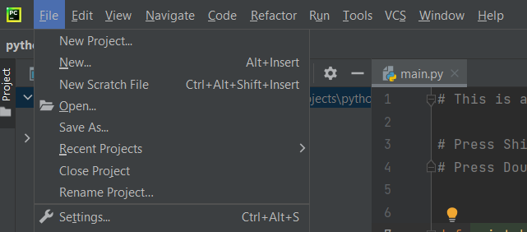
  - Expand the Project you create and click on “Python Interpreter”. You will all anaconda Python packages available for this project.
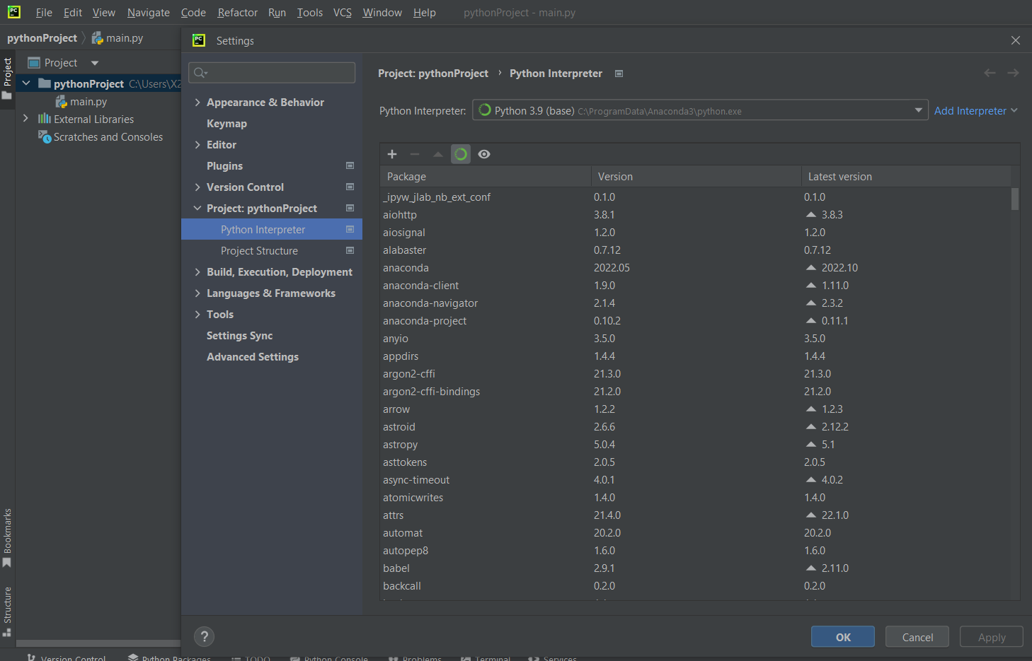

  - This confirms successful creation of Python Project with Anaconda Python Environment.

