Adding PySpark libraries to Package
- Download Spark library from
https://spark.apache.org/downloads.html
- Downloaded library will be in .tgz extension
- Extract folder using tar -xzf command from windows cmd
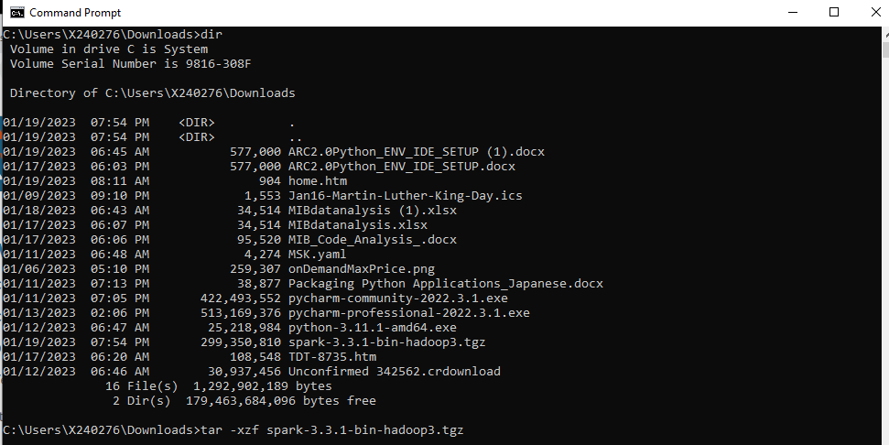
- Extracted folder will be
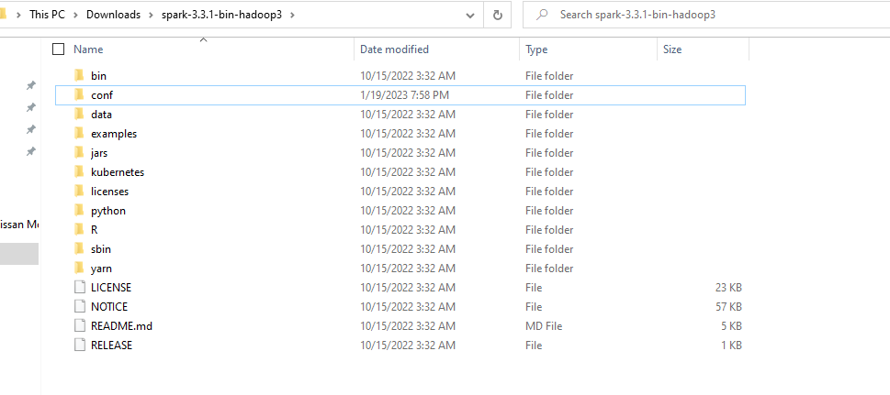
- Open PyCharm Go to File > Settings > Project: ${Your_Project_Name} > Project Structure
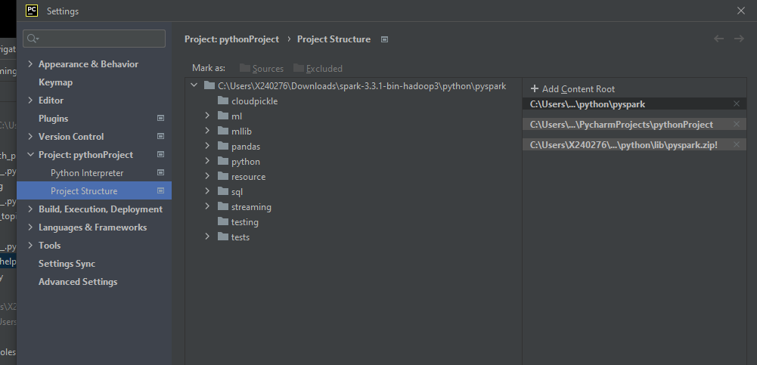
- Click “+ Add Content Root” on the right top most(You can find in above screenshot).
- Add following libraries downloaded from Spark folder extracted from Step c.
- Below are the libraries required.
C:\Users\X240276\Downloads\spark-3.3.1-bin-hadoop3\python\lib\pyspark.zip
C:\Users\X240276\Downloads\spark-3.3.1-bin-hadoop3\python\pyspark

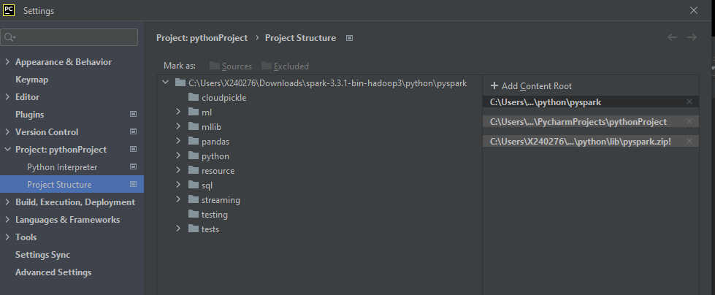

- Successfully added Spark libraries to the Python project.
- You can import libraries into without throwing any unresolved exceptions.

