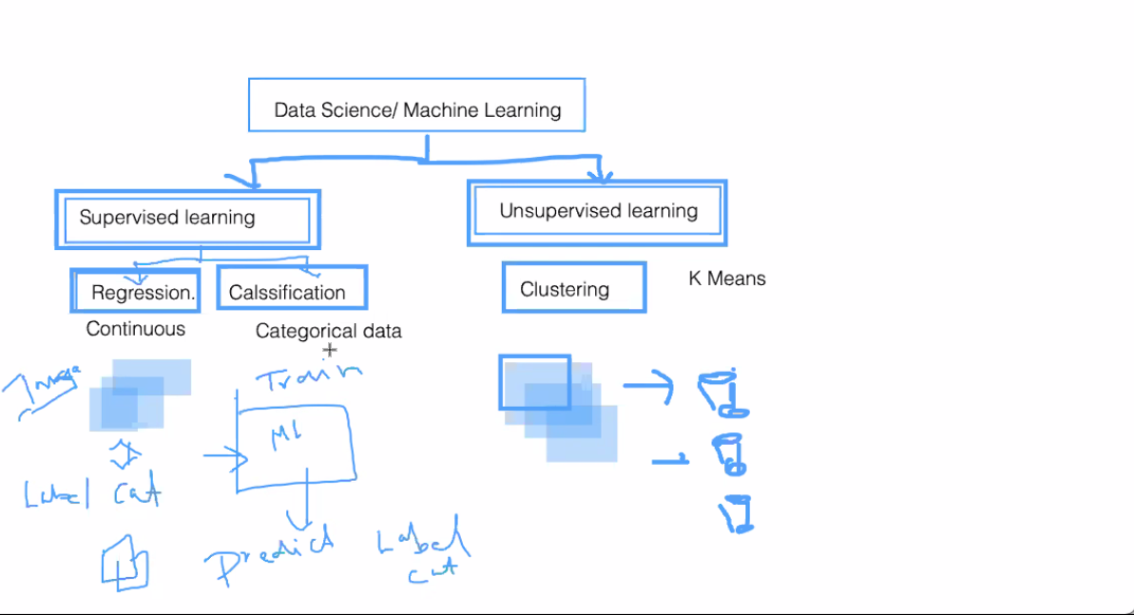
Google Spam - Classification Model
OLA AND UBER pricing distancing - clustreing model
uber

Supervised (Labled Data) Like we give bunch of images of cat and we lable those images as cat and next time if we pass the diff image it will predict what the image is. (prediction model)
Regression : whenever your data is continous
ex: like house price can be 50L , 100L , 1cr , 2cr
ex: like student marks.
ex: price of iphone
ex: predicting the covid cases

Classification : when the data is categrocal
ex: like either student can pass or fail and
ex: gender can be male or female
ex: I can buy the phone or not buy
ex: will covid cases increase or decrease

Unsupervised :
Clustreing : where we put similar data without labeling but baseed on certain similaties
ex: putting different newspapers in separate buckets with the help of algorithams like K-means

Understanding the Data Pattern:
Measure of central tendency like mean / average
Calculate the median
Mode(Freqency of data)

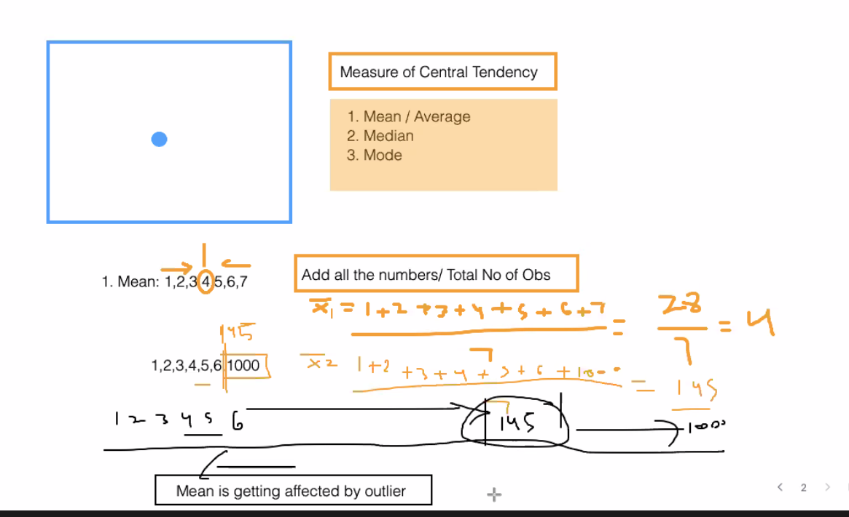

Based on the above pic : mean is getting affected by outlier 1000 then we go for Median
Median : 1,5,3,2,4,6,7
Arrange them first : 1,2,3,4,5,6,7
Formaula : n+1/2 so 7+1/2 = 4th position is the median
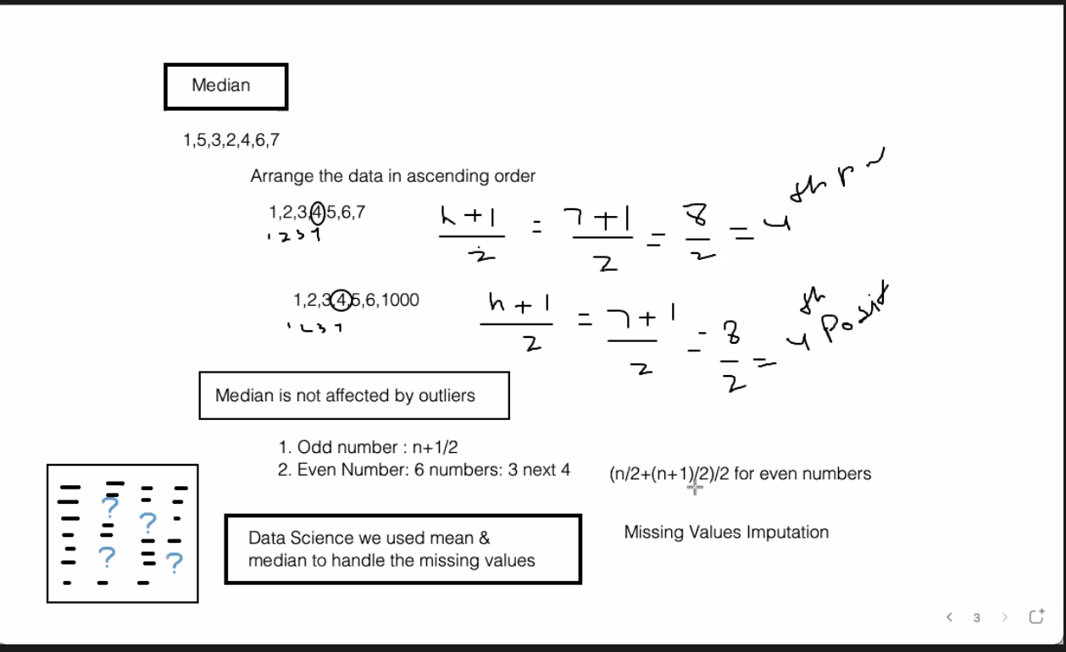

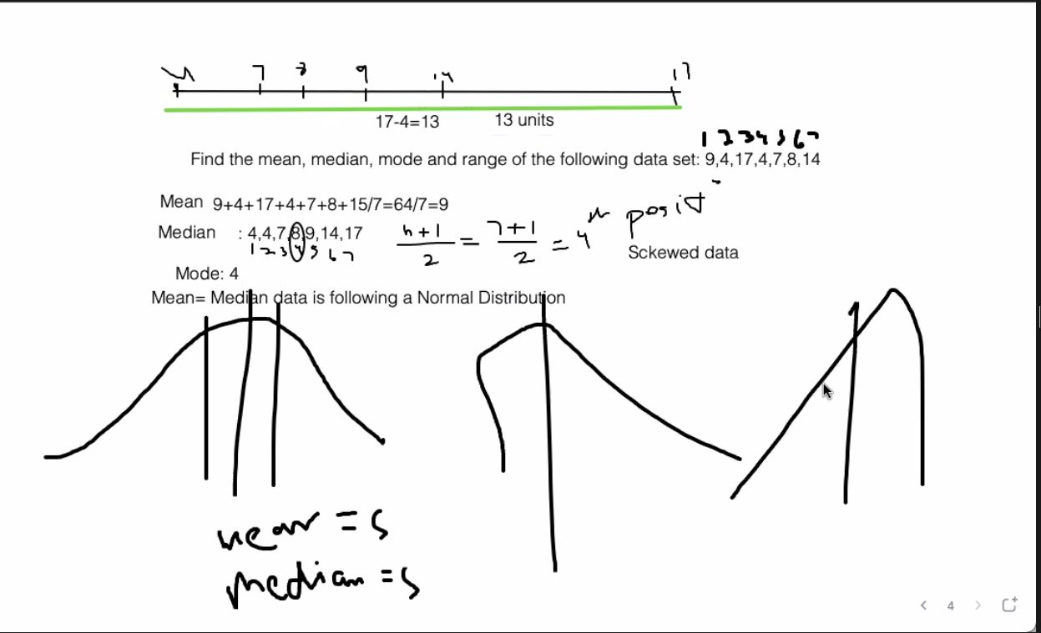

How do we find the spread of date :
1.Range : Max-Min
2. Box Plot
3. Variance
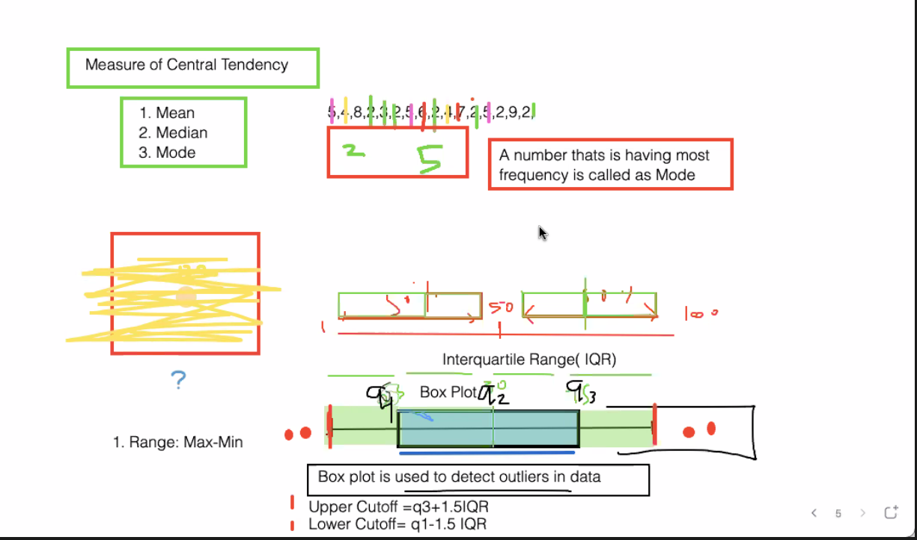
IQR=Q3-Q1
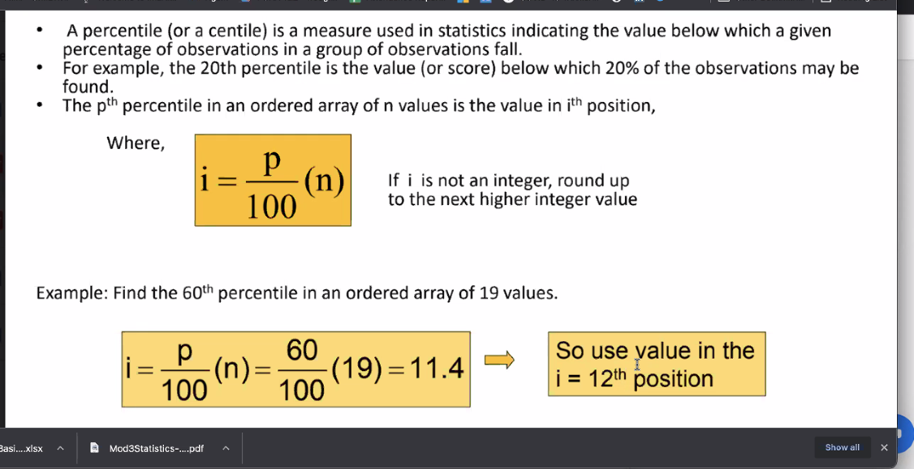
To find the 25% (q1) and 75% (q3)
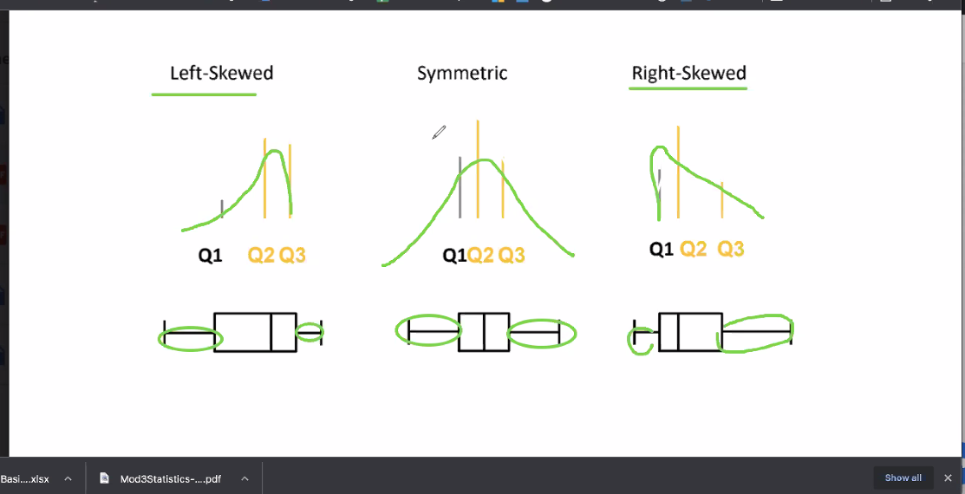

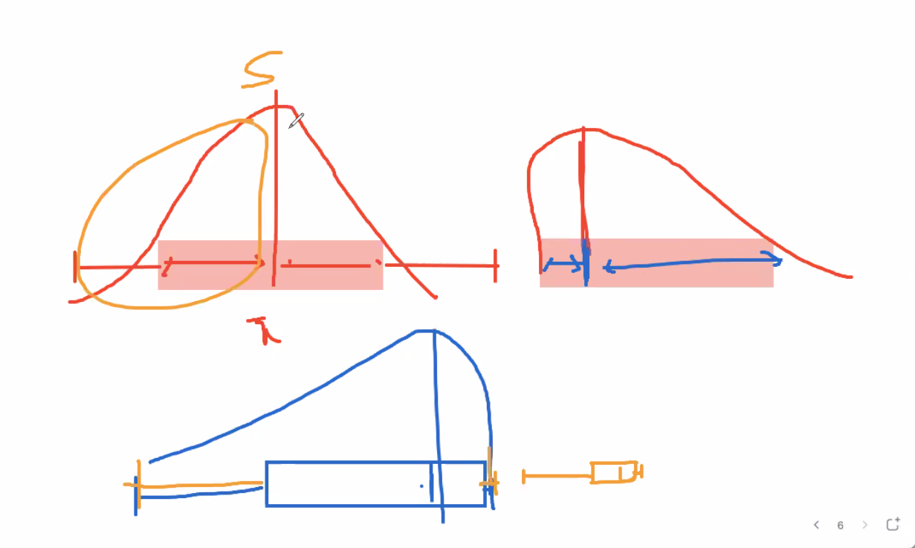

Great example for standard deviation :
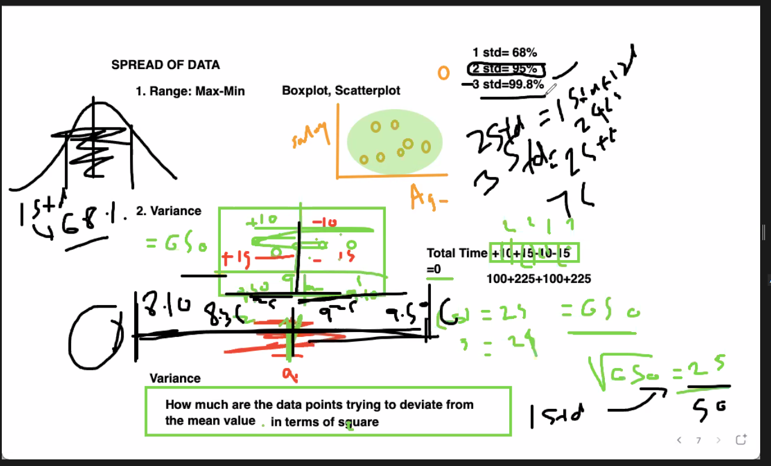
Pandas types and differences:
Single [] always gives us the series where as [[ ]] gives us the dataframe
Series :
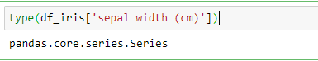
Df :
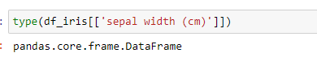

Issue with series:
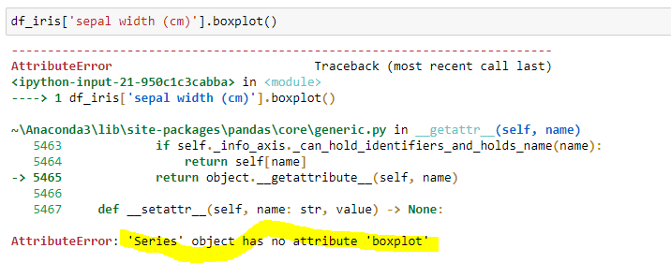
Resolved after adding another [ ] so now it is not a series but a dataframe
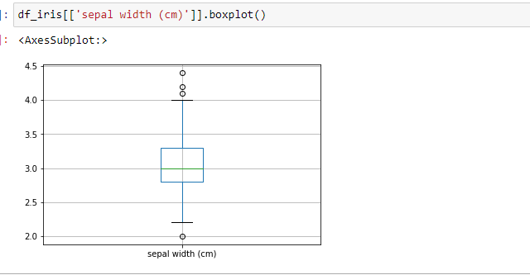

df_iris[['sepal width (cm)','sepal length (cm)']] to grab two columns
df_iris[['sepal width (cm)']] to grab one column

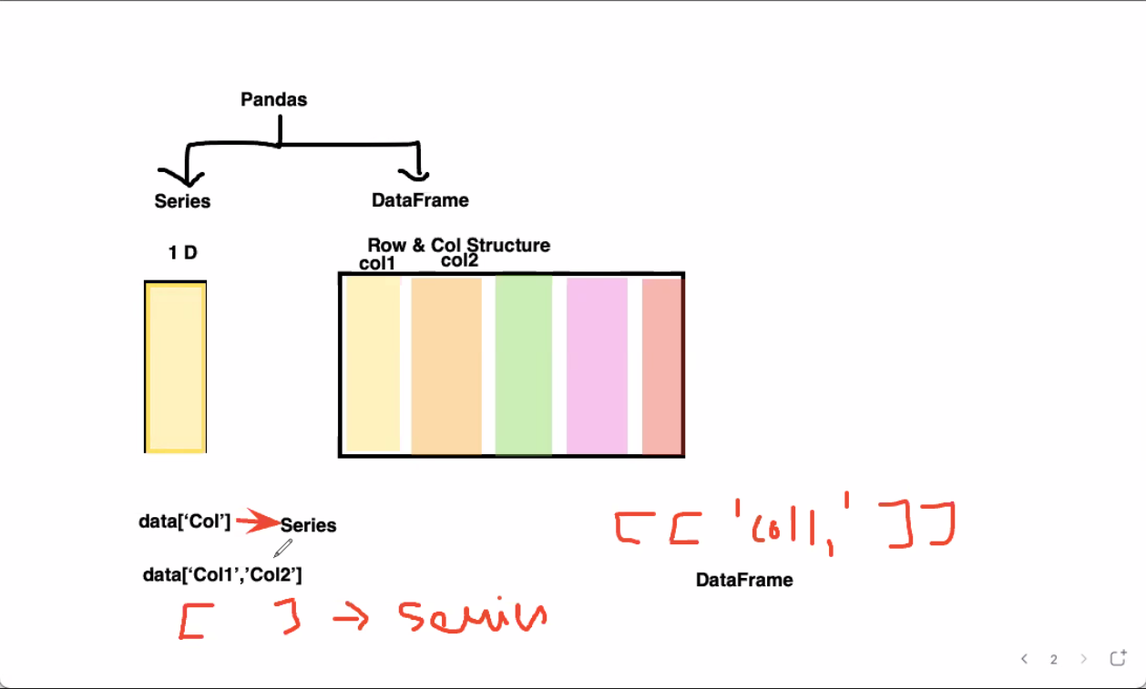
https://www.machinelearningplus.com/plots/python-boxplot/

Correlation:
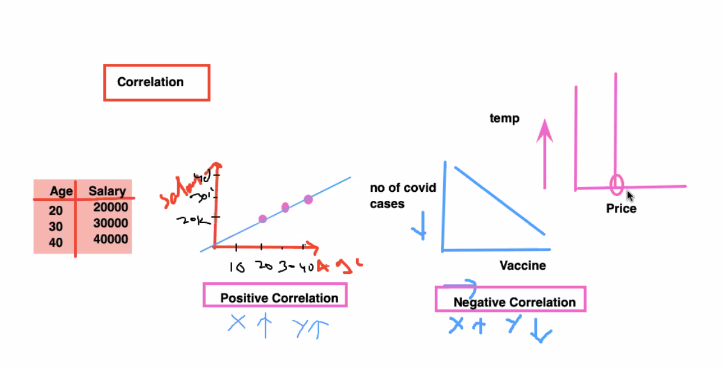
Third one is no correlation : temperature increases but price of the will not change just becoz the temp is increasing . No correlation between temp and house of the price.
Why do need correlation : in linear regression model features should be having correlation with the labels but not the individual features. So in order to find out if there is any correlation between the featues so calculate the correlation and see.

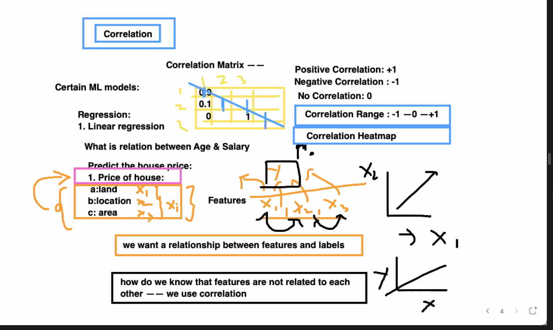

Empirical Value:
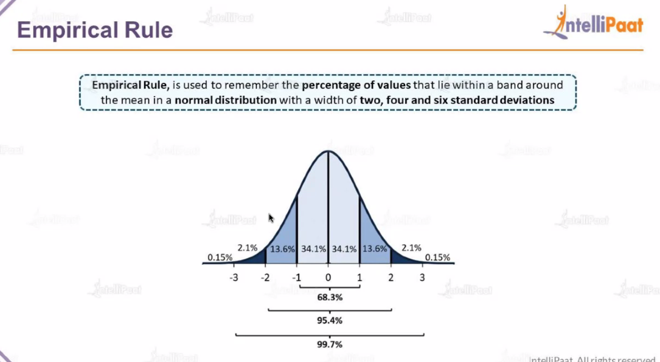

Std :
Hint : 68% of the time he travelled between 40 and 60 kmph
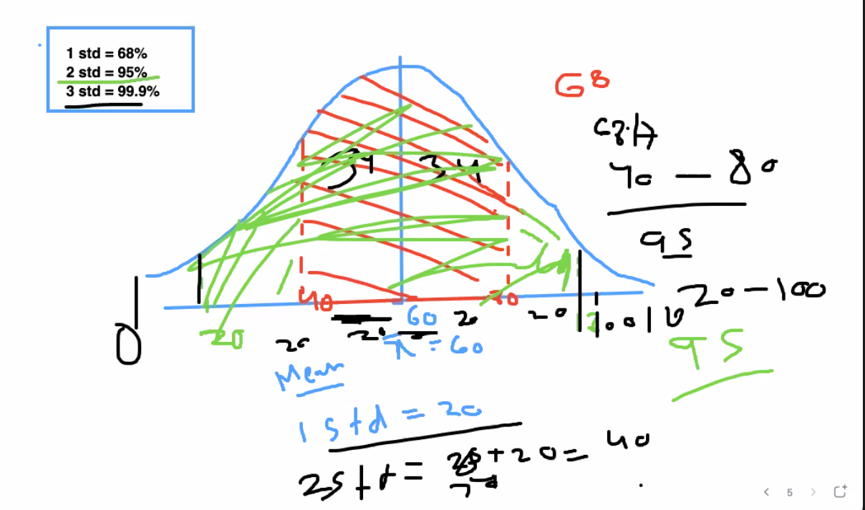

Z- Score : To find out how far you are mean interms of std.
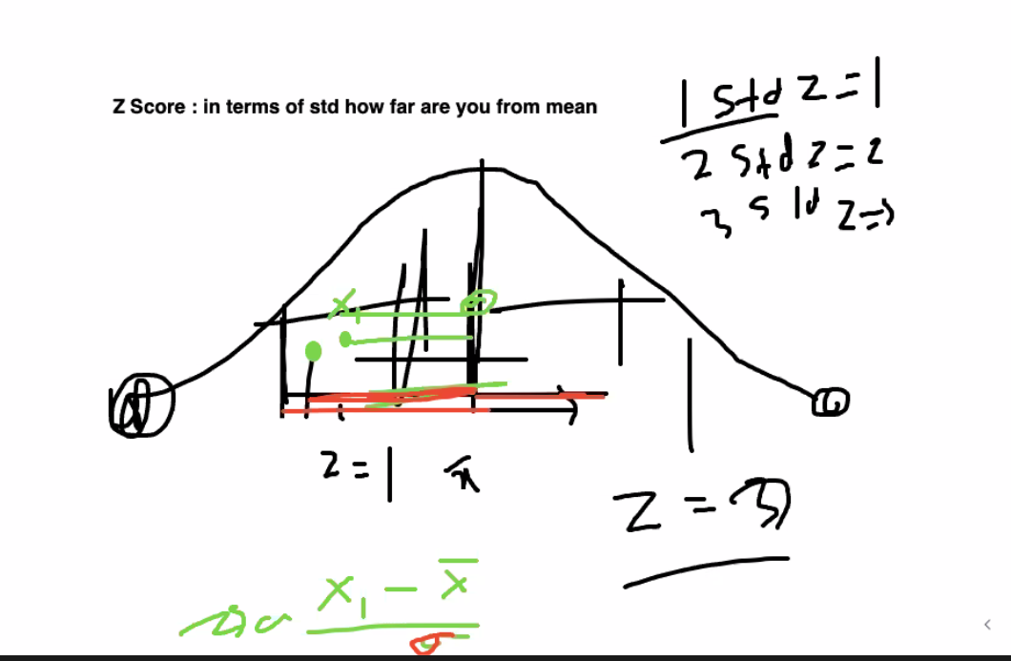
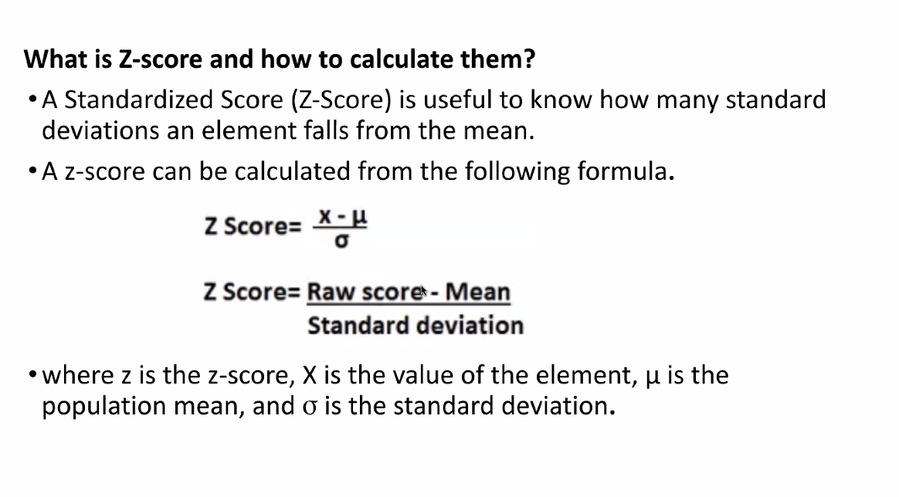
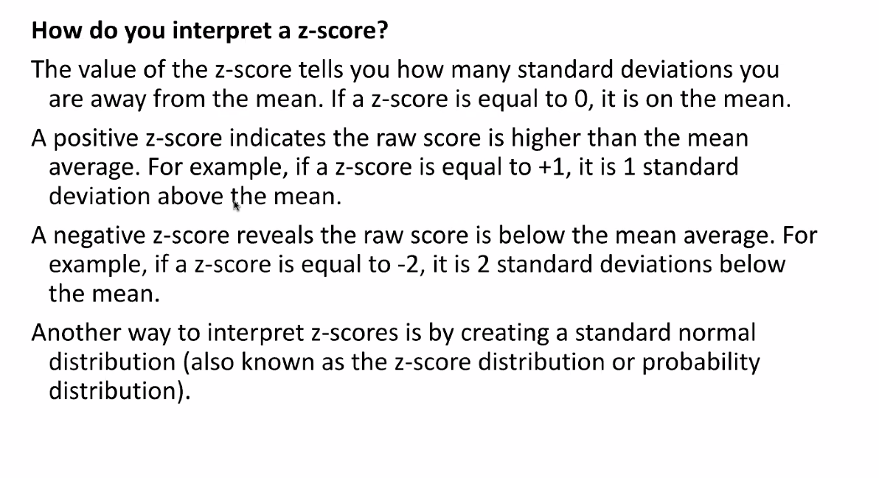
https://drive.google.com/drive/folders/1iInBkRbo6wTaBlsF9VJijsaRAci3xMYy
https://www.jmp.com/en_us/statistics-knowledge-portal/what-is-regression/simple-linear-regression-assumptions.html

