# Database Name is mainclinicdb

### tbl_products(Registration of products)

|  |  |  |  |
| --- | --- | --- | --- |
| Title | DataType | Data types description | Description |
| pro_id | bigint | 8 Bytes  9,223,372,036,854,775,807 | Product entry number |
| P_id | nvarchar(MAX) | 2 GByte  1 billion characters | Product  alphanumeric id |
| p_name | nvarchar(MAX) | 2 GByte  1 billion characters | Product name |
| p_price | nvarchar(MAX) | 2 GByte  1 billion characters | Product price |
| p_dte | datetime | Date and time both values | Product registered date |
| p_description | nvarchar(MAX) | 2 GByte  1 billion characters | Description of product |
| photo | image | Image datatype | Save the image |

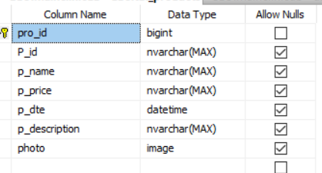

### tbl_services(Registration of services)

|  |  |  |  |
| --- | --- | --- | --- |
| Title | DataType | Data types description | Description |
| Sentry_no | bigint | 8 Bytes  9,223,372,036,854,775,807 | Service entry number |
| Rate_ID | nvarchar(MAX) | 2 GByte  1 billion characters | Id of service |
| Service_Name | nvarchar(MAX) | 2 GByte  1 billion characters | Service name |
| Gender | nchar(10) | 10 characters | Services for which gender is registering |
| Service_Price | float | Value in decimal | Service price |
| Service_Date | datetime | Date and time both values | Date on which service registered |
| Service_Description | nvarchar(MAX) | 2 GByte  1 billion characters | Some additional details of service |

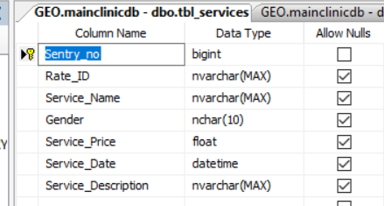

### tbl_memberreg(registration of members)

|  |  |  |  |
| --- | --- | --- | --- |
| Title | DataType | Data types description | Description |
| mid | bigint | 8 Bytes  9,223,372,036,854,775,807 | Member entry number |
| M_ID | nvarchar(MAX) | 2 GByte  1 billion characters | Member  alphanumeric id |
| m_name | nvarchar(MAX) | 2 GByte  1 billion characters | Member name |
| m_contactinfo | nvarchar(MAX) | 2 GByte  1 billion characters | Member  contact number |
| m_age | nvarchar(MAX) | 2 GByte  1 billion characters | Member  age |
| m_address | nvarchar(MAX) | 2 GByte  1 billion characters | Member  address |
| m_dte | datetime | Date and time both values | Date on which member registered |

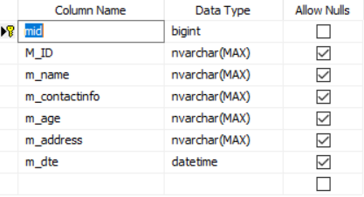

### tbl_inventrry(To add products to inventory)

|  |  |  |  |
| --- | --- | --- | --- |
| Title | DataType | Data types description | Description |
| Entryno | bigint | 8 Bytes  9,223,372,036,854,775,807 | Inventory entry number |
| I_Id | nvarchar(MAX) | 2 GByte  1 billion characters | Inventory alphanumeric id |
| Pro_id | nvarchar(MAX) | 2 GByte  1 billion characters | Product alphanumeric id |
| Product_name | nvarchar(MAX) | 2 GByte  1 billion characters | Product name |
| Recent_Purchase_Quantity | nvarchar(MAX) | 2 GByte  1 billion characters | The recent purchased quantity of chosen product |
| Totalquantity | bigint | 8 Bytes  9,223,372,036,854,775,807 | Total quantity in stock |
| Stock_Status | nchar(10) | 10 characters | For stock in/or stock out |
| Stockin_date | datetime |  | Date of stock |
| Sale_Quantity | nvarchar(MAX) | 1 billion characters | Sale quantity |
| Stock_outdate | datetime | Date and time both values | The date of selling product |

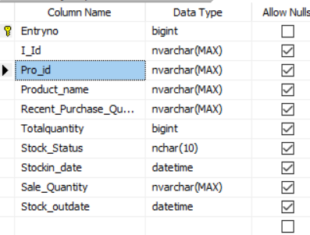

### tbl_reservation (reservation data)

|  |  |  |  |
| --- | --- | --- | --- |
| Title | DataType | Data types description | Description |
| R_Entryno | bigint | 8 Bytes  9,223,372,036,854,775,807 | Reservation entry number |
| Re_id | nvarchar(MAX) | 2 GByte  1 billion characters | Reservation  Alphanumeric id |
| Rate_ID | nvarchar(MAX) | 2 GByte  1 billion characters | Service rate id |
| Service_Name | nvarchar(MAX) | 2 GByte  1 billion characters | Name of service the customer reserved |
| Gender | nchar(10) | 10 characters | Customer gender |
| Service_Description | nvarchar(MAX) | 2 GByte  1 billion characters | Description of service the customer want to reserved |
| Member_ID | nvarchar(MAX) | 2 GByte  1 billion characters | Customer id if registered |
| Memebr_name | nvarchar(MAX) | 2 GByte  1 billion characters | Customer name if registered |
| m_contactinfo | nvarchar(MAX) | 2 GByte  1 billion characters | Customer contact number |
| m_age | nvarchar(MAX) | 2 GByte  1 billion characters | Customer age |
| m_address | nvarchar(MAX) | 2 GByte  1 billion characters | Customer address |
| Reservation_Date | datetime | Date and time both values | The date on which he reserved the service |
| Reservation_Time | time(7) | TIME is stored in the format: *hh:mm:ss.nnnnnnn*, with a range of 00:00:00.0000000 through 23:59:59:9999999 | Time of reservation |
| Reservation_Served_EndTime | time(7) | TIME is stored in the format: *hh:mm:ss.nnnnnnn*, with a range of 00:00:00.0000000 through 23:59:59:9999999 | Time after getting service and customer leave |
| R_Date | datetime | Date and time both values | Date on which the service reserved |
| Serve_Emplyee | nvarchar(MAX) | 2 GByte  1 billion characters | The employee who served |
| Reservation_Status | nvarchar(50) | 1 and 50 characters | Status of reservation, either pending, cancelled or served |

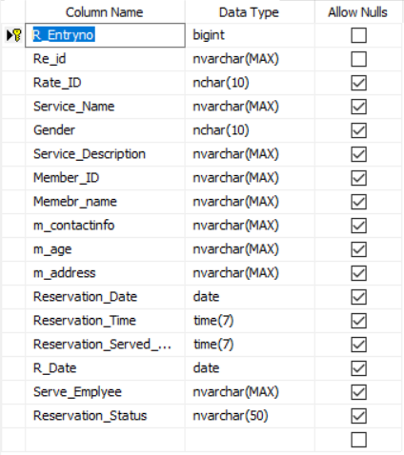

### tbl_productsales (Transaction of services and products)

|  |  |  |  |
| --- | --- | --- | --- |
| Title | DataType | Data types description | Description |
| Transaction_ID | bigint | 8 Bytes  9,223,372,036,854,775,807 | Transaction entry number |
| Member_Name | nvarchar(MAX) | 2 GByte  1 billion characters | Member name who purchase the product |
| Memebr_ID | nvarchar(MAX) | 2 GByte  1 billion characters | Member ID who purchase the product |
| Product_Details | nvarchar(MAX) | 2 GByte  1 billion characters | Products and its details like price, discount of that product. Data for single item. ,which are purchased by member |
| Product_Total_Items | float | Data with decimal value | Total items, the member purchased |
| ProPrice_without_Discount | float | Data with decimal value | Price of products without discount |
| ProPrice_with_Discount | float | Data with decimal value | Price of product with discount |
| Product_Remarks | nvarchar(MAX) | 2 GByte  1 billion characters | Remarks of product |
| Service_Details | nvarchar(MAX) | 2 GByte  1 billion characters | Details for each single service. And these services save together in it. |
| SerPrice_without_Discount | float | Data with decimal value | Price of service without discount |
| SerPrice_with_Discount | float | Data with decimal value | Price of products with discount |
| Service_Remarks | nvarchar(MAX) | 2 GByte  1 billion characters | Remarks of service |
| Transaction_Date | datetime | Date and time both values | Date on which sale takeplace |

### 

### 

### 