Machine Learning – Assignment_2

Kongari Kiran Kumar

700734361

Code:

Output:

Code:

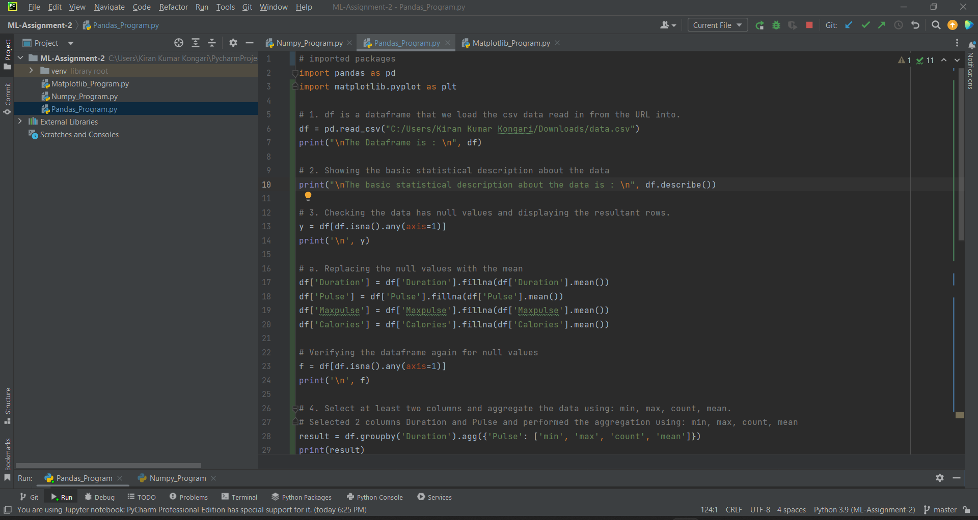

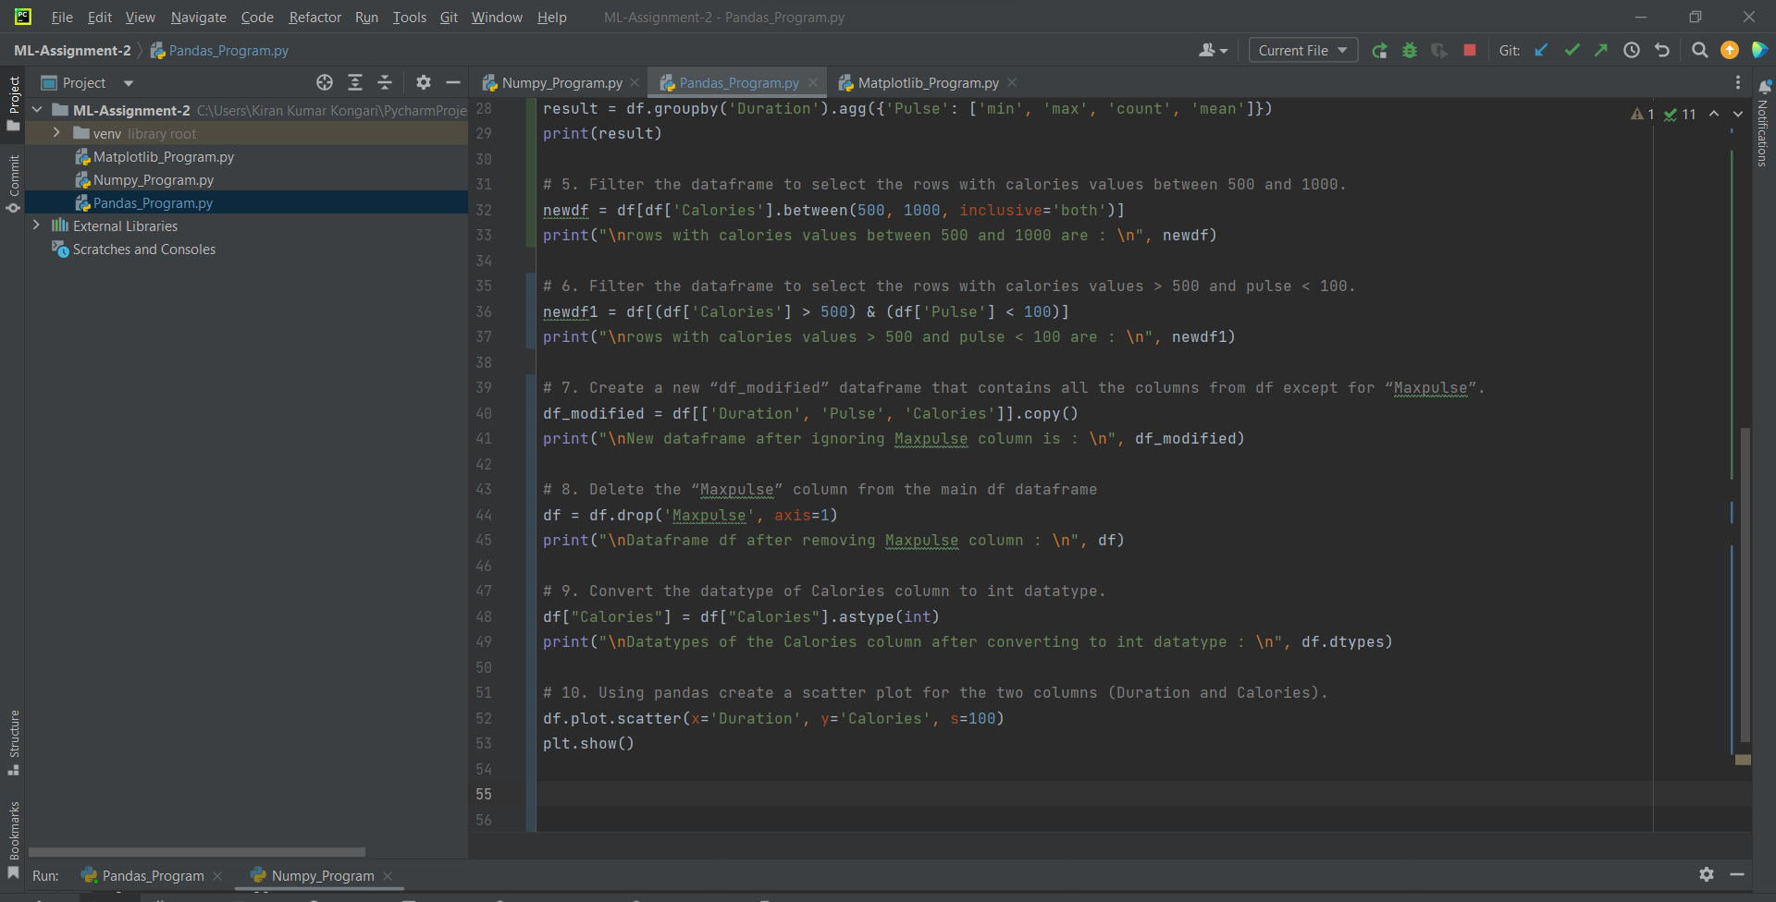

Output:

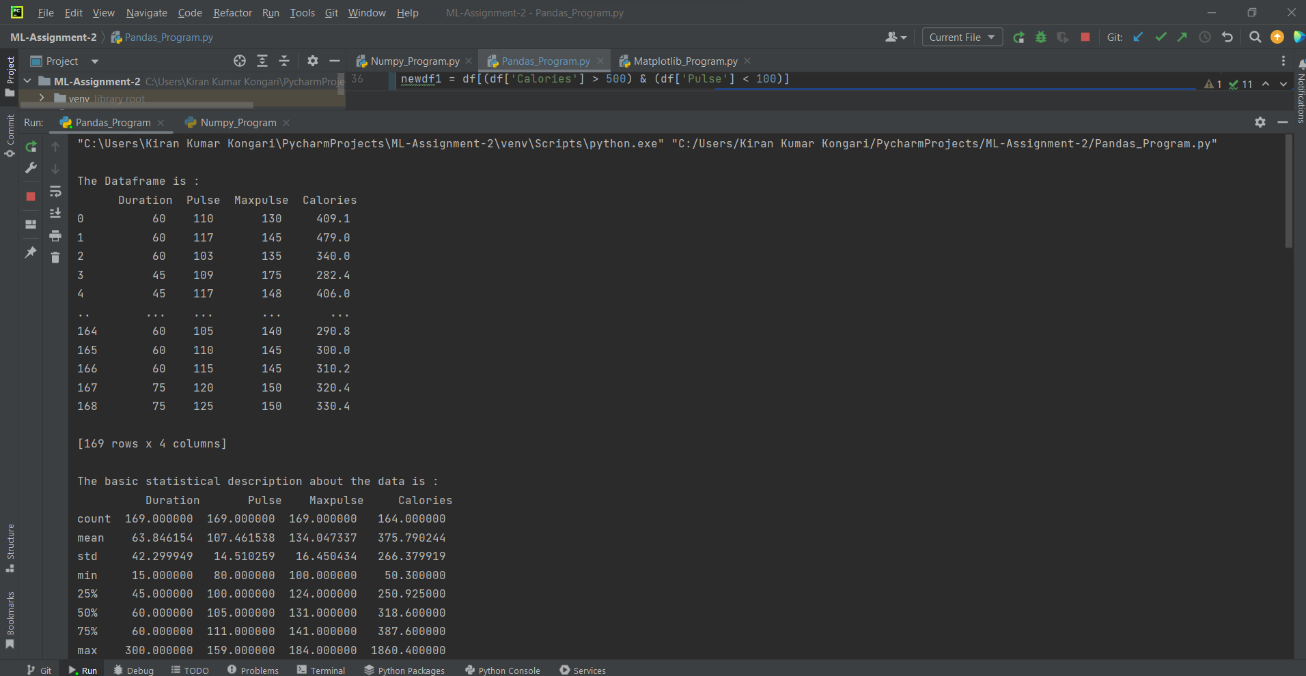

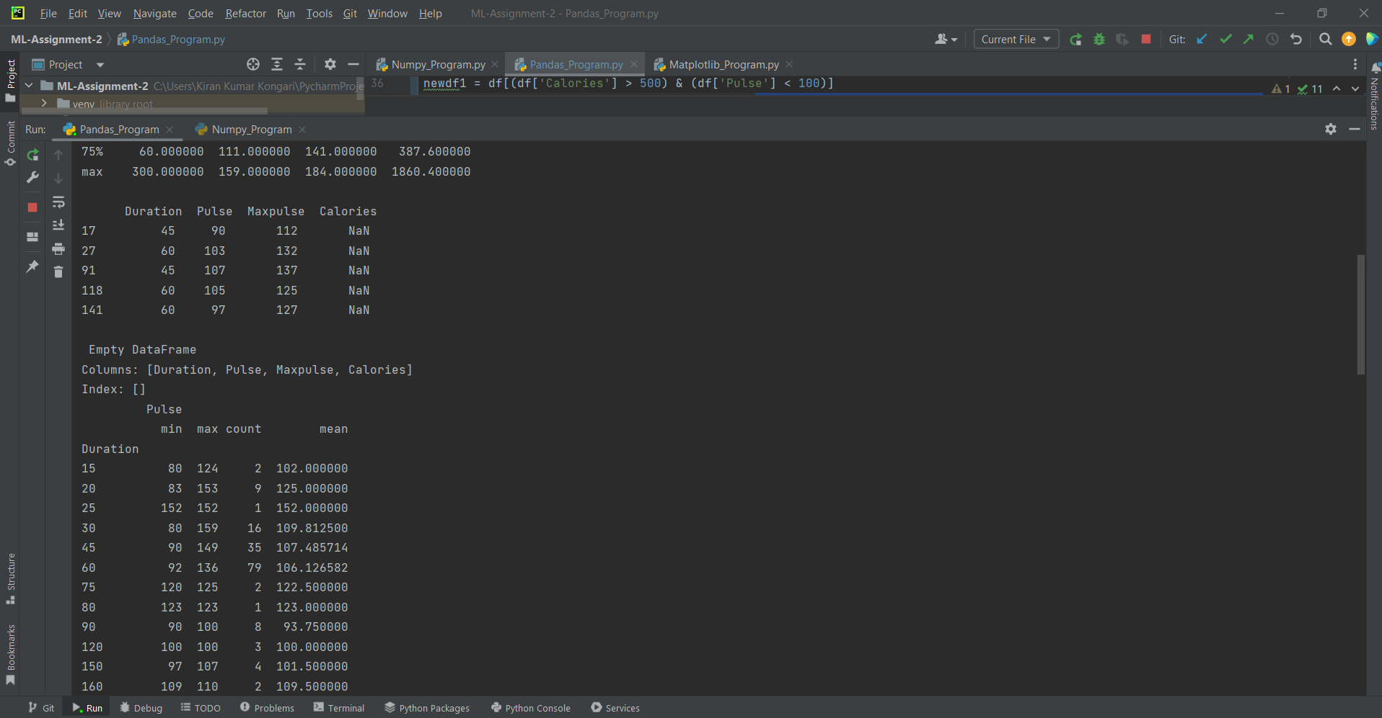

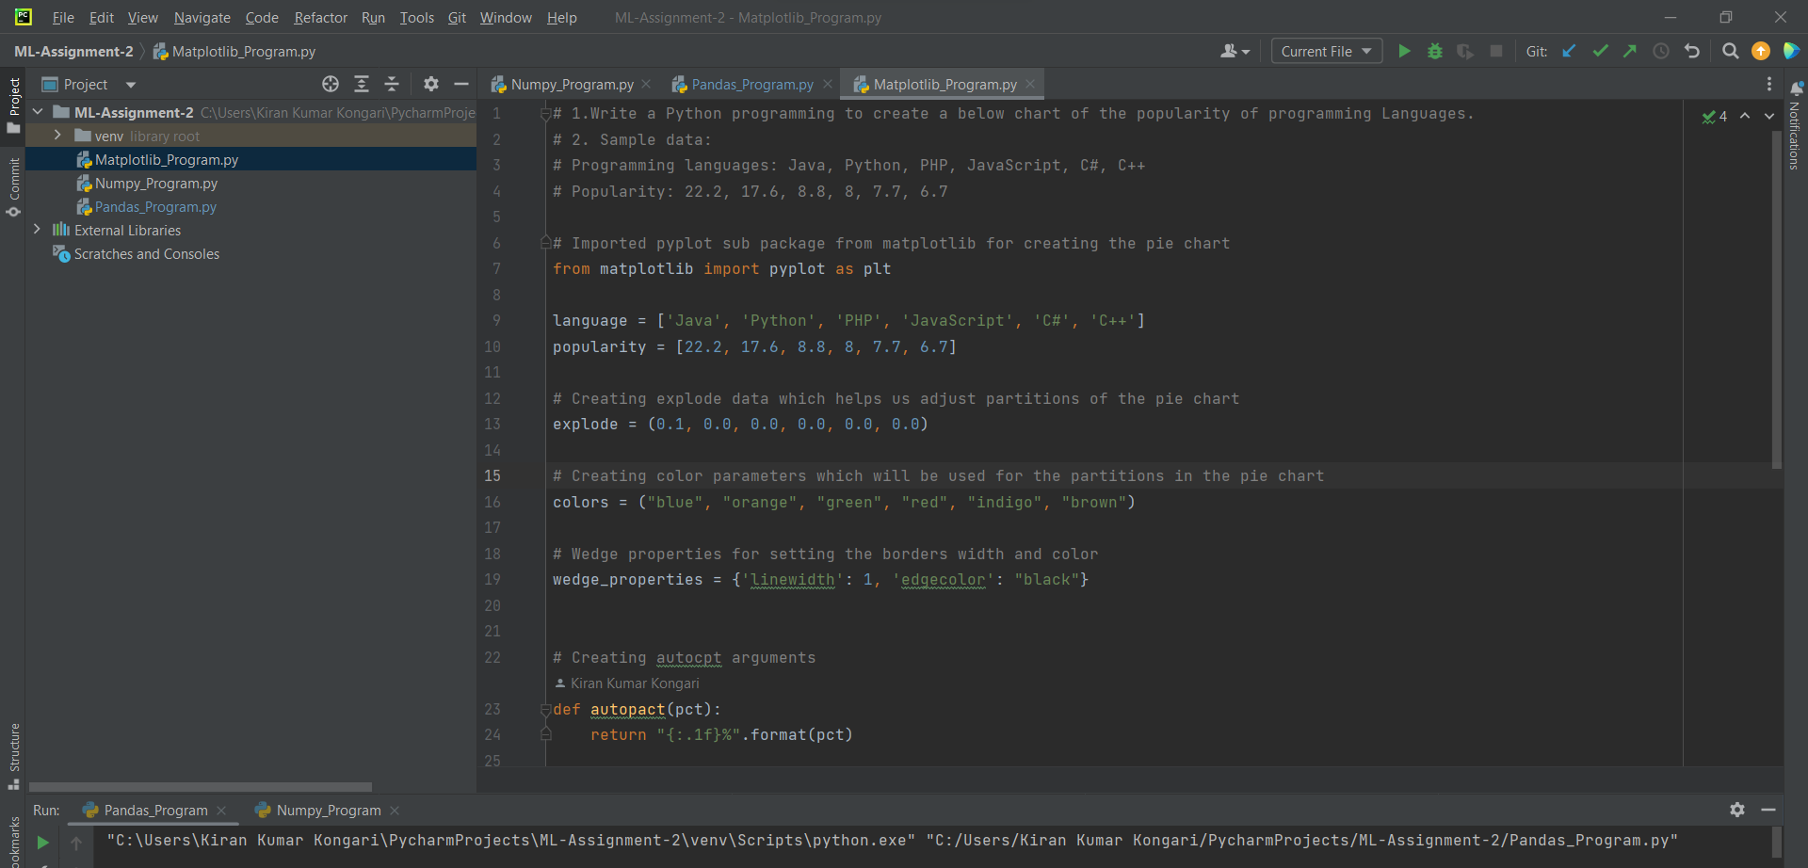

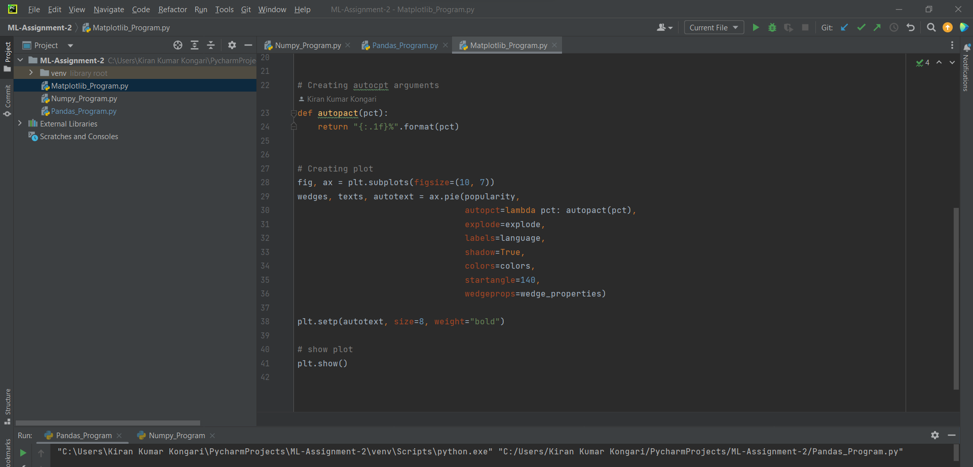

Output:

