**Assignment-3**

**Kiran Kumar Kongari**

**700734361**

**“For both the questions I have considered 80% of the dataset as training data and 20% of the dataset as testing data.”**

**Code:**

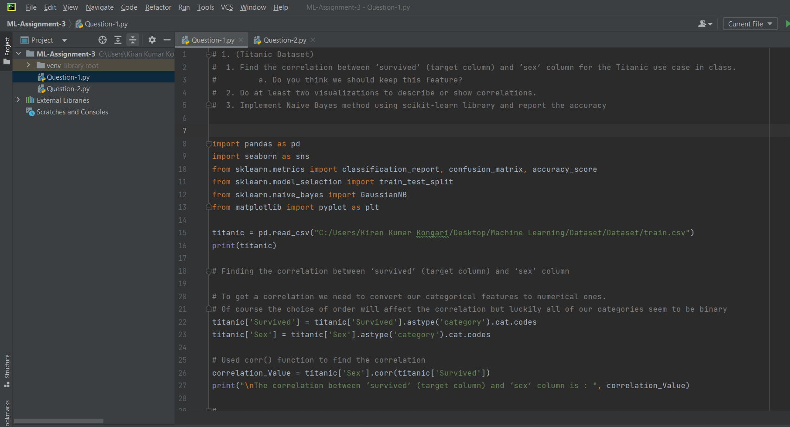

**Output:**

**Heatmap plot:**

**Histplot:**

**Scatterplot:**

**Code:**

**Output:**

**Linear Support Vector Machine on first run:**

**Linear Support Vector Machine on first run:**

**Which algorithm you got better accuracy? Can you justify why?**

On every run LinearSVC is giving different accuracy value sometimes more and sometimes less value, the reason for that is LibLinear contains a random number generator, the seed of which we do not control. So it is indeed normal. Whereas coming to Naïve bayes it is giving an accuracy of 0.3720 every time. So based on the observation unable to predict which one is better. But considering consistency Naïve bayes is better.