**Assignment-4**

**Kiran Kumar Kongari**

**700734361**

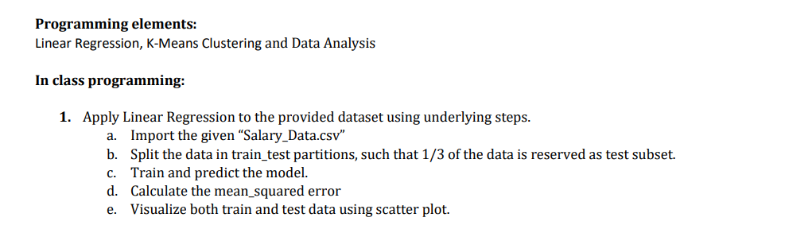

**Code:**

**Output:**

**--Plotting the Final Output i.e., the test data(red dots) and predicted data(black line)**

**Ans:**

**Code:**

**Output:**

**Code:**

**Output:**





**Code:**

**output:**

**Code:**

**Output:**

