**Assignment-5**

**Kiran Kumar Kongari**

**700734361**

**GithubLink:** https://github.com/KiranKumarKongari/MachineLearning-Assignment-5/tree/master

**Code:**

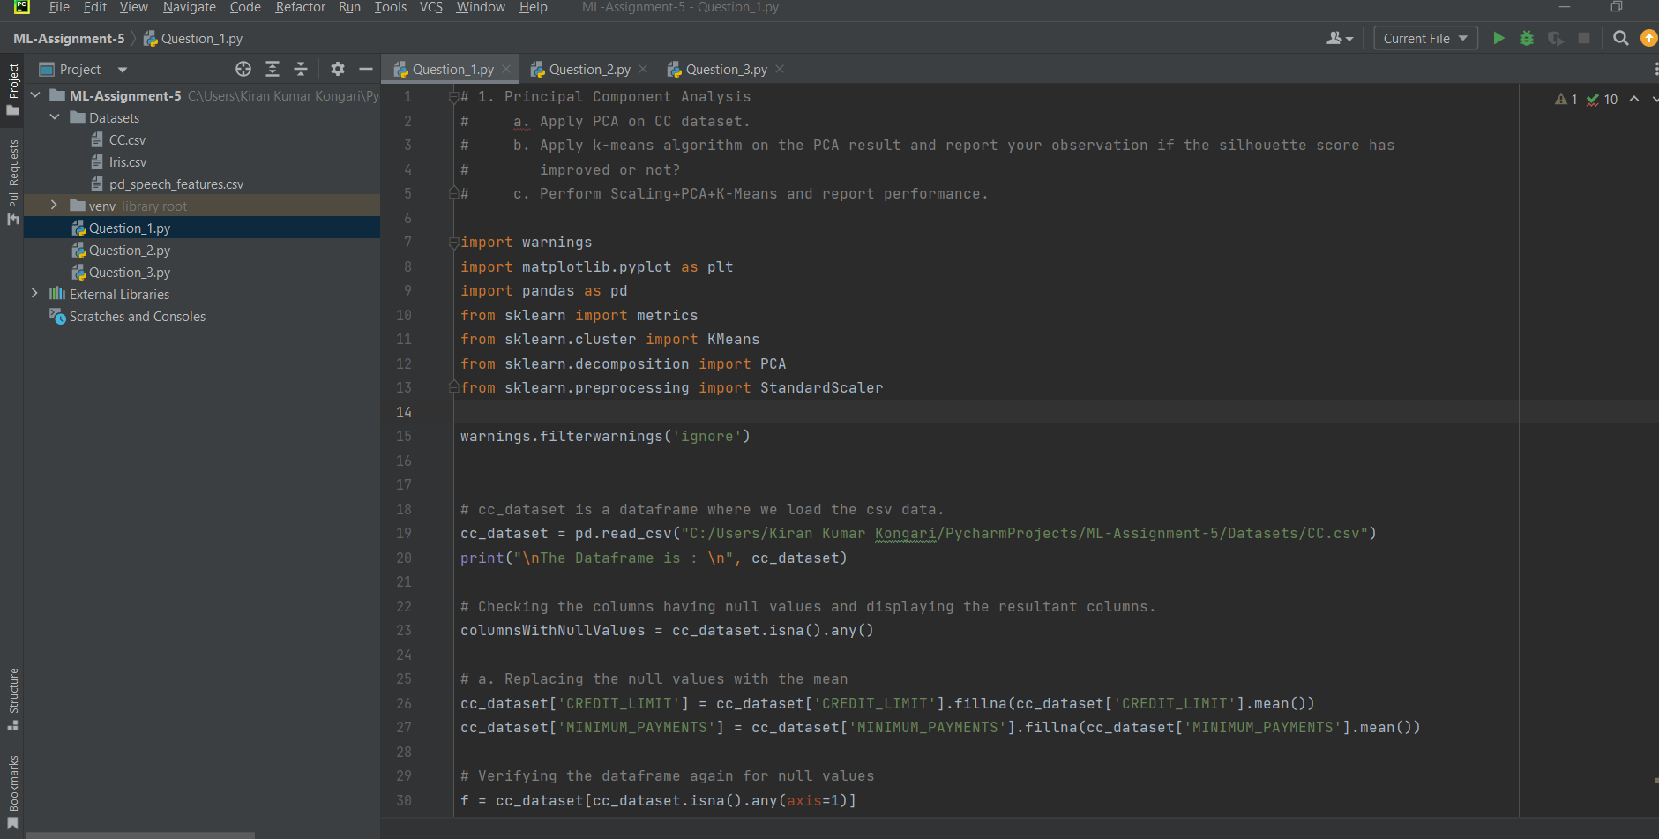

**Output:**

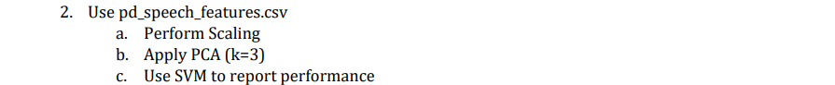

**Code:**

**Output:**

**Output:**

**4. Briefly identify the difference between PCA and LDA**

