CSC/ECE 573 Section 001

Fall 2019

PROJECT #2

Go Back N ARQ Protocol

Name 1: Sai Kiran Mayee Maddi Student ID1: 200257327
Name 2: Abhishek Arya Student ID2: 200206728

Task 1

Size of the file Transferred: 1054.08 KB ~ 1.1MB
Round Trip Time: 0.05 s
Transferred File: clientTest.txt

To maintain the host and server on two different hosts separated by router hops we configured server and client in PC and on VCL to carry out the mentioned tasks.

Traceroute (on MAC):
This can also be obtained by using traceroute 152.7.99.61 (ip address of the server) from the terminal on MAC (client machine).

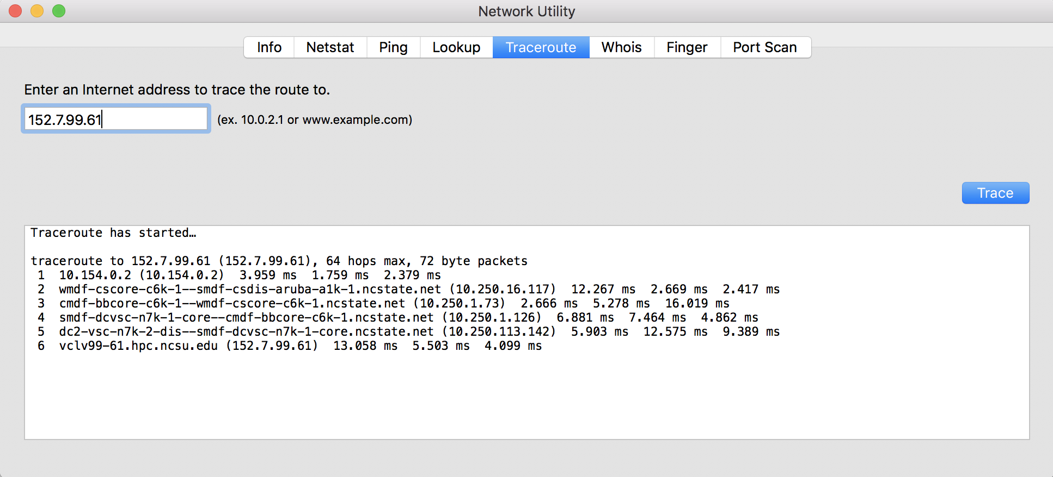

Effect of window size N

MSS (Maximum Segment Size) = 500
Packet Loss Probability = 0.05
Varying N (Window Size) from 1 to 1024

Window Size (N) | RTT 1 | RTT 2 | RTT 3 | RTT 4 | RTT 5 | Average RTT
1 | 16.1842 | 15.6213 | 16.6412 | 15.6393 | 18.1255 | 16.0215
2 | 10.2640 | 8.8366 | 9.7181 | 8.4068 | 8.2452 | 9.0941
4 | 7.9443 | 6.9156 | 6.6709 | 9.0552 | 7.8711 | 7.6914
8 | 6.5370 | 6.0025 | 5.9674 | 7.4206 | 6.8049 | 6.5465
16 | 6.5468 | 6.2572 | 5.1899 | 6.4325 | 6.1910 | 6.1235
32 | 6.3078 | 5.6934 | 4.8855 | 7.1407 | 6.3558 | 6.0766
64 | 5.7477 | 5.3603 | 5.7850 | 6.4446 | 5.8316 | 5.8338
128 | 6.0071 | 5.3327 | 5.3571 | 4.6543 | 5.2621 | 5.3226
256 | 5.7693 | 5.9578 | 5.9647 | 6.2802 | 5.8554 | 5.9655
512 | 4.9588 | 6.4834 | 4.9181 | 5.7208 | 6.0050 | 5.6172
1024 | 9.2708 | 9.6882 | 10.9735 | 10.1095 | 12.6665 | 10.5417

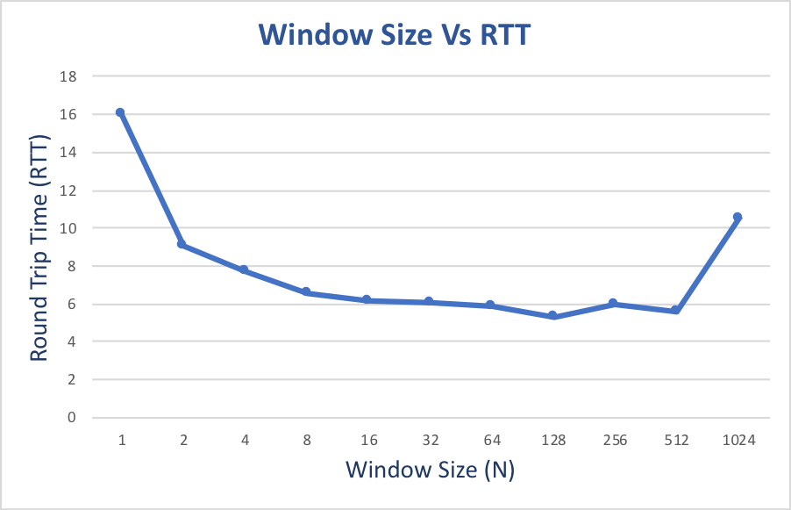

Results:

In the Go-back-N protocol, if the window size is small then the server receives packets slowly with multiple timeouts and thus clients end up in receiving the ACK’s slowly. On the other hand, with large window size if packet is lost due to timeout or ACK loss then all the packets in the non-acknowledged packets in the window are sent leads to higher transfer time (We can observe that the delay is increased for 1024). Hence, best window size should be for values of N according to our results are from N = 16 to 512.

Task 2: Effect of MSS

N (Window size) = 64
Packet Loss Probability = 0.05
Varying MSS from 100 to 1000 in the increments of 100

MSS | RTT 1 | RTT 2 | RTT 3 | RTT 4 | RTT 5 | Average RTT
100 | 27.2136 | 31.9101 | 27.4469 | 29.0039 | 29.9596 | 29.1068
200 | 15.0255 | 14.1224 | 13.7415 | 13.9182 | 14.6347 | 14.2885
300 | 9.3257 | 9.7361 | 9.1526 | 8.8970 | 9.3955 | 9.3014
400 | 6.9043 | 7.3249 | 6.0396 | 6.7818 | 7.0701 | 6.8241
500 | 5.1940 | 5.5554 | 6.0796 | 5.7933 | 5.8851 | 5.7380
600 | 5.1368 | 4.1784 | 4.3738 | 4.6282 | 4.7946 | 4.6224
700 | 4.1615 | 3.9701 | 3.9065 | 4.0882 | 3.9691 | 4.0018
800 | 3.6402 | 3.5871 | 3.7690 | 3.2722 | 3.2670 | 3.4871
900 | 3.0069 | 3.5841 | 3.0610 | 3.3839 | 4.3114 | 3.4695
1000 | 3.0624 | 3.2977 | 2.9300 | 2.5808 | 2.7409 | 3.0078

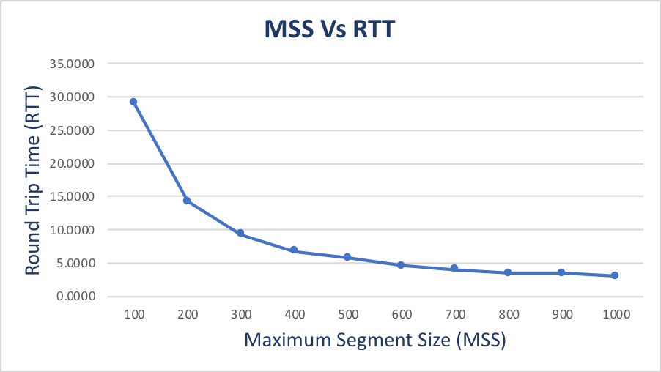

Results:
As the value of MSS increases, the average RTT decreases. This is because smaller MSS causes larger packet transfers, and hence there is a possibility of a greater number of packet losses and greater number of retransmissions. Larger MSS value leads to lesser number of retransmissions, hence the average delay decreases exponentially

Task 3: Effect of Loss Probability p

MSS = 500
N =64
Varying P value from 0.01 to 0.10 in the increments of 0.1

Loss Probability (p) | RTT 1 | RTT 2 | RTT 3 | RTT 4 | RTT 5 | Average RTT
0.01 | 1.5184 | 1.2551 | 1.1660 | 1.4379 | 1.3211 | 1.3397
0.02 | 2.3925 | 2.0956 | 3.0150 | 2.4306 | 2.7236 | 2.5315
0.03 | 3.3558 | 3.2729 | 4.2375 | 3.3841 | 2.7388 | 3.3978
0.04 | 4.1847 | 3.8 | 3.9397 | 4.2106 | 4.5198 | 4.1241
0.05 | 5.7138 | 6.0327 | 5.5329 | 6.4402 | 5.7495 | 5.8938
0.06 | 5.9754 | 7.4925 | 6.0843 | 7.2817 | 5.4980 | 6.4664
0.07 | 8.5281 | 8.7687 | 7.8264 | 7.8949 | 7.6004 | 8.1237
0.08 | 10.2173 | 9.5208 | 8.5186 | 9.0326 | 9.8260 | 9.4231
0.09 | 11.2877 | 10.9182 | 11.2696 | 11.1203 | 9.7719 | 10.8735
0.1 | 12.0171 | 11.8726 | 12.2751 | 11.3312 | 11.2897 | 11.7571

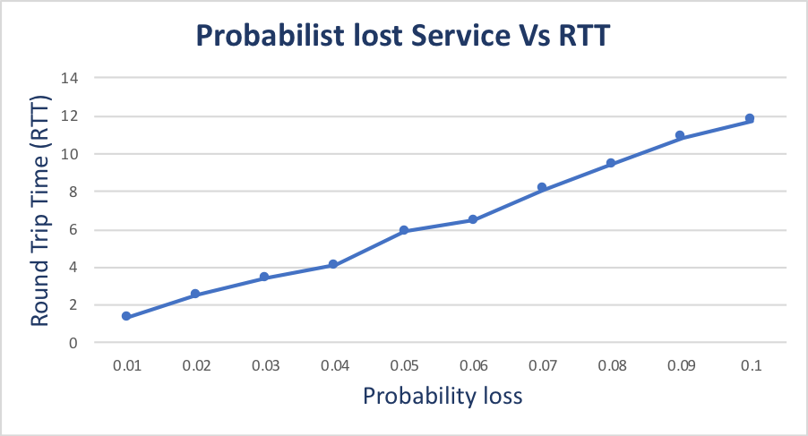

Results:
We can say that as the probability loss increases the average RTT also increases which is the indication that as the probability increases there is a packet loss, retransmission takes place and hence the average delay increases.

