Name: Kiran Pacharne
Roll Number: 33325

Step 1) Login to Your GitHub Account

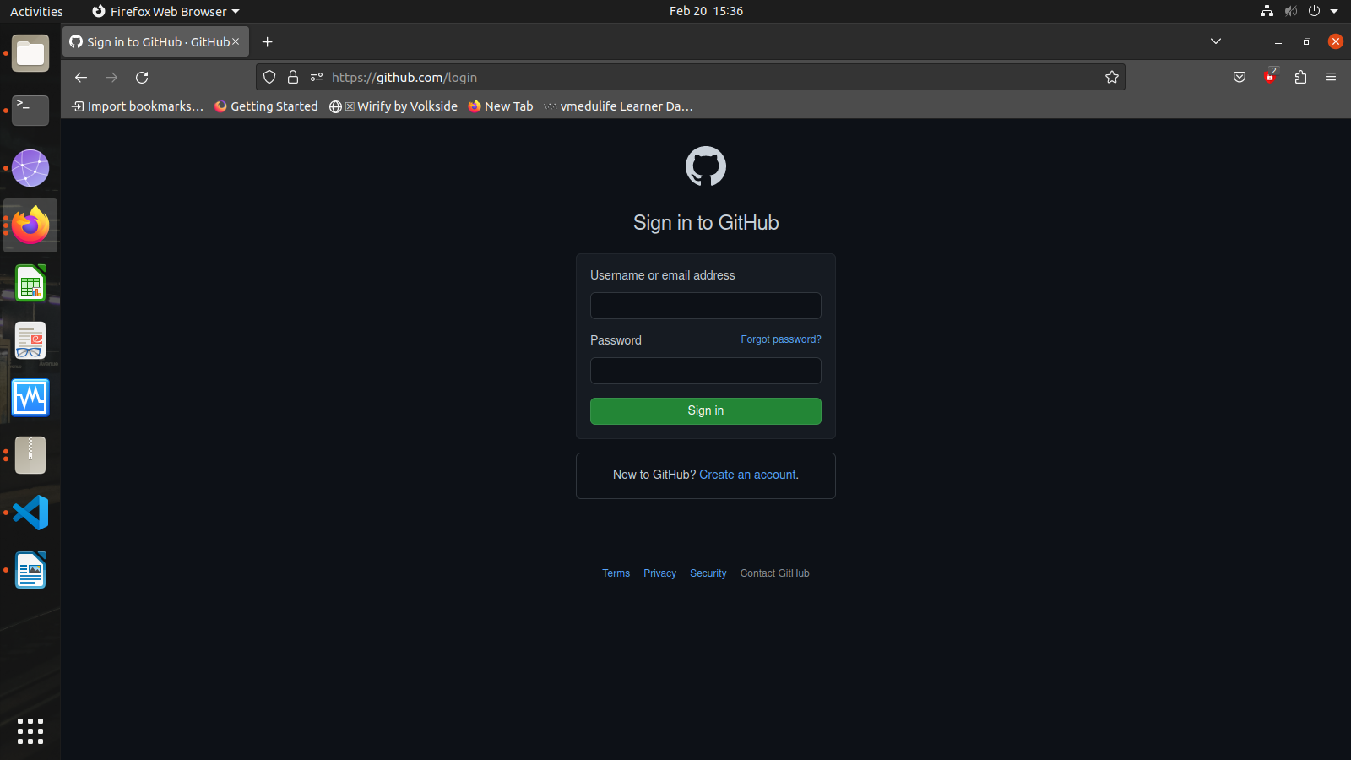

Step 2) Create a new repository. And set she repository on Private(so that only you can decide who can commit)

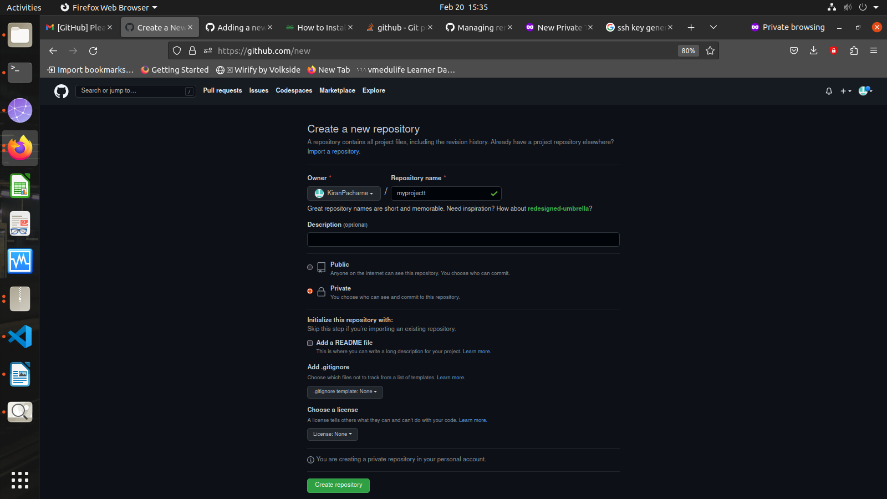

step 3) open the vs code folder that you have to push on to the git repository

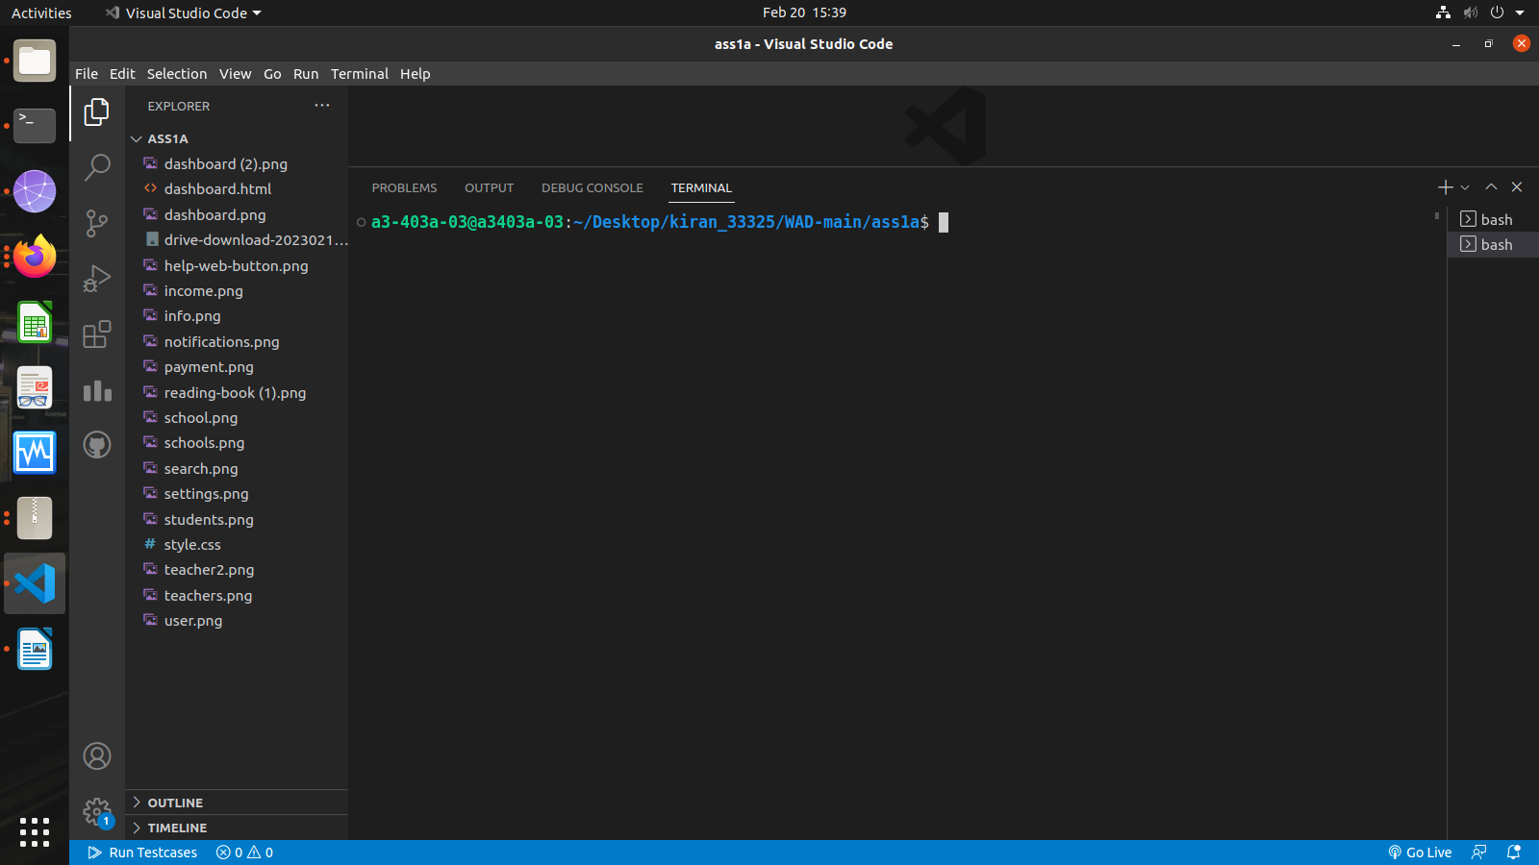

step 4) Then open the new terminal and give the following commands:
- git init
- git add .
- Git commit -m”first commit”
- git remote add origin https://github.com/KiranPacharne/myprojects.git
- git push -u origin master
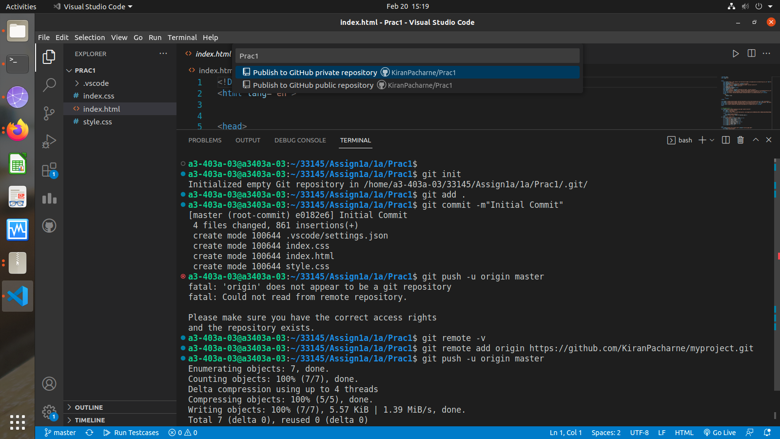
- After this we have successfully created a git hub repository and pushed a folder.

