**DenseNet**

**DenseNet connects each layer to every other layer in a feed-forward manner.**

**Why is connectivity?**

As networks grow deeper, maintaining effective information and gradient flow becomes a challenge. Various architectures, including ResNets, Highway Networks, and Stochastic Depth, have been developed to create shorter paths between layers, ensuring better optimization and training of deeper models.

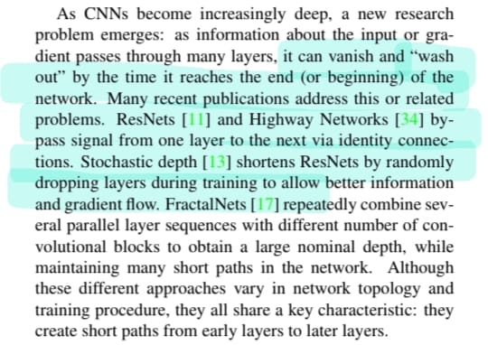

Then why DenseNet?

* Improved Information Flow
* Feature Reuse: By concatenating features, DenseNet allows reuse of features across layers.
* Regularization Effect
* DenseNet outperforming ResNet on datasets like CIFAR-10, CIFAR-100, SVHN, and ImageNet

What make DensNet different?

DenseNet focuses on feature reuse, leading to more compact and efficient models without the need for excessive parameter growth.

**composite function**

* Batch Normalization
* Rectified Linear Unit (ReLU)
* Convolution (3 × 3 Conv)

DenseNet layers combine these steps into a composite function, which processes and passes information forward efficiently

**Bottleneck Layers**:

Introduce 1×1 convolutions to reduce the number of input feature maps, improving efficiency.

**Compression**

Compression involves using a **compression factor** θ, where 0<θ≤1

if a dense block contains m feature maps, the transition layer generates θ×m times m output feature maps.

**DenseNet-BC**: Combines bottleneck layers and compression (reducing feature maps in transition layers) for even more compact models.

**Growth rate** determines how many feature maps each layer produces.

the total input feature maps are calculated as: k0+k×(l−1)

**Implementation Details**

* models consist of **three dense blocks** (except for **ImageNet**), each having an equal number of layers.
* Before the first dense block, an initial convolution layer with 16 output channels is applied to input images.
* Each side of the input to convolutional layers is **zero-padded by 1 pixel** to maintain feature-map size.
* dense blocks use **1×1 convolutions**, followed by **2×2 average pooling** for down-sampling.

**ImageNet Experiments**:

* DenseNet-BC structure includes **four dense blocks** for 224×224 input images.

Accuracy

On SVHN, DenseNet (L=100,k = 24) surpasses Wide ResNet, but deeper models (L=250) do not show significant improvements due to potential overfitting on simpler tasks.

Without compression or bottleneck layers, there is a general trend that DenseNets perform better as L and k increase

For CIFAR-10+:

* Error drops from **5.24%** (1.0M parameters) to **3.74%** (27.2M parameters).

**Parameter Efficiency:**

DenseNet-BC models are highly **parameter-efficient**:

Example: A 250-layer DenseNet-BC (15.3M parameters) **outperforms models** like FractalNets and Wide ResNets, which exceed **30M parameters**.

**Overfitting:**

DenseNets are **less prone to overfitting** due to efficient parameter utilization

Without data augmentation:

* On C10, error reduces by **29%** (from 7.33% to 5.19%).
* On C100, error reduces by **30%** (from 28.20% to 19.64%).

Overfitting is rare but observed in a single scenario, where increasing kk from 12 to 24 resulted in a slight increase in error.

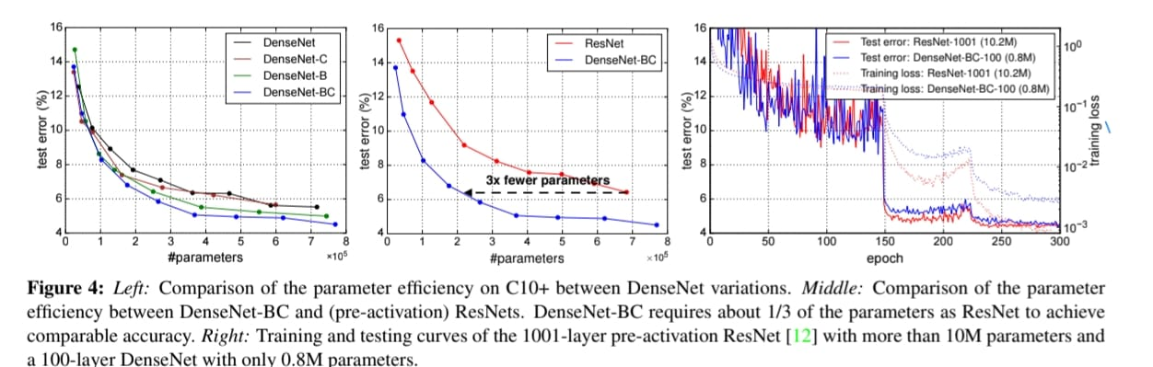

**Model Compactness**

**Parameter Efficiency**:

* **DenseNet-BC** emerges as the most parameter-efficient variant of DenseNet.
* DenseNet-BC achieves **comparable accuracy to ResNets** while requiring only about **1/3 of the parameters**. For example:
  + A DenseNet-BC with **0.8 million trainable parameters** matches the performance of a **1001-layer ResNet** with **10.2 million parameters**.
* Compared to popular architectures like **AlexNet** and **VGG-net**, pre-activation ResNets typically achieve better results using fewer parameters. However, DenseNet-BC is even more efficient than ResNets, making it highly competitive.

**Feature Reuse**:

* DenseNet's dense connectivity allows feature maps learned by any layer to be accessed by all subsequent layers. This results in better **feature reuse** and significantly improves model compactness.
* **Feature Sharing Across Layers**: Layers actively use features extracted by earlier layers within the same dense block, promoting widespread feature reuse.
* **Smooth Information Flow**: Transition layers distribute their weights across all preceding layers in the dense block, ensuring seamless information flow from start to end.
* **Redundancy in Transition Layers**: Outputs of transition layers are often assigned lower weights by subsequent layers, indicating some redundancy. This supports the effectiveness of compression in DenseNet-BC.
* **Focus on High-Level Features**: The final classification layer utilizes features from the entire network but gives more weight to features produced in later layers, indicating that high-level abstractions are formed towards the end.

**Implicit Deep Supervision**

* DenseNets implicitly provide deep supervision to individual layers through dense connections, which ensure all layers receive direct input from the loss function and gradient signals.
* This is similar to Deeply Supervised Nets (DSN), where classifiers are explicitly attached to each hidden layer to enforce discriminative feature learning.