LeNet-Paper

Why not fully connected Layers? And disadvantage of FCN.

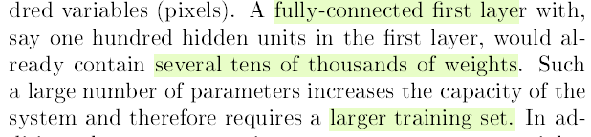

Another disadvantage of FCN.

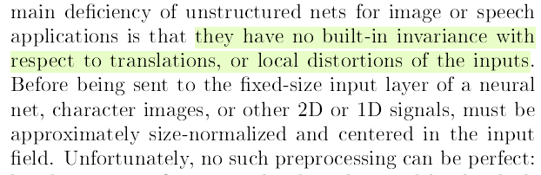

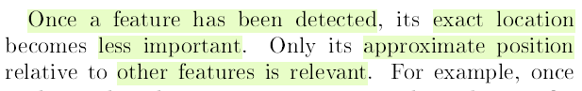

Handwritten texts are diff in size, shape, position of characters etc.

What does the initial layers of CNN do?

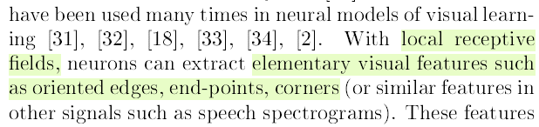

Usefulness of this approach.

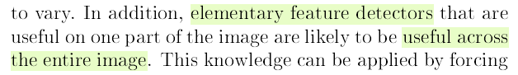

What is receptive field?

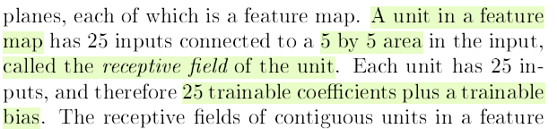

What is kernel?

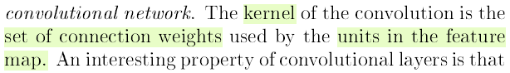

What are pooling layers?(Pooling layers are a type of sub samplers)

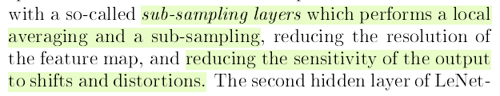

Architecture of LeNet-5 and preprocessing steps…..

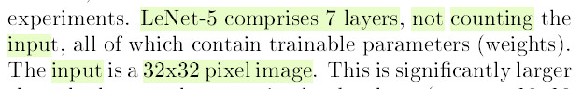

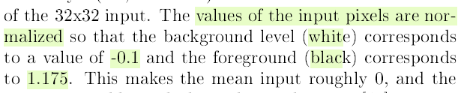

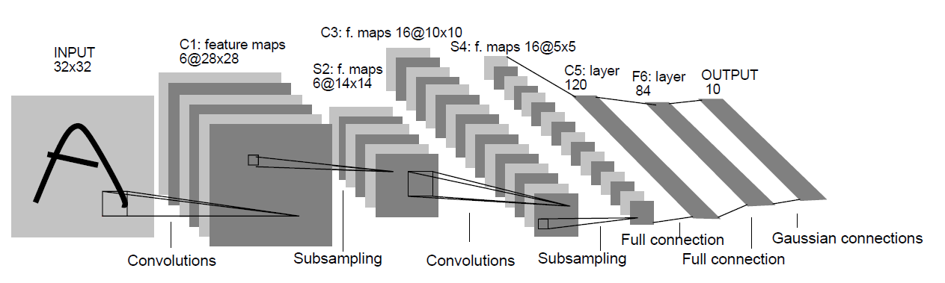

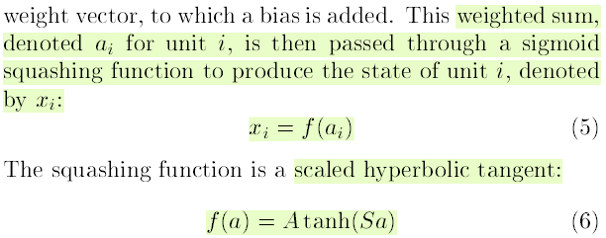

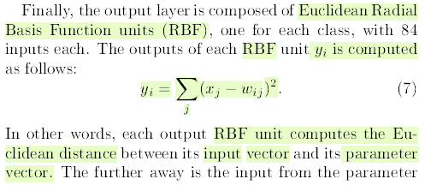

|  |  |  |
| --- | --- | --- |
| **C1** | Convolution (6 filters) | Tanh |

|  |  |  |
| --- | --- | --- |
| **S2** | Subsampling (Pooling) | No activation (average pooling) |

|  |  |  |
| --- | --- | --- |
| **C3** | Convolution (16 filters) | Tanh |

|  |  |  |
| --- | --- | --- |
| **S4** | Subsampling (Pooling) | No activation (average pooling) |

|  |  |  |
| --- | --- | --- |
| **C5** | Fully Connected Conv | Tanh |

|  |  |  |
| --- | --- | --- |
| **F6** | Fully Connected (84) | Tanh |

|  |  |  |
| --- | --- | --- |
| **Output** | Fully Connected (10) | Sigmoid or Softmax |

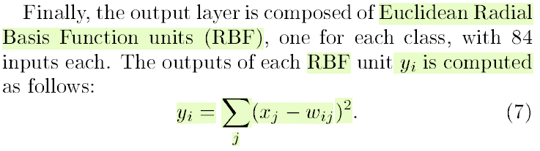

Training dataset is MNIST dataset

70,000 training examples

10,000 test examples (written by different set of writer)

Results

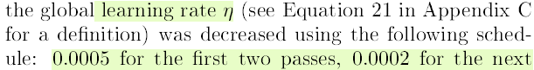

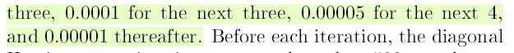

Overfitting

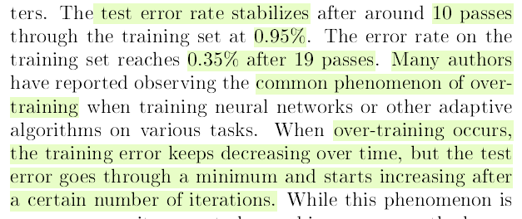

82 Mis-Classifications some can also be recognized by humans so further improvements are to be expected

