

**Uno Morse Conversie**



**PROBLEM STATEMENT**



**Objectives**

🠶 Making job of Secret agents like RAW, CBI, SPYs easier

🠶 Conversion of secretly transmitted Morse signal into Audio signal within seconds

🠶 Transmission of secret signal with just one button

🠶 Any alphabet, any symbol, any number can be transmitted by just one button

**Proposed Methodology**



Can be divided into 3 parts:

🠶 Taking input from user, converting into csv

🠶 Conversion of this csv into text using Machine Learning concept i.e., Kmeans clustering

🠶 Converting this text into Audio using gTTs library



**Architectural Diagrams**

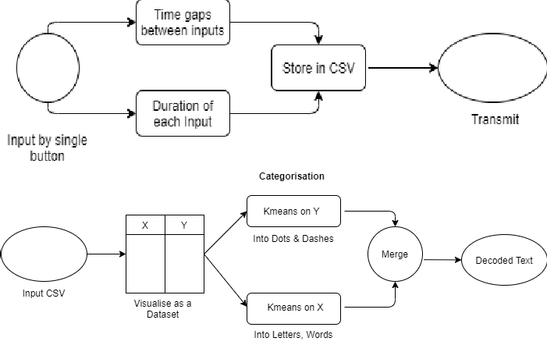🠶 Input Mechanism:

🠶 Conversion mechanism:



**Results**

🠶 Input is converted into csv, then categorised using ML

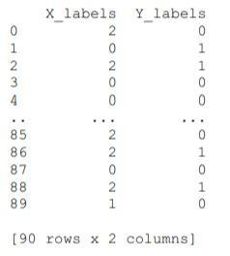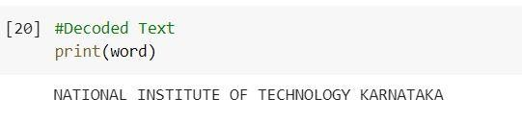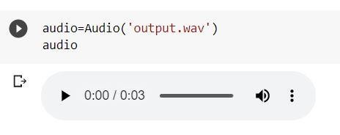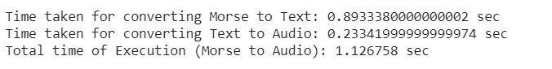

in this way:

🠶 Categorised data is converted into text:

🠶 Text is converted into Audio:

🠶 Time of Execution: