In order to run our Branch Predictor code on the provide virtual environment, Sun Java 1.8 is needed. The VM currently has OpenJDK and code will not run on this due to compatibility issues of version.

Follow the below **3-steps** to install Sun Java on VM provided. The JDK will be downloaded from remote repository and run automatically on VM, no intervention is required.

(I have followed steps from here src: <http://tecadmin.net/install-oracle-java-8-jdk-8-ubuntu-via-ppa/#>)

1. Run this command anywhere from home directory: when prompted for sudo password I used UCRiverside. Hit Enter to accept agreement.

$ **sudo add-apt-repository ppa:webupd8team/java**



1. Run : **$ sudo apt-get update**

This will start downloading few files from remote repo- Takes few min: Especially at 100% we need to wait few min for the update to happen(see screenshot below)

In the end it will display below error msg- Ignore.

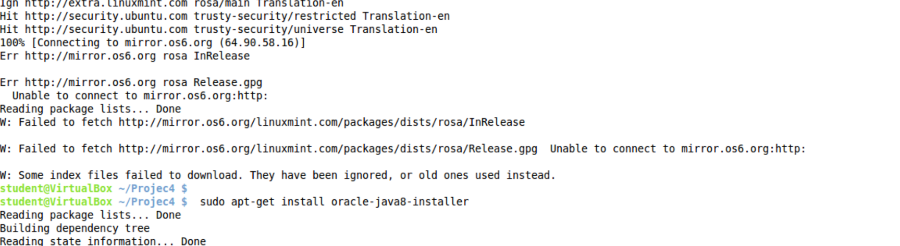

1. Run cmd : **$ sudo apt-get install oracle-java8-installer**

**Press OK and YES when Blue screen comes.**

See above screenshot upon successful completion.

If Install is successful-Run CMD: **$ java -version**

Output should be this:

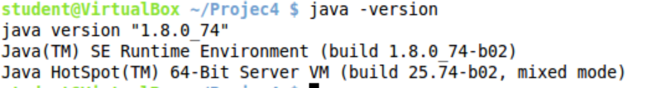

**Now you can run the Branch Predictor code. Copy the BranchPredictorv2.jar java file, config.properties and sample trace file in the same directory.**

**To run the code, > java -jar BranchPredictorv2.jar**

**If you want to use different trace file, copy new trace file into same directory and change in config.properties the name of the trace file.**