1. Open SSMS

Go to Database which you need to be imported as VS project. Right click on the specific db and go to task then navigate to 'Generate Scripts ....

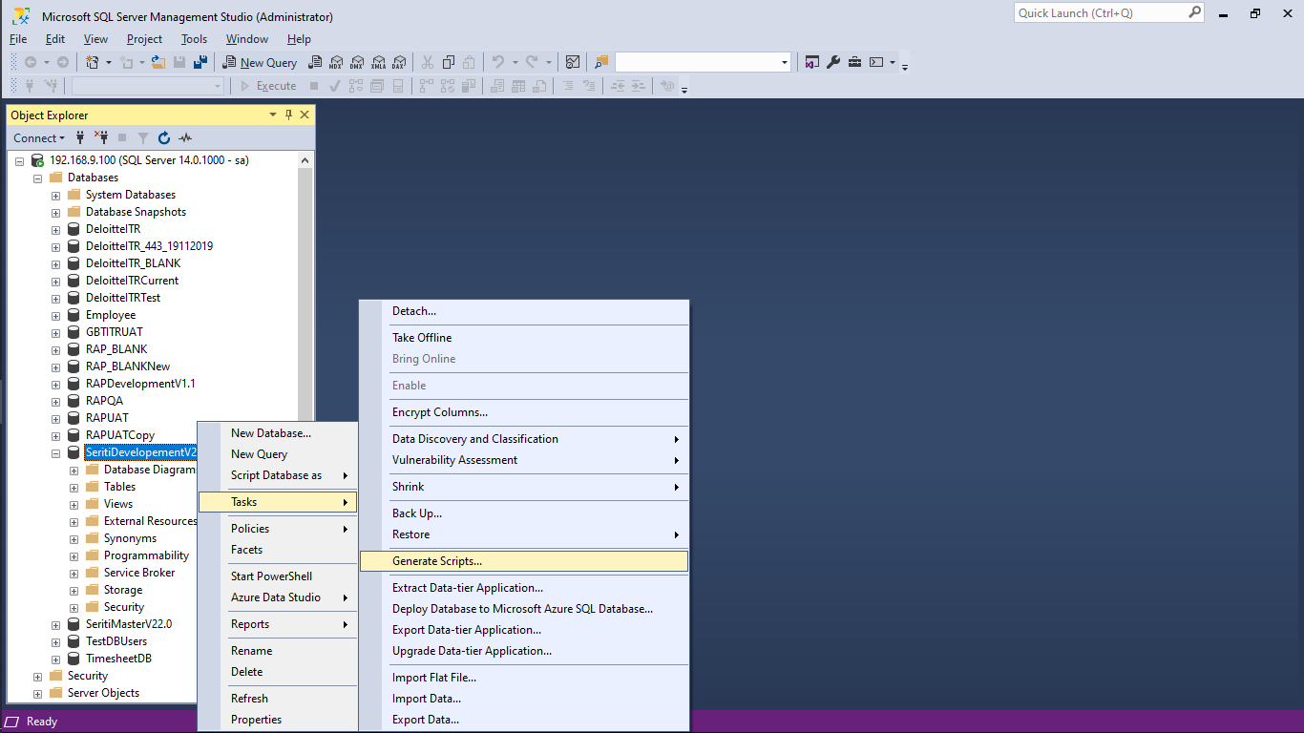

1. Then in Generete Script window click on next then Select first Option 'Script entire database and all database' and click on next. 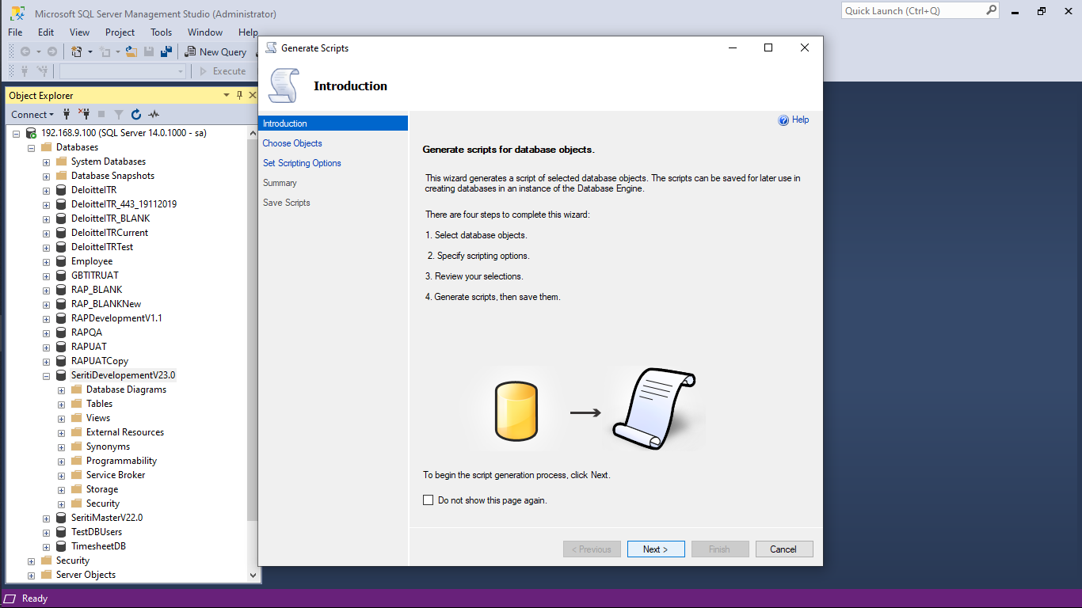
2. {if database is too large in that you can create multiple Scripts by choosing second option 'Select specific objects' repete this process till you cover all tables and other files}

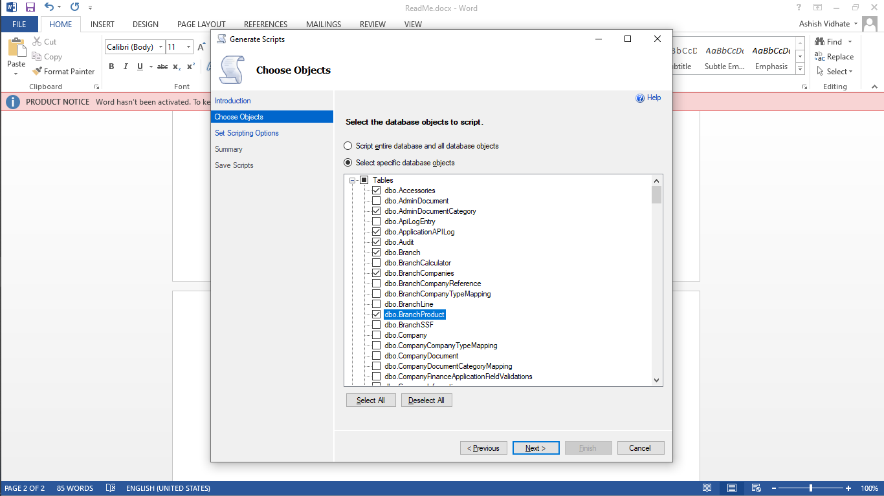

1. Select the Script name if you’re making multiple Script for Large database.

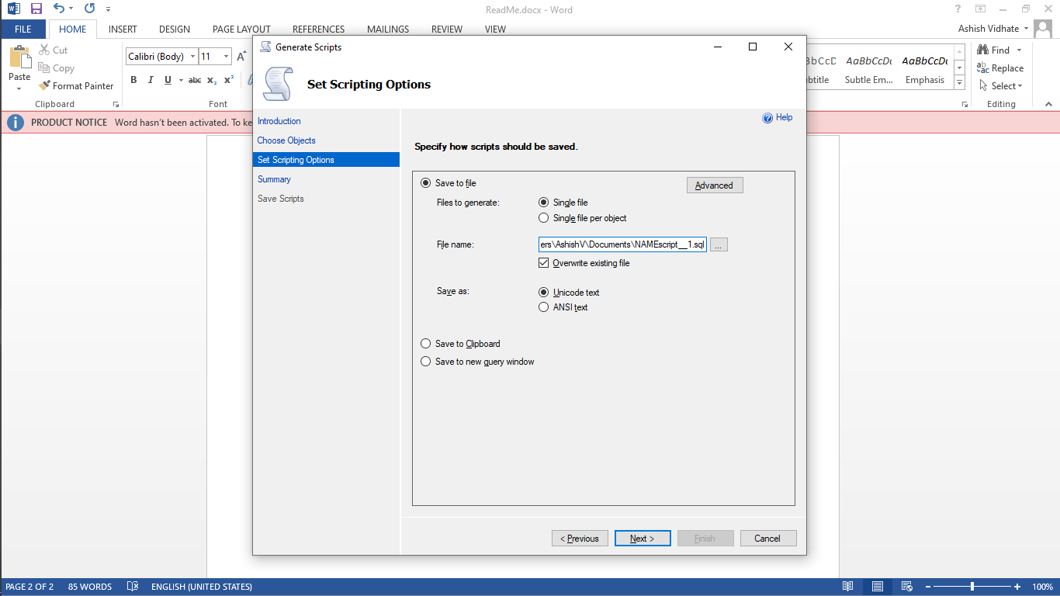

Select the Advance Option for Coping Data with schema.

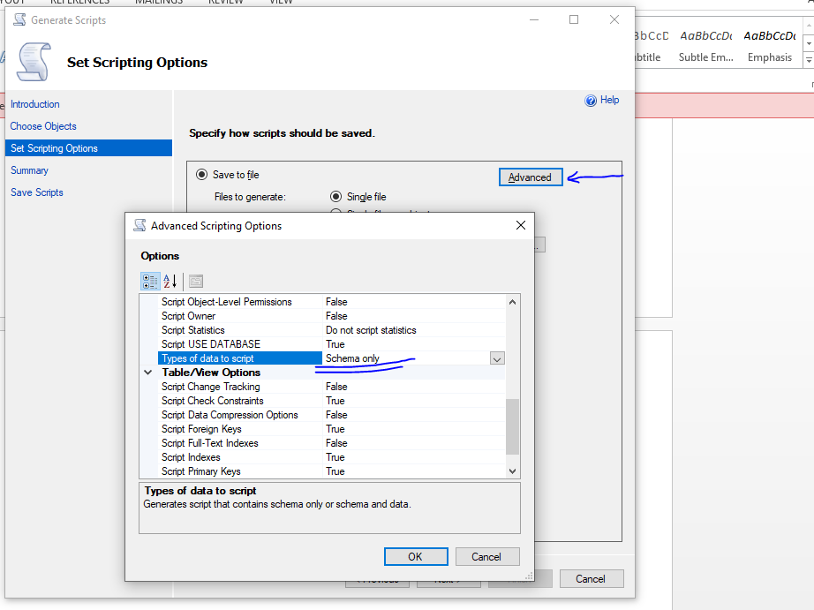

Select the other option of data and Schema

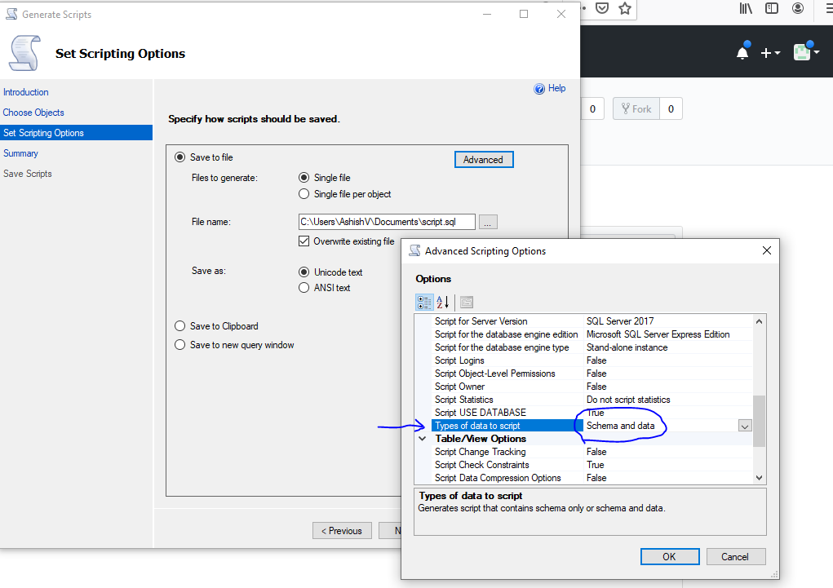

Always keep Login Option false for every script or it’ll be gives error in Visual Studio

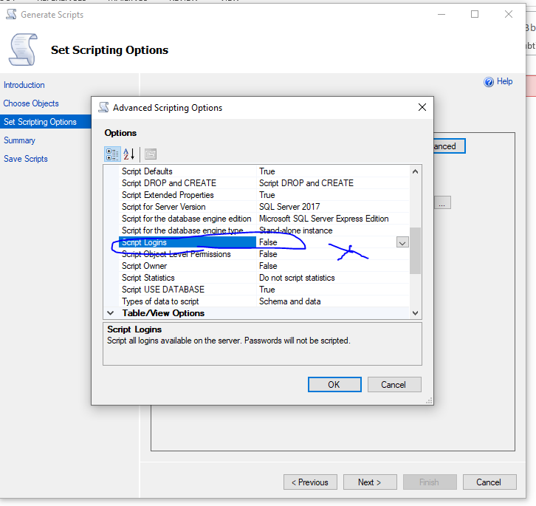

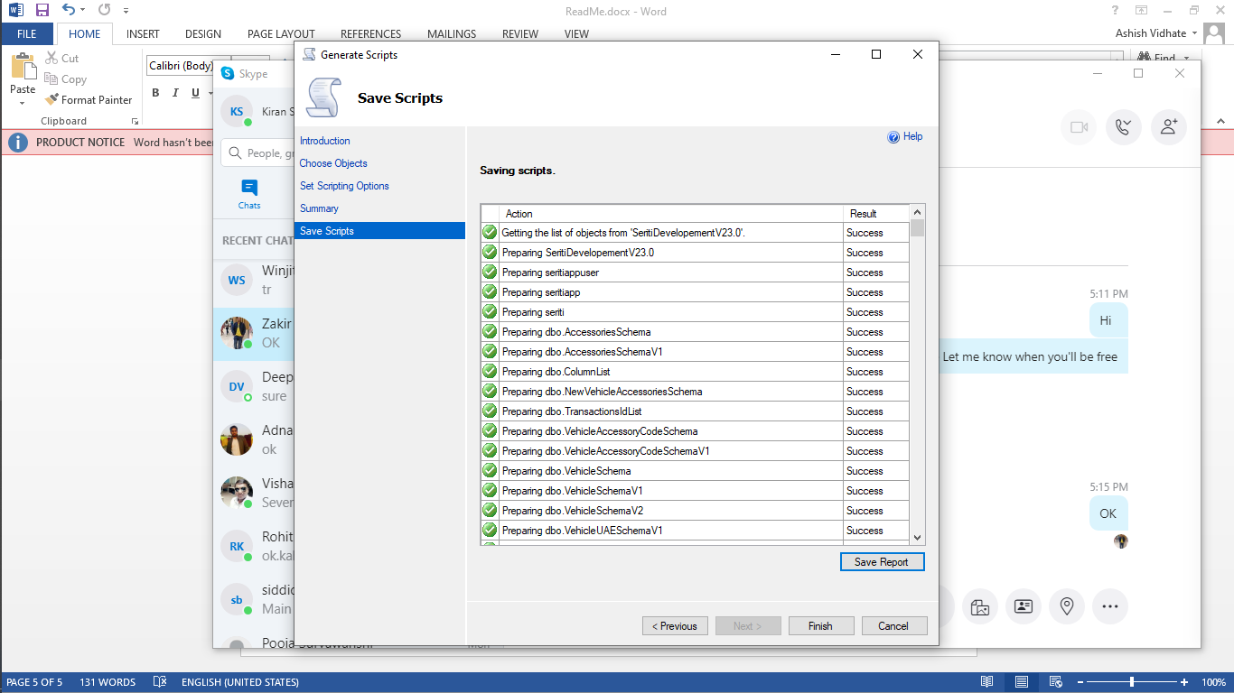

1. GO to Visual Studio Select Database project

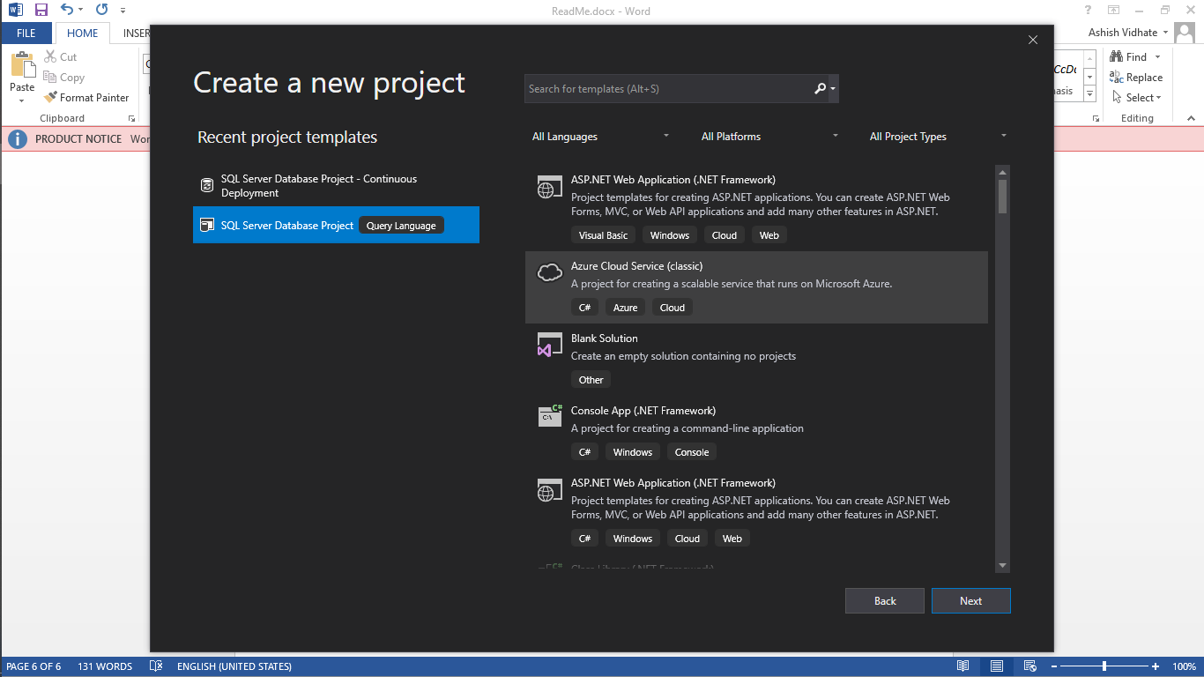

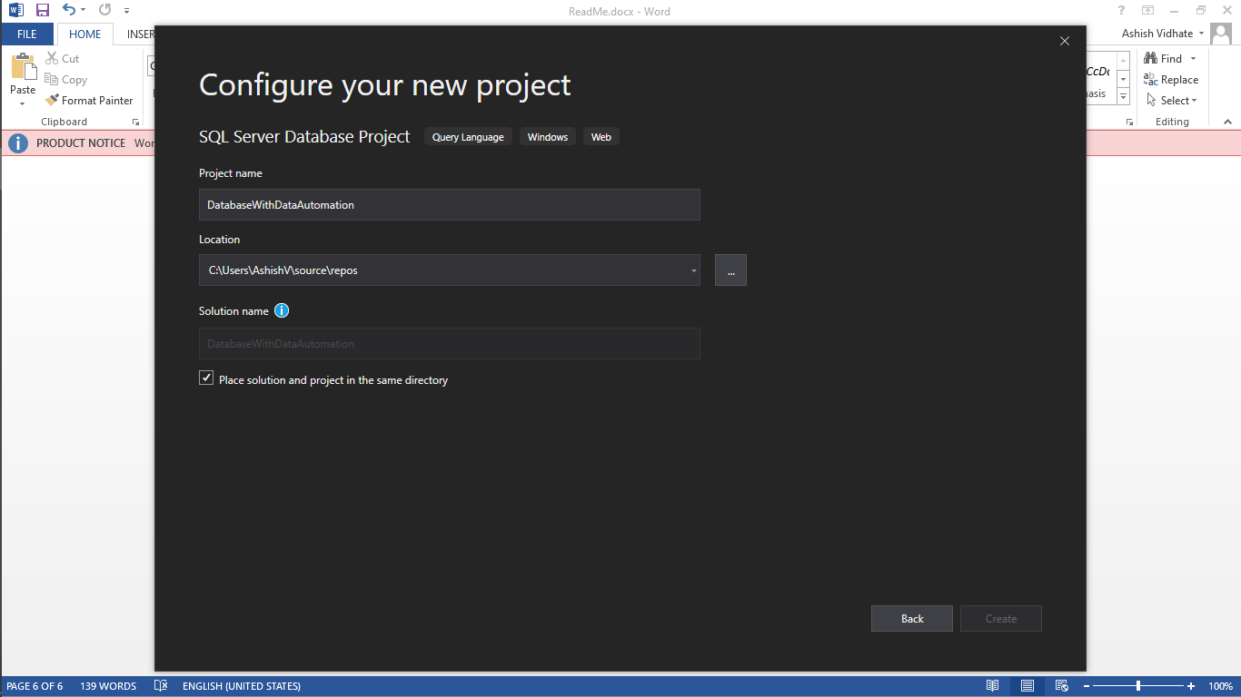

Importing Database using Script we generated (\*.sql)

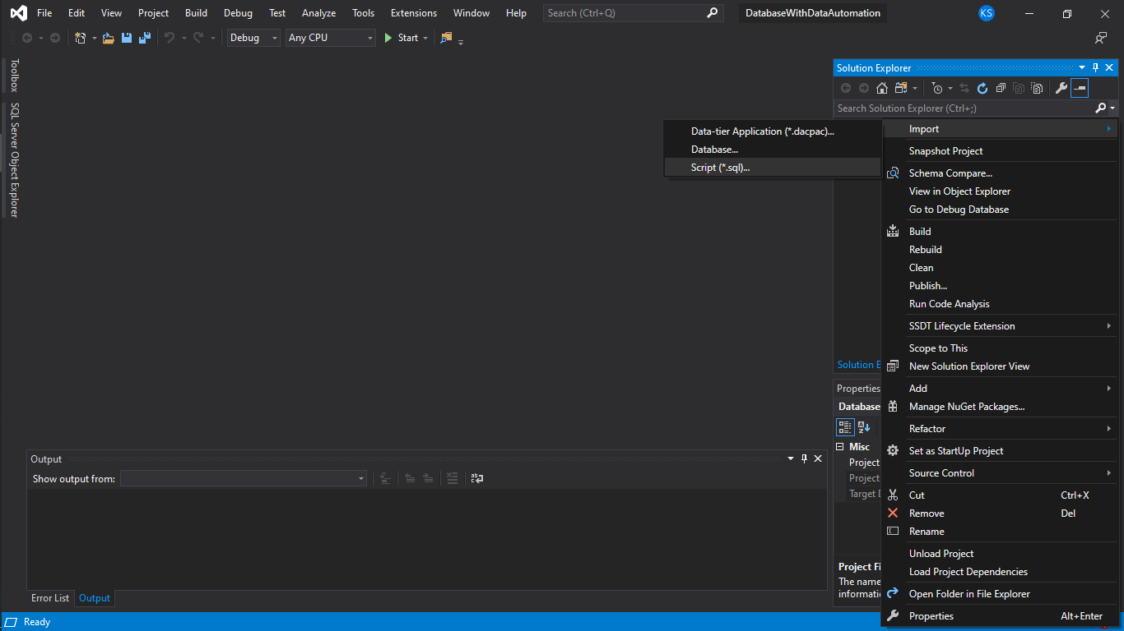

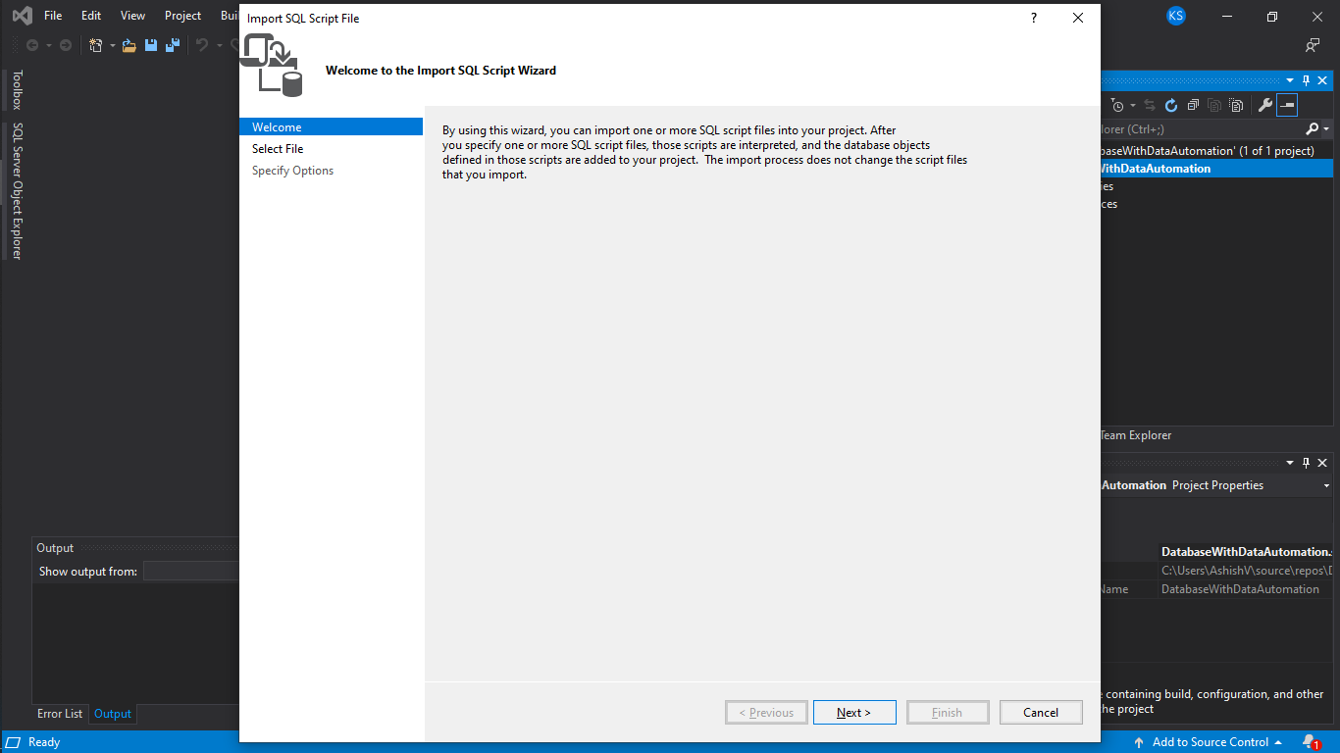

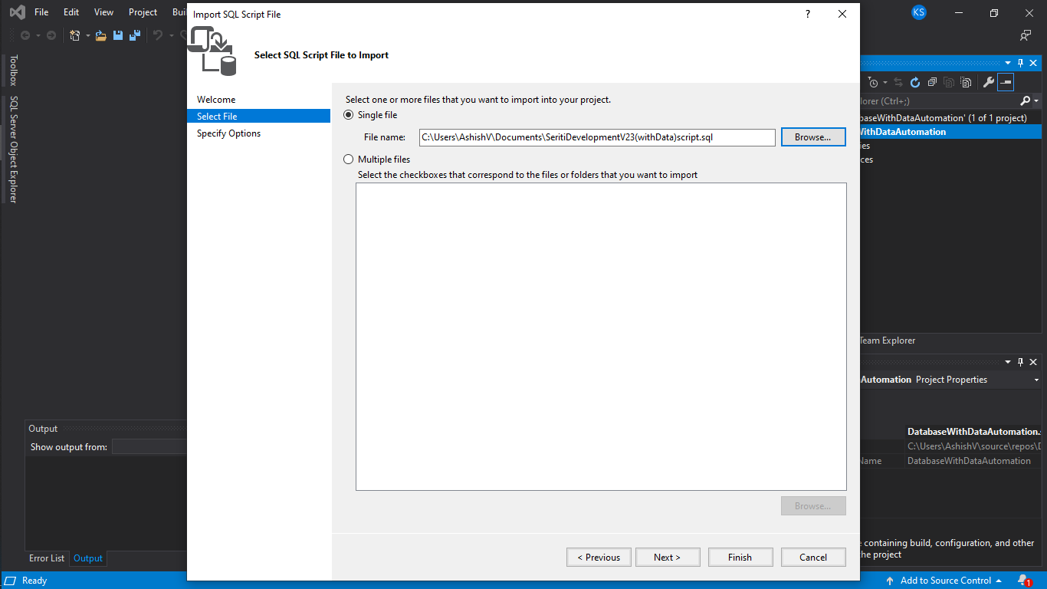

Since there is No Data and Schema Option in the Visual Studio we cannot migrate Data though it is in the script.

