* After rejoining the LUN to the RAID with below command. We were able to list the VG and observed that its partially activated in the attribute.  
mdadm --manage /dev/md0 --add /dev/dm-8

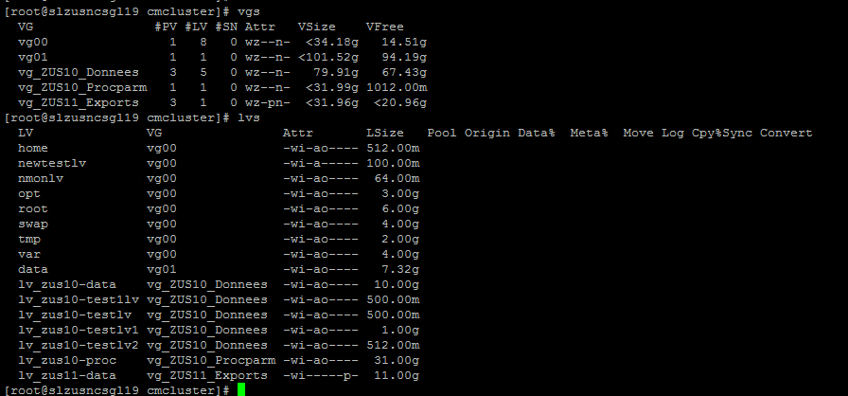

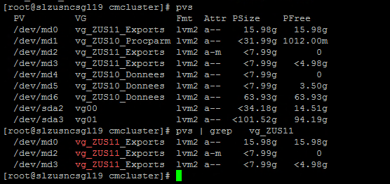

Command to restore the VG  
#vgextend --restoremissing vg_ZUS11_Exports /dev/md2

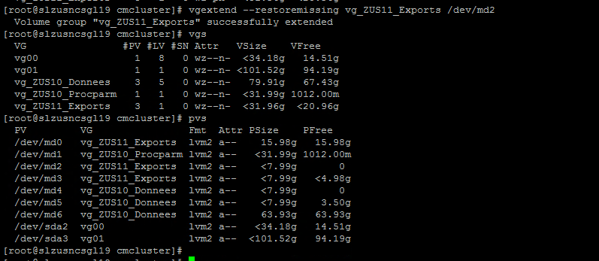

After starting package we were found the blow error in package log.  
it says NFS client is not resolving while exporting.

“Feb 11 14:46:18 - Node "slzusncsgl19.sres.stech": Exporting filesystem on /data/ZUS11/Donnees/NFS

exportfs: Failed to resolve slmusfloflo4.sres.stech”

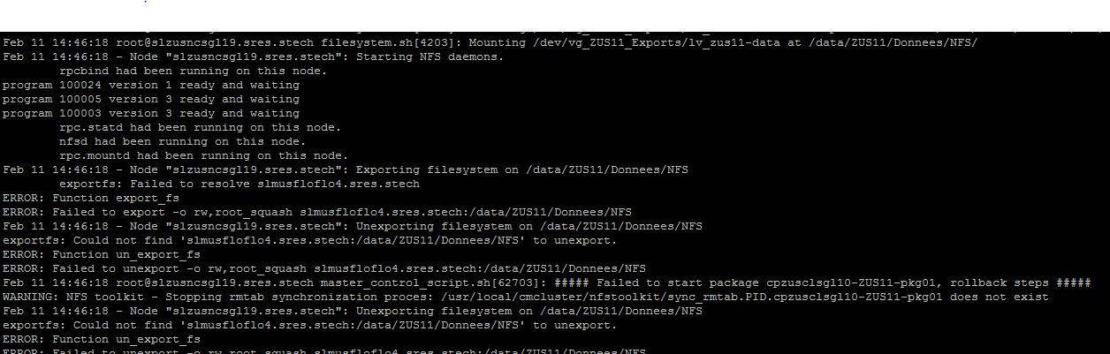

We tried commenting the NFS export entry and checkconf but we got error saying NFS export is missing.  
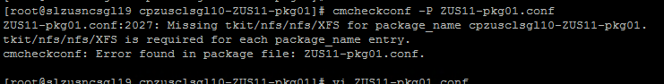

Since the NFS not resolving from the cluster as a workaround we added second node as NFS client.  


Package were started successfully.

