Kiran zafar BSCS-2019-36

Pakistan aisa q he?
Abstract:
This report analyzes data generated by gap minder to know the cause behind the current state of Pakistan. It highlights the factors due to which Pakistan is lagging in international race. Tax revenue, female participation, poverty, GDP per capita and absence of real democracy are some factors due to which Pakistan is still underdeveloped country. Democracy remains an illusion for many due to “the lack of proper, meaningful and non-discriminatory representation for all regions in decision-making.” The absence of democracy and lack of political development in Pakistan are responsible for this state of Pakistan.
Purpose statement:
This report highlights the reason behind the current situation of Pakistan.
Problem statement:
It has been 71 years Pakistan is an independent country. Two years after its independence china appeared. If we compare human development report china is ranked at 85th while Pakistan is at 147th place out of 189 countries. Despite of having world’s one third population China fought poverty, unemployment and reached to this point. Moreover, India who got independence with us is also at 129th position and many more other countries. What are the reasons due to which Pakistan is behind of the countries that got independent later than us and have much more serious problems.
Following are points that describes why Pakistan is the way it is
- Tax revenue
Tax revenue is the income that is gained by governments through taxation. Pakistan reached highest tax revenue in year 1995.And after that it suddenly decreased until it got stabled in year 2000. What happened during these 5 years The reason behind this is political instability as it can be seen in democracy score graph at the time 1995 Pakistan democracy score was at its peak and stabled since 1988 but due to political unrest it instantly reduced to negative 6. This was the time when Pervaiz Musharraf demolished Nawaz government and imposed martial law. This was a great setback to economy which leads poor tax revenue. Since then it is decreasing day by day.
China is an emerging country and is near to become super power. However, it can be seen there is a large difference in tax revenue of Pakistan and china up till 2000. In 2008, revenue seems to be same for both country and after that china is going uphill while Pakistan’s graph is declining. Why is this so? Despite having large number of tax revenue as compared to china Pakistan is still underdeveloped and china is going to be next super power. The reason behind this, is corruption and Pakistan did not use tax for the purpose it was collected. Taxation department is plagued by corruption and it is big reason behind declining graph as well as collected tax is not spent on what it is meant for. While china used it little tax revenue for development and now it has beaten Pakistan.
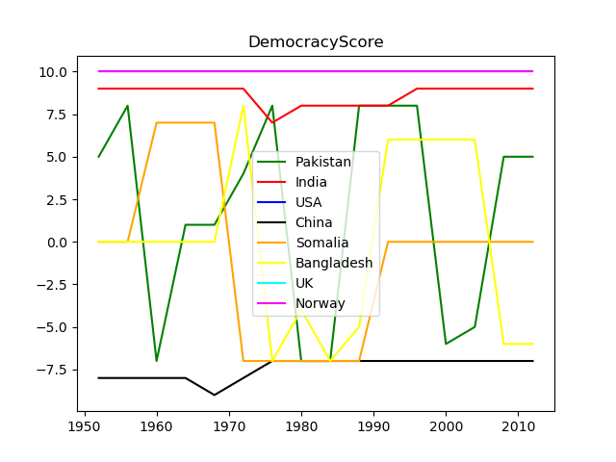
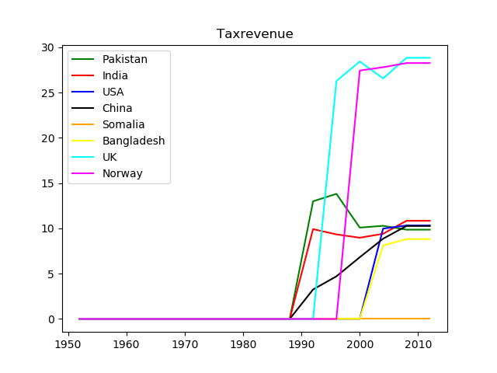

- Female participation:
Pakistan spends only 2.6 percent of total GDP on education, which is the lowest in South Asia. In 1997, it was 3 percent, the highest in the country’s history. As a consequence of this low expenditure overall, more than half of the country’s population is uneducated. And hundreds of thousands of poor children are out of school.
First world countries like USA, UK, Norway have equal ratio of girls to boys primary education and china is at top since 2008 and this is the reason that women labor force participation in their countries is also large. For a powerful economy both men and women should have equal participation. In Pakistan, usually there is a single earning person and rest of family depends on him. Since Pakistani women are kept illiterate so they are unable to earn. This inequality leads to lower participation of women in labor force. Women schooling is not appreciated by our society and this concept must be changed. In China their women work like men and hold half of the economy. If we want Pakistan to be prosperous as other countries women must participate in economy and this can be only achieved by making women literate.

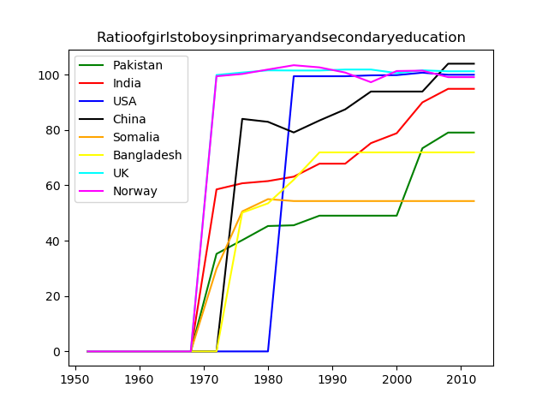
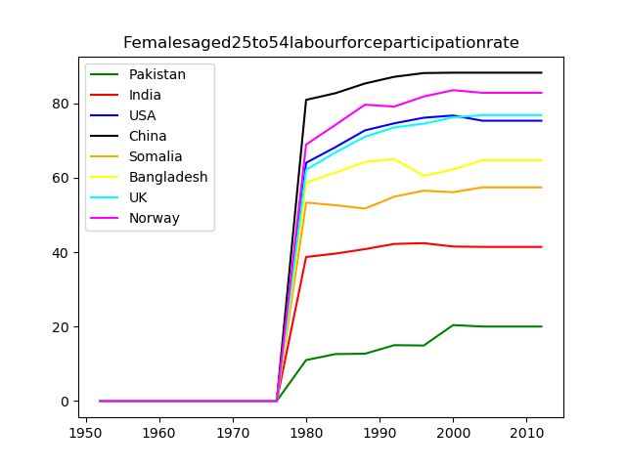
- poverty
Another reason of lag of Pakistan is poverty. Almost half of its population is below international line of poverty. There is two and half lac debt per head of population and this is due to very low income per person. As it can be seen in graph china decreased its poverty by increasing income per person. Average annual income of Pakistan is 100,768.49PKR whereas Norway average annual income is 2,070,047.48PKR that is why there is no poverty in Norway.
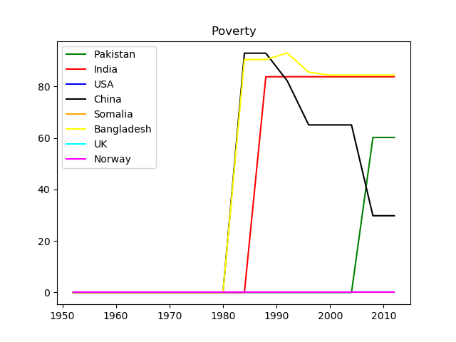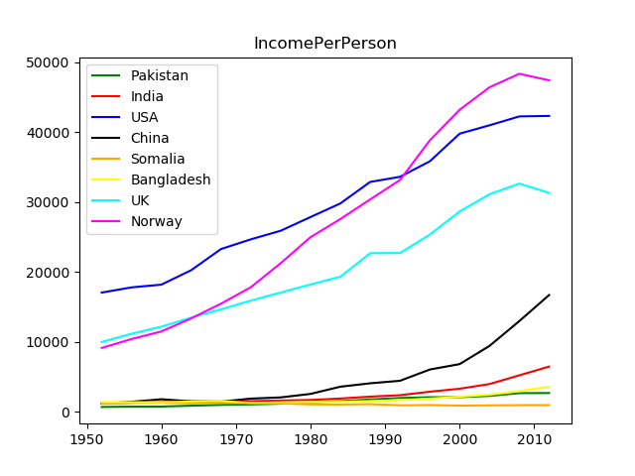
- GDP per capita:
Pakistan is an agricultural country. It has more agricultural land than Norway but in GDP graph Norway is at the highest rank. Pakistan agricultural sector has 18.3% contribution in GDP which is lowest of all. This means we do not use land in an efficient way. At least we can use it to fulfill our own food requirements. Pakistan can use it to increase their exports.
Import export also affects GDP. First world countries have more exports than imports if this not possible then they make sure that exports remain equal to imports. But this is not in case of Pakistan. Pakistan imports more than its export. This unbalance of payment has great impact on GDP per capita. Look at the trade balance graph from the beginning of time it is floating below zero.
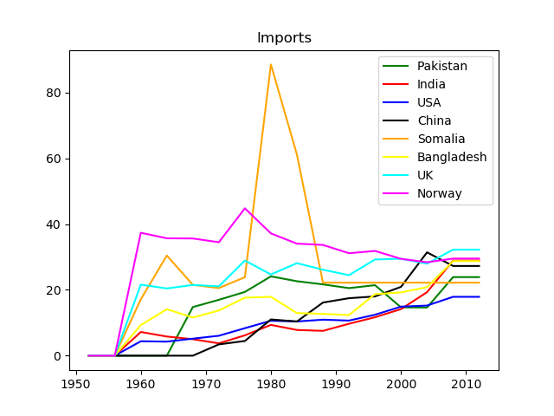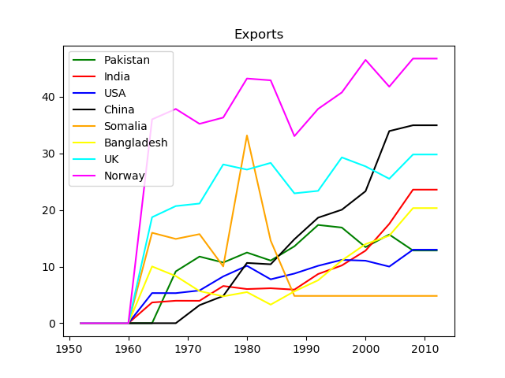
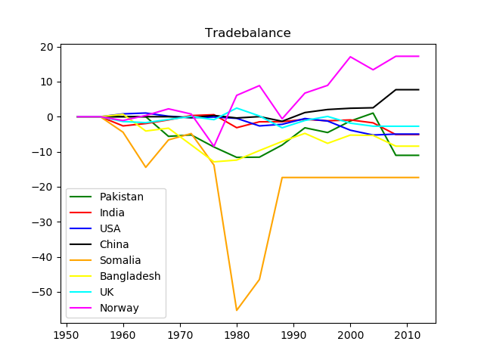

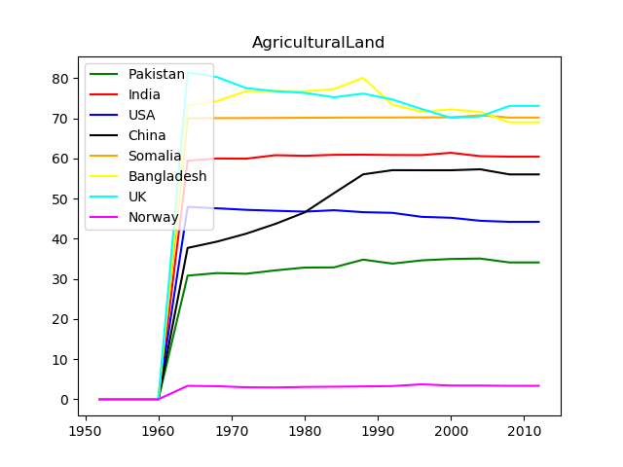
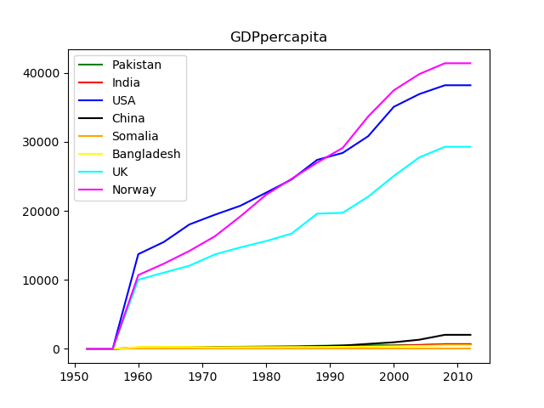

Positive points:
Pakistan is very lucky to have youth as a major part of population. Other countries like UK, USA have old population. This youth is a precious gem for Pakistan but problem is, youth is not directed where it should be. If Pakistan spends on youth they can change its fate. Another plus point for Pakistan is that there is no long term unemployment. UK suffers the highest rate of unemployment. Here the question arises if Pakistan has median population and no long term unemployment then why it is still underdeveloped? Answer is Pakistan suffers from diseases like corruption, poor law enforcement, democracy instability, injustice that has eaten it up like termite. Well youth can be the one who can change it but for this Pakistan has to first spend on this youth like on education, health etc.
