Plan : Block yahoo.com and Wikipedia.org from EC2 , while allowing all other websites.
Before Making any changes – Observe all websites are accessible from EC2 instance.
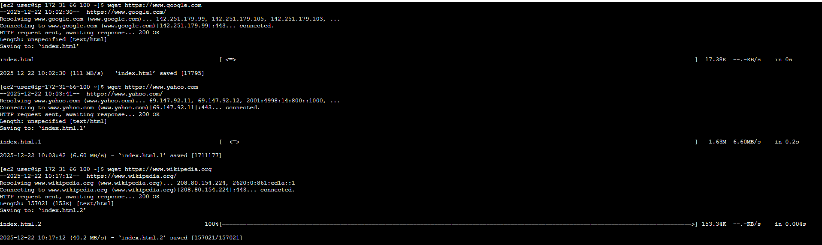
Navigate to VPC Console or Route 53 Console > Domain List
- Create a domain list and enter Wikipedia.org and yahoo.com

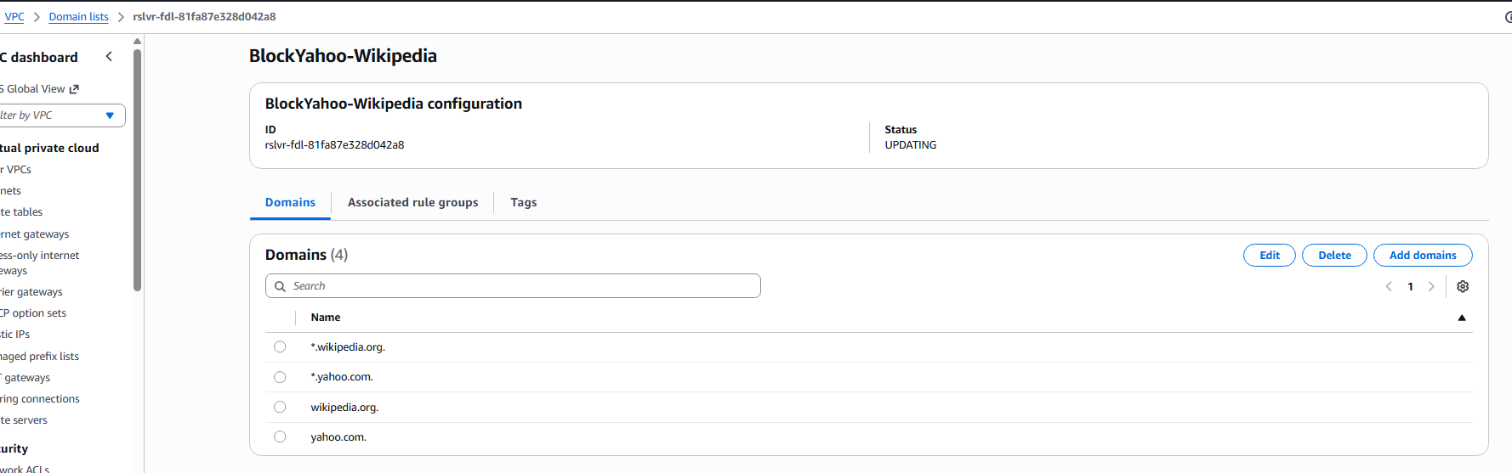

2 . Create Rule Group under DNS Firewall and associate it with Domain list you already created in step 1.
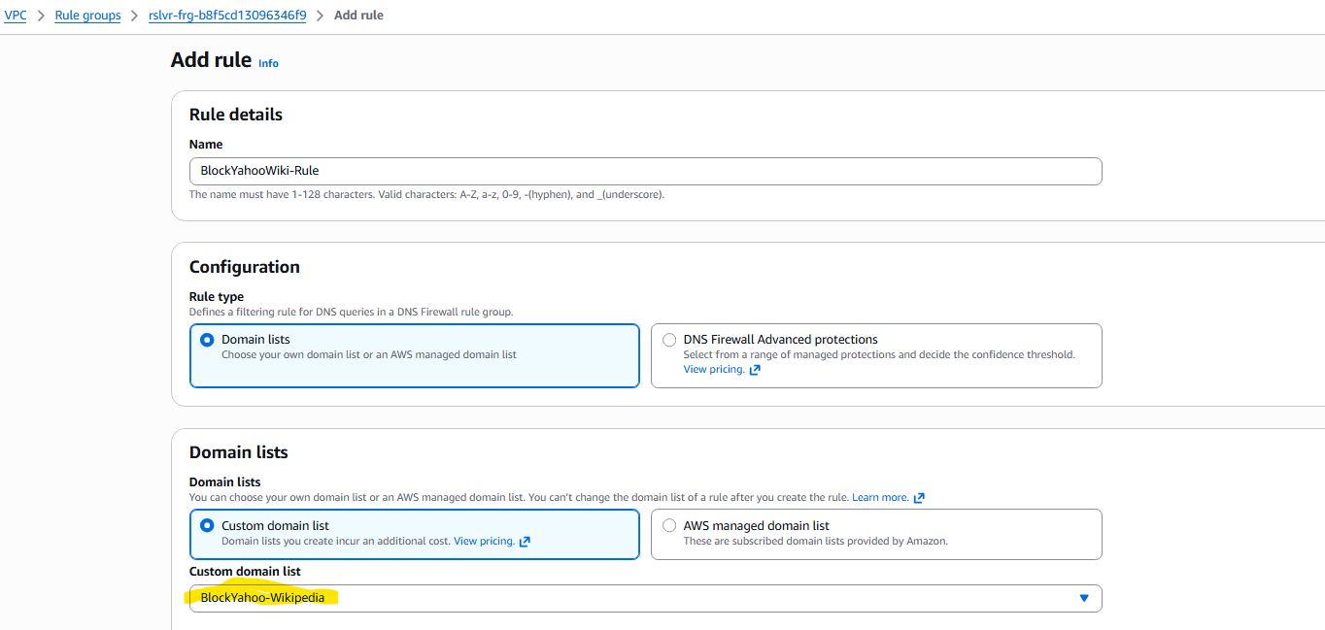

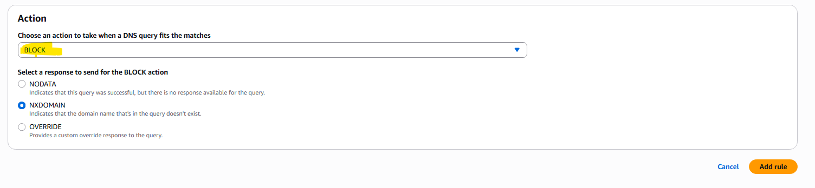

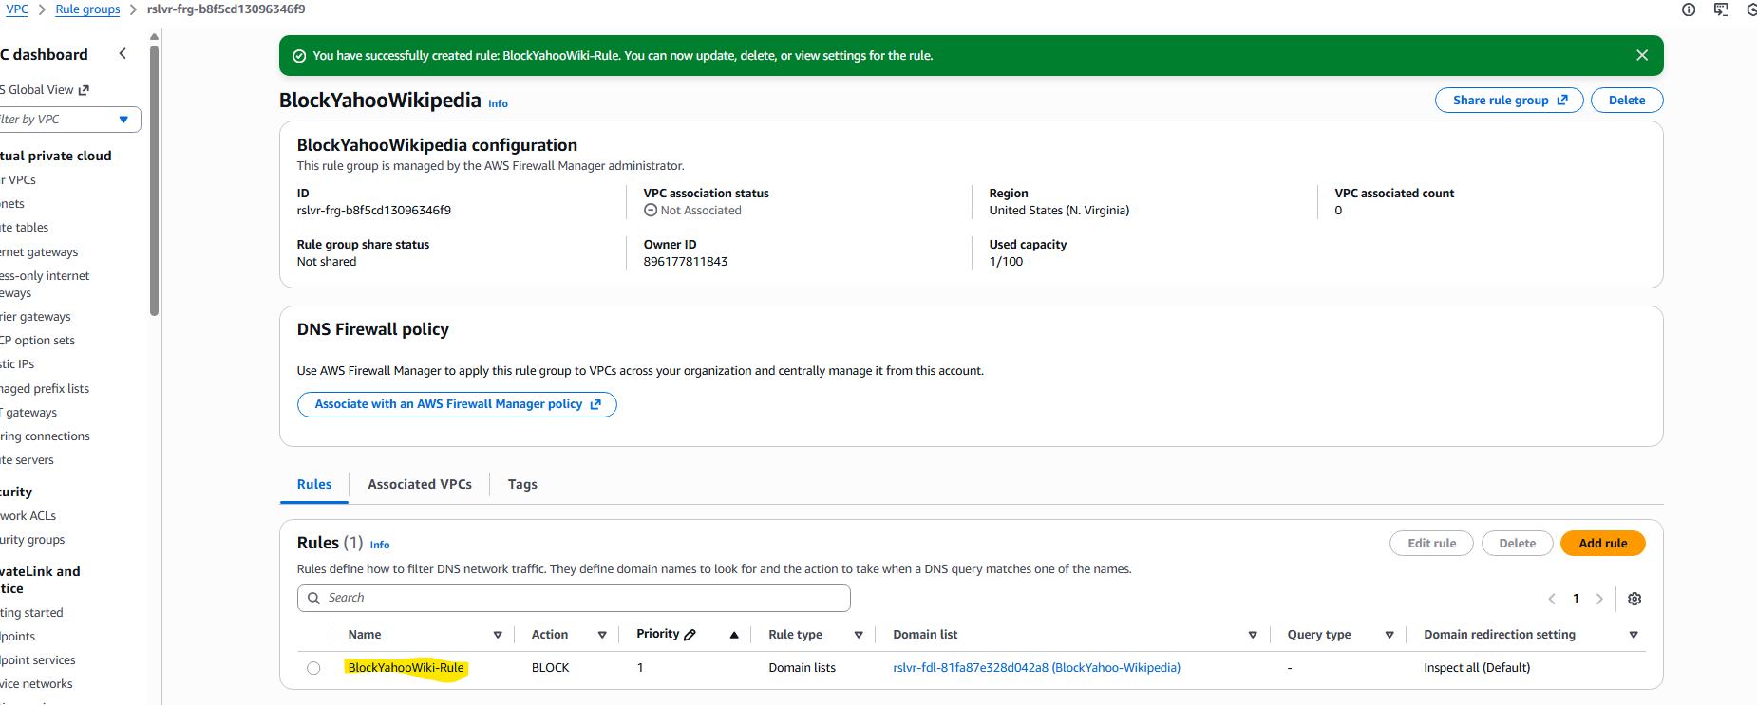
- Associate the rule group with your VPC.
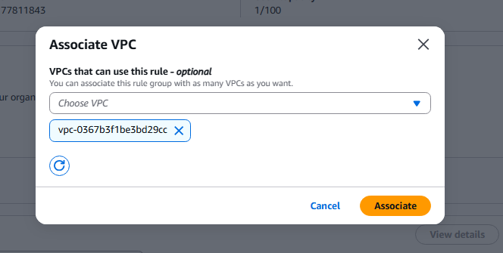

End State : Notice that Wikipedia.org and yahoo.com are blocked but google.com still works.

