Date : 2/7/2026
Compare Version Numbers
Single Number II

Date : 4/7/2026
LeetCode Count Good Nodes in Binary Tree – DFS
LeetCode 567: Permutation in String
- Don't Reset From Scratch: Rebuilding a map and restarting the loop every time you hit a wrong character is too slow. It causes a Time Limit Exceeded (TLE) error.
- The "Give Back" Rule: Instead of throwing the map away, just slide the left side of your window forward and add that character's count back to restore your blueprint.
- Arrays Beat Maps: For lowercase letters ('a' to 'z'), a simple int[26] array is way faster and uses less memory than a HashMap.
- Golden Rule: When data goes bad, don't clear the board. Just shrink the window from the left until it becomes good again.

6/July / 2026
572. Subtree of Another Tree
91. Decode Ways

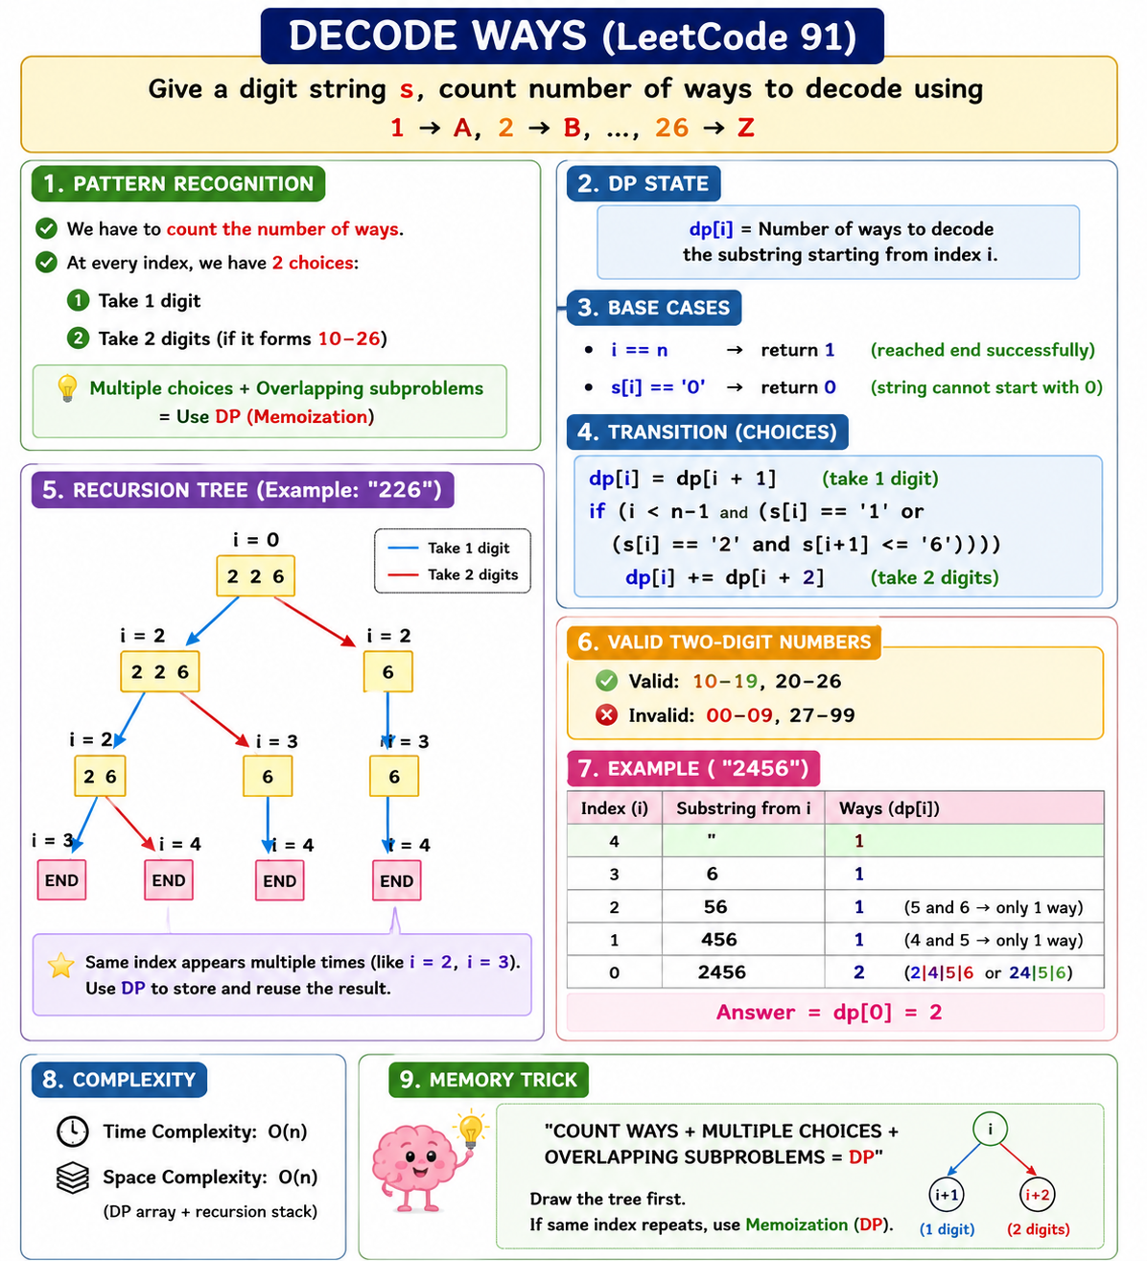
525. Contiguous Array

Date 7/7/2026
1584. Min Cost to Connect All Points
🌳 MST (Minimum Spanning Tree)
- Connect all vertices.
- Minimum total cost.
- No cycles.
- V − 1 edges.

🌳 Prim's Algorithm
Idea: Grow one tree.
- Start from any node.
- visited[] → Nodes already in MST.
- minDist[] → Cheapest cost to connect a node to the MST.
- Pick the unvisited node with the smallest minDist.
- Update minDist.
- Repeat.
Complexity: O(n²) Time, O(n) Space
Remember: ✅ Choose the next NODE.

🌲 Kruskal's Algorithm
Idea: Sort all edges.
- Generate all edges.
- Sort by weight.
- Pick the smallest edge.
- If it creates a cycle → Skip.
- Else → Add it.
- Use DSU (Union-Find) for cycle detection.
- Stop after V − 1 edges.
Complexity: O(E log E) Time, O(E) Space
Remember: ✅ Choose the next EDGE.

⚖️ Prim vs Kruskal
Prim | Kruskal
Grow one tree | Sort edges
Uses visited[], minDist[] | Uses DSU
Best for Dense Graphs | Best for Sparse Graphs

647. Palindromic Substrings
1046. Last Stone Weight
2013. Detect Squares

