GOVT. POLYTECHNIC FOR WOMEN, JAMMU

**DEPARTMENT OF COMPUTER ENGINEERING**

**VALIDITY CERTIFICATE**

This is to certify that this practical notebook belongs to the students of 5th Semester Diploma in computer Engineering(2023-2024) of Government Polytechnic for Women, Jammu having –

**SUBJECT -: MINOR PROJECT**

NAME : Kiranjeet kour

CLASS R.NO : 210701

NAME : Nusrat Banoo

CLASS R.NO : 210703

NAME : Ameesha verma

CLASS R.NO : 210704

NAME : Nisha Kumari

CLASS R.NO : 210718

NAME : Mehrul Nisa

CLASS R.NO : 220757

NAME : Sunaina devi

CLASS R.NO : 220755

**ACKNOWLEDGEMENT**

We take this opportunity to thank Faculty of computer (ER. Neha Dhar) for their valuable guidance, encouragement & support in the project work entitled "Website (JK Polytechnic help)" for the fulfillment of 3 yrs. Diploma in Computer Engineering from J&K State Board of Technical Education. They guided me in different phases of Project Development They support not only changed my approach to development but also enhanced my skills and abilities. By working under her leading approach, we learned a lot of things which will be helpful in my future. Last but not least, we own my overwhelming gratitude to other supporting staff during the course of this project for giving me the constant support & motivation to continue with this evidence.

**INDEX**

**INTRODUCTION**

* PURPOSE OF THE PROJECT
* CURRENT SYSTEM
* CURRENT SYSTEM
* PROPOSAL
* GLOSSARY
* SCOPE OF THE PROJECT
* ADVANTAGES

**REQUIREMENTS**

* SOFTWARE REQUIREMENTS
* HARDWARE REQUIREMENTS
* FUNCTIONAL REQUIREMENTS
* NON-FUNCTIONAL REQUIREMENTS SOFTWARE

**SYSTEM DESIGN**

* WEB FORM DESIGN
* COMPONENTS OF WEB FORM
* HOME PAGE
* LINKS AND PAGES

**TESTING**

* SYSTEM TESTING
* UNIT TESTING
* INTEGRATION TESTING
* VALIDATION TESTING

**DIGRAM**

* WEB PAGE LINK TO INDEX
* DATA LINK TO WEB PAGE

INTRODUCTION

The growing significance of websites for various organizations is well known. In recognizing that we decided to develop a website for the college which compromises which contain the previous year’s question paper of the Department present in our collage .

**Purpose of the project**:  
The purpose of our project is to design, publish a website for our college which consists of the previous year’s question paper of the Department present in our collage.,

**Current and Proposed System:**  
**Current System:**  
Our College does not have this type of Website.  
  
**Proposal System:**  
Initially the college does not have a proper website for the question papers . As this a static website. So that updating of the question in it is easy for the anyone .

**Glossary:**

|  |  |
| --- | --- |
| **TERM** | **DEFINITION** |
| HTML | Hyper Text Markup Language |
| CSS | Cascading Style Sheets |
| JS | Java Script |

**Scope of the project:** This SRS applies to all the official web applications that are developed to provide the question paper to the students of our collage .As we upload the Session 2022 & 2023 question paper in website .This website will be maintained by Computer Department .

**Advantages:**

The above technologies are required to implement the requirements due to following advantages.

* This is platform with contain question papers .So that Student does not have to face problem at the time of the exam.
* Easy to handle. As it does not contain complex languages.
* Provide the question papers in high quality.
* User friendly Interface.
* This Website is Response to all the devices and browsers.
* Easy to use Interface.
* It also consists of the toggle switch with which help we can change dark to light mode.

**REQUIREMENTS**  
 **Software Requirements:**

* Browser: Internet Explorer or Mozilla Firefox or Opera
* Flash player plug-in
* Operating system: Any Windows version/MAC

**Hardware Requirements:**

* Processor: Intel Pentium IV or above
* Ram: 512G or more
* Hard Disk: 40 GB or more

**Functional Requirements:**

* The system provides all the previous year question paper from 2022.
* All the contact of our collage is present in this website

**Non-Functional Requirements:**

* Runs on low performance systems and on any environment.
* Cost effective deployment(When buying out storage space).
* All the languages used to develop the system is user friendly and Text based .

**SYSTEM DESIGN**

System design is the solution to the creation of a new system. This phase is composed of several systems. This phase focuses on the detailed implementation of the feasible system. Its emphasis on translating design specifications to performance specification. System design has two phases of development logical and physical design. During logical design phase the analyst describes inputs (sources), out puts (destinations), databases (data sources) and procedures (data flows) all in a format that meats the uses requirements. The analyst also specifies the user needs and at a level that virtually determines the information flow into and out of the system and the data resources. Here the logical design is done through data flow diagrams and database design. The physical design is followed by physical design or coding. Physical design produces the working system by defining the design specifications, which tell the programmers exactly what the candidate system must do. The programmers write the necessary programs that accept input from the user, perform necessary processing on accepted data through call and produce the required report on a hard copy or display it on the screen.

**HOMEPAGE**  
The home page of a website is the first page that a user perceives upon entering the website URL at the browser address area. The entire website depends on how the home page is designed which forms the platform for viewing other web forms. In short, a home page forms the abstract of the entire website.

**LINKS&WEBPAGES**  
Through the home page a number of other web pages can be linked. Each link gives an elaborated detail about itself with adequate lists .

**TESTING**  
 **SYSTEM TESTING**  
Testing is a set activity that can be planned and conducted systematically. Testing begins at the module level and work towards the integration of entire computers-based system. Nothing is complete without testing, as it is vital success of the system.  
  
**Testing Objectives:**  
There are several rules that can serve as testing objectives, they are :

1.Testing is a process of executing a program with the intent of finding an error  
2. A good test case is one that has high probability of finding an undiscovered error.  
3. A successful test is one that uncovers an undiscovered error.  
  
If testing is conducted successfully according to the objectives as stated above, it would uncover errors in the software. Also testing demonstrates that software functions appear to the working according to the specification, that performance requirements appear to have been met.

There are three ways to test a program  
1. For Correctness  
2. For Implementation efficiency  
3. For Computational Complexity.  
  
Tests for correctness are supposed to verify that a program does exactly what it was designed to do. This is much more difficult than it may at first appear, especially for large programs. Tests for implementation efficiency attempt to find ways to make a correct program faster or use less storage. It is a code-refining process, which reexamines the implementation phase of algorithm development.  
  
The following ideas should be a part of any testing plan:  
  
1. Preventive Measures  
2. Spot checks  
3. Testing all parts of the program  
4. Test Data  
5. Looking for trouble  
6. Time for testing  
7. Re Testing  
2. Integrated Testing  
3. Final/ System testing  
  
**UNIT TESTING**  
As this system was partially GUI based WINDOWS application, the following were tested in this phase  
1. Tab Order  
2. Reverse Tab Order  
3. Field length  
4. Front end validations  
**INTEGRATION TESTING**  
Test data should be prepared carefully since the data only determines the efficiency and accuracy of the system. Artificial data are prepared solely for testing. Every program validates the input data.  
  
**VALIDATION TESTING**  
In this, all the Code Modules were tested individually one after the other. The following  
were tested in all the modules  
1. Loop testing  
2. Boundary Value analysis  
3. Equivalence Partitioning Testing

**DIAGRAM REPRESENTATION OF THE DATA**

**WEB PAGE TO INDEX**

**START**

DATA

HTML 1

DEPARTMENT 1

DEPARTMENT n…

DEPARTMENT 2

**HTML**

**CSS**

**INDEX PAGE**

**PROJECT FOLDER**

**Js**

HTML n

**DATA LINK TO WEB PAGE**

SEMESTER n...

SEMESTER 2

SEMESTER 1

HTML SEM n...

HTML SEM2

HTML SEM1

DATA

DEPARTMENT 1

DEPARTMENT 2

DEPARTMENT 4

DEPARTMENT 5

DEPARTMENT 3

**HTML**

**SCREENSHOTS:**

**Dark Mode:**

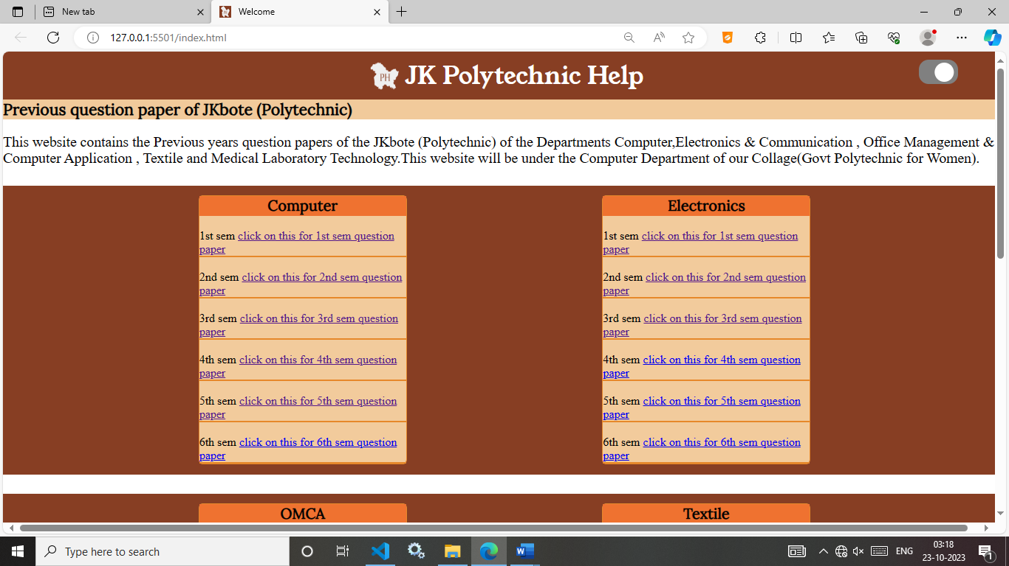

**Light mode:**

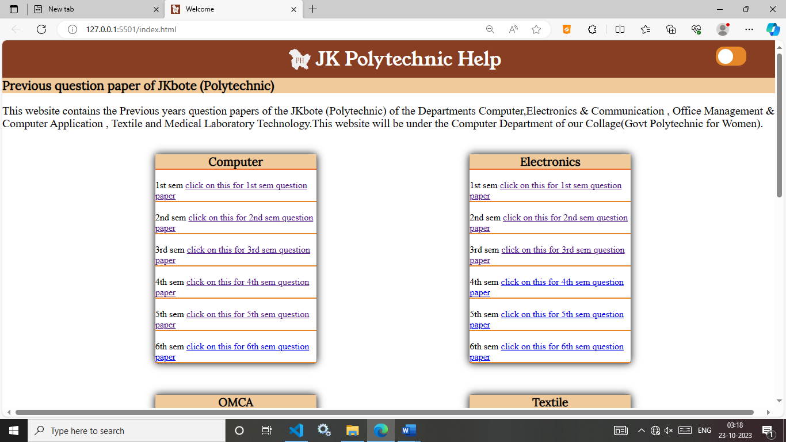

**Mobile view:**

