**Project name: Happy Pet**

**Project Members:**

**Kiran Kittur (TL): 210543181043 Pranav Kolle: 210543181044**

**Sayali Chavan: 210543181018**

**Kalpesh Desale: 210543181035**

**Abstract:**

“An animal has not much mind than the human, but they have a loving heart and loyalty.”

Pet keeping is a common part of many cultures. Humans have been sharing their lives with

animals from time immemorial. According to research, pets can have a profound effect on us.

Interacting with a pet that behaves properly can have a positive effect on you and the people

around you.

In our project, we are designing a platform for all the animals and animal lover. One can buy

and sell the pet online in trusted hand. For the homeless animals, one can contact to nearby animal shelter will take care of those animals. Doctor, trainer and caretaker contact and details are also been provided to take care of their pet.

**Implementation Technologies:**

1. **Spring Framework:**

Spring Framework is a Java platform that provides comprehensive infrastructure support for developing Java applications. Spring handles the infrastructure so you can focus on your application.

Spring enables you to build applications from “Plain Old Java Objects” (POJOs) and to apply enterprise services non-invasively to POJOs. This capability applies to the Java SE programming model and to full and partial Java EE.

**1.1 Features of Spring Framework:**

**1. Lightweight**

Spring is modular lightweight framework which allows you to selectively use any of its modules on the top of Spring Core.

**2. Inversion of Control (IOC)**

This is another top feature of Spring framework where application dependencies are satisfied by the framework itself. Framework creates the object in runtime and satisfies application dependencies.

**3. Aspect Oriented Programming (AOP)**

Aspect Oriented Programming (AOP) is very popular in programming world and in Spring it is well implemented. Developer can use Aspect Oriented Programming (AOP feature of Spring to develop application in which business logic is separated from system services.

**4. Container**

Spring provides their own container for managing the bean lifecycle.

**5. MVC Framework**

Spring MVC Framework is used for developing MVC based web applications.

**6. Transaction Management**

Spring framework provides generic Transaction Management layer which can be used with or without J2EE(JEE) environment.

**7. JDBC Exception Handling**

Spring provides their own abstraction of JDBC exception which further simplifies the exception handling in program.

**1.2 Advantages of Spring Framework:**

**1. Solving difficulties of Enterprise application development**

Spring is solving the difficulties of development of complex applications, it provides Spring Core, Spring IoC and Spring AOP for integrating various components of business applications.

**2. Support Enterprise application development through POJOs**

Spring supports development of Enterprise application development using the POJO classes which removes the need of importing heavy Enterprise container during development. This makes application testing much easier.

**3. Easy integration other frameworks**

Spring designed to be used with all other frameworks of Java, you can use ORM, Struts, Hibernate and other frameworks of Java together. Spring framework do not impose any restriction on the frameworks to be used together.

**4. Application Testing**

Spring Container can be used to develop and run test cases outside enterprise container which makes testing much easier.

**5. Modularity**

Spring framework is modular framework and it comes with many modules such as Spring MVC, Spring ORM, Spring JDBC, Spring Transactions etc. which can used as per application requirement in modular fashion.

**6. Spring Transaction Management**

Spring Transaction Management interface is very flexible it can configure to use local transactions in small application which can be scaled to JTA for global transactions.

**1.3 Hibernate:**

Hibernate is a high-performance Object/Relational persistence and query service, which is licensed under the open-source GNU Lesser General Public License (LGPL) and is free to download. Hibernate not only takes care of the mapping from Java classes to database tables (and from Java data types to SQL data types), but also provides data query and retrieval facilities. This tutorial will teach you how to use Hibernate to develop your database-based web applications in simple and easy steps.

1. **The JDBC Template**

The central class of the Spring JDBC abstraction framework is the **JdbcTemplate** class that includes the most common logic in using the JDBC API to access data, such as handling the creation of connection, statement creation, statement execution, and release of resource. The**Jdbc-Template**class can be found in the **org.springframework.jdbc.core**package.

The **JdbcTemplate** class instances are thread-safe once configured. A single **JdbcTemplate** can be configured and injected into multiple DAOs.

We can use the **JdbcTemplate** to execute the different types of SQL statements. **Data Manipulation Language** (**DML**) is used for inserting, retrieving, updating, and deleting the data in the database such as **SELECT**, **INSERT**, or **UPDATE** statements

**2.1** **MySQL**

MySQL, the most popular Open Source SQL database management system, is developed, distributed, and supported by Oracle Corporation.

**Features of MySQL:**

* **MySQL is a database management system.**

A database is a structured collection of data. It may be anything from a simple shopping list to a picture gallery or the vast amounts of information in a corporate network. To add, access, and process data stored in a computer database, you need a database management system such as MySQL Server. Since computers are very good at handling large amounts of data, database management systems play a central role in computing, as standalone utilities, or as parts of other applications.

* **MySQL databases are relational.**

A relational database stores data in separate tables rather than putting all the data in one big storeroom. The database structures are organized into physical files optimized for speed. The logical model, with objects such as databases, tables, views, rows, and columns, offers a flexible programming environment.

* **MySQL software is Open Source.**

Open Source means that it is possible for anyone to use and modify the software. Anybody can download the MySQL software from the Internet and use it without paying anything.

* **The MySQL Database Server is very fast, reliable, scalable, and easy to use.**

MySQL Server was originally developed to handle large databases much faster than existing solutions and has been successfully used in highly demanding production environments for several years. Although under constant development, MySQL Server today offers a rich and useful set of functions. Its connectivity, speed, and security make MySQL Server highly suited for accessing databases on the Internet.

* **MySQL Server works in client/server or embedded systems.**

The MySQL Database Software is a client/server system that consists of a multithreaded SQL server that supports different back ends, several different client programs and libraries, administrative tools, and a wide range of application programming interfaces (APIs).

**3.HTML:**

HTML (Hypertext Markup Language) is the code that is used **to structure a web page and its content**. For example, content could be structured within a set of paragraphs, a list of bulleted points, or using images and data tables

**4.BootStrap:**

Bootstrap is a free front-end framework for faster and easier web development Bootstrap includes HTML and CSS based design templates for typography, forms, buttons, tables, navigation, modals, image carousels and many other, as well as optional JavaScript plugins Bootstrap also gives you the ability to easily create responsive designs

**5.Javascript:**

JavaScript is commonly used for **creating web pages**. It allows us to add dynamic behaviour to the webpage and add special effects to the webpage. On websites, it is mainly used for validation purposes. JavaScript helps us to execute complex actions and also enables the interaction of websites with visitors.

**6.Hardware and Software Requirements (Minimum):**

**Hardware:**

1. Intel i3 processor 3rd generation or later / AMD Ryzen 200 2nd generation or later

2. 2 GB ddr3 ram.

3. Windows 7 Home edition or later.

4. 200 GB Sata HDD Space

5. Data Connection 200 kbps

**Software:**

1. Eclipse 4.7 Oxygen
2. MySQL 5.7 with Workbench 8.0
3. Google Chrome version 79.0
4. Apache Tomcat Server 8.5
5. Maven Dependencies
6. **ER Diagram:**

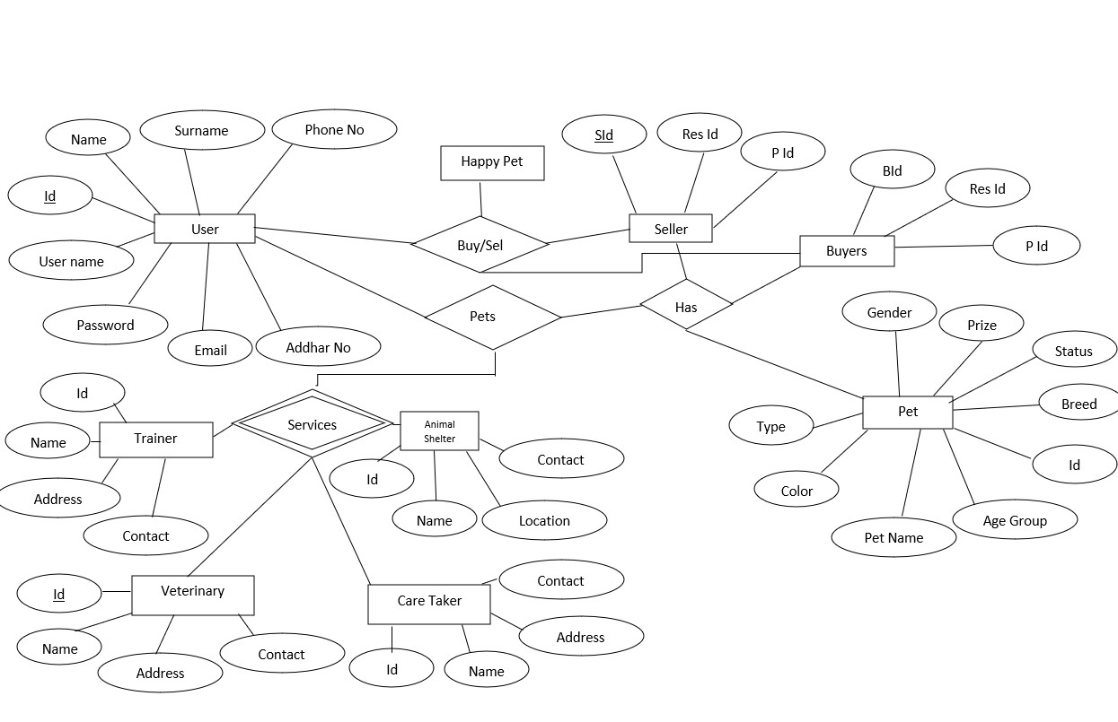

1. **Table Structures:**
2. **Table Name: user**

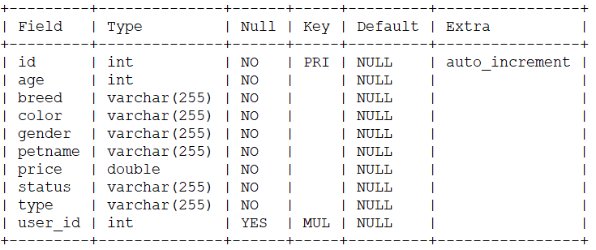

1. **Table Name: pet**

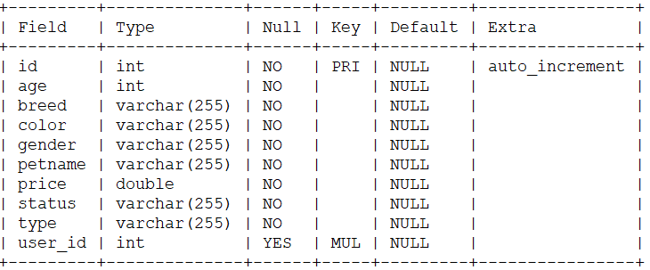

1. **Table Name: petcaretakers**

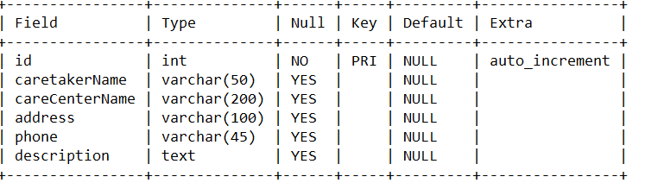

1. **Table Name: animalshelter**

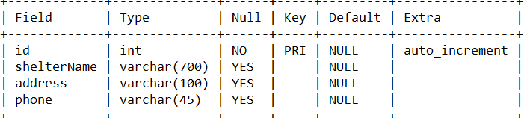

1. **Table Name: veterinary**

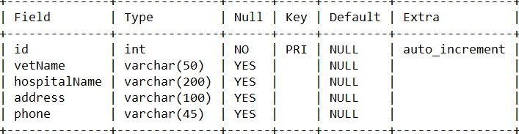

1. **Table Name: trainer**

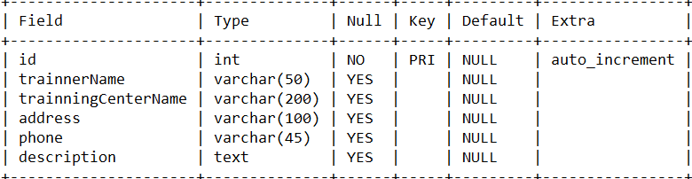

1. **Table Name : buysell**

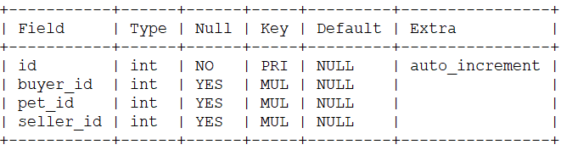

1. **UML Diagrams:**

**Use Case flow Diagram (User):**

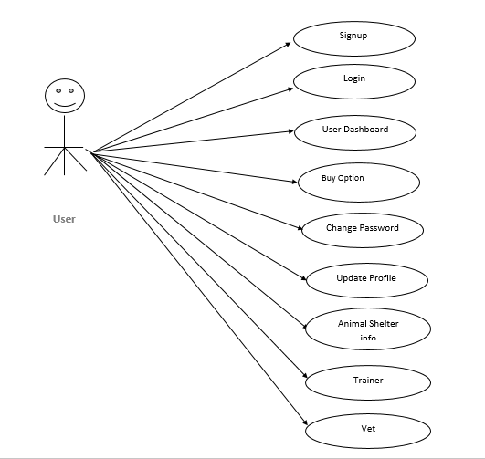

**Use Case flow Diagram (Buy):**

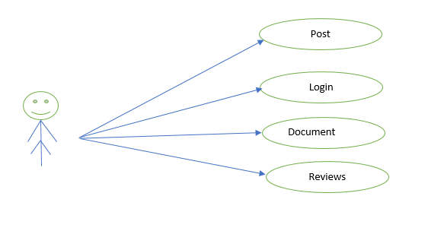

**Use Case flow Diagram (Seller):**

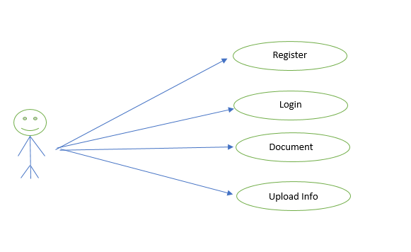

**Fig 1: Use Case diagrams**

1. **Collaboration Diagram**

Buy/ Sell Successfully

See His/Her

Buy/Sell

1.Login

**User**

2.LogOut

3.Buy/sell

1. **sequence Diagram**

Home page

Pet care

Animal Shelter

Buy

Pet trainer

Pet veterinary

Sign Up

Sign In

Seller Dashboard /

Buyer Dashboard

Seller Dashboard

Add Pet / View Pet

Buy Dashboard

1. **Component Diagram**

Add Pet

Sell

Buy

User logging

Register

Home

Buy Pet

1. **State Diagram**

**User**

Logout

Sell

Buy

Login

Registration

1. **Class Diagram**

Veterinary

-id

-vatName

-hospitalName

-address

-phone

Animal shelter

-id

- shelterName

-address

-phone

Pet caretakers

-id

- caretakerName

- careCenterName

- address

- phone

- description

Component Status

1.Regstration

2.Pet

3. Pet caretakers

4. Animal shelter

5. Veterinary

6. Trainer

Pet

-id

-age

-bread

-color

-gender

-petname

-price

-Status

-type

-rt-id

-b-id

Registration

-id

-adharno

-email

-fname

-lname

-password

-phone_no

-username

-usertype

Trainer

-id

- trainnerName

-trainningCenterName

- address

-phone

- description

1. **End to End Flow of Application:**

**User:**

1. User will login to the portal or will have to register if he is not a registered user.
2. After registration User will login and Dashboard page will be displayed to him which will display The Status.
3. In the User wants to Sell a pet he can Add his pet details in to the pet registration page
4. And the all details will render or display to the buy Page where other user will be seeing all the updated pets
5. Where if you want to buy a pet in that case you have to register first then you have to login and you can buy a pet.
6. For other services like pet care, pet trainer, pet veterinary, animal shelter you have to register you can use the services.
7. **Future Scope of Project:**

This Web Application has great future scope. A platform for all the animals and animal lover. For the homeless animals, we can post their picture so nearby animal shelter will accept that pet and will take care of those animals. Animal Lover can share their feeling post on our site.

We can also add the pet food and toys for sell and buy. We can book the appointment for trainer, caretaker and veterinary. We can also show the offer and services by trainer, caretaker and veterinary.

We can add filter to search the pet by breed, color, gender, prize, etc. We can also add online payment option.

DIGITAL VETERINARY & PET HEALTH Packaged Facts expects a great deal of activity and advancement in internet-based platform solutions that assist veterinary professionals, and digital health applications and devices that make it easier for pet owners to monitor their pets' health.