PYTHON & BASH — DEVOPS ASSIGNMENT
Name: Kiran
Course: DevOps
Assignment: Python & Bash
1. Grade Checker
Objective : The objective of this task is to create a Python program that accepts a student's score as input and determines the corresponding grade using conditional statements.
Code:
score = int(input("enter the score = "))

if score >= 90:
grade = "A"

elif score >= 80:
grade = "B"

elif score >= 70:
grade = "C"

elif score >= 60:
grade = "D"

else:
grade = "F"
print("Grade:", grade)

Command Used:
python3 01_grade_checker.py
Explanation:
The program takes the score from the user and converts it into an integer using int(). It then uses if, elif, and else statements to check the score range. Based on the score, the appropriate grade is stored in the grade variable. Finally, the grade is displayed using the print() function.

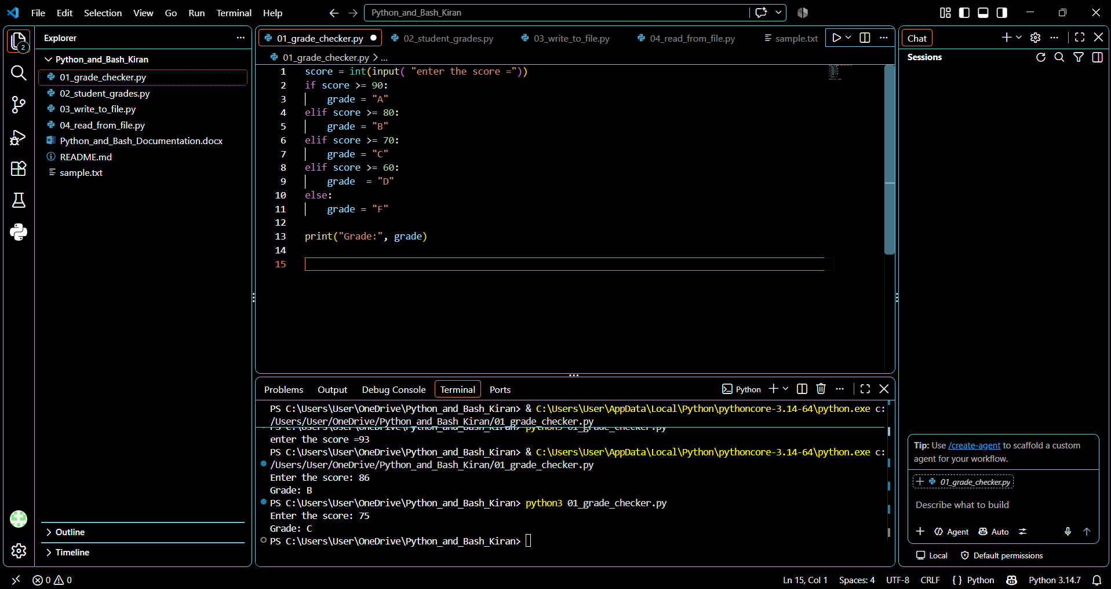

2. Student Grades
Objective:
The objective of this task is to use a Python dictionary to store student names and their grades. The program allows the user to add new students, update existing grades, and display all student grades.
Code:
student = {
"Rahul": "A",
"Priya": "B",
"Amit": "C",
}
while True:
print("\n---Student Grades---")
print("1. Add new student name")
print("2. Update existing students grade")
print("3. Display all students and grades")
print("4. Exit")
choice = input("Enter your choice (1-4): ")
if choice == "1":
name = input("Enter student name: ")
grade = input("Enter student grade: ").upper()
if name in student:
print("Student already exists. Use option 2 to update the grade.")
else:
student[name] = grade
print("Student added sucessfully")
elif choice == "2":
name = input("Enter student name: ")
if name in student:
grade = input("Enter new student grade: ").upper()
student[name] = grade
print("Student grade updated successfully.")
else:
print("Student not found.")
elif choice == "3":
print("\n---Student Grades---")
for name, grade in student.items():
print(f"{name}: {grade}")
elif choice == "4":
print("Exiting the program.")
break
else:
print("Invalid choice. Please try again.")

Command Used:
python3 02_student_grades.py

Explanation:
A dictionary is used to store student names as keys and grades as values. The program provides a menu that allows the user to add a new student, update an existing student's grade, display all student grades, or exit the program. The if and elif statements are used to process the user's menu choice.

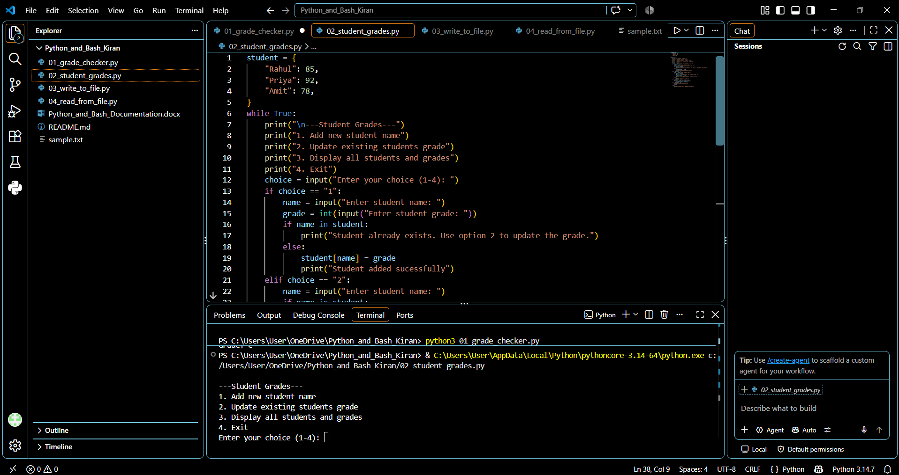

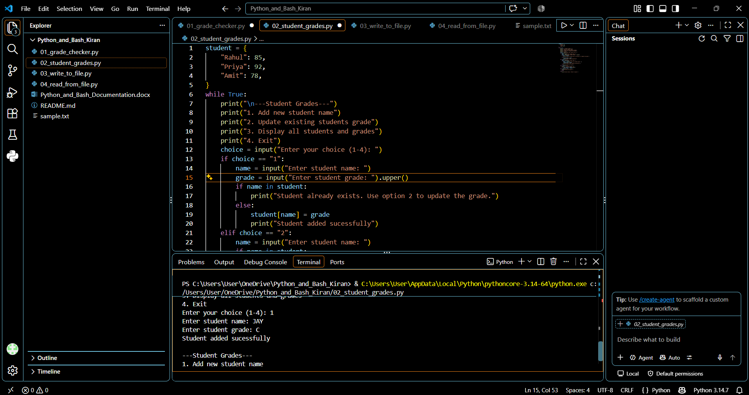
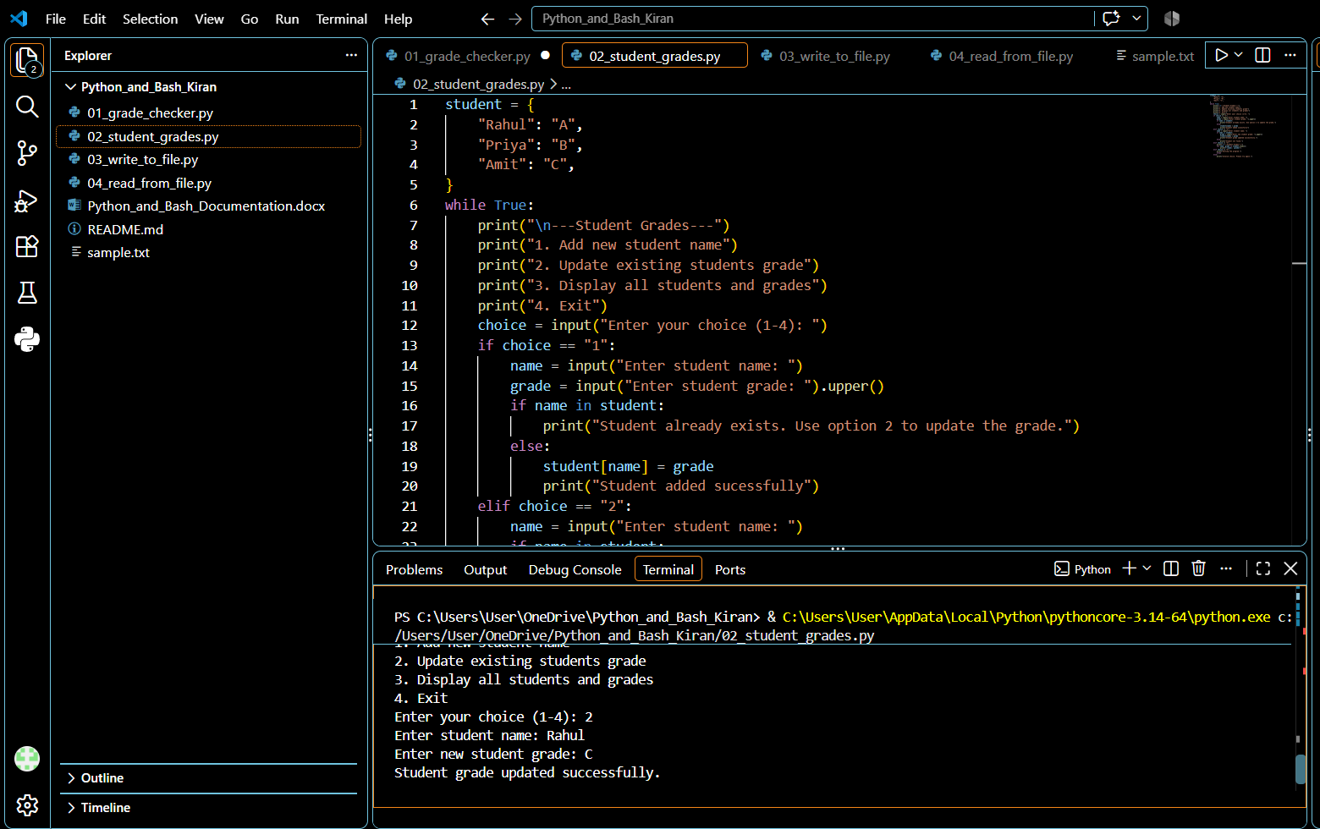

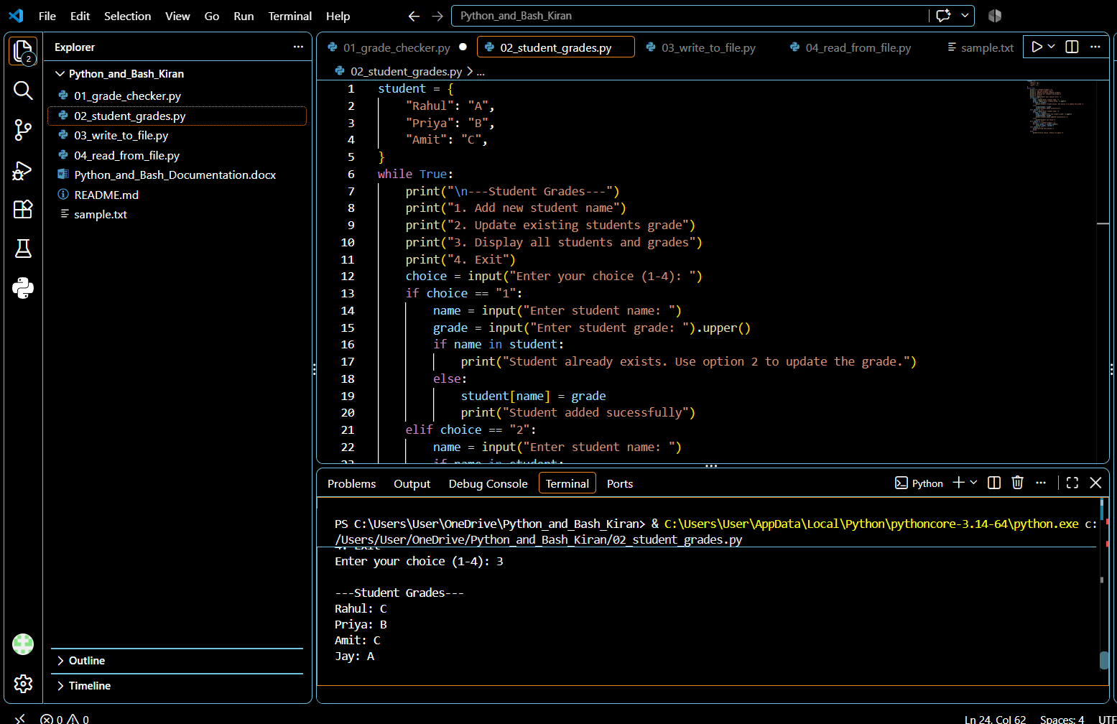

3. Write to a File
Objective:
The objective of this task is to create a text file and write content into it using Python file handling functions.
content = """Python and Bash Assignment

This file was created using Python file handling.
The program uses open() and write() to create and write content to a text file.
"""

with open("sample.txt", "w") as file:
file.write(content)

print("Content successfully written to sample.txt")
Command Used:
python3 03_write_to_file.py
Explanation:
The program uses the open() function with "w" mode to create or open sample.txt for writing. The write() function is then used to write the specified content into the file. The with statement automatically closes the file after the operation is completed.
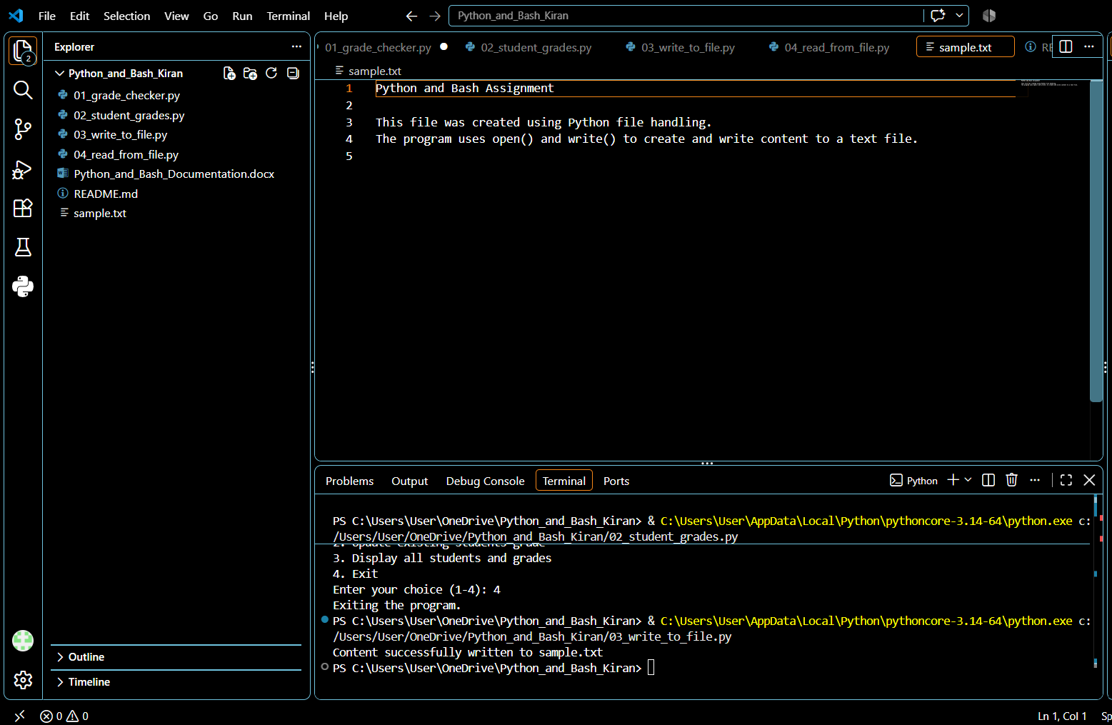

4. Read from a File
Objective:
The objective of this task is to read and display the contents of the text file created in Task 3.
Code:
with open("sample.txt", "r") as file:
content = file.read()

print("Content of sample.txt:")
print("----------------------")
print(content)
Command Used:
python3 04_read_from_file.py

Explanation:
The program opens sample.txt in read mode using "r". The read() function reads the complete contents of the file and stores them in the content variable. The content is then displayed in the terminal using print().
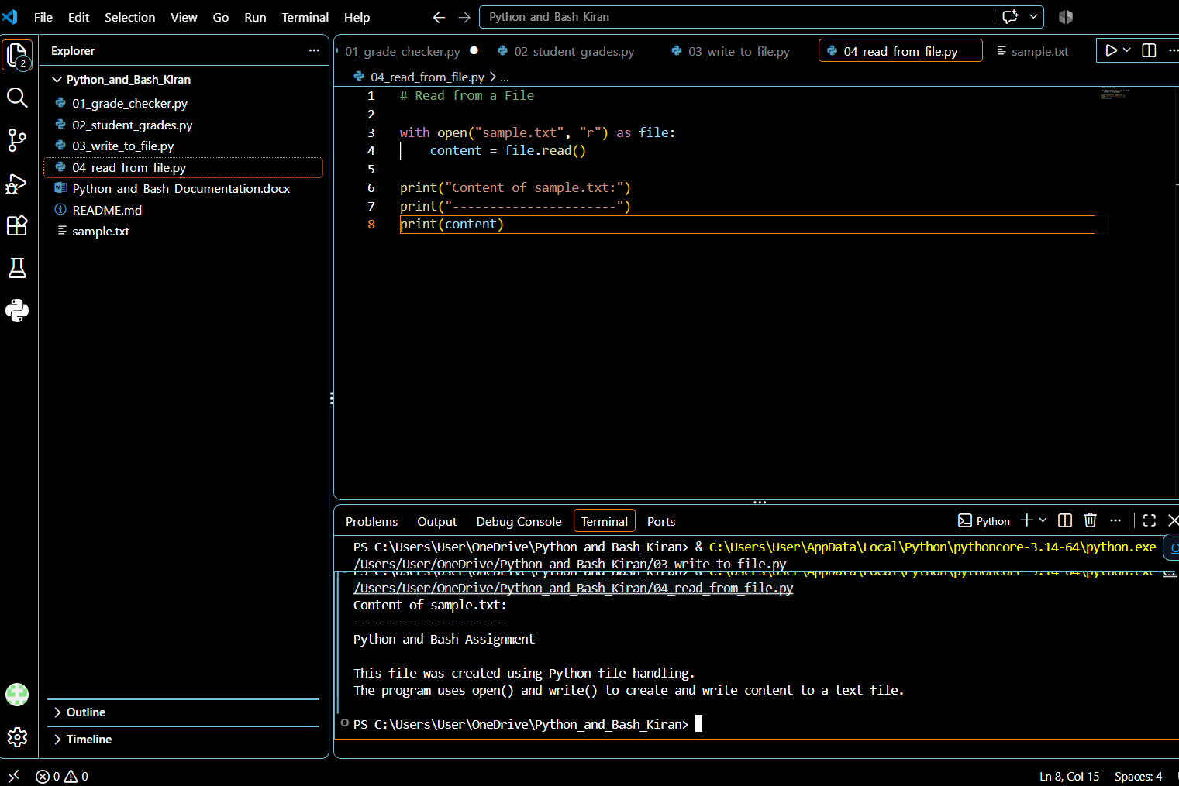

5. GitHub Repository
The complete source code for this assignment has been uploaded to GitHub. The repository contains all Python programs, the sample text file, and the README file.
GitHub Repository:
https://github.com/Kirankcdv/Python_and_Bash_Kiran.git
6. Conclusion
This assignment provided practical experience with basic Python programming concepts. The tasks demonstrated the use of conditional statements, dictionaries, user input, and file handling operations. The assignment also provided experience in organizing source code and maintaining the project using GitHub.

