**Farmer**

Mid-term verification

* Crop Name (input: text)
* Farmer Name (input: text)
* Area in acre (input: number)
* Additional Info (input: textbox)
* Progress (input: select: percentage)
* Months remaining till harvest (input: number)

Requesting for Certification

* Crop Name (input: text)
* Crop quantity (input: number) in quantity(kg)
* Crop quality (input: select: bad, average , good)
* Desired price (input: number) in rupees
* Description (input: textbox)

Orders

* List of orders

Pick up from courier

* Orders picked up courier

**Authority**

New applications

* Full name
* Ph no
* Personal address
* Eth address

Crop validation

* Crop Name
* Farmer name
* Registered on
* Plot address
* Time required till harvest
* Area of cultivation
* Additional info about the crop

Midterm verification

* Farmer name
* Months till harvest
* Crop
* Progress
* Further required

Final certification

* Crop name
* Quantity
* Quality
* Desired price
* Description

**Customer**

Cart

* List of products
* Payment segment

Profile and Address

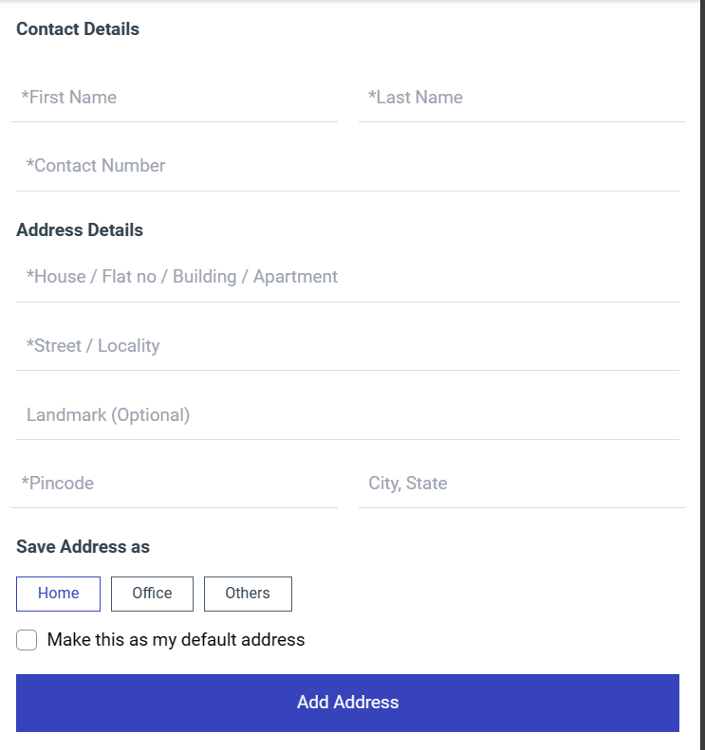

Orders

* List of Orders