**Development part-2**

**Continue building tha sentimental analysis solution by employing NLP techniques and generating insights**

Sentiment analysis is a natural language processing (NLP) technique that can help extract insights from text data. Here are the steps to build a sentiment analysis solution and generate insights:

+----------------------+

| Text Data |

| (e.g., Reviews, |

| Social Media) |

|  |
| --- |
|  |

|

V

|  |
| --- |
|  |

| Data Preprocessing |

| (Cleaning, Tokenize, |

| Removing Stopwords,|

| Lemmatization, etc.)|

|  |
| --- |
|  |

|

V

|  |
| --- |
|  |

| Feature Extraction |

| (Word Embeddings, |

| TF-IDF, etc.) |

|  |
| --- |
|  |

|

V

|  |
| --- |
|  |

| NLP Techniques |

| (Sentiment Analysis,|

| Named Entity Recog,|

| Topic Modeling, |

| Machine Translation|

| etc.) |

|  |
| --- |
|  |

|

V

|  |
| --- |
|  |

| Model Training |

| (Machine Learning |

| or Deep Learning) |

|  |
| --- |
|  |

|

V

|  |
| --- |
|  |

| Insights |

| (Sentiment Scores, |

| Topics, Entities, |

| Translations, etc.)|

|  |
| --- |
|  |

**Dataset Link:https://www.kaggle.com/datasets/crowdflower/twitter-airline-sentiment**

**Data** **Collection:**

Gather text data from various sources, such as social media, reviews, or customer feedback.

**Data** **Preprocessing:**

Clean the text data by removing special characters, numbers, and stopwords.

Tokenize the text into words or phrases.

**Labeling:**

Annotate the data with sentiment labels (positive, negative, neutral) for supervised learning. You can use pre-labeled datasets or label the data manually.

**Feature** **Extraction**:

Convert the text into numerical features using techniques like TF-IDF (Term Frequency-Inverse Document Frequency) or word embeddings (Word2Vec, GloVe).

**Model** **Selection:**

Choose a sentiment analysis model, such as Naïve Bayes, Support Vector Machines, or deep learning models like LSTM or BERT.

**Model** **Training:**

Rain the selected model on your labeled data.

**Model** **Evaluation:**

Assess the model’s performance using metrics like accuracy, precision, recall, and F1-score.

**Deployment:**

Deploy the sentiment analysis model in your application or use it for analyzing text data.

**Insight** **Generation:**

Analyze the sentiment results to gain insights.

Monitor changes in sentiment over time.

Identify common topics or entities mentioned in the positive or negative sentiment.

**Visualization:**

Create visualizations like word clouds, sentiment distribution plots, or time series charts to present insights.

**Customization**:

Fine-tune the model for domain-specific sentiment analysis if necessary.

**Feedback** **Loop:**

Continuously improve the model by collecting user feedback and retraining it with new data.

**Scale** **and** **Automate:**

Automate the sentiment analysis process for real-time data streams if needed.

NLP definition

Natural Language Processing (NLP) is a subfield of artificial intelligence (AI) that focuses on the interaction between computers and human language. It involves the development of algorithms and models that enable computers to understand, interpret, and generate human language in a way that is both meaningful and useful.

**Key** **components** **of** **NLP** **include:**

Natural Language Understanding (NLU): NLU involves the comprehension of human language by computers. It includes tasks such as text analysis, sentiment analysis, language translation, and named entity recognition. NLU helps computers extract meaning and context from text.

Natural Language Generation (NLG): NLG focuses on the generation of human-like language by computers. This can be used to create coherent and contextually relevant responses in chatbots, summarize text, or even generate content like news articles.

Text Processing: NLP involves text processing tasks like tokenization (breaking text into words or sentences), part-of-speech tagging (labeling words as nouns, verbs, etc.), and syntactic parsing (understanding sentence structure).

Machine Learning and Deep Learning: NLP heavily relies on machine learning and deep learning techniques to build models that can perform tasks like sentiment analysis, machine translation, and speech recognition.

**Applications:**

NLP has a wide range of applications, including chatbots, virtual assistants, language translation, voice recognition, search engines, and text analysis in areas such as healthcare, finance, and social media.

Nlp techniques in sentimental analysis

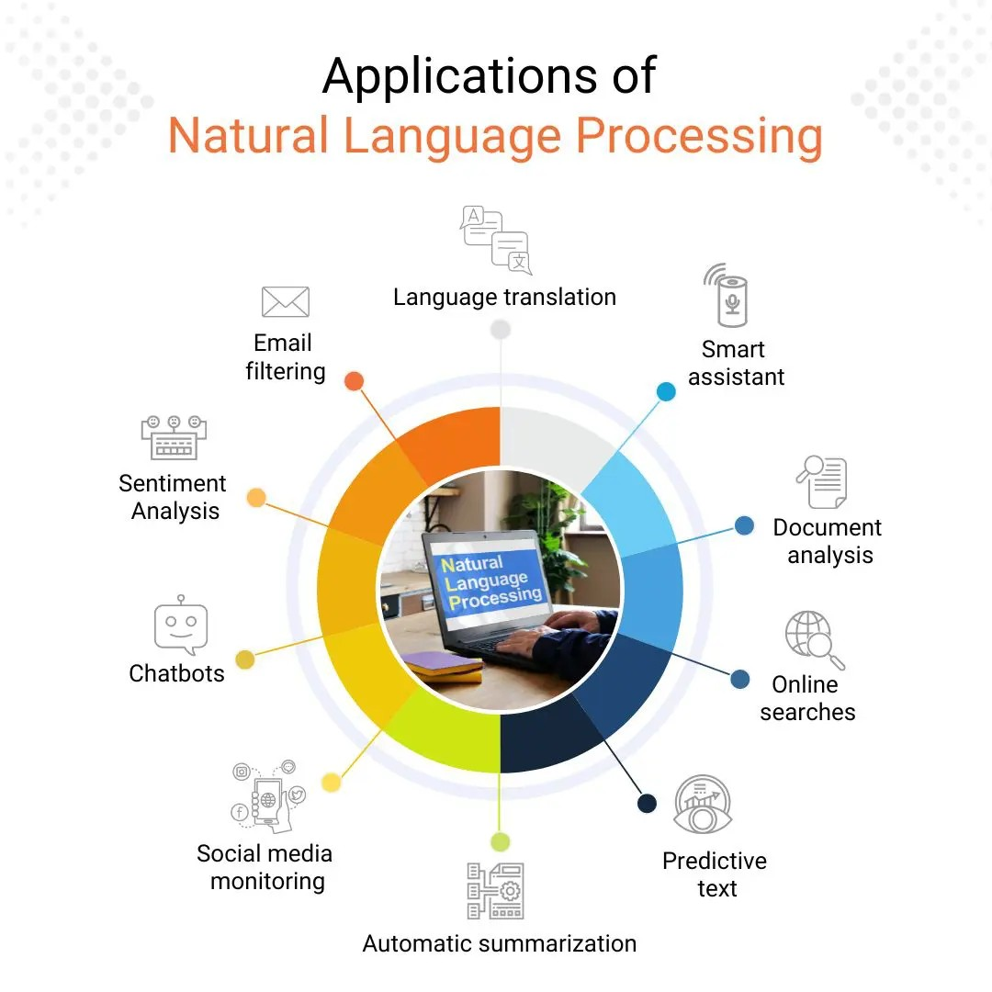

**Nlp** **techniques** **in** **sentimental** **analysis**

Natural Language Processing (NLP) techniques play a crucial role in sentiment analysis, which is the task of determining the sentiment or emotional tone expressed in a piece of text. Here are some NLP techniques commonly used in sentiment analysis

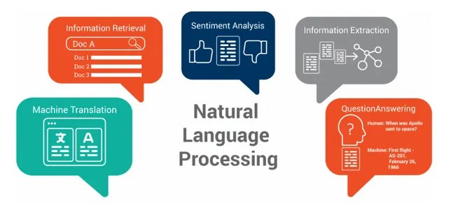

Here's a basic example using **Python** and the **NLTK** **library** for text analysis

Import nltk

From nltk.sentiment.vader import SentimentIntensityAnalyzer

# Sample text data

Text = “I love this product. It’s fantastic!”

# Initialize the VADER sentiment analyzer

Sid = SentimentIntensityAnalyzer()

# Perform sentiment analysis

Sentiment_scores = sid.polarity_scores(text)

# Determine the sentiment label based on the compound score

Compound_score = sentiment_scores[‘compound’]

If compound_score >= 0.05:

Sentiment_label = ‘Positive’

Elif compound_score <= -0.05:

Sentiment_label = ‘Negative’

Else:

Sentiment_label = ‘Neutral’

# Generate insights based on sentiment

Insight = “The sentiment of the text is{}with compound score of {:.2f}.”.format(sentiment_label, compound_score)

# Output the insights

Print(insight)

**Explanation**

In this example, we analyze the sentiment of the given text, determine a sentiment label (positive, negative, or neutral), and generate insights based on the sentiment.

The program will output the sentiment insights. For the sample text provided, the output might look like:

**Output:**

The sentiment of the text is Positive with a compound score of 0.73.

Sentiment analysis, also known as opinion mining, is a common NLP task used to determine the sentiment or emotional tone in a piece of text. I’ll provide you with a Python code example using the TextBlob library, which is a simple and beginner-friendly way to perform sentiment analysis.

First, you need to install the **TextBlob** library if you haven’t already. You can **install** it **using** **pip:**

Pip install textbl

Now, you can create a Python script to perform sentiment analysis:

From textblob import TextBlob

# Sample text for sentiment analysis

Text = “I love this product. It’s fantastic!”

# Create a TextBlob object

Analysis = TextBlob(text)

# Perform sentiment analysis

Polarity = analysis.sentiment.polarity

# Determine sentiment based on polarity

If polarity > 0:

Sentiment = “Positive”

Elif polarity < 0:

Sentiment = “Negative”

Else:

Sentiment = “Neutral”

# Output the sentiment and polarity

Print(f”Sentiment: {sentiment}”)

Print(f”Polarity: {polarity:.2f}”)

**In** **this** **code**:

We import the **TextBlob** class from the **textblob** library.

We provide a sample text for sentiment analysis.

We create a **TextBlob** object with the text.

We use the **sentiment**.**polarity** property to calculate the polarity score.

We determine the sentiment (positive, negative, or neutral) based on the polarity score.

When you run the script, it will provide the sentiment and polarity of the sample text. For the given sample text, the output might look like:

Sentiment: Positive

Polarity: 0.73

You can replace the sample text with your own text for sentiment analysis. For more advanced sentiment analysis tasks or large-scale projects, you might consider using more specialized NLP libraries and models like **VADER**, **spaCy**, or pretrained models like **BERT** or **GPT**.

**Continuing** **to** **build** a **sentiment** **analysis** **solution** **using** **NLP** **techniques** **and** **generating** **insights** **offers** **several** **advantages**:

**Understanding** **Customer** **Sentiment**:

It allows you to gain a deeper understanding of how customers feel about your products, services, or brand. This insight can help you make data-driven decisions to improve customer satisfaction and loyalty.

**Market** **Research**:

Sentiment analysis can be used for market research to monitor trends, identify emerging issues, and track the sentiment of competitors. It helps businesses stay competitive and adapt to changing market conditions.

**Content Optimization: By analyzing sentiment in user-generated content, such as reviews and social media posts, you can identify areas for improvement and optimize your content and messaging for better engagement.**

**Content** **Optimization**:

By analyzing sentiment in user-generated content, such as reviews and social media posts, you can identify areas for improvement and optimize your content and messaging for better engagement.

**Customer** **Support** **and** **Feedback**:

Sentiment analysis can be applied to customer support interactions to assess customer satisfaction and identify areas where customer support can be improved. This can lead to better customer experiences.

**Identifying** **Issues**:

It helps in quickly identifying and addressing issues or negative sentiment that could potentially harm your reputation, allowing you to take proactive measures.

**Personalization**:

Sentiment analysis can be used to personalize user experiences. For example, e-commerce sites can recommend products based on a user’s sentiment towards similar products.

**Crisis** **Management**:

In case of a crisis or negative PR, sentiment analysis can help in monitoring the sentiment of public reactions and guiding your response strategy.

**Competitive** **Analysis**:

You can use sentiment analysis to compare your brand’s sentiment with that of competitors, helping you understand your relative market position.

**Feedback** **Loops**:

Continuous sentiment analysis creates feedback loops for ongoing improvements. It helps you track how changes in products or services impact customer sentiment over time.

**Data**-**Driven** **Decision** **Making**:

Sentiment analysis provides quantifiable data for decision-making, reducing reliance on intuition and ensuring that decisions are based on evidence.

**Scalability**:

NLP and sentiment analysis can be automated and scaled to handle large volumes of data, making it suitable for both small businesses and large enterprises.

**Cross**-**lingual** **Analysis**:

NLP tools can be used for sentiment analysis in multiple languages, allowing you to understand global customer sentiment.

**Research** **and** **Insights**:

Sentiment analysis is not limited to business applications. It’s also used in academic research, political analysis, and various fields to gain insights into public sentiment on a wide range of topics.