Application Validator Tool -Documentation

Author: Kiran Madival

Version: 1.0

Date: 24/10/2024

Table of Contents

1. Introduction

2. Features

3. Installation Guide

4. How to Use

5. Technical Overview

6. Credential Management

7. Export and Print Capabilities

8. FAQ

9. Troubleshooting

10. License and Credits

# 1. Introduction

The Application Validator Tool is designed to streamline the process of verifying application installation status across multiple servers. By entering server names and application names, users can instantly check which applications are installed on each server, saving valuable time and effort in application validation tasks. This tool provides a visual interface to display the validation results, making it easy to monitor the application status in a centralized manner.

# 2. Features

* **Quick Verification**: Check the installation status of applications on multiple servers simultaneously.
* **Simple Interface**: User-friendly GUI for adding server and application names and viewing results.
* **Real-Time Results**: Instantly display which applications are installed and which are missing.
* **Export and Print**: Save or print reports for documentation and audit purposes (if applicable).
* **Customizable Options**: Easily add or remove servers and applications to validate based on specific needs.

# 3. Installation Guide

**1. Prerequisites:**  
- Administrator privileges on the machine running the tool.  
- Network connectivity to target servers for retrieving information.

**2. Installation Steps:**  
- Download the tool’s executable file.  
- Right-click the file and select 'Run as Administrator.'

# 4. How to Use

## Main Interface

The tool features a clean and organized layout (as shown below):  
  
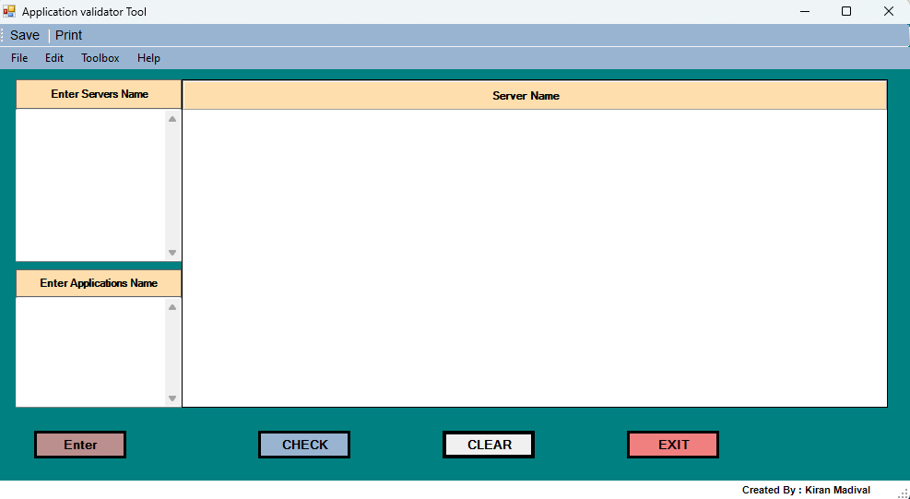

* Enter Server Names: In the 'Enter Servers Name' field, add the names of the servers you wish to validate.
* Enter Application Names: In the 'Enter Applications Name' field, list the applications you want to check.
* Check Application Status: Click on the CHECK button to display the installation status of each application on the specified servers.
* View Results: The main display area will show each server along with the corresponding application status (e.g., Installed or Not Installed).
* Clear Data: Use the CLEAR button to reset the fields and enter new server or application details if needed.
* Exit: Click on EXIT to close the tool when finished.

Example:  
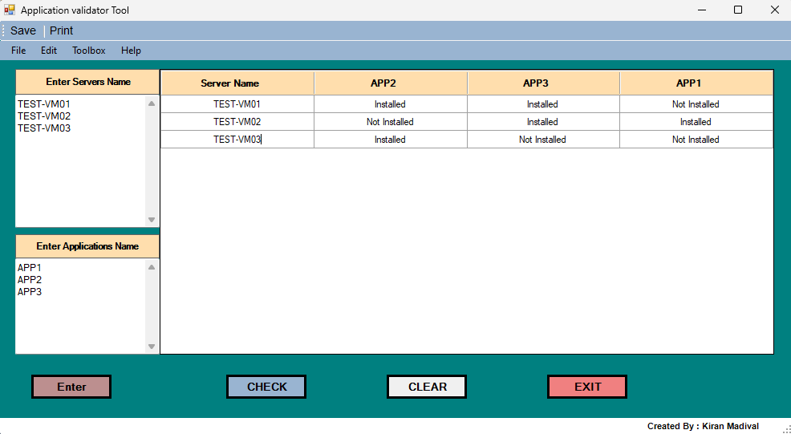

# 5. Technical Overview

**Language**: Developed using PowerShell and Windows Forms for the GUI.

**Input Fields**: Server names and application names are taken as input to dynamically validate application installations.

**Main Functionality**: Uses PowerShell commands to remotely connect to specified servers and verify application installation status.

# 6. Credential Management

Enter your credentials once, and the tool takes care of the rest. Stored temporarily in C:\temp, these credentials are ready for action through your entire session. When you hit "Clear" or close the tool, we’ll clear them out instantly—keeping things safe, simple, and secure.

# 7. Export and Print Capabilities

The tool includes options for exporting and printing reports:  
  
Export to Excel/PDF/CSV: Allows users to save validation results in multiple formats for record-keeping and audits.  
Print: Provides a print option for hard-copy documentation of validation results.

# 8. FAQ

### Q1: Can I add multiple applications at once?

A1: Yes, simply enter the names of the applications you want to check in the 'Enter Applications Name' field.

### Q2: What types of applications can this tool validate?

A2: This tool can check for any applications that are installed on the specified servers, provided it has the necessary permissions.

### Q3: Is this tool compatible with non-Windows servers?

A3: Currently, this tool is designed for Windows-based environments.

# 9. Troubleshooting

### Issue: Results are not displaying after pressing CHECK.

Solution: Ensure that the server names and application names are entered correctly and that you have network access to the servers.

### Issue: Unable to connect to a server.

Solution: Verify that the server is online and that you have the necessary permissions and credentials to access it.

# 10. License and Credits

Developed by: Kiran Madival

Acknowledgments: Feedback and suggestions for improvements are always welcome.