Drive Space Monitoring Tool – Documentation

Author: Kiran Madival

Version: 1.0

Date: 24/10/2024

Table of Contents

1. Introduction

2. Features

3. Installation Guide

4. How to Use

5. Technical Overview

6. Credential Management

8. FAQ

9. Troubleshooting

10. License and Credits

# 1. Introduction

The Drive Space Checking Tool is designed to assist administrators in monitoring disk usage across multiple servers. This tool allows users to quickly check the available and used disk space on specified drives, providing a clear overview of each server's storage capacity. It also offers features to export and print disk usage reports, making it easier to track storage trends over time.

# 2. Features

* **Multi-Server Disk Check:** Check disk space on multiple servers simultaneously by entering server names.
* **Detailed Drive Information:** Displays total space, free space (in GB), and free space percentage for each drive on each server.
* **User-Friendly Interface:** Simplifies navigation and operation for quick and efficient drive space monitoring.
* **Export and Print:** Ability to save or print drive space information for documentation and audit purposes.
* **Clear and Exit Options:** Easily reset the fields for a new operation or exit the tool.

# 3. Installation Guide

**1. Prerequisites:**  
- Administrator privileges on the machine running the tool.  
- Network connectivity to target servers for retrieving drive information.

**2. Installation Steps:**  
- Download the tool’s executable file.  
- Right-click the file and select 'Run as Administrator.'

# 4. How to Use

## Main Interface

The tool features a clean and organized layout (as shown below):  
  
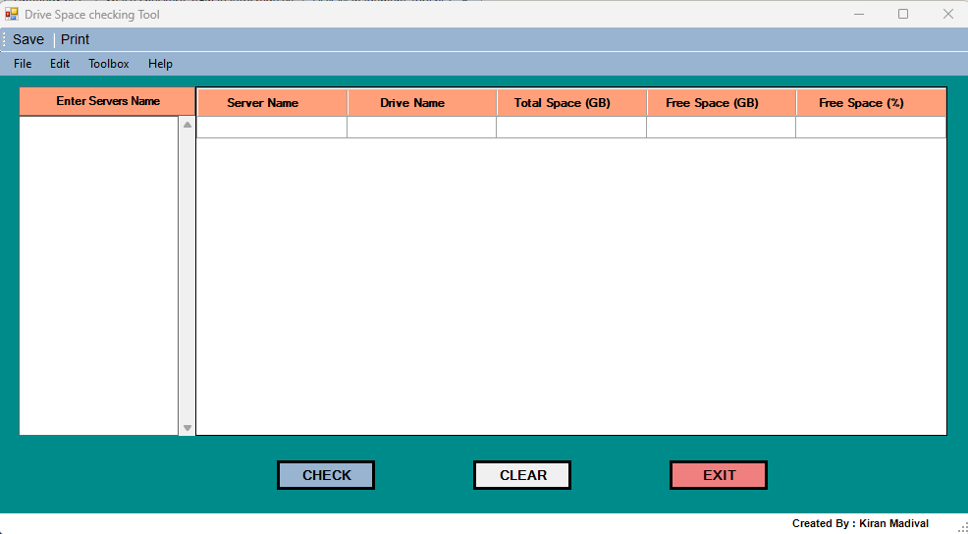

* **Enter Server Names:** Input server names in the 'Enter Servers Name' section on the left.
* **Check Disk Space:** Click CHECK to load disk information for each drive on the specified servers.
* **Save or Print:** Use the 'Save' or 'Print' options in the menu to document the current disk space details.
* **Clear Fields:** Press CLEAR to reset the tool and prepare it for a new operation.
* **Exit Tool:** Press EXIT to close the application.

Example:  
  
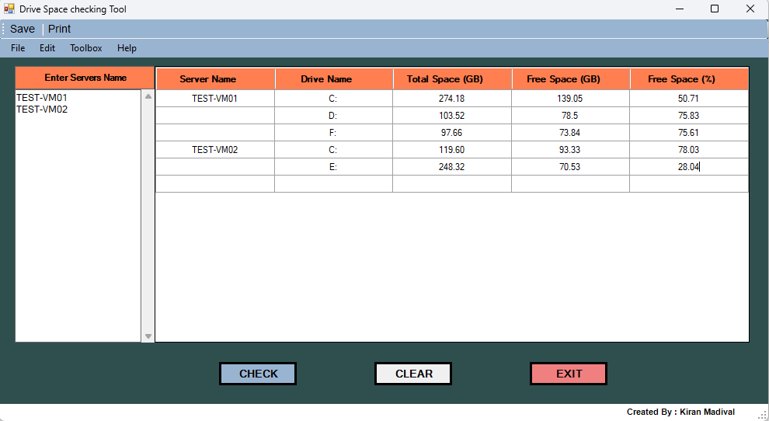

# 5. Technical Overview

The Drive Space Checking Tool leverages PowerShell scripting combined with Windows Forms to create an intuitive interface for monitoring disk usage across remote servers. It uses Windows Management Instrumentation (WMI) to retrieve disk space information and display it in a structured format.

**Core Components:**  
- PowerShell Scripting: Provides the backend logic to retrieve disk space information.  
- Windows Forms GUI: Ensures an intuitive user experience.  
- WMI Integration: Enables remote disk space data collection from servers.  
- Export Functionality: Allows exporting drive space data to Excel, PDF, or CSV.

# 6. Credential Management

Say goodbye to repeated logins! Enter your credentials once, and the tool remembers them—just for this session. They’re securely parked in **C:\temp** and automatically erased on exit or when you clear, giving you full control with zero hassle.

7. Export and Print Capabilities

The tool includes export and print options to facilitate auditing and documentation:  
- Export: Save the drive space information in Excel, PDF, or CSV formats.  
- Print: Generate a hard copy of the current disk usage details directly from the tool.

# 8. FAQ

**Q: Can this tool check disk space on Linux servers?**

A: No, this tool is specifically designed for checking disk space on Windows servers.

**Q: What if a server is unreachable?**

A: The tool will display an error message and allow you to proceed with other available servers.

Q: Do I need admin rights on the target servers?

A: Yes, administrator privileges are required to retrieve drive space information remotely.

# 9. Troubleshooting

- Unable to load disk space data: Ensure the server names are correct and the target servers are reachable.  
- Permission Denied: Run the tool with administrator privileges to access disk space information.  
- Error in data retrieval: Check network connectivity and ensure WMI service is enabled on target servers.

# 10. License and Credits

Developed by: Kiran Madival  
Acknowledgments: Suggestions and feedback for improvement are welcome.