A

Project Report

on

# To Supply Leftover Food To Poor

by

### Kiranmai Nalla

from

### CMR Technical Campus

as part of

### Salesforce Developer Virtual Internship

organised by



in collaboration with



# 

# Project Overview

This project, "To Supply Leftover Food to the Poor," is focused on addressing the challenge of food waste and hunger in underserved communities. Designed to connect surplus food from donors to those in need, the initiative leverages the Salesforce platform to streamline the collection, management, and distribution processes. By creating a centralized system for donor registration, recipient tracking, and logistics coordination, the project aims to bridge the gap between food surplus and scarcity effectively.

Through this initiative, we aim to enhance the operational efficiency of food redistribution, improve the accessibility of surplus food for vulnerable populations, and reduce overall food waste. By fostering collaboration among donors, volunteers, and recipient organizations, the project supports long-term goals of promoting social equity and sustainability while building stronger community partnerships.

# Objectives

The primary objective of this project is to address the dual challenges of food waste and hunger by creating a sustainable system for redistributing surplus food to those in need. By establishing a streamlined process, the project aims to connect food donors, such as restaurants, event organizers, and households, with community organizations and individuals facing food insecurity. This initiative seeks to build a reliable network for food collection, storage, and distribution while fostering a culture of social responsibility among individuals and businesses.

Another key objective is to ensure the efficient and equitable delivery of food donations through a user-friendly platform that simplifies coordination and tracking. The project aims to deliver measurable results, such as reducing food waste, improving access to nutritious meals for vulnerable communities, and fostering partnerships among stakeholders. Additionally, the initiative seeks to enhance community awareness about the importance of addressing hunger and promoting sustainability, ultimately contributing to the well-being and resilience of society.

Businees Goals

The primary business goal of this project is to significantly reduce food waste by creating a streamlined and efficient system for surplus food redistribution. By leveraging the Salesforce platform, the project aims to build a robust network of donors, volunteers, and recipient organizations. This network will enable restaurants, caterers, event organizers, and households to seamlessly donate excess food, fostering a culture of sustainability and social responsibility.

Additionally, the project seeks to strengthen community engagement by encouraging businesses and individuals to actively contribute to combating hunger. Through these efforts, the initiative aims to establish strong partnerships with key stakeholders, promoting corporate social responsibility and enhancing the collective effort to address food insecurity.

The project also targets specific measurable outcomes to ensure its success and scalability. One key deliverable is the development and implementation of a user-friendly Salesforce-based platform that facilitates food donation management, real-time logistics coordination, and recipient tracking.

The platform will aim to collect and distribute surplus food to a significant number of underprivileged individuals or families each month, with a focus on meeting specific benchmarks to evaluate impact. Compliance with food safety standards will be a priority to ensure that quality and safe food reaches recipients.

Furthermore, the initiative will generate detailed analytical reports to track progress, measure outcomes, and identify opportunities for improvement. By achieving these objectives, the project will address both immediate and long-term challenges of food waste and hunger in a sustainable and scalable manner.

# Salesforce Key Features and Concepts Utilized

This project extensively leverages Salesforce's powerful capabilities to build a streamlined and effective system for managing surplus food distribution. Key features include the creation of

**Custom Objects**

Custom objects were created to organize and manage specific data sets related to the project, such as donor information, recipient details, food inventory, and logistics. These objects, which serve as the foundation for organizing and managing data related to donors, recipients, food inventory, and logistics.They ensure that all relevant information is stored in an easily accessible and structured manner.

**Custom Tabs**

Custom tabs were implemented to enhance navigation and usability within the Salesforce environment. Each tab is linked to a specific object or functionality, such as donor management, food inventory, or reporting. These tabs make it easy for users to locate and interact with the data and tools relevant to their roles, ensuring a smooth user experience.

**The Lightning App Builder**

The Lightning App Builder was utilized to create a dynamic and visually appealing Home Page for the project. This page serves as the central hub, integrating various components like flows and dashboards to provide a comprehensive view of the project's activities and progress.

The intuitive design allows users to quickly access critical information and actions, improving operational efficiency.

**Fields**

Custom fields were added to capture and display essential data within each object. These fields ensure that all necessary information, such as food type, quantity, expiration date, donor details, and recipient needs, is recorded accurately. By tailoring fields to the specific requirements of the project, data relevance and integrity are maintained.

**Flows**

Flows were used to automate complex processes and workflows, such as assigning volunteers for food pickups, notifying stakeholders about new donations, and managing the distribution of surplus food. These automation tools reduce manual effort, minimize errors, and ensure timely execution of tasks, improving overall operational efficiency.

**Triggers**

Triggers were implemented to execute specific actions automatically when predefined events occur. For example, triggers can update inventory records when a new donation is added or send notifications to volunteers when food is ready for pickup. These features enable real-time responses and maintain data consistency across the platform.

**Profiles**

User roles and permissions were managed using profiles. This ensures that each user has access only to the data and functionalities relevant to their responsibilities. For example, administrators have full access to the system, while volunteers or donors are granted restricted access based on their roles. This feature ensures data security and streamlined operations.

**Public Groups**

Public groups were created to facilitate collaboration and communication among stakeholders, such as volunteers, donors, and administrators. These groups enable sharing of specific data and functionalities, fostering teamwork and coordination in executing the project's objectives.

#### Report Types, Reports, and Dashboards

Custom report types were defined to generate meaningful insights from the data collected in the system. Reports were designed to track key metrics, such as the number of meals distributed, food donations received, and volunteer activities. Dashboards provided real-time visualizations of these metrics, enabling stakeholders to monitor progress, identify trends, and make informed decisions to optimize the project's impact.

# Detailed Steps to Solution Design

# 

### Steps for Salesforce Developer Account Creation and Activation

A Salesforce Developer Account is essential for building and testing custom applications on the Salesforce platform. Below are the detailed steps to create and activate a Salesforce Developer Account:

##### Step 1: Visit the Salesforce Developer Website

1. Open your preferred web browser and go to the official Salesforce Developer site: <https://developer.salesforce.com/>.
2. On the homepage, click on the **"Sign Up"** button in the top-right corner.

##### Step 2: Fill Out the Registration Form

1. Provide your personal details such as name, email, role, company, and country.
2. Create a unique username in the format of an email address (e.g., yourname@developer.com), accept the terms, and click **"Sign Up"**.

##### Step 3: Activate Your Account

1. After signing up, Salesforce sends an account activation email to the email address you provided during registration.
2. Open the activation email from Salesforce .
3. Click on the **"Verify Account"** or **"Activate Your Account"** link in the email.

##### Step 4: Set Your Password

1. Create a secure password, confirm it, and choose a security question with an answer.
2. Click **"Save"** or **"Submit"** to complete the activation process.

##### Step 5: Log In to Your Developer Account

1. Once your account is activated, you will be redirected to the Salesforce login page.
2. Enter your **Username** and **Password** to log in.
3. After logging in, you will see the Salesforce Developer dashboard, where you can begin building and testing applications.

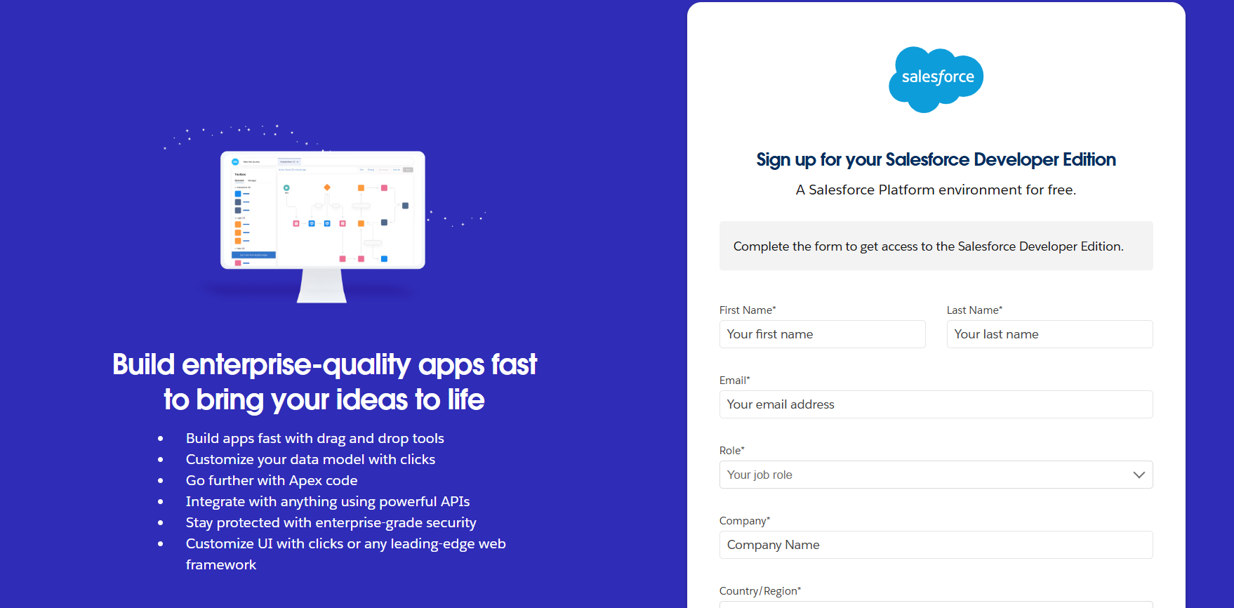

fig.1:Salesforce Developer signup page

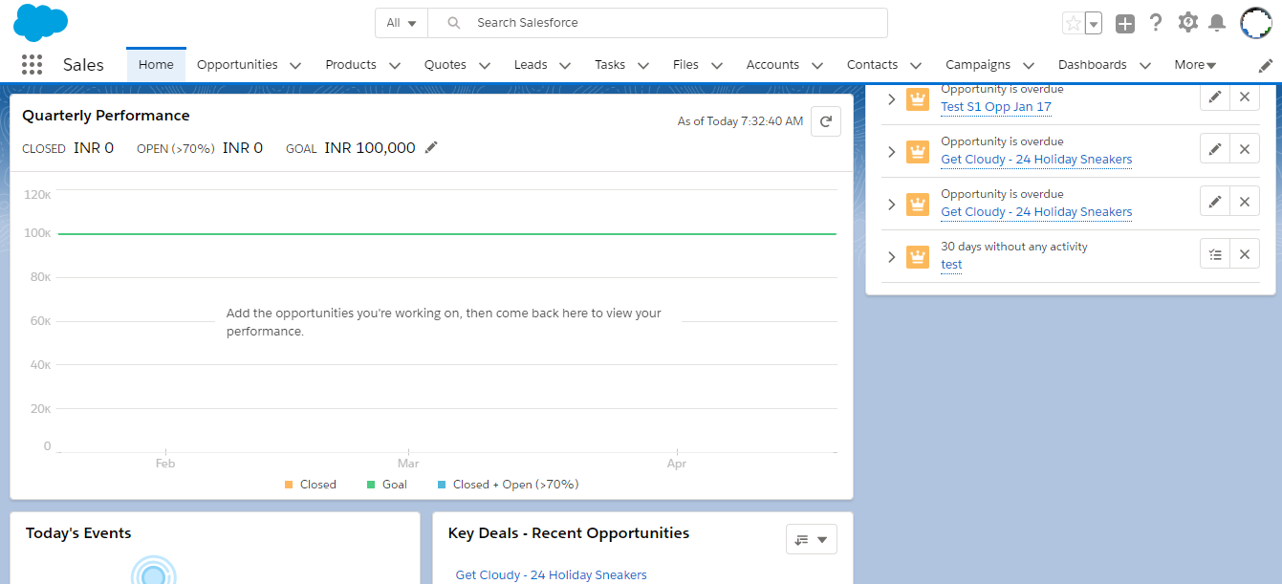

fig.2: Salesforce Developer page

### Object Creation in Salesforce

Salesforce objects are used to store data related to an application. Custom objects are created to meet specific requirements for storing and managing unique data.

**1. Venue Object**

The Venue object stores information about food distribution venues, including venue name, email address, and contact details, enabling efficient location management.

**2. Drop-Off Point Object**

The Drop-Off Point object tracks locations where donated food can be collected or delivered, including details like location name and operational timings.

**3. Task Object**

The Task object records specific activities or responsibilities, including task descriptions, assigned users, and deadlines, ensuring project goals are met.

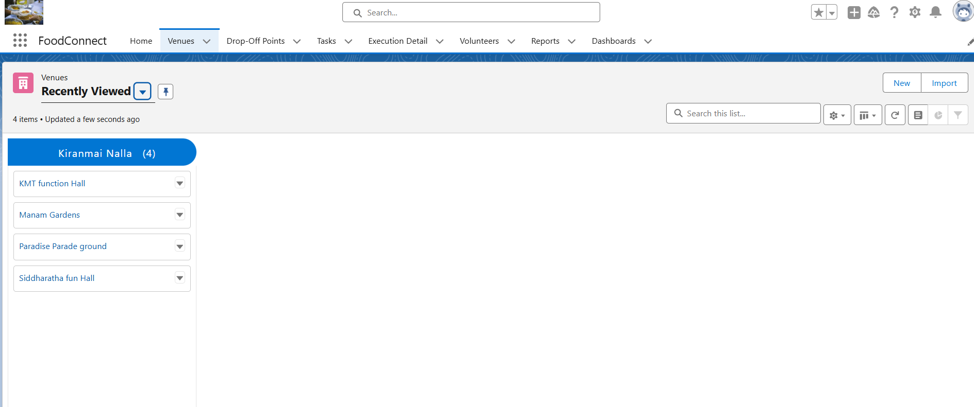

fig.3: Objects created for the application.

#### 4. Volunteer Object

The Volunteer object manages volunteer information such as name, contact details, and assigned tasks, facilitating efficient task delegation.

#### 5. Execution Details Object

The Execution Details object captures the progress and status of tasks, tracking metrics like completion rates and volunteer performance for reporting purposes.

### Tabs in Salesforce

In Salesforce, tabs provide a user interface to access custom objects, records, and other Salesforce functionalities. They are displayed in the navigation bar and allow users to interact with data directly.

### Steps to Create Custom Tabs for Objects

#### Step 1: Navigate to Setup

1. Log in to your Salesforce Developer account.
2. In the top-right corner, click the **gear icon** and select **Setup**.

#### Step 2: Access the Tabs Section

1. In the Setup menu, type **"Tabs"** in the Quick Find box.
2. Click on **Tabs** under the **User Interface** section.

#### Step 3: Create a Custom Tab

1. Click the **"New"** button next to the **Custom Object Tabs** section.
2. Select the object for which you want to create a tab (e.g., Venue, Drop-Off Point, etc.) from the dropdown menu.
3. Choose a **Tab Style** to represent the object visually (e.g., an icon or color).

#### Step 4: Add to Applications

1. Assign the custom tab to specific applications. For this project, include the tabs in the **custom application** related to food distribution.
2. Check the relevant applications where the tab should appear.

#### Step 5: Save and Activate

1. Click **Next**, review the tab settings, and click **Save**.
2. The tab is now created and added to the application for user access.

### Custom Tabs for Each Object

#### 1. Venue Tab

The Venue tab allows users to view, create, and manage venue records, including names, addresses, and associated events.

#### 2. Drop-Off Point Tab

The Drop-Off Point tab displays information about collection or delivery points, helping users track operational locations efficiently.

#### 3. Volunteer Tab

The Volunteer tab provides access to volunteer records, allowing users to manage contact details and assign roles or responsibilities.

#### 4. Task Tab

The Task tab lets users view and update task-related data, such as task descriptions, deadlines, and assignments.

#### 5. Execution Details Tab

The Execution Details tab gives insights into task progress, volunteer participation, and overall execution metrics, aiding in project monitoring and reporting.

By creating these custom tabs, the project ensures easy navigation and efficient management of key data for the "Supply Leftover Food to Poor" initiative.

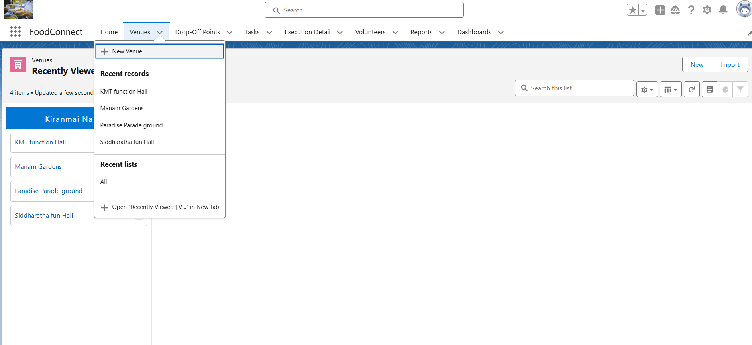

fig.4: Tabs for custom objects.

### Creating a Lightning App in Salesforce

A Lightning App in Salesforce provides a custom interface that integrates relevant objects, tabs, and tools to streamline workflows. For the "Supply Leftover Food to Poor" project, a Lightning App was created to manage data for Venue, Drop-Off Point, Volunteer, Task, and Execution Details objects effectively.

#### Steps to Create a Lightning App

#### Step 1: Navigate to the App Manager

1. Log in to your Salesforce Developer account.
2. Go to **Setup** by clicking the gear icon in the top-right corner.
3. In the Quick Find box, type **"App Manager"** and click on it.

#### Step 2: Start Creating a New Lightning App

1. Click the **"New Lightning App"** button in the App Manager.
2. Choose **App Type** as **Lightning App** and click **Next**.

#### Step 3: Configure App Details

1. Provide a name for the app (e.g., "Food Connect Management").
2. Enter a **Description** (e.g., "Manage food distribution processes and resources efficiently").
3. Upload a logo for visual identification (optional).
4. Click **Next** to proceed.

#### Step 4: Set Navigation and Utility Items

1. Choose the **Navigation Style** as **Standard Navigation** for desktop access.
2. Add utility bar items (optional) like **Notes**, **History**, or **Chatter** to assist users.
3. Click **Next** to continue.

#### Step 5: Add Tabs to the Lightning App

1. Select relevant objects (e.g., Venue, Drop-Off Point, Volunteer, Task, Execution Details) and include them as tabs in the app.
2. Add other essential tabs, such as **Reports**, **Dashboards**, or any custom tabs created.
3. Click **Next** after arranging the tabs in the desired order.

#### Step 6: Assign User Profiles

1. Assign the Lightning App to user profiles, such as **System Administrator** or **Standard User**, based on access requirements.
2. Click **Save & Finish** to complete the app creation process.

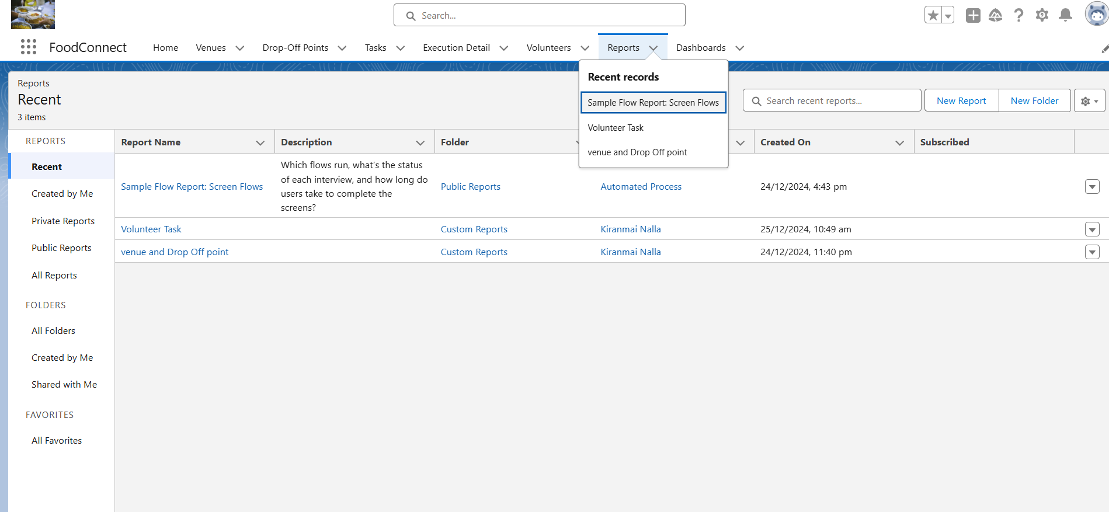

fig.5: Reports and dashboards for lighting app.

### Usage of the Lightning App

The Lightning App for the "Supply Leftover Food to Poor" project enables seamless management and monitoring of key aspects:

1. **Centralized Management:** Users can manage venues, drop-off points, volunteers, tasks, and execution details from a unified interface.
2. **Improved Efficiency:** The app organizes workflows, allowing for quick navigation between objects and reducing time spent on data entry and retrieval.
3. **Enhanced Reporting:** Integrated **Dashboards** and **Reports** help monitor task completion, volunteer participation, and distribution metrics effectively.
4. **User Collaboration:** Utility tools like **Chatter** facilitate communication and collaboration among team members.
5. **Customizable Layout:** The app adapts to user preferences, ensuring a smooth user experience tailored to the project's needs.

This Lightning App serves as the backbone of the project, empowering stakeholders to achieve the initiative's goals efficiently.

### Flows in Salesforce

Salesforce Flows are powerful automation tools that allow users to collect data, update records, automate processes, and streamline workflows through a visual interface. Flows enable users to create guided experiences and automate repetitive tasks without requiring extensive coding knowledge.

For the "Supply Leftover Food to Poor" project, a **Screen Flow** called **"Venue Form" Flow** was created to collect details about venues, such as Venue Name, Email, Phone Number, Latitude, and Longitude.

### Steps to Create the "Venue Form" Screen Flow

#### Step 1: Navigate to Flow Builder

1. Log in to your Salesforce Developer account.
2. Go to **Setup** by clicking the gear icon.
3. In the Quick Find box, type **"Flows"** and select **Flows**.
4. Click **New Flow**, then choose the **Screen Flow** type and click **Create**.

#### Step 2: Configure Flow Properties

1. Set the **API Name** as Venue_Form.
2. Add a **Description** (e.g., "A Screen Flow to collect venue details for the food distribution project").
3. Click **Save** to secure your flow configurations.

#### Step 3: Add Input Fields to the Flow Screen

1. Drag and drop the **Screen Element** onto the canvas.
2. Name the screen **"Venue Details Form"**.
3. Add fields: Venue Name, Email, Phone Number, Latitude, and Longitude. Click **Done**.

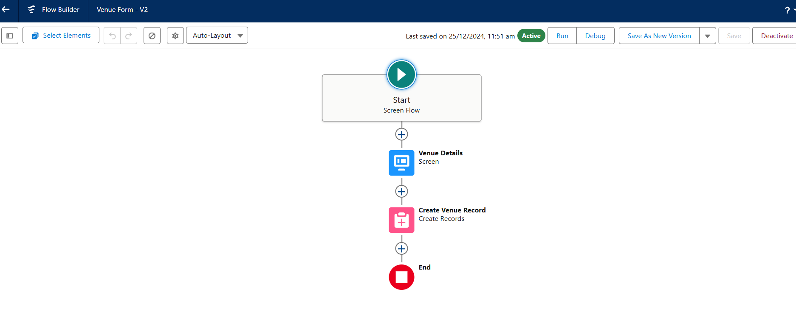

fig.6: Screen Flow for Venue From.

#### Step 4: Store Data in Salesforce

1. Drag and drop the **Create Records** element onto the canvas.
2. Configure it to create a new record in the **Venue Object**.
3. Map each input field (Venue Name, Email, etc.) to its respective field in the object.

#### Step 5: Add Flow Navigation

1. Connect the **Start** node to the **Venue Details Form** screen.
2. Link the **Screen Element** to the **Create Records** element.
3. Connect the **Create Records** element to the **End** node.

#### Step 6: Save and Activate the Flow

1. Click **Save** to ensure all configurations are stored.
2. Click **Activate** to make the flow available for use.

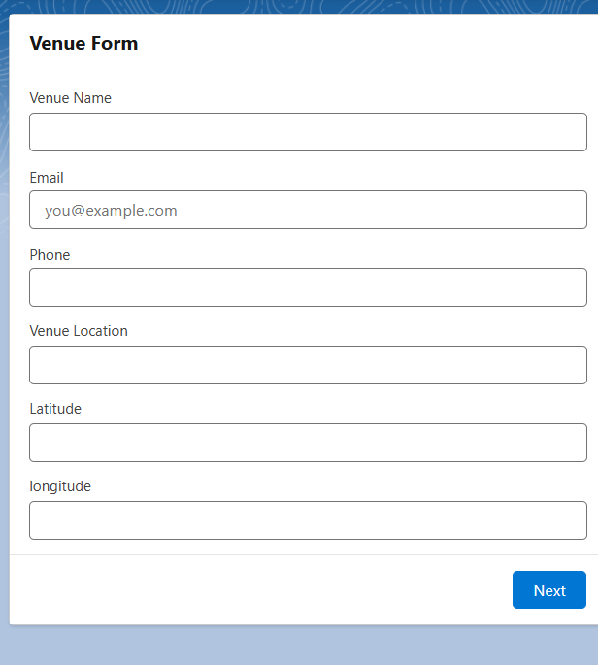

fig.7:Venue From For Home Page.

### Triggers in Salesforce

Triggers in Salesforce are Apex scripts that execute automatically when specific database events, such as insert, update, delete, or undelete, occur on an object. Triggers are used to automate processes, enforce business logic, or perform complex data manipulations.

In the "Supply Leftover Food to Poor" project, an Apex Trigger named **"Drop-Off Point"** was created to automate processes related to managing drop-off point records.

#### Purpose of the "Drop-Off Point" Trigger

This Trigger is to assign Distance field to the Distance Calculation field. So that we can assign the distance in the sharing rules.

#### Trigger Code

**Code:**

trigger DropOffTrigger on Drop_Off_point__c (before insert) {

for(Drop_Off_point__c Drop : Trigger.new){

Drop.Distance__c = Drop.distance_calculation__c;

}

}

### Steps to Create the "Drop-Off Point" Trigger

1. Navigate to Developer Console
2. Create a New Trigger
3. Write the Trigger Logic
4. Save and Test the Trigger

### Creation of Reports in Salesforce

Reports in Salesforce are essential tools for analyzing data, tracking performance, and gaining actionable insights. A report organizes data into rows and columns, allowing users to view, filter, and summarize records based on specific criteria. Salesforce provides various report types and formats to cater to diverse reporting needs.

**Steps to create the Reports**

1. Go to the app(FoodConnect) >> click on the reports tab
2. Click on New Folder.

Folder Label : Custom Reports

Folder Unique Name : CustomReports

1. Open Custom Reports and click on New Report
2. Select Report Type : Venue with DropOff with Volunteer
3. Then click on Start Report.

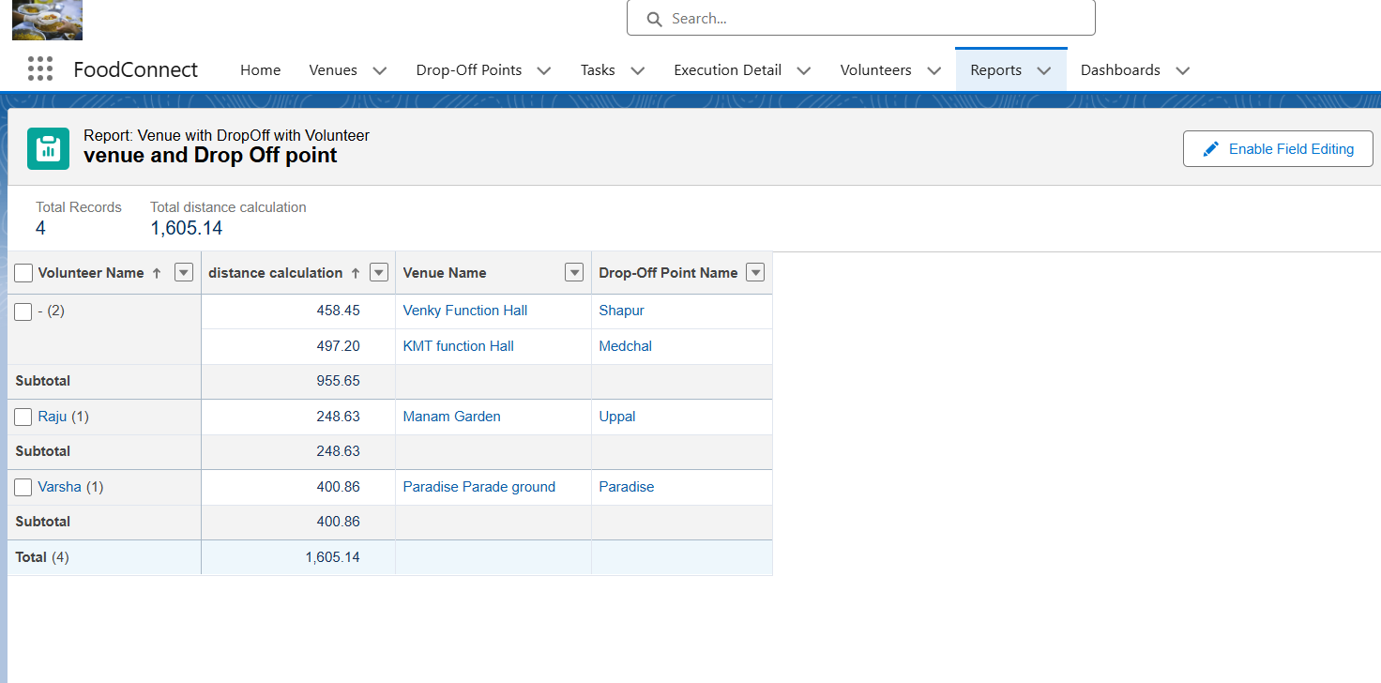

fig.8: Reports for data stored.

6.In GROUP ROWS : Add Volunteer Name

7.In Columns : Add Venue Name, Drop-Off point Name, Distance.

8.Now click on Save & Run.

9.Give Label as :

10.Report Name : venue and Drop Off point

11.Report Unique Name : Auto Populated

12.Click on Select Folder and select Custom Report, then click on Save.

### Dashboards in Salesforce

Dashboards in Salesforce are visual representations of reports, providing at-a-glance insights into key metrics and performance indicators. A dashboard comprises multiple components, such as charts, graphs, and tables, each tied to a report. Dashboards help stakeholders monitor data trends and make informed decisions efficiently.

#### Steps to Create a Dashboard in Salesforce

1. Navigate to Dashboards Tab
2. Configure Dashboard Properties
3. Add Dashboard Components
4. Adjust Dashboard Settings
5. Save and Share the Dashboard

### Usage in the "Supply Leftover Food to Poor" Project

For the project, dashboards serve as critical tools to track and visualize:

* **Venue Coverage:** A pie chart showing the distribution of active vs. inactive venues.
* **Task Progress:** A bar graph illustrating task completion rates by volunteer teams.
* **Volunteer Performance:** Metrics highlighting individual or group contributions.
* **Execution Metrics:** Insights into food distribution timelines and efficiencies.

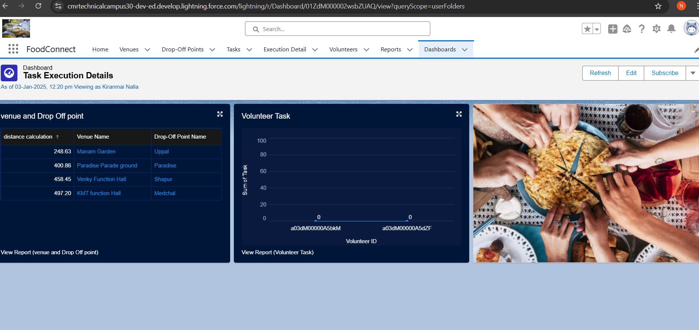

fig.9: Dashboards created for the application.

### Creation Of Home Page

1. Go to setup >> type Lightning App Builder in quick find box >> Click on the Lightning App Builder and Select the New.
2. Select Home Page and give Label as HOME Page.
3. Select Standard Home Page.
4. Near Components search for Flow and Drag and Drop in Right Side Section..
5. On the right hand side:

Flow : Venue Flow

1. Near Components search for Dashboard, then Drag and Drop it in first Section.
2. Click on Save and Activation, then click on App Default, then Add Assignments.
3. Add FoodConnect App and then Save.

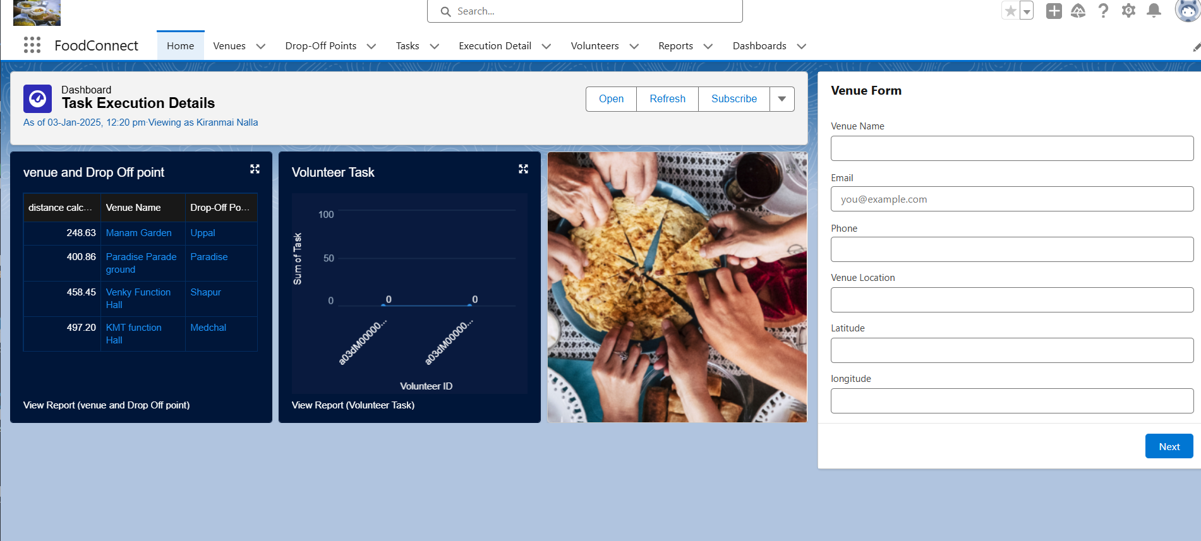

fig.10: Home Page

# Testing and Validation

Thorough testing and validation ensure that the Salesforce solution functions as expected and meets project requirements. For the "Supply Leftover Food to Poor" project, testing was carried out across multiple levels to ensure reliability, performance, and user satisfaction.

### Unit Testing

Unit testing focuses on verifying the correctness of Apex classes and triggers by simulating different scenarios and evaluating how the system behaves. For this project, test classes were created using Salesforce’s testing framework, leveraging mock data to validate functionality.

The **Drop-Off Point Trigger** was tested to ensure it correctly validates latitude and longitude values and automates volunteer assignment. Achieving over 75% code coverage was crucial to meet Salesforce deployment standards and to ensure the application’s robustness.

### User Interface Testing

User interface (UI) testing ensures that the application’s front end is user-friendly, fully functional, and error-free. Screen flows, such as the **Venue Form Flow**, were thoroughly tested to confirm that all input fields worked correctly and that data was saved properly to the related objects.

Custom tabs for objects like **Venue**, **Drop-Off Point**, **Volunteer**, and **Tasks** were validated for usability and accessibility. The Lightning App created for the project was tested to ensure its components, navigation, and layout were intuitive and efficient.

# Key Scenarios Addressed by Salesforce in the Implementation Project

The "Supply Leftover Food to Poor" project leverages Salesforce's powerful features to address a range of real-world use cases. These scenarios demonstrate how Salesforce effectively supports various processes and ensures seamless execution of the project's objectives.

### 1. Venue Management

Salesforce handles the creation and management of venue records, including critical details like venue name, contact information, and geolocation (latitude and longitude). This enables accurate tracking of food collection points and ensures the efficient assignment of tasks to volunteers.

### 2.Volunteer Allocation

By utilizing custom objects and triggers, Salesforce automates the assignment of volunteers to specific venues or tasks based on availability and proximity. This ensures an equitable workload distribution and minimizes manual intervention, enhancing operational efficiency.

### 3. Task Tracking and Execution

Salesforce allows for the creation, tracking, and monitoring of tasks through custom objects and Lightning components. Administrators can assign tasks to volunteers, track their progress, and ensure timely execution, improving overall accountability.

### 4. Data Collection and Validation through Screen Flows

Custom screen flows, such as the **"Venue Form" Flow**, streamline the collection of essential data. The flow validates user inputs in real time, ensuring data integrity and accuracy, while reducing errors during the data entry process.

### 5. Centralized Reporting and Insights

Salesforce provides robust reporting capabilities to track key metrics like venue coverage, task progress, volunteer performance, and food distribution efficiency. These reports allow stakeholders to make data-driven decisions and monitor the project’s overall success.

### 6. Real-Time Notifications and Updates

With Apex triggers and workflow automation, Salesforce ensures that users are notified of critical updates, such as new drop-off points or task completions. This facilitates proactive management and timely interventions.

### 7. Scalability and Future Enhancements

Salesforce’s scalable platform enables the project to expand by adding new venues, tasks, or volunteers. The system is designed to accommodate additional requirements or functionalities, ensuring long-term sustainability.

# Conclusion

The "Supply Leftover Food to Poor" project successfully demonstrates how Salesforce can be leveraged to streamline and automate critical processes for a social initiative. Through the implementation of custom objects, screen flows, Apex triggers, and robust reporting, the project addresses key operational challenges and delivers an efficient system for managing venues, volunteers, tasks, and drop-off points.

This project has achieved significant milestones, including the creation of a centralized platform for data management, automation of volunteer assignments, validation of geolocation data for venues and drop-off points, and real-time tracking of task progress. Additionally, dashboards and reports provide actionable insights, empowering stakeholders to monitor performance and make informed decisions.

Overall, the project showcases Salesforce's capabilities in building scalable, efficient, and user-friendly solutions for impactful social causes. The system is poised to scale further and adapt to future needs, ensuring the initiative continues to deliver value and foster positive change in the community.