**Plant Disease Prediction**

*by*

**C THANMAYEE REDDY 22MIS1056**

**MVNSS KIRANMAI 22MIS1096**

**GADDAM NIKITHA 22MIS1178**

*under the guidance of*

**Dr. Pattabiraman V.**

in partial fulfillment of the course

**SWE2009 - Data Mining Techniques**



**School of Computer Science and Engineering**

**Vellore Institute of Technology**

**Chennai – 600127**

**April 2024**

**BONAFIDE CERTIFICATE**

Certified that this project report entitled “**Plant Disease Prediction”** is a bonafide work of **C Thanmayee - 22MIS1056, MVNSS Kiranmai – 22MIS1096, Gaddam Nikitha – 22MIS1178,** who carried out the Project work under my supervision and guidance for **SWE2009-Data Mining Techniques.**

**Dr. Pattabiraman V.**

Professor

School of Computer Science and Engineering (SCOPE),

VIT University, Chennai

Chennai – 600 127.

**Dataset Link:** <https://www.kaggle.com/datasets/abdallahalidev/plantvillage-dataset>

**TABLE OF CONTENTS**

|  |  |
| --- | --- |
| **S. No** | **Content** |
| **-** | Bonafide Certificate |
| **-** | Acknowledgements |
| **1** | Abstract |
| **2** | Scope |
| **3** | Objective |
| **4** | Introduction |
| **5** | Literature Review |
| **6** | Data Description |
| **7** | Architecture |
| **8** | Proposed Methodology |
| **9** | Novelty |
| **10** | Results and Discussion |
| **11** | Results Conclusion |
| **12** | References |
| **13** | Appendix Code |

# **Abstract**

This project uses neural networks (CNN), a powerful tool in image recognition, to solve the important problem of early detection and diagnosis of plant diseases. The CNN model is trained on various datasets containing signature images of healthy and diseased plants. Thanks to this training, the CNN learned to correctly classify new leaf images, quickly distinguish between healthy and diseased samples, as well as identify specific diseases if present. The importance of this distribution for farmers and agricultural experts is its reliability and efficiency. This capability is particularly important in agriculture, where timely response to disease outbreaks can play an important role in reducing crop losses and maintaining crop yields. In addition, the early detection and diagnosis provided by CNN directly contributes to food security and permaculture. By detecting diseased plants early, farmers can implement treatment strategies that will reduce the spread of the disease and the overall impact on crops. Additionally, improving resource use through early intervention is based on permaculture principles that encourage efficient use of resources such as water, pesticides and fertilizers. It plays an important role in protecting food production and supporting long-term agriculture. Harnessing the potential of CNNs holds promise against the ongoing challenges of ensuring food security in a rapidly changing agricultural environment.

***Keywords****:* *Convolutional Neural Networks (CNNs), Early detection, Plant diseases, Dataset, Classification, Healthy vs. diseased plants, Automated process, Farmers, Agricultural experts, Deep Learning, Timely interventions, Crop health, Food security, Sustainable agriculture, Crop losses, Resource utilization, Targeted treatment strategies, Disease management, Technological advancement, Safeguarding food production systems, Agricultural resilience.*

1. **Scope**

The project aims to develop a complex method for early detection and diagnosis of plant diseases using convolutional neural networks (CNN) applied to leaf images. This requires training CNN models on different datasets containing signature images of healthy and diseased plants, focusing on rapid classification and exposure to plant pathogens, including the ability to identify specific pathogens. The project also includes the use of image enhancement techniques to improve the overall capabilities of the model and the use of useful information to analyze the performance and performance of the model. The importance of this program lies in its ability to automate disease detection, improve crop health monitoring and improve resource utilization, directly contributing to food security and long-term agriculture. Additionally, future work will include a review of integration, learning transitions, and continuous improvement models, as well as the integration of auditing and automated study recommendations to increase the efficiency of the application process in agriculture. Finally, the project aims to provide a promising solution to the ongoing challenges of food security in the rapidly changing agricultural environment by leveraging the potential of CNNs.

1. **Objective**

The project aims to change plant diseases and management by collecting large-scale data on plant leaves from previous studies to improve quality. Using this information, a convolutional neural network (CNN) model is trained to separate images into healthy and diseased groups and classify diseases. Simple metrics such as accuracy, precision, recall and F1 score are used in performance evaluation. Once the training is completed, the model will be used as a useful tool in disease detection for farmers and experts. Tests and case studies validate the effectiveness of the approach in real-world situations to improve food security and promote permaculture, while providing participants with reliable disease control tools.

The key objectives include:

* Model Comparison: This project aims to compare different CNN models to determine the best model for separating leaf images into healthy and diseased groups. This includes evaluating factors such as modeling complexity, learning time, and computational performance.
* Optimization: Another aim is to increase the performance of the CNN model in disease classification by improving its hyperparameters and architecture. This includes optimizations such as learning rate, batch size, and layering to increase accuracy and reduce learning time.
* Dataset Diversity: This project focuses on collecting diverse datasets containing signatures of various diseases and healthy leaves. This allows the CNN model to be trained on a variety of scenes, thus improving its ability to expand and accurately classify new images.
* Performance evaluation: It is important to evaluate the performance of the CNN model using metrics such as accuracy, precision, recall and F1 score. These measurements provide a quantitative measure of the model's performance in disease detection, guiding further development and optimization.
* Deployment as a useful tool: After training and evaluation, the trained CNN model will be used as a tool for farmers and agronomists. The device will provide rapid diagnostics, allowing stakeholders to make informed and timely decisions to preserve healthy crops.
* Real-world experiments and research data: The ultimate goal includes experiments and research data to test the effectiveness and efficiency of the theory in the agricultural world. This validation process ensures that the tools developed are valid, reliable and capable of solving the problems faced by farmers in disease diagnosis and control.
* By achieving these objectives: The program aims to revolutionize the prediction and management of plant diseases by achieving these objectives. Farmers and agronomists will have access to powerful and effective tools that can detect diseases accurately and instantly, allowing them to save time and reduce crop losses. Finally, the program contributes to food security, promotes permaculture and improves capacity to adapt to agricultural challenges.

1. **Introduction**

Plant disease prediction is an important field that aims to change agriculture through early detection and accurate classification of diseases. Researchers have made significant progress in identifying diseases using advanced techniques such as neural networks (CNN). Compared with other methods, CNN showed the best ability to identify and classify plant diseases. The aim is to help farmers detect diseases at an early stage, allowing timely intervention.

To achieve this goal, various methods have been applied, such as using CNNs to identify and classify tomato diseases. New technologies, such as coupling with CNNs to detect rice diseases, have achieved good results beyond existing methods. Machine learning techniques such as CNNs and advanced image processing techniques are used to solve the complexity of plant disease prediction.

The combination of pre-CNN models and innovative neural network architectures has led to significant advances in disease detection and classification. Although there are difficulties in obtaining relevant data, researchers are working to create their own data and produce new solutions, resulting in high accuracy. Comparison of traditional machine learning and deep learning shows the superiority of deep learning models, especially CNNs, in terms of their importance in plant disease prediction.

In summary, advances in predicting plant diseases will improve agriculture and crop management. The combination of technology, new methods and efforts to solve existing limitations demonstrates the potential for change in this field.

1. **Literature Review**

Paper [1] demonstrates a method that uses deep learning to identify leaf diseases by taking into account canals and canal pruning systems. Channel tracking helps the model focus on important features, while channel pruning reduces the model's computation by removing unnecessary channels. The aim of this method is to increase the efficiency and accuracy of identification of leaf diseases. Paper [2] reports research on the detection of foliar diseases using image processing. Can discuss various methods and applications in this field such as image classification, extraction, classification algorithms. The aim is to better understand the state-of-the-art for detecting foliar diseases through image analysis.

Paper [3] reviews the use of deep learning techniques for disease detection and classification. Can discuss various deep learning methods and applications for this work, highlighting their advantages, disadvantages and applications. This review provides information on the current state of research using deep learning to identify and classify plant pathogens and aims to guide future research in this field. Paper [4] discusses the application of convolutional neural networks (CNN) in plant disease prediction. CNN is a deep learning model that is especially useful for image analysis tasks. This article will explore how to train a CNN on data of leaf images to predict the presence of disease based on observed symptoms. Our aim is to develop a reliable and effective method for the early detection of plant diseases that are important for crop management and agriculture.

Paper [5] discusses the use of deep neural networks (DNN) in detecting crop diseases.The article can explore how to train a DNN on product images to detect diseases based on visual cues. The aim is to develop effective tools for farmers to detect and control crop diseases, thereby increasing crop yields and reducing losses. Paper [6] proposes a method combining deep learning and social internet of things (IoT) technologies to predict plant diseases. The proposed approach can use deep learning models to analyze data collected by IoT devices in the field of agriculture. Through the integration of social IoT, such as information sharing among farmers, there is a way to improve the accuracy of disease prediction and support permaculture management. The aim is to provide farmers with timely and reliable information to effectively combat pests, thereby increasing yields and promoting permaculture practices.

Paper [7] discusses the use of Internet of Things (IoT) and machine learning to predict plant diseases, focusing on leaf blight of tea trees. Research could explore how IoT devices can be used to collect information about the environment and plant health that can be used to train learning models. The goal is to create a system that can accurately predict tea leaf blight and allow farmers to take preventive measures to protect their crops.

Paper [8] presents PLDD, a deep learning-based leaf disease detection system. The system will use a deep learning model learned from data obtained from the tree's leaves to accurately identify the disease. Using deep learning, the system can learn and extract features in the image and thus find the right bacteria. The aim is to provide farmers with reliable, effective tools to detect and control plant diseases, ultimately increasing yields and farm performance. Paper [9] presents the evaluation of a smart sensor system designed to predict plant diseases using short-term temporal (LSTM) networks. Smart systems can collect information about the environment and the health of plants, which can be used as input to LSTM networks for disease prediction. Field tests can demonstrate the effectiveness and accuracy in predicting plant diseases and demonstrate its potential for practical use in agriculture. The aim is to provide farmers with reliable tools for early detection and control of diseases, ultimately increasing yields and reducing losses.

Paper [10] presents an integrated meta-system for plant disease detection designed for IoT-based environment. This approach can provide multiple classifiers in a unified model using meta-learning techniques to improve overall performance. The lightweight nature of this approach makes it suitable for devices with limited IoT usage. The aim is to provide an effective and accurate way to detect plant diseases in IoT-based agriculture to help farmers manage diseases in a timely manner and increase yields.

1. **Dataset Description**

The given file [11] has three folders (train, test, val) and subfolders for each set of images (health, multidisease, rust, scab). There are 87,848 leaf images divided into 4 categories (healthy, various diseases, rust, scratches). Photos are labeled by the type of disease or type of disease affecting the leaves. This collection includes photographs of vegetation affected by various diseases and conditions, such as rust, scab, and various diseases, as well as photographs of healthy vegetation. This image was collected from the Plant Village warehouse. This information is intended for use in plant disease research and classification.

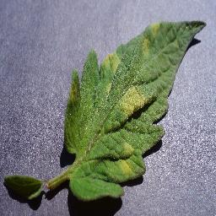

Fig.1 Fig.2

Fig.3 Fig.4

Fig.5 Fig.6

|  |  |  |
| --- | --- | --- |
| **S.no** | **Plant type** | **Category** |
| 1 | Tomato leaf mold | Not healthy |
| 2 | Potato late blight | Not healthy |
| 3 | Grape black rot | Not healthy |
| 4 | Apple black rot | Not healthy |
| 5 | Tomato leaf | Healthy |
| 6 | Raspberry leaf | Healthy |

The images above are some of the images in our healthy or unhealthy database. Grape Black Rot, Potato Late Blight, Fruit Blight, Apple Black Rot fall into the unhealthy category while the other picture of tomatoes and raspberry leaves above belong to the healthy category.

Healthy: This category contains images of leaves that are not affected by any disease or disease. These images can be used as a reference for what healthy vegetation should look like.

Multiple Diseases: This category contains images of leaves affected by more than one disease or condition simultaneously. This could help scientists understand how different diseases interact or co-occur on a single leaf.

Rust: Rust is a fungal disease that affects many plants, including crops such as wheat, corn, and soybeans. Rust in the document includes images of leaves showing signs of rust, such as orange or red-brown blisters on the leaves.

Scab: Scab is another fungal disease that affects plants, causing black skin on leaves and fruits. Scab disease in the literature includes images of leaves showing symptoms of the disease, such as dark, raised lesions on the leaves.

The dataset is preprocessed, including resizing images to similar size, normalizing pixel values, and splitting the dataset into training, validation, and testing sets. Then, choose a suitable machine learning model such as neural network (CNN) for image classification. The architecture of the CNN is designed to specify the number and type of layers (convolutional, pooling, and all layers) as well as dynamic processing. The model is then trained using the previous method and learns to classify the image by adjusting the weight of the image based on the difference between the prediction and the actual text at different times.

During training, the model's performance is evaluated on a practical basis to monitor overfitting. Finally, the training model is tested on the test set to evaluate its performance on unseen data. Once trained and tested, the model can be used in disease detection and plant classification applications, leading to the development of electronic systems for the diagnosis and management of plants.

1. **Architecture**

The Plant Defect Prediction program is designed to meet the urgent need for early detection and diagnosis of plant diseases in the agricultural sector. It starts with obtaining different information that includes pictures of healthy plants and plants suffering from various diseases. These images, captured using digital imaging equipment, were meticulously pre-processed to ensure consistency and improve their quality. Preprocessing steps include resizing the image to standard dimensions, normalization to accommodate changes in illumination and color, and enhancement techniques to improve contrast in the data. Then, some of the data is split for testing and validation purposes, which is important to evaluate the effectiveness of the CNN model.

Through repeated training, the CNN learns to extract important features from images before applying convolution and pooling layers. These extracted features serve as discriminatory markers for different plant pathogens, allowing the model to accurately predict the presence of pathogens in new plant images and classify their consumption as healthy. In addition to disease prediction, the system also provides information such as recommended treatment strategies and preventive measures based on the identified diseases. This approach not only simplifies the process of monitoring the health of crops but also provides timely information to farmers and agronomists to reduce crop losses and increase agricultural productivity.

**OVERALL FLOW DIAGRAM OF PROJECT**

**IMAGE ACQUISITION**

**PRE-PROCESSING OF IMAGE SAMPLE**

**Training**

**Sets**

**Validation Set**

**Feature extraction**

**Feature Extraction**

**CNN**

**Dataset Disease of Leaf**

**Test**

**Display Disease and Solution**

**No**

**Yes**

**Healthy**

**Defect**

Fig.7

1. **Image Acquisition:**

Images in the PlantVillage dataset may have been captured using digital cameras in various locations to capture different plant species and disease symptoms. Focus on visual symptoms such as discoloration. Disease metadata is added to each image for machine learning. Quality control ensures the accuracy of the dataset. Overall, this system creates a comprehensive database for plant disease research and automated surveys.

**Unhealthy leaf sample Healthy leaf sample**

Fig.8 Fig.9

The above are the images of tomato leaves classified into healthy and unhealthy. Fig.8 shows you the unhealthy leaf called tomato late blight whereas Fig.9 shows you the image of a healthy tomato leaf.

1. **Pre-Processing of image sample:**

In predicting plant disease architecture, prioritizing image models is an important step in preparing images for input into machine learning models. This process usually involves resizing the image to the correct size, normalizing pixel values ​​to the sample size, and using data enhancement techniques such as rotation and flipping to show more of the training model.

This step helps create feedback and improve the model's ability to learn from images. Feature extraction techniques such as edge detection or texture analysis can be used to extract relevant features from images. In general, preprocessing plays an important role in improving the quality of input data and improving the performance of learning models for predicting plant diseases.

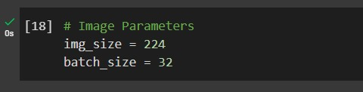

Fig.10

1. **Training sets:**

In this architecture, the training set is a subset of the data containing images of leaves and their corresponding diseases. This technique is used to train learning models to recognize patterns and features in images representing different diseases. By re-presenting training images and adjusting parameters, the model learns to classify images according to symptoms of the disease. The training process usually involves dividing training into groups. Once training is complete, the model can be evaluated on separate batches to ensure its generalization to new, unseen objects. The training process is important for creating accurate and reliable diagnostic models.

Fig.11

1. **Validation set:**

A validation process is a dataset used to evaluate the effectiveness of machine learning models. The validation process differs from the training process to ensure that the model is tested on unseen objects to evaluate its overall ability. By evaluating the model of the implemented system, researchers and developers can identify and resolve issues such as overfitting, where the model performs well on training data but not as well on new information. The validation process helps fine-tune the hyperparameters and architecture of the model to improve its performance and generalization ability. Overall, the validation process played an important role in ensuring the validity and reliability of diagnostic models before they were used in real applications.

Fig.12

1. **Feature Extraction:**

Feature extraction is an important step in leaf image processing to extract important information that can distinguish diseases or conditions. During training, feature extraction is performed on each image in the training set to capture important features such as texture, shape and color. These features are used as input to machine learning models, allowing them to learn patterns and relationships between organisms associated with these features. This process helps the model identify and classify plant diseases based on observed symptoms, allowing for accurate disease prediction.

**Interveinal chlorosis**

**Lesions**

Fig.13 Fig.14 Fig.15

Fig.13 above shows early potato, a type of fungal disease that affects potato plants and is caused by the fungus Alternaria solani. It usually starts as a minor disease on the lower leaves of the plant and can spread to the upper leaves if left untreated. This disease is more common in hot, wet conditions and can reduce potato yields if not properly controlled. Blisters on leaves caused by early blight are called lesions. This disease begins as small black cells with a bull's-eye pattern and consists of dark and light concentric rings. As the disease progresses, the lesions enlarge and coalesce, causing affected leaves to turn brown and dry. Severe disease can cause defoliation and reduce the plant's ability to photosynthesize and produce tubers.

Fig.14 shows an unblemished, healthy tomato with a beautiful green color and smooth surface. The leaves are shaped with special leaflets and important veins running through them. No signs of discoloration, spots or lesions indicate that the leaves are not affected by disease or pests. In general, the leaves look strong, which is an indication of a healthy tomato.

Fig.15 shows Tomato leaf blight caused by the fungus Fulvia fulva (formerly Cladosporium fulvum), a fungal disease affecting tomatoes. It affects only the leaves of the plant, starting with a small pale green to slightly yellow tint on the leaf surface. These spots gradually grow and form fuzzy, white to gray mold on the undersides of the leaves, giving the disease its characteristic appearance. Yellowing of some parts of the leaves, especially between the veins, is called interveinal chlorosis. This may be a symptom of various nutrient deficiencies such as nitrogen, iron or magnesium, or may be caused by environmental stresses such as poor water quality or poor soil. Determining the cause of intravascular chlorosis is important to provide the necessary treatment to restore plant health.

In the validation set, the same feature extraction process for images is used to extract features to evaluate the performance of the model. The extracted features are used for prediction, and the prediction model is compared with the literature to evaluate its accuracy and generalizability. By evaluating the model's validation process, researchers can determine whether the model has learned important features from training data and whether it is optimized for unseen new data. In general, trait extraction plays an important role in enabling machine learning models to predict plant diseases based on observed symptoms.

1. **Proposed works**

**CNN:**

In our plant disease project, we use convolutional neural networks(CNN) to identify diseases in plant leaves. The goal is to create a method that can confirm whether a given leaf sample is healthy or unhealthy (diseased) based on observed symptoms.

**Role of CNN in Plant Disease Prediction:**

CNN plays an important role in our work by analyzing images of plant leaves. CNNs are well-suited for this task because they can learn well and extract features from images, making them good for image classification. The data we are working on includes leaf images divided into healthy and unhealthy (diseased) groups. The CNN architecture consists of several layers, including a convolutional layer for extraction and a layered layer for residual reduction.

During training, the CNN learns patterns and features in images that indicate different diseases. This is accomplished through an iterative process in which the model adjusts its parameters based on prediction error and the actual disease in training. The training process consists of feeding a series of images to the model, calculating the loss (error), and adjusting the model weights to reduce this loss. After training, the model is evaluated using the validation process to evaluate its performance and ensure that it generalizes well to unseen data. Performance metrics such as accuracy, precision, and recall were calculated to evaluate the model's ability to identify healthy and unhealthy leaves.

In the prediction phase, a CNN model is prepared to predict the health of new leaf samples. The model creates images and makes predictions while feeding sample pages. If the forecast shows that the leaves are not healthy, the model shows specific diseases or conditions affecting the plant based on the symptoms shown in the image and provides prevention or treatment to show the image. This information is very important because it helps farmers and agronomists diagnose plant diseases and take appropriate measures to control them.

If the prediction indicates that the page is healthy, the model only displays confirmation of the page's health. This information is important because it lets farmers know that the plant is disease-free and does not need to be processed immediately. Providing clear and actionable predictions, our CNN models are designed to help farmers make informed decisions about their crops, ultimately improving farming performance and grain yields.

1. **Novelty**

A new development in plant disease prediction is combining state-of-the-art Convolutional Neural Network (CNN) architecture with comprehensive registry data to improve early detection and diagnosis of plants. Unlike traditional methods that rely on manual analysis or simple machine learning algorithms, this approach uses the deep learning capabilities of CNNs to extract complex leaf-shaped features and patterns with regularity and efficiency. By training a CNN model on a variety of field images, it learns to recognize subtle signs of disease, classifying leaves as healthy or diseased, as well as identifying specific disease when using type. This not only provides farmers and agronomists with reliable disease control tools, but also serves the broader purpose of improving global food security and promoting permaculture. Additionally, the use of CNN allows the system to adapt and extend well to invisible data, providing good performance across a wide range of environments and facility types. Fundamentally, this new approach represents a significant advance in the field of plant pathology, providing flexible solutions and offering stakeholders the opportunity to reduce the risk of plant diseases and support agricultural ecosystems.

1. **Results and Discussion**

The top three models are Inception_v3, VGG, and Densenet, with accuracy rates of 85.33%, 94.11%, and 95.76%, respectively. This model mainly uses the CNN model, which has various applications and results.

Inception_v3, VGG, DenseNet, Model 1 which is CNN model without precautions are proposed in our plant disease detection studies. It showed greater accuracy compared to established models such as and even its predecessor model 1. Model 2 which is CNN model with precautions consistently outperforms other models in accurately identifying classifying pathogens. This discovery demonstrates the potential of model 2 to increase the accuracy and reliability of our plant diseases, giving hope for progress in this field.

|  |  |  |
| --- | --- | --- |
| **Model** | **Accuracy** | **Loss** |
| Inception_v3 | 85.33% | 0.3550 |
| VGG | 94.11% | 0.1938 |
| Densenet | 95.76% | 0.1312 |
| CNN model without precautions | 96.12% | 0.0941 |
| CNN model with precautions | 97.73% | 0.0713 |

**Comparative model study**

Fig.16

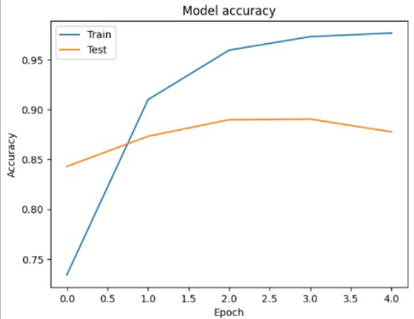 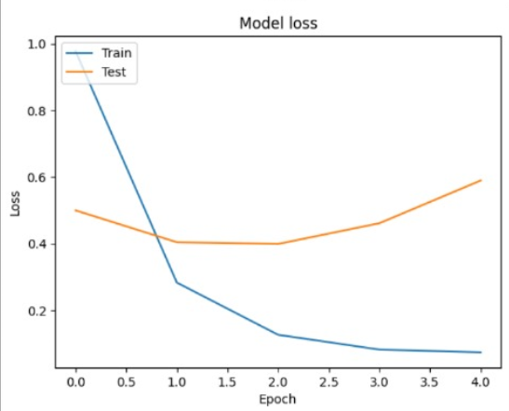

**Graph showing accuracy and loss for training and testing for Proposed Model**

Fig.17

1. **Conclusion**

In summary, a convolutional neural network (CNN)-based method for plant disease prediction using leaf images has been shown to be effective and efficient in many aspects. Through this research, we examined the strengths and limitations of various CNN architectures in accurately classifying leaves as healthy or diseased and instantly identifying specific diseases. The training model of different data showed good performance, demonstrating its potential as a reliable tool for early detection and diagnosis of plant diseases.

The importance of model selection is emphasized, with some designs showing the best performance across different strains. We further improve the accuracy and performance of our prediction models using optimization techniques such as hyperparameter tuning and transfer learning.

Looking forward, the information gained from this study may inform the development of increasingly accurate automated diagnostic systems for plant pathology. Comparative analysis can serve as a springboard for future research, including the search for composite models or structural models to accommodate the complexity of leaf shapes. By harnessing the power of deep learning to predict plant diseases, we aim to provide farmers and agronomists with reliable tools to control good bacteria, thereby ensuring food safety and promoting permaculture practices. Finally, the combination of CNN-based methods and plant pathology holds the promise of reducing the impact of plant diseases and improving the global response of agriculture.

1. **References**

[1] *Chen R, Qi H, Liang Y, Yang M. Identification of plant leaf diseases by deep learning based on channel attention and channel pruning. Front Plant Sci. 2022 Nov 10;13:1023515. doi: 10.3389/fpls.2022.1023515. PMID: 36438120; PMCID: PMC9686387.*

[2] *Gavhale, Ms & Gawande, Ujwalla. (2014). An Overview of the Research on Plant Leaves Disease detection using Image Processing Techniques. IOSR Journal of Computer Engineering. 16. 10-16. 10.9790/0661-16151016.*

[3] *L. Li, S. Zhang and B. Wang, "Plant Disease Detection and Classification by Deep Learning—A Review," in IEEE Access, vol. 9, pp. 56683-56698, 2021, doi: 10.1109/ACCESS.2021.3069646.*

[4] *S, Hema & Sharma, Niteesha & Sowjanya, Y & Santoshini, Ch & Durga, R & Akhila, V.. (2021). Plant disease prediction using convolutional neural network. EMITTER International Journal of Engineering Technology. 9. 283-293. 10.24003/emitter.v9i2.640.*

[5] *Zanzaney, Archishman & Hegde, Rajeshwari & Jain, Lakshya & Choudhuri, Saurabh Suman & Sharma, Chaitanya. (2023). Crop Disease Detection Using Deep Neural Networks. 1-5. 10.1109/NMITCON58196.2023.10276311.*

[6] *G. Delnevo, R. Girau, C. Ceccarini and C. Prandi, "A Deep Learning and Social IoT Approach for Plants Disease Prediction Toward a Sustainable Agriculture," in IEEE Internet of Things Journal, vol. 9, no. 10, pp. 7243-7250, 15 May15, 2022, doi: 10.1109/JIOT.2021.3097379.*

[7] *Z. Liu, R. N. Bashir, S. Iqbal, M. M. A. Shahid, M. Tausif and Q. Umer, "Internet of Things (IoT) and Machine Learning Model of Plant Disease Prediction–Blister Blight for Tea Plant," in IEEE Access, vol. 10, pp. 44934-44944, 2022, doi: 10.1109/ACCESS.2022.3169147.*

[8] *R. K. Lakshmi and N. Savarimuthu, "PLDD—A Deep Learning-Based Plant Leaf Disease Detection," in IEEE Consumer Electronics Magazine, vol. 11, no. 3, pp. 44-49, 1 May 2022, doi: 10.1109/MCE.2021.3083976.*

[9] *K. S. Patle, R. Saini, A. Kumar and V. S. Palaparthy, "Field Evaluation of Smart Sensor System for Plant Disease Prediction Using LSTM Network," in IEEE Sensors Journal, vol. 22, no. 4, pp. 3715-3725, 15 Feb.15, 2022, doi: 10.1109/JSEN.2021.3139988.*

[10] *R. Maurya, S. Mahapatra and L. Rajput, "A Lightweight Meta-Ensemble Approach for Plant Disease Detection Suitable for IoT-Based Environments," in IEEE Access, vol. 12, pp. 28096-28108, 2024, doi: 10.1109/ACCESS.2024.3367443.*

[11] **Plant Village Dataset**

<https://www.kaggle.com/datasets/abdallahalidev/plantvillage-dataset>

1. **Appendix Code**

**Importing the dependencies**

**Data Preprocessing**



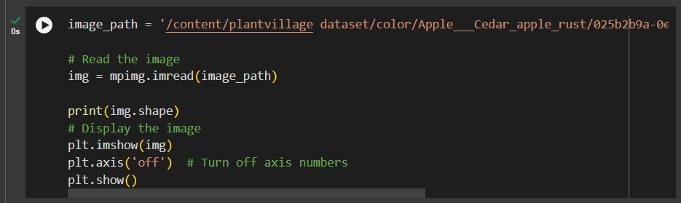

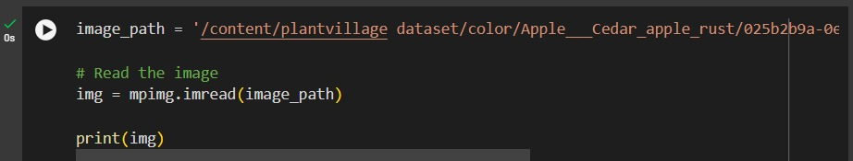

**Convolutional Neural Network**

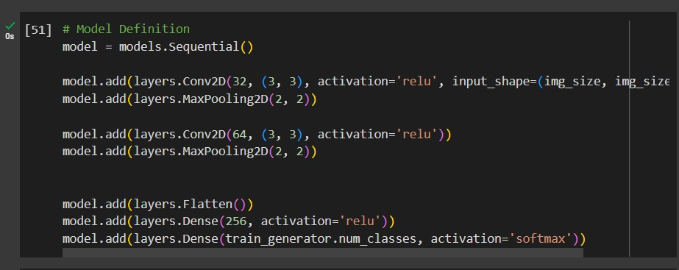

**Model Training**

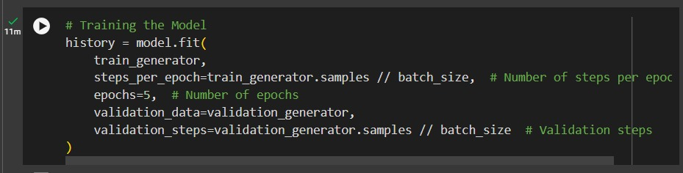

**Model Evaluation**

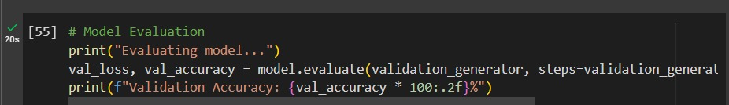

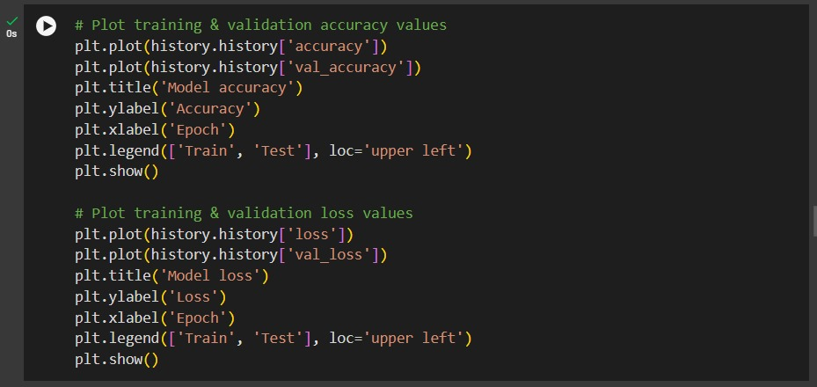

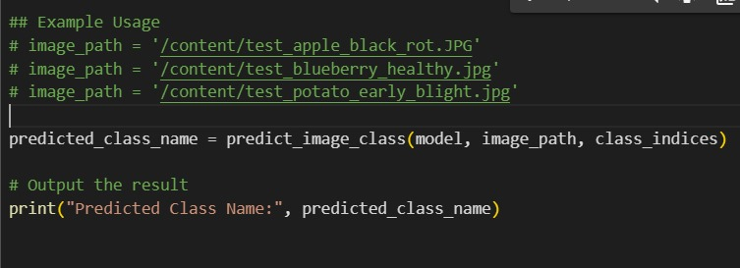

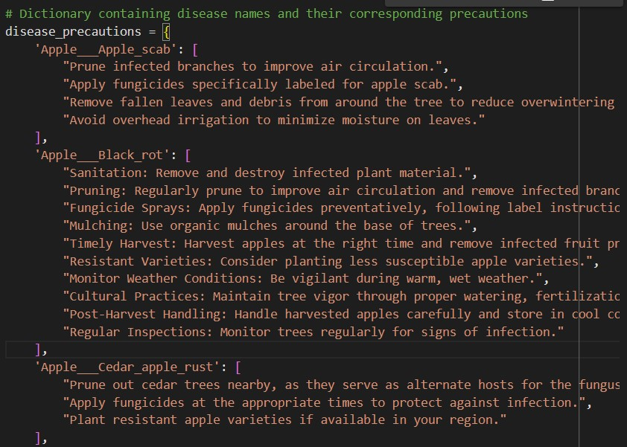

**Plagiarism check**

