**USECASE DIAGRAMS:**

**COLLEGE MANAGEMENT SYSTEM:**

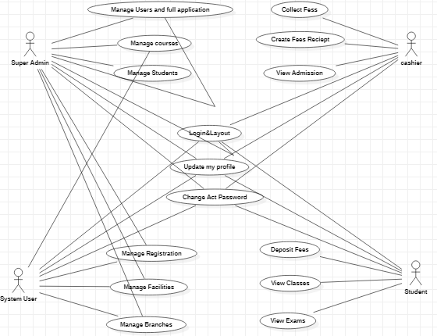

**LIBRARY MANAGEMENT SYSTEM**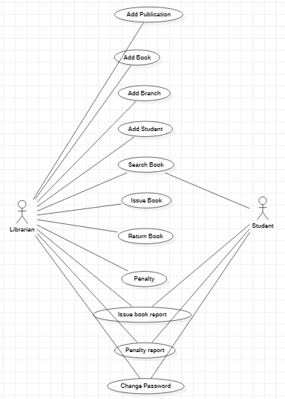

**RAILWAY RESERVATION SYSTEM:**

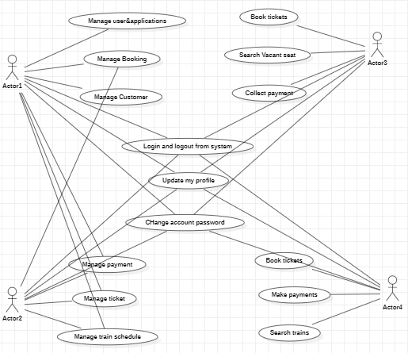

**ATM:**

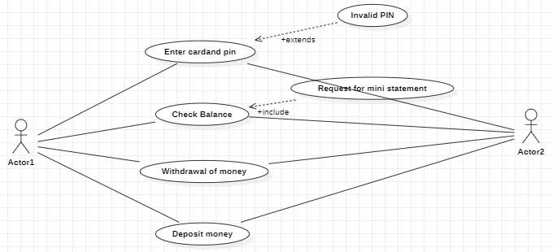

**CUSTOMER SUPPORT SYSTEM:**

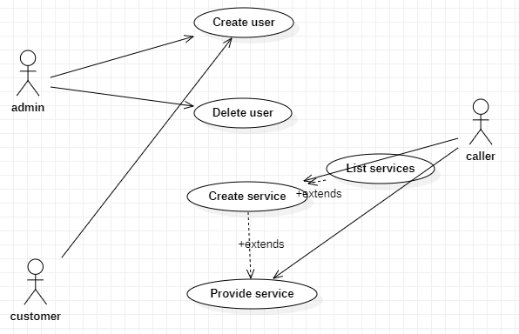

**UBER CAB SYSTEM:**

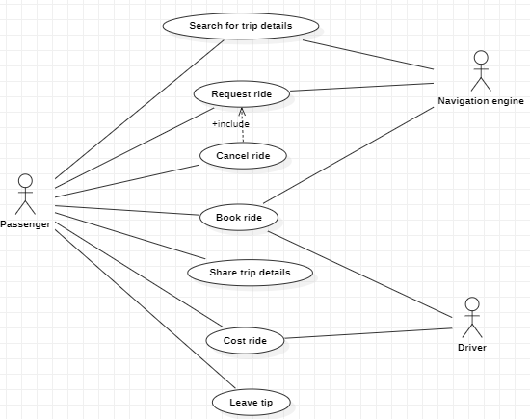

**CLASS DIAGRAMS:**

**COLLEGE MANAGEMENT SYSTEM:**

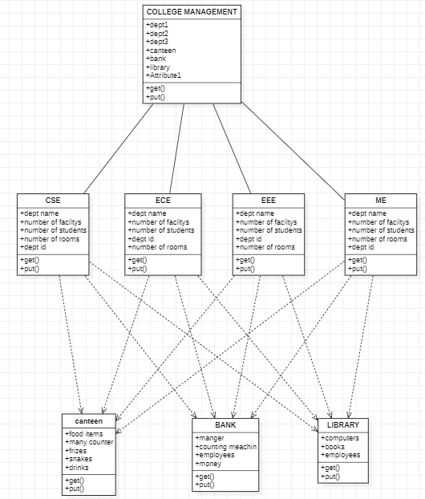

**LIBRARY MANAGEMENT SYSTEM:**

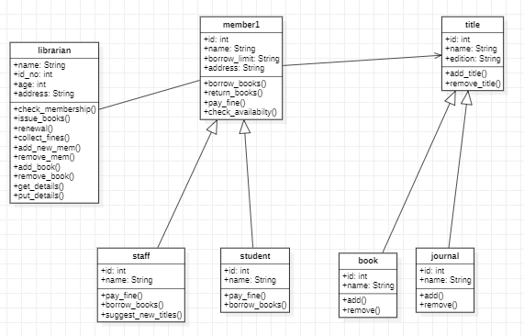

**RAILWAY RESERVATION SYSTEM:**

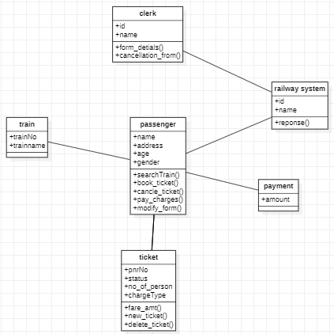

**CUSTOMER SUPPORT SYSTEM:**

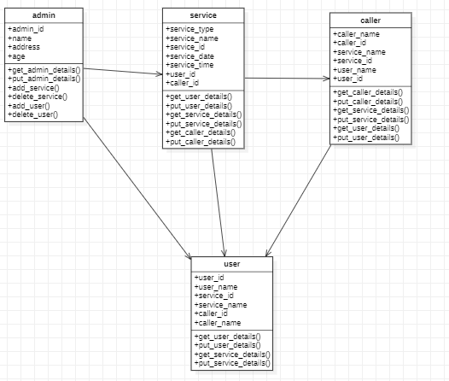

**ATM:**

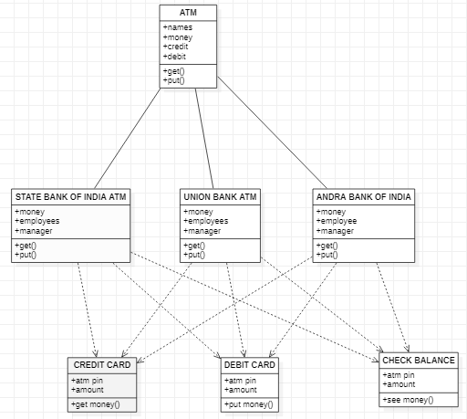

**POINTOFSALES:**

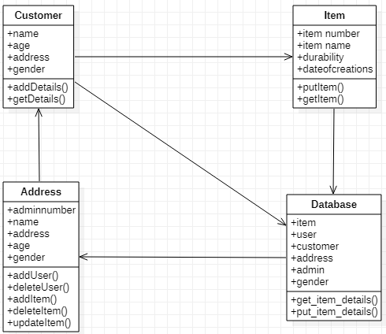

**SEQUENCE DIAGRAMS:**

**COLLEGE MANAGEMENT SYSTEM:**

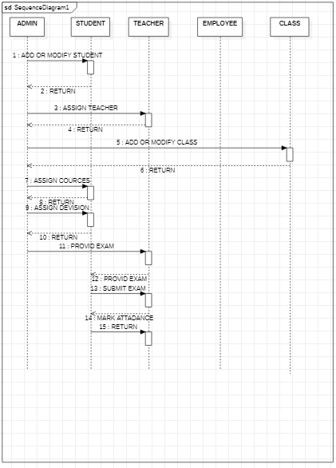

**LIBRARY MANAGEMENT SYSTEM:**

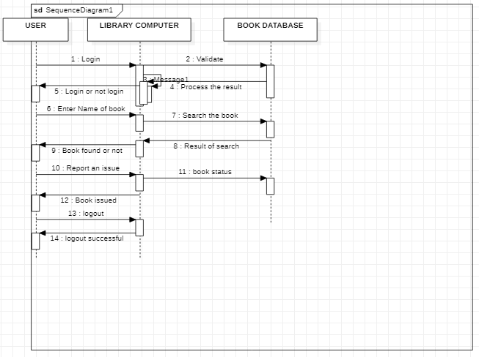

**ATM:**

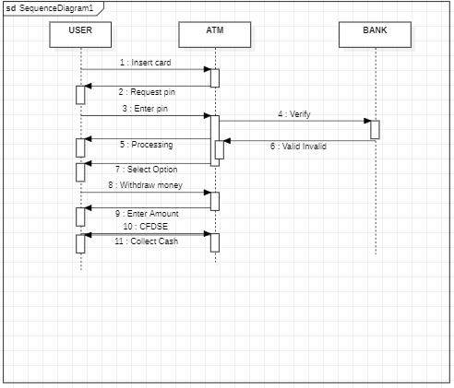

**RAILWAY RESERVATION SYSTEM:**

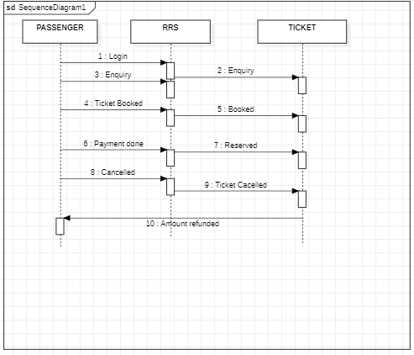

**CAB BOOKING SYSTEM:**

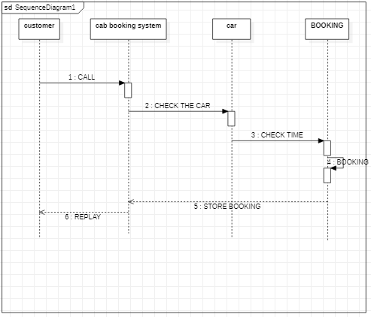

**CUSTOMER SUPPORT SYSTEM:**

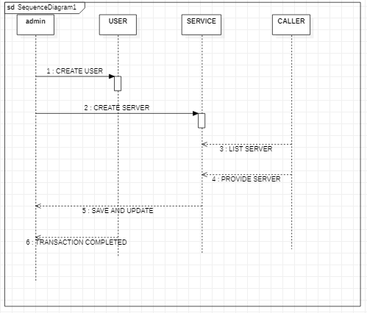

**COLLOBORATION DIAGRAMS:**

**COLLEGE MANAGEMENT SYSTEM:**

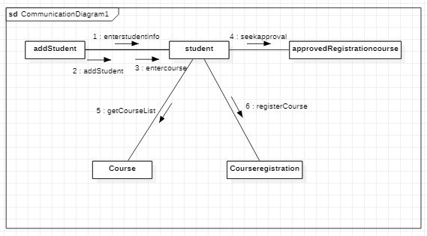

**LIBRARY MANAGEMENT SYSTEM:**

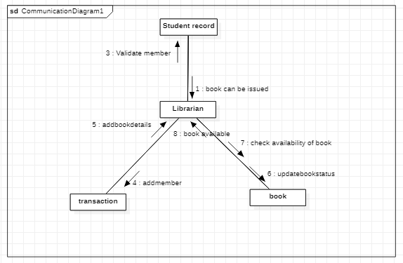

**ATM:**

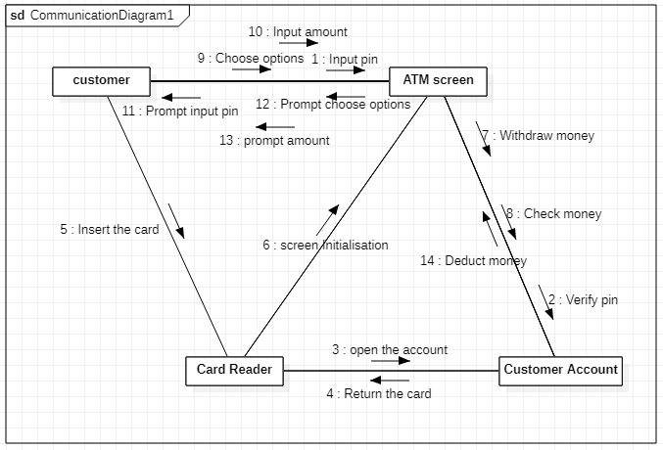

**RAILWAY RESERVATION SYSTEM:**

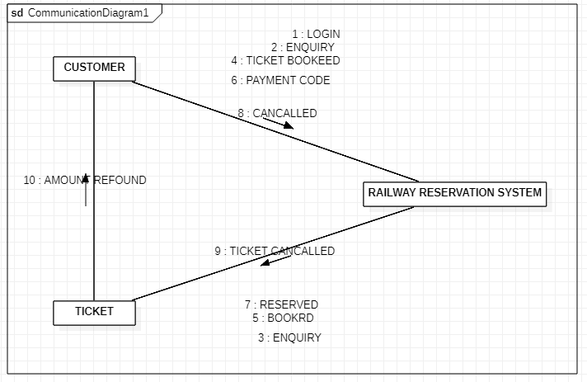

**CAB BOOKING SYSTEM:**

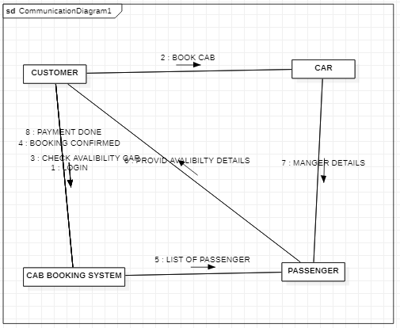

**CUSTOMER SUPPORT SYSTEM:**

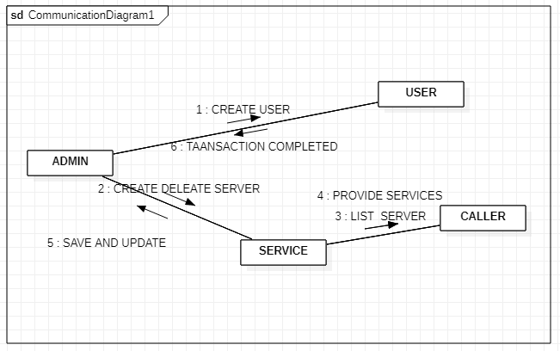

**ACTIVITY DIAGRAMS:**

**COLLEGE MANAGEMENT SYSTEM:**

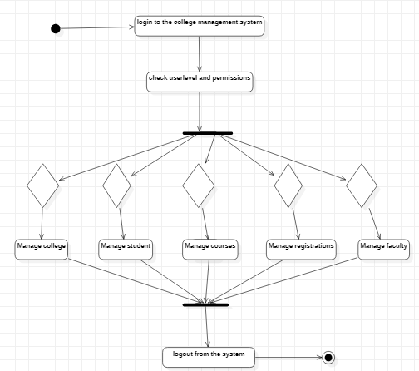

**LIBRARY MANAGEMENT SYSTEM:**

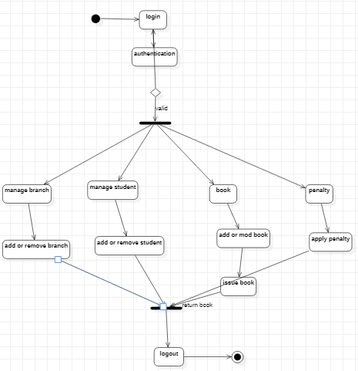

**ATM:**

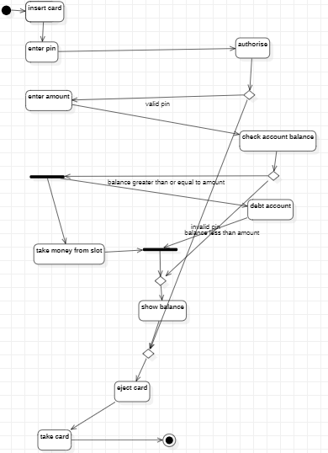

**RAILWAY RESERVATION SYSTEM:**

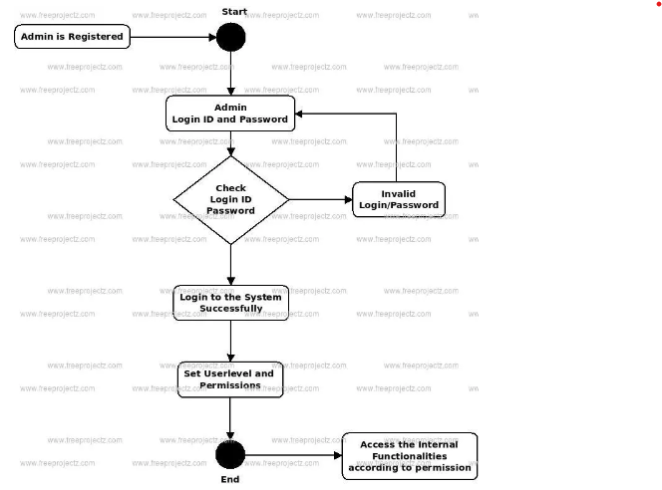

**CUSTOMER SUPPORT SYSTEM:**

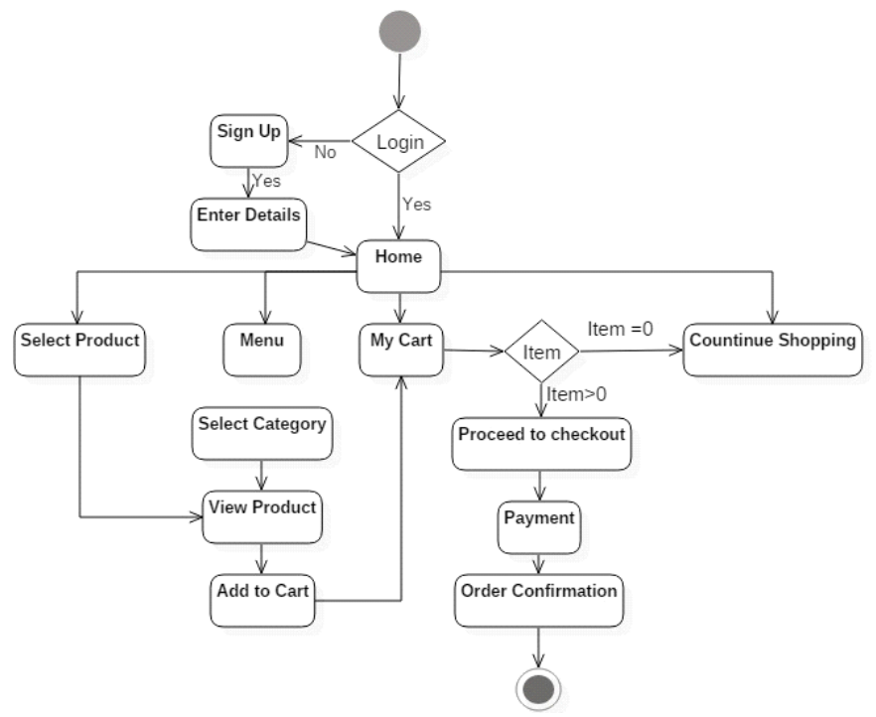

**POINT OF SALES:**

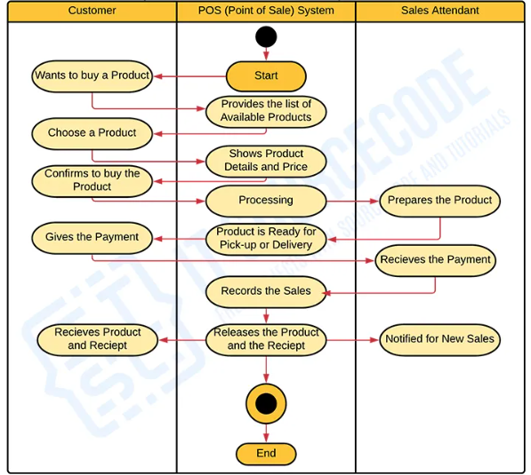

**STATE CHART DIAGRAMS:**

**COLLEGE MANAGEMENT SYSTEM:**

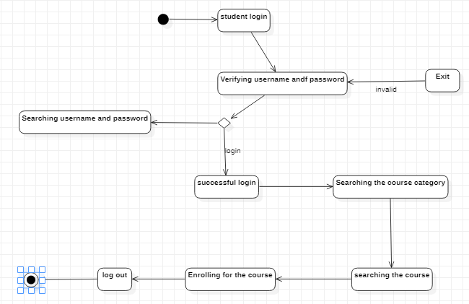

**LIBRARY MANAGEMENT SYSTEM:**

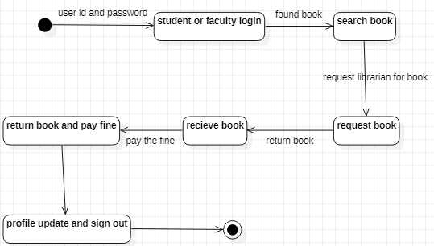

**ATM:**

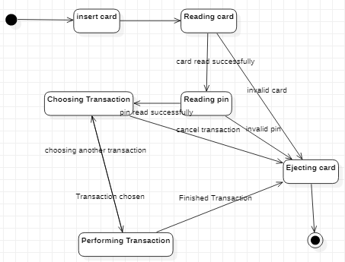

**RAILWAY RESERVATION SYSTEM:**

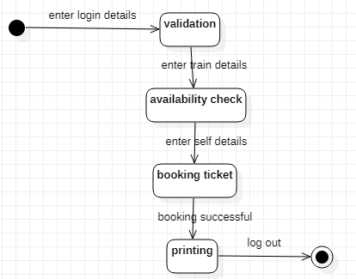

**CUSTOMER SUPPORT SYSTEM:**

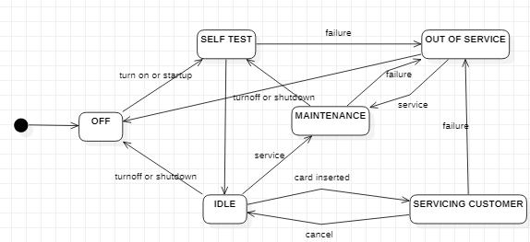

**UBER CAB SYSTEM:**

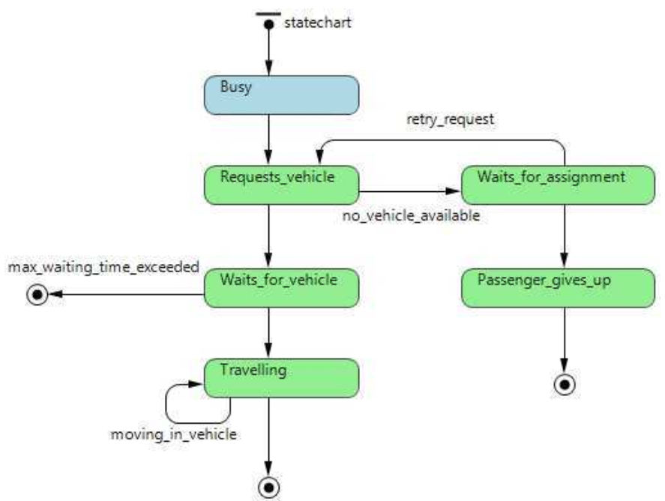

**COMPONENT DIAGRAMS:**

**COLLEGE MANAGEMENT SYSTEM:**

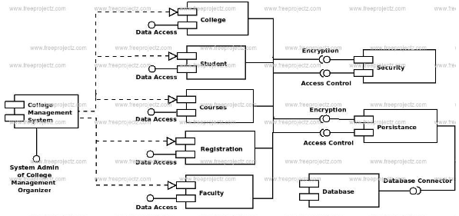

**LIBRARY MANAGEMENT SYSTEM:**

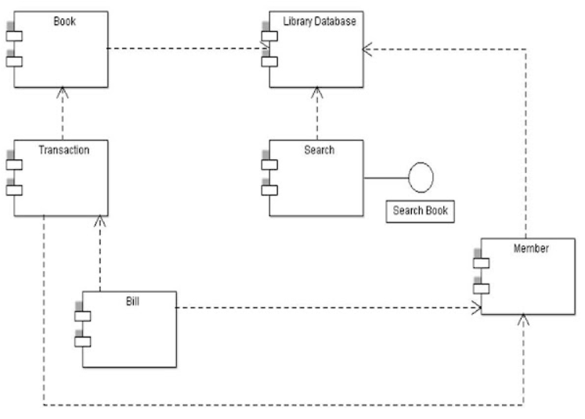

**ATM:**

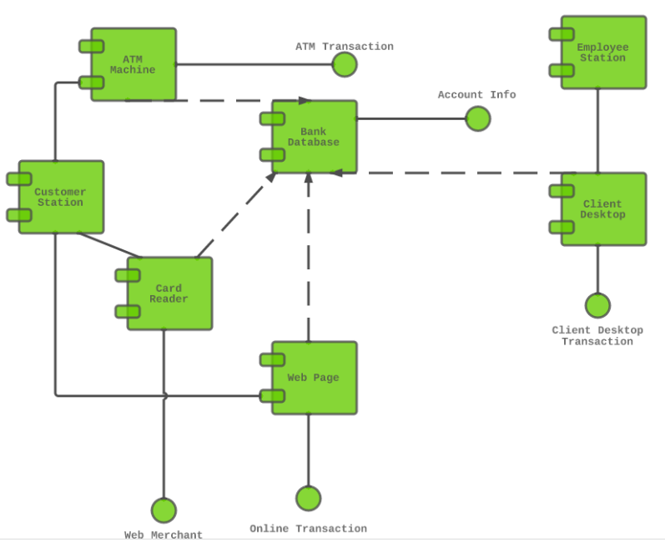

**RAILWAY RESERVATION SYSTEM:**

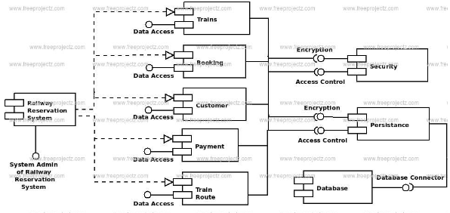

**CUSTOMER SUPPORT SYSTEM:**

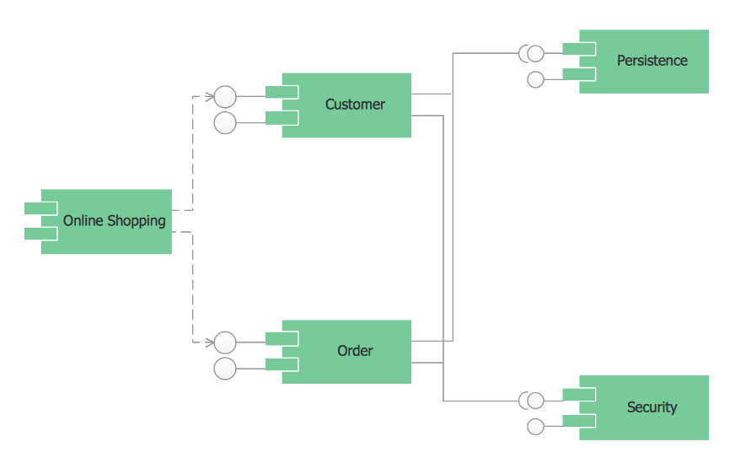

**POINT OF SALES:**

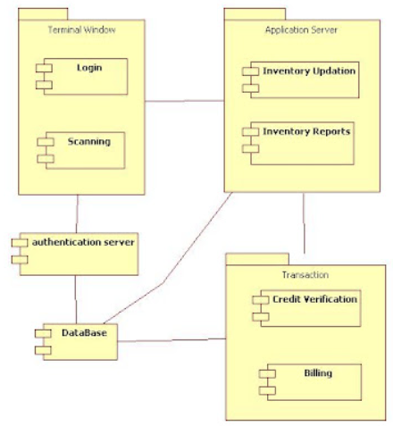

**DEPLOYMENT DIAGRAMS:**

**COLLEGE MANAGEMENT SYSTEM:  
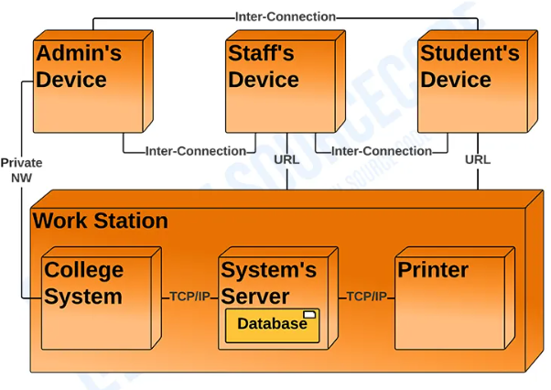**

**LIBRARY MANAGEMENT SYSTEM:**

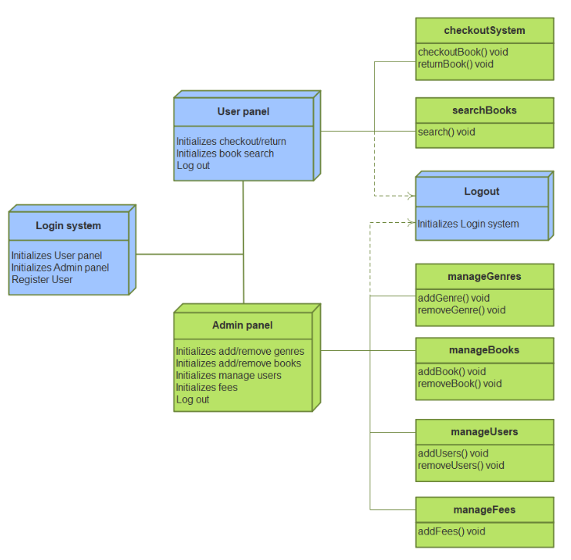

**ATM:**

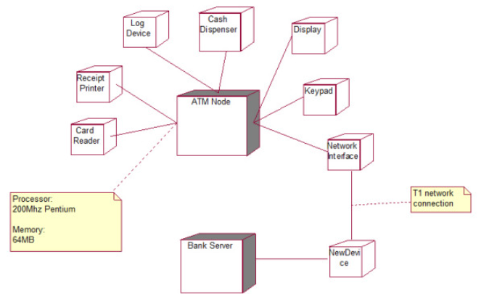

**RAILWAY RESERVATION SYSTEM:**

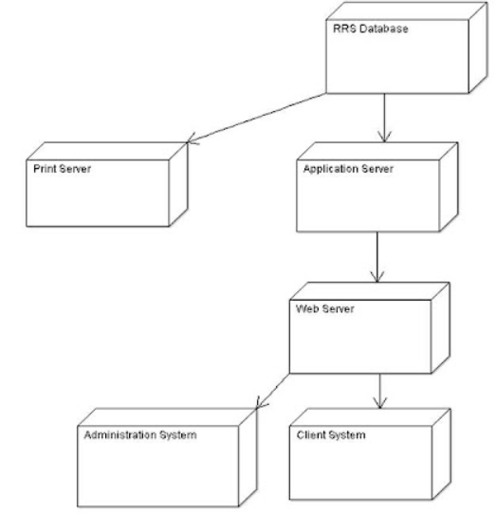

**CUSTOMER SUPPORT SYSTEM:**

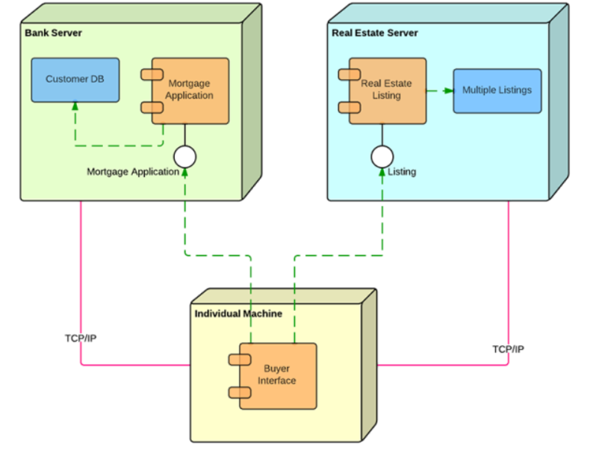

**POINT OF SALES:**

