**Software Requirements Specification**

Version 1.0 for **Online Movie Ticket Selling System**

Prepared by

|  |  |  |
| --- | --- | --- |
| Nasim Adabi | 40079444 | nasim.adabi@gmail.com |
| Mahshad Saghaleini | 40058409 | mahshad.saghaleini@gmail.co |
| Nandini Bandlamudi | 40105415 | bandlamudi.nandini@gmail.com |
| Venkata pavan kumar reddy Ravi | 40083392 | pavan.03121996@gmail.com |
| Kiranmayie | 40092284 | 2809kiran@gmail.com |
| Hina Masood Ahmed | 40076287 | m.hinathahseen@gmail.com |
| Swetha Chenna | 40092019 | swethachenna2018@gmail.com |
| <> | <> | <> |

|  |  |
| --- | --- |
| Instructor: | *Nora Houari* |
| Course: | SOEN 6471 |
| Date: | 17 June 2019 |

**Document history**

|  |  |  |  |
| --- | --- | --- | --- |
| **Date** | **Version** | **Description** | **Author** |
|  |  |  |  |
|  |  |  |  |
|  |  |  |  |
|  |  |  |  |

**Table of contents**

1. Introduction 5

Purpose 5

Scope 5

Definitions, acronyms, and abbreviations 5

References 5

2. Overall description 6

Product perspective 6

Product functions 6

User characteristics 6

Constraints 6

Assumptions and dependencies 7

3. Specific requirements 8

3.1 External interfaces 8

3.2 Functional requirements 9

Actor goal list 9

3.3 Non-functional requirements 11

3. Analysis Models 13

**List of figures**

Figure 1. A client-server architecture. 6

Figure 2. An example user interface.. 8

Figure 3. Use case model. 10

# Introduction

The introduction of the Software Requirements Specifications Document provides an overview of the entire document.

## Purpose

The purpose of this document is to present a detailed description of the system. It will explain the purpose, the features and the constraints of the system, the exposed interfaces, the conditions under which it will function and how it will react to different inputs. This document is intended for the instructor, the Teaching Assistants and any developers planning to implement, maintain or service this library system.

## Scope

A brief description of what the Software Requirements Specifications Document applies to; what is affected or influenced by this document.

## Definitions, acronyms, and abbreviations

Provides the definitions of all terms, acronyms, and abbreviations required to properly interpret the Software Requirements Specifications Document. This information may be provided by reference to the project’s Glossary.

## References

Provide a list of all documents referenced in the SRS.

# Overall description

This section describes the background to the requirements: The general factors that affect the product, such as constraints, assumptions and dependencies.

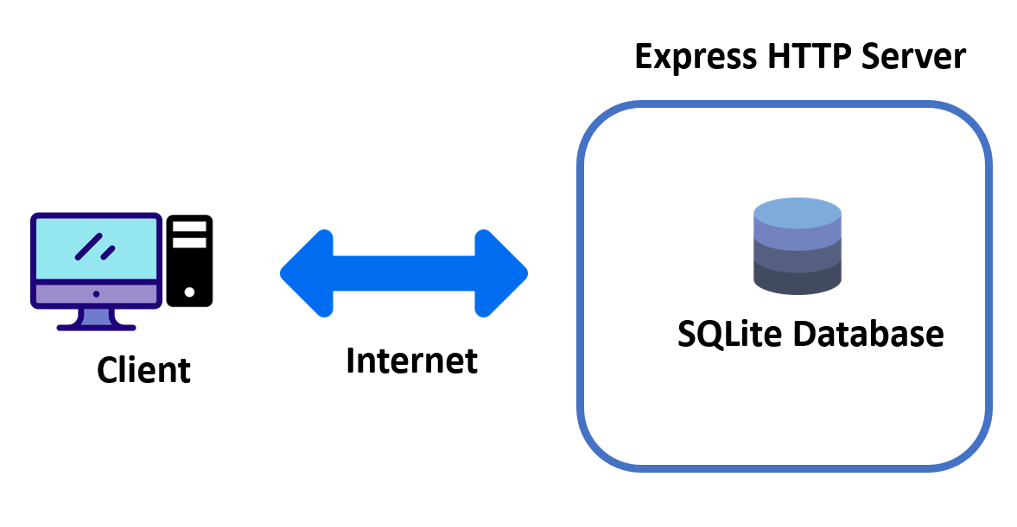

Figure 1. A client-server architecture.

## Product perspective

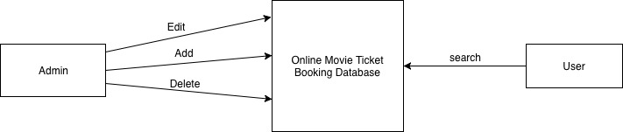

Figure 2. Object perspective

## Product functions

This system is an online web application for users to be able to purchase their ticket for a movie. In the application, there are two kinds of access for the users. First, there is a user with an Admin access who have access to add or delete a movie. Second, there is a user with a Customer/Client access who is able to view the list of movies, select their choice and receive the ticket.

For both above mentioned user types, first user must register in the system with a unique email address. Then, they must login in order to be able to buy a ticket.

## User characteristics

Intended user of this system can be anyone who has a basic knowledge of the internet and web pages. They don’t required to be expertise. They only need to be familiar with online purchasing on the internet.

## Constraints

Describe any items that will limit the options of the developers (such as regulations, hardware limitations, safety and security etc.)

## Assumptions and dependencies

For running this application Java EE with the minimum 0.0 version and MySQL database with the minimum 0.0 version is required.

# Specific requirements

This section contains all requirements in detail: Functional as well as non-functional requirements (quality attributes and constraints). The quality attributes are listed according to the *ISO/IEC 25010* standard that classifies software quality in a structured set of characteristics and sub-characteristics.

### External interfaces

A detailed description of all inputs into the system and all outputs from it (in terms of content and form).

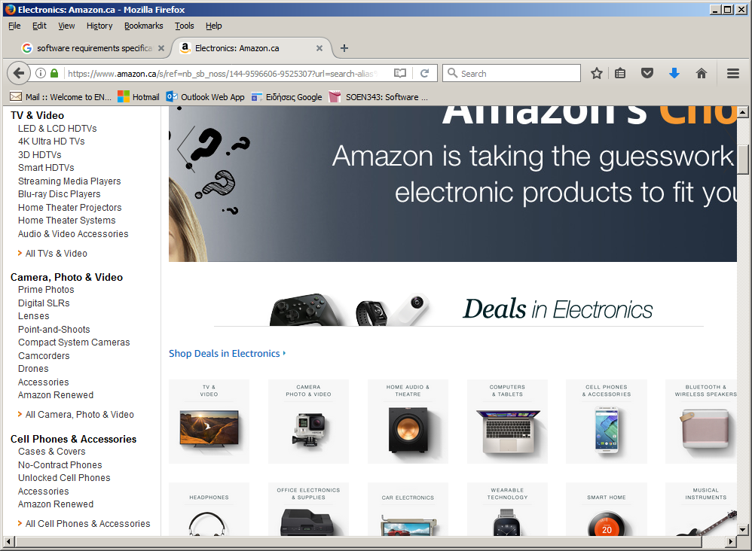

Figure 3. An example user interface..

### 3.2 Functional requirements

Functional requirements capture the intended behaviour of the system. This section contains the *Actor Goal List* and the *Use Case view*.

#### Actor goal list

|  |  |
| --- | --- |
| Actor | Goal |
| Administrators | Add movie  Remove movie  Edit movie Info |
| Clients | Book and buy a ticket |
| Users | Log in  Search for movie  Pay for booking |

#### Use case view

The use case model is shown in Figure 4.

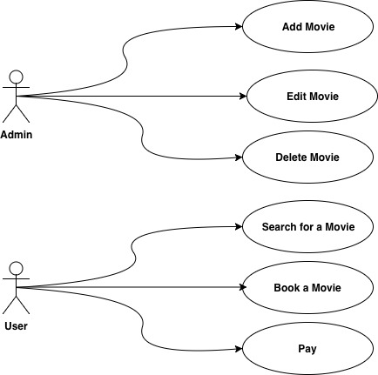

Figure 4. Use case model.

### 3.3 Non-functional requirements

#### Performance efficiency

Description goes here.

#### Compatibility

Description goes here.

#### Usability

Description goes here.

#### Reliability

Description goes here.

#### Security

Description goes here.

#### Maintainability

Description goes here.

#### Design constraints

Decisions that must be followed, such as languages, processes, prescribed use of tools, architectural and design constraints, purchased components, class libraries, etc.

#### (On-line) user documentation and help

Description.

#### Legal, copyright and other notices

Description.

# Analysis Models

List all analysis models used in developing specific requirements previously given in this SRS. Each model should include an introduction and a narrative description. Furthermore, each model should be traceable the SRS’s requirements.

Illustrate (system) ***UML sequence diagrams*** (one for each **critical** scenario), identify system operations and describe operation contracts, **one per critical system operation**.

You may also use ***UML state diagrams*** to describe **critical use cases**, one state diagram per use case.

Finally, create a **UML conceptual class diagram** (“**domain model”)**  for the system. If the model gets too large, you can use **UML package diagrams** to provide logical grouppings for the model.