QUEUE DATA STRUCTURE

- Implement Queue using Stack Data Structure.
Solution
class MyQueue {

Stack<Integer> s1 = new Stack();
Stack<Integer> s2 = new Stack();

// Push element x to the back of queue.
public void push(int x) {
while (!s2.isEmpty())
s1.push(s2.pop());

s1.push(x);
}

// Removes the element from in front of queue.
public int pop() {
while (!s1.isEmpty())
s2.push(s1.pop());

return s2.pop();
}

// Get the front element.
public int peek() {
while (!s1.isEmpty())
s2.push(s1.pop());

return s2.peek();
}

// Return whether the queue is empty.
public boolean empty() {
return s1.isEmpty() && s2.isEmpty();
}

}

- Given a stream of integers and a window size, calculate the moving average of all integers in the sliding window.
Implement the MovingAverage class:
MovingAverage(int size): Initializes the object with the size of the window size.
double next(int val): Returns the moving average of the last size values of the stream.

Input
["MovingAverage", "next", "next", "next", "next"]
[[3], [1], [10], [3], [5]]
Output
[null, 1.0, 5.5, 4.66667, 6.0]

Solution:

class MovingAverage {
int sum=0;
int count=0;
int size=0;

Queue<Integer>q1=new LinkedList<>();

public MovingAverage(int size) {
this.size=size;
}//constructor closed

public double next(int val) {
count++;
q1.add(val);
int front =count>size ?q1.poll():0;
count =count > size?--count:count;
sum = sum -front+val;

return sum/(double)count;

}//function closed

}//class closed

- Given a linked list where in addition to the next pointer, each node has a child pointer, which may or may not point to a separate list. These child lists may have one or more children of their own, and so on, to produce a multilevel data structure, as shown in below figure.

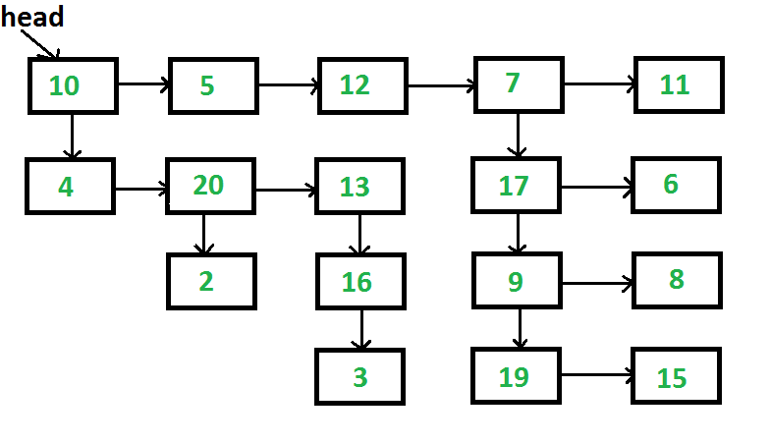

Output: 10->5->12->7->11->4->20->13->17->6->2->16->9->8->3->19->15

Solution:
public static Node flattenList(Node head) {
if (head == null) return null;

Queue<Node> queue = new LinkedList<>();
Node curr = head;

while (curr != null) {
if (curr.child != null) {
queue.add(curr.child);
}
if (curr.next == null && !queue.isEmpty()) {
curr.next = queue.poll();
}
curr = curr.next;
}
return head;
}

TC: O(n)
SC: O(n)

- Given a Binary tree and a key in the binary tree, find the node right to the given key. If there is no node on right side, then return NULL. Expected time complexity is O(n) where n is the number of nodes in the given binary tree.
Solution:

Node nextRight(Node first, int k)
{
// Base Case
if (first == null)
return null;

// Create an empty queue for level order traversal
// A queue to store node addresses
Node res = null;
Queue<Node> q = new LinkedList<Node>();

// Enqueue Root and its level
q.add(first);

// A standard BFS loop
while (q.size() != 0) {
// Get the count of the elements in the queue,
// this
// is also the count of elements present at the
// current level
int n = q.size();
// loop through the elements of the current
// level
for (int i = 0; i < n; i++) {
Node temp = q.peek();
q.remove();
// if the key is found we check if there is
// any
// element next to it and return the answer
// accordingally
if (temp.data == k) {
if (i != n - 1) {
return q.peek();
}
else
return null;
}
// while the current level elements are
// processed we push their children into the
// queue
if (temp.left != null)
q.add(temp.left);
if (temp.right != null)
q.add(temp.right);
}
}

// We reach here if given key x doesn't exist in
// tree
return null;
}
TC: O(n)
SC:O(n)

- Given an array and an integer K, find the maximum for each and every contiguous subarray of size K.
Solution:

static void printMax(int arr[], int N, int K)
{

// Create a Double Ended Queue, Qi
// that will store indexes of array elements
// The queue will store indexes of
// useful elements in every window and it will
// maintain decreasing order of values
// from front to rear in Qi, i.e.,
// arr[Qi.front[]] to arr[Qi.rear()]
// are sorted in decreasing order
Deque<Integer> Qi = new LinkedList<Integer>();

/* Process first k (or first window)
elements of array */
int i;
for (i = 0; i < K; ++i) {

// For every element, the previous
// smaller elements are useless so
// remove them from Qi
while (!Qi.isEmpty()
&& arr[i] >= arr[Qi.peekLast()])

// Remove from rear
Qi.removeLast();

// Add new element at rear of queue
Qi.addLast(i);
}

// Process rest of the elements,
// i.e., from arr[k] to arr[n-1]
for (; i < N; ++i) {

// The element at the front of the
// queue is the largest element of
// previous window, so print it
System.out.print(arr[Qi.peek()] + " ");

// Remove the elements which
// are out of this window
while ((!Qi.isEmpty()) && Qi.peek() <= i - K)
Qi.removeFirst();

// Remove all elements smaller
// than the currently
// being added element (remove
// useless elements)
while ((!Qi.isEmpty())
&& arr[i] >= arr[Qi.peekLast()])
Qi.removeLast();

// Add current element at the rear of Qi
Qi.addLast(i);
}

// Print the maximum element of last window
System.out.print(arr[Qi.peek()]);

}//function closed

TC: O(n)
SC: O(k)

