- Given a snake and ladder board, find the minimum number of dice throws required to reach the destination or last cell from the source or 1st cell. Basically, the player has total control over the outcome of the dice throw and wants to find out the minimum number of throws required to reach the last cell. If the player reaches a cell which is the base of a ladder, the player has to climb up that ladder and if reaches a cell is the mouth of the snake, and has to go down to the tail of the snake without a dice throw.
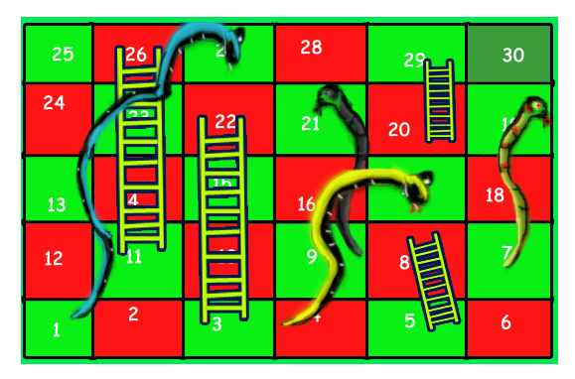

For example, consider the board shown, the minimum number of dice throws required to reach cell 30 from cell 1 is 3.
Following are the steps:
a) First throw two dice to reach cell number 3 and then ladder to reach 22
b) Then throw 6 to reach 28.
c) Finally through 2 to reach 30.
There can be other solutions as well like (2, 2, 6), (2, 4, 4), (2, 3, 5).. etc.

Solution:

public class SnakesLadder {
// An entry in queue used in BFS
static class qentry {
int v; // Vertex number
int dist; // Distance of this vertex from source
}

// This function returns minimum number of dice
// throws required to Reach last cell from 0'th cell
// in a snake and ladder game. move[] is an array of
// size N where N is no. of cells on board If there
// is no snake or ladder from cell i, then move[i]
// is -1 Otherwise move[i] contains cell to which
// snake or ladder at i takes to.
static int getMinDiceThrows(int move[], int n)
{
int visited[] = new int[n];
Queue<qentry> q = new LinkedList<>();
qentry qe = new qentry();
qe.v = 0;
qe.dist = 0;

// Mark the node 0 as visited and enqueue it.
visited[0] = 1;
q.add(qe);

// Do a BFS starting from vertex at index 0
while (!q.isEmpty()) {
qe = q.remove();
int v = qe.v;

// If front vertex is the destination
// vertex, we are done
if (v == n - 1)
break;

// Otherwise dequeue the front vertex and
// enqueue its adjacent vertices (or cell
// numbers reachable through a dice throw)
for (int j = v + 1; j <= (v + 6) && j < n;
++j) {
// If this cell is already visited, then
// ignore
if (visited[j] == 0) {
// Otherwise calculate its distance and
// mark it as visited
qentry a = new qentry();
a.dist = (qe.dist + 1);
visited[j] = 1;

// Check if there a snake or ladder at
// 'j' then tail of snake or top of
// ladder become the adjacent of 'i'
if (move[j] != -1)
a.v = move[j];
else
a.v = j;
q.add(a);
}
}
}

// We reach here when 'qe' has last vertex
// return the distance of vertex in 'qe'
return qe.dist;
}

public static void main(String[] args)
{
// Let us construct the board given in above diagram
int N = 30;
int moves[] = new int[N];
for (int i = 0; i < N; i++)
moves[i] = -1;

// Ladders
moves[2] = 21;
moves[4] = 7;
moves[10] = 25;
moves[19] = 28;

// Snakes
moves[26] = 0;
moves[20] = 8;
moves[16] = 3;
moves[18] = 6;

System.out.println("Min Dice throws required is "
+ getMinDiceThrows(moves, N));
}
}

TC: O(N)
SC: O(N)

- Given a source vertex s from a set of vertices V in a weighted digraph where all its edge weights w(u, v) are non-negative, find the shortest path weights d(s, v) from source s for all vertices v present in the graph.
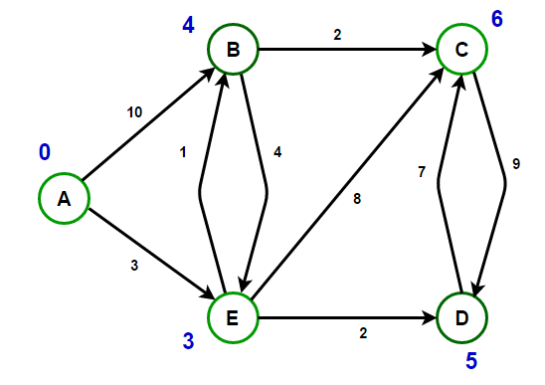

Solution:

class Edge
{
int source, dest, weight;

public Edge(int source, int dest, int weight)
{
this.source = source;
this.dest = dest;
this.weight = weight;
}
}

// A class to store a heap node
class Node
{
int vertex, weight;

public Node(int vertex, int weight)
{
this.vertex = vertex;
this.weight = weight;
}
}

// A class to represent a graph object
class Graph
{
// A list of lists to represent an adjacency list
List<List<Edge>> adjList = null;

// Constructor
Graph(List<Edge> edges, int n)
{
adjList = new ArrayList<>();

for (int i = 0; i < n; i++) {
adjList.add(new ArrayList<>());
}

// add edges to the directed graph
for (Edge edge: edges) {
adjList.get(edge.source).add(edge);
}
}
}

class Main
{
private static void getRoute(int[] prev, int i, List<Integer> route)
{
if (i >= 0)
{
getRoute(prev, prev[i], route);
route.add(i);
}
}

// Run Dijkstra’s algorithm on a given graph
public static void findShortestPaths(Graph graph, int source, int n)
{
// create a min-heap and push source node having distance 0
PriorityQueue<Node> minHeap;
minHeap = new PriorityQueue<>(Comparator.comparingInt(node -> node.weight));
minHeap.add(new Node(source, 0));

// set initial distance from the source to `v` as infinity
List<Integer> dist;
dist = new ArrayList<>(Collections.nCopies(n, Integer.MAX_VALUE));

// distance from the source to itself is zero
dist.set(source, 0);

// boolean array to track vertices for which minimum
// cost is already found
boolean[] done = new boolean[n];
done[source] = true;

// stores predecessor of a vertex (to a print path)
int[] prev = new int[n];
prev[source] = -1;

// run till min-heap is empty
while (!minHeap.isEmpty())
{
// Remove and return the best vertex
Node node = minHeap.poll();

// get the vertex number
int u = node.vertex;

// do for each neighbor `v` of `u`
for (Edge edge: graph.adjList.get(u))
{
int v = edge.dest;
int weight = edge.weight;

// Relaxation step
if (!done[v] && (dist.get(u) + weight) < dist.get(v))
{
dist.set(v, dist.get(u) + weight);
prev[v] = u;
minHeap.add(new Node(v, dist.get(v)));
}
}

// mark vertex `u` as done so it will not get picked up again
done[u] = true;
}

List<Integer> route = new ArrayList<>();

for (int i = 0; i < n; i++)
{
if (i != source && dist.get(i) != Integer.MAX_VALUE)
{
getRoute(prev, i, route);
System.out.printf("Path (%d —> %d): Minimum cost = %d, Route = %s\n",
source, i, dist.get(i), route);
route.clear();
}
}
}

public static void main(String[] args)
{
// initialize edges as per the above diagram
// (u, v, w) represent edge from vertex `u` to vertex `v` having weight `w`
List<Edge> edges = Arrays.asList(
new Edge(0, 1, 10), new Edge(0, 4, 3), new Edge(1, 2, 2),
new Edge(1, 4, 4), new Edge(2, 3, 9), new Edge(3, 2, 7),
new Edge(4, 1, 1), new Edge(4, 2, 8), new Edge(4, 3, 2)
);

// total number of nodes in the graph (labelled from 0 to 4)
int n = 5;

// construct graph
Graph graph = new Graph(edges, n);

// run the Dijkstra’s algorithm from every node
for (int source = 0; source < n; source++) {
findShortestPaths(graph, source, n);
}
}
}

TC: O(E.log V)

- Given a directed acyclic graph (DAG) of n nodes labeled from 0 to n - 1, find all possible paths from node 0 to node n - 1 and return them in any order.
The graph is given as follows: graph[i] is a list of all nodes you can visit from node i (i.e., there is a directed edge from node i to node graph[i][j]).
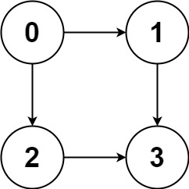

Input: graph = [[1,2],[3],[3],[]]
Output: [[0,1,3],[0,2,3]]
Explanation: There are two paths: 0 -> 1 -> 3 and 0 -> 2 -> 3.

Solution:

public List<List<Integer>> allPathsSourceTarget(int[][] graph) {
List<List<Integer>> ans = new LinkedList();
List<Integer> current = new ArrayList();
current.add(0);
dfs(0,current,graph,graph.length-1,ans);
return ans;
}

private void dfs(int src, List<Integer> current, int graph[][], int dest, List<List<Integer>> ans){
if(src == dest){
ans.add(new ArrayList(current));
return;
}
for(int n : graph[src]){
current.add(n);
dfs(n,current,graph,dest,ans);
current.remove(current.size()-1);
}
}

- Write a function to find a mother vertex in the graph. A mother vertex in a graph G = (V, E) is a vertex v such that all other vertices in G can be reached by a path from v.
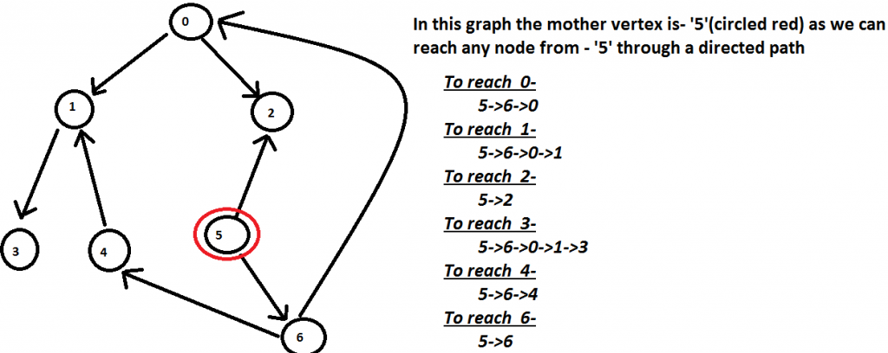

Solution:
// A recursive function to print DFS starting from v

static void DFSUtil(ArrayList<ArrayList<Integer> > g,

int v, boolean[] visited)

{

// Mark the current node as

// visited and print it

visited[v] = true;

// Recur for all the vertices

// adjacent to this vertex

for (int x : g.get(v)) {

if (!visited[x]) {

DFSUtil(g, x, visited);

}

}

}

// Returns a mother vertex if exists.

// Otherwise returns -1

static int

motherVertex(ArrayList<ArrayList<Integer> > g, int V)

{

// visited[] is used for DFS. Initially

// all are initialized as not visited

boolean[] visited = new boolean[V];

// To store last finished vertex

// (or mother vertex)

int v = -1;

for (int i = 0; i < V; i++) {

if (!visited[i]) {

DFSUtil(g, i, visited);

v = i;

}

}

// If there exist mother vertex (or vertices)

// in given graph, then v must be one

// (or one of them)

// Now check if v is actually a mother

// vertex (or graph has a mother vertex).

// We basically check if every vertex

// is reachable from v or not.

// Reset all values in visited[] as false

// and do DFS beginning from v to check

// if all vertices are reachable from

// it or not.

boolean[] check = new boolean[V];

DFSUtil(g, v, check);

for (boolean val : check) {

if (!val) {

return -1;

}

}

return v;

}

// A recursive function to print DFS starting from v

static void DFSUtil(ArrayList<ArrayList<Integer> > g, int v, boolean[] visited)
{

// Mark the current node as
// visited and print it
visited[v] = true;
// Recur for all the vertices
// adjacent to this vertex
for (int x : g.get(v)) {
if (!visited[x]) {
DFSUtil(g, x, visited);
}
}
}
// Returns a mother vertex if exists.
// Otherwise returns -1
static int motherVertex(ArrayList<ArrayList<Integer> > g, int V)
{
// visited[] is used for DFS. Initially
// all are initialized as not visited
boolean[] visited = new boolean[V];
// To store last finished vertex
// (or mother vertex)
int v = -1;
for (int i = 0; i < V; i++) {
if (!visited[i]) {
DFSUtil(g, i, visited);
v = i;
}
}
// If there exist mother vertex (or vertices)
// in given graph, then v must be one
// (or one of them)
// Now check if v is actually a mother
// vertex (or graph has a mother vertex).
// We basically check if every vertex
// is reachable from v or not.
// Reset all values in visited[] as false
// and do DFS beginning from v to check
// if all vertices are reachable from
// it or not.
boolean[] check = new boolean[V];
DFSUtil(g, v, check);
for (boolean val : check) {
if (!val) {
return -1;
}
}
return v;
}

Time Complexity: O(V + E)
Auxiliary Space: O(V)
// A recursive function to print DFS starting from v

static void DFSUtil(ArrayList<ArrayList<Integer> > g,

int v, boolean[] visited)

{

// Mark the current node as

// visited and print it

visited[v] = true;

// Recur for all the vertices

// adjacent to this vertex

for (int x : g.get(v)) {

if (!visited[x]) {

DFSUtil(g, x, visited);

}

}

}

// Returns a mother vertex if exists.

// Otherwise returns -1

static int

motherVertex(ArrayList<ArrayList<Integer> > g, int V)

{

// visited[] is used for DFS. Initially

// all are initialized as not visited

boolean[] visited = new boolean[V];

// To store last finished vertex

// (or mother vertex)

int v = -1;

for (int i = 0; i < V; i++) {

if (!visited[i]) {

DFSUtil(g, i, visited);

v = i;

}

}

// If there exist mother vertex (or vertices)

// in given graph, then v must be one

// (or one of them)

// Now check if v is actually a mother

// vertex (or graph has a mother vertex).

// We basically check if every vertex

// is reachable from v or not.

// Reset all values in visited[] as false

// and do DFS beginning from v to check

// if all vertices are reachable from

// it or not.

boolean[] check = new boolean[V];

DFSUtil(g, v, check);

for (boolean val : check) {

if (!val) {

return -1;

}

}

return v;

// A recursive function to print DFS starting from v

static void DFSUtil(ArrayList<ArrayList<Integer> > g,

int v, boolean[] visited)

{

// Mark the current node as

// visited and print it

visited[v] = true;

// Recur for all the vertices

// adjacent to this vertex

for (int x : g.get(v)) {

if (!visited[x]) {

DFSUtil(g, x, visited);

}

}

}

// Returns a mother vertex if exists.

// Otherwise returns -1

static int

motherVertex(ArrayList<ArrayList<Integer> > g, int V)

{

// visited[] is used for DFS. Initially

// all are initialized as not visited

boolean[] visited = new boolean[V];

// To store last finished vertex

// (or mother vertex)

int v = -1;

for (int i = 0; i < V; i++) {

if (!visited[i]) {

DFSUtil(g, i, visited);

v = i;

}

}

// If there exist mother vertex (or vertices)

// in given graph, then v must be one

// (or one of them)

// Now check if v is actually a mother

// vertex (or graph has a mother vertex).

// We basically check if every vertex

// is reachable from v or not.

// Reset all values in visited[] as false

// and do DFS beginning from v to check

// if all vertices are reachable from

// it or not.

boolean[] check = new boolean[V];

DFSUtil(g, v, check);

for (boolean val : check) {

if (!val) {

return -1;

}

}

return v;

// A recursive function to print DFS starting from v

static void DFSUtil(ArrayList<ArrayList<Integer> > g,

int v, boolean[] visited)

{

// Mark the current node as

// visited and print it

visited[v] = true;

// Recur for all the vertices

// adjacent to this vertex

for (int x : g.get(v)) {

if (!visited[x]) {

DFSUtil(g, x, visited);

}

}

}

// Returns a mother vertex if exists.

// Otherwise returns -1

static int

motherVertex(ArrayList<ArrayList<Integer> > g, int V)

{

// visited[] is used for DFS. Initially

// all are initialized as not visited

boolean[] visited = new boolean[V];

// To store last finished vertex

// (or mother vertex)

int v = -1;

for (int i = 0; i < V; i++) {

if (!visited[i]) {

DFSUtil(g, i, visited);

v = i;

}

}

// If there exist mother vertex (or vertices)

// in given graph, then v must be one

// (or one of them)

// Now check if v is actually a mother

// vertex (or graph has a mother vertex).

// We basically check if every vertex

// is reachable from v or not.

// Reset all values in visited[] as false

// and do DFS beginning from v to check

// if all vertices are reachable from

// it or not.

boolean[] check = new boolean[V];

DFSUtil(g, v, check);

for (boolean val : check) {

if (!val) {

return -1;

}

}

return v;

}

