- Given a list of departure and arrival airports, find the itinerary in order. It may be assumed that departure is scheduled from every airport except the final destination, and each airport is visited only once, i.e., there are no cycles in the route.
Input:

LAX —> DXB
DFW —> JFK
LHR —> DFW
JFK —> LAX

Output: LHR —> DFW —> JFK —> LAX —> DXB

Solution:

// This function populates 'result' for given input 'dataset'
private static void printResult(Map<String, String> dataSet)
{
// To store reverse of given map
Map<String, String> reverseMap = new HashMap<String, String>();

// To fill reverse map, iterate through the given map
for (Map.Entry<String,String> entry: dataSet.entrySet())
reverseMap.put(entry.getValue(), entry.getKey());

// Find the starting point of itinerary
String start = null;
for (Map.Entry<String,String> entry: dataSet.entrySet())
{
if (!reverseMap.containsKey(entry.getKey()))
{
start = entry.getKey();
break;
}
}

// If we could not find a starting point, then something wrong
// with input
if (start == null)
{
System.out.println("Invalid Input");
return;
}

// Once we have starting point, we simple need to go next, next
// of next using given hash map
String to = dataSet.get(start);
while (to != null)
{
System.out.print(start + "->" + to + ", ");
start = to;
to = dataSet.get(to);
}
}

TC: O(n)
SC: O(n)

- Given a directed graph and two vertices (say source and destination vertex), determine if the destination vertex is reachable from the source vertex or not. If a path exists from the source vertex to the destination vertex, print it.
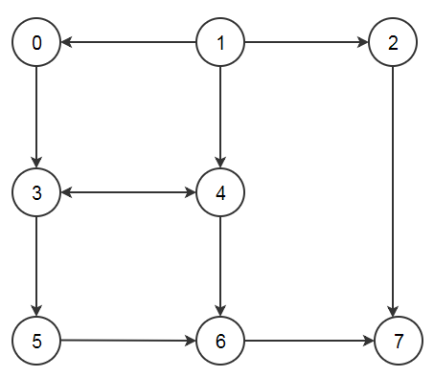
Solution:
// This class represents a directed graph using adjacency list
// representation
class Graph
{
private int V; // No. of vertices
private LinkedList<Integer> adj[]; //Adjacency List

//Constructor
Graph(int v)
{
V = v;
adj = new LinkedList[v];
for (int i=0; i<v; ++i)
adj[i] = new LinkedList();
}

//Function to add an edge into the graph
void addEdge(int v,int w) {
adj[v].add(w);
}

//prints BFS traversal from a given source s
Boolean isReachable(int s, int d)
{
LinkedList<Integer>temp;

// Mark all the vertices as not visited(By default set
// as false)
boolean visited[] = new boolean[V];

// Create a queue for BFS
LinkedList<Integer> queue = new LinkedList<Integer>();

// Mark the current node as visited and enqueue it
visited[s]=true;
queue.add(s);
// 'i' will be used to get all adjacent vertices of a vertex
Iterator<Integer> i;
while (queue.size()!=0)
{
// Dequeue a vertex from queue and print it
s = queue.poll();

int n;
i = adj[s].listIterator();

// Get all adjacent vertices of the dequeued vertex s
// If a adjacent has not been visited, then mark it
// visited and enqueue it
while (i.hasNext())
{
n = i.next();

// If this adjacent node is the destination node,
// then return true
if (n==d)
return true;

// Else, continue to do BFS
if (!visited[n])
{
visited[n] = true;
queue.add(n);
}
}
}
// If BFS is complete without visited d
return false;
}

}

TC: O(V+E)
SC: O(V)

- Given the root of a Directed graph, The task is to check whether the graph contains a cycle if yes then return true, return false otherwise.
Input: N = 4, E = 6

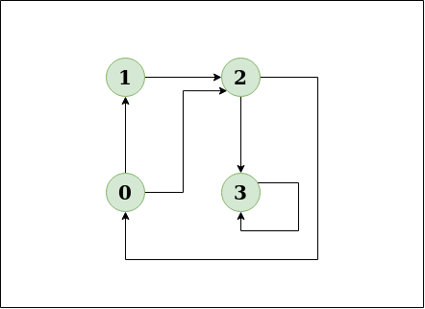

Solution:

private final int V;
private final List<List<Integer>> adj;

public Graph(int V)
{
this.V = V;
adj = new ArrayList<>(V);

for (int i = 0; i < V; i++)
adj.add(new LinkedList<>());
}

private boolean isCyclicUtil(int i, boolean[] visited,
boolean[] recStack)
{

// Mark the current node as visited and
// part of recursion stack
if (recStack[i])
return true;

if (visited[i])
return false;

visited[i] = true;

recStack[i] = true;
List<Integer> children = adj.get(i);

for (Integer c: children) {
if (isCyclicUtil(c, visited, recStack))
return true;
}

recStack[i] = false;

return false;
}

private void addEdge(int source, int dest)
{
adj.get(source).add(dest);
}

// Returns true if the graph contains a
// cycle, else false
private boolean isCyclic()
{

// Mark all the vertices as not visited and
// not part of recursion stack
boolean[] visited = new boolean[V];
boolean[] recStack = new boolean[V];

// Call the recursive helper function to
// detect cycle in different DFS trees
for (int i = 0; i < V; i++)
if (isCyclicUtil(i, visited, recStack))
return true;

return false;
}

TC: O(V+E)
SC: O(V)

- We are given a directed graph. We need compute whether the graph has negative cycle or not. A negative cycle is one in which the overall sum of the cycle comes negative.
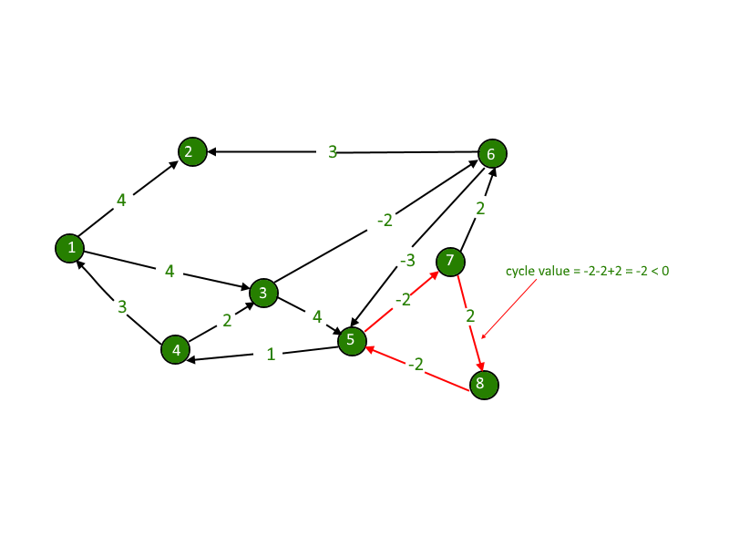

Solution:
// Number of vertices in the graph
static final int V = 4;

/* Define Infinite as a large enough value. This
value will be used for vertices not connected
to each other */
static final int INF = 99999;

// Returns true if graph has negative weight cycle
// else false.
static boolean negCyclefloydWarshall(int graph[][])
{

/* dist[][] will be the output matrix that will
finally have the shortest
distances between every pair of vertices */
int dist[][] = new int[V][V], i, j, k;

/* Initialize the solution matrix same as input
graph matrix. Or we can say the initial values
of shortest distances are based on shortest
paths considering no intermediate vertex. */
for (i = 0; i < V; i++)
for (j = 0; j < V; j++)
dist[i][j] = graph[i][j];

/* Add all vertices one by one to the set of
intermediate vertices.
---> Before start of a iteration, we have shortest
distances between all pairs of vertices such
that the shortest distances consider only the
vertices in set {0, 1, 2, .. k-1} as intermediate
vertices.
----> After the end of a iteration, vertex no. k is
added to the set of intermediate vertices and
the set becomes {0, 1, 2, .. k} */
for (k = 0; k < V; k++)
{

// Pick all vertices as source one by one
for (i = 0; i < V; i++)
{

// Pick all vertices as destination for the
// above picked source
for (j = 0; j < V; j++)
{

// If vertex k is on the shortest path from
// i to j, then update the value of dist[i][j]
if (dist[i][k] + dist[k][j] < dist[i][j])
dist[i][j] = dist[i][k] + dist[k][j];
}
}
}

// If distance of any vertex from itself
// becomes negative, then there is a negative
// weight cycle.
for (i = 0; i < V; i++)
if (dist[i][i] < 0)
return true;

return false;
}

- Write a function that returns true if a given undirected graph is a tree and false otherwise. For example, the following graph is a tree.
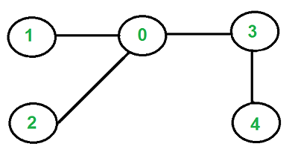

But the following graph is not a tree.
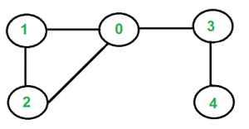

Solution:

// A recursive function that uses visited[] and parent
// to detect cycle in subgraph reachable from vertex v.
boolean isCyclicUtil(int v, boolean visited[], int parent)
{
// Mark the current node as visited
visited[v] = true;
Integer i;

// Recur for all the vertices adjacent to this vertex
Iterator<Integer> it = adj[v].iterator();

while (it.hasNext())
{
i = it.next();

// If an adjacent is not visited, then recur for
// that adjacent
if (!visited[i])
{
if (isCyclicUtil(i, visited, v))
return true;
}

// If an adjacent is visited and not parent of
// current vertex, then there is a cycle.
else if (i != parent)
return true;
}
return false;
}

// Returns true if the graph is a tree, else false.
boolean isTree()
{
// Mark all the vertices as not visited and not part
// of recursion stack
boolean visited[] = new boolean[V];
for (int i = 0; i < V; i++)
visited[i] = false;

// The call to isCyclicUtil serves multiple purposes
// It returns true if graph reachable from vertex 0
// is cyclic. It also marks all vertices reachable
// from 0.
if (isCyclicUtil(0, visited, -1))
return false;

// If we find a vertex which is not reachable from 0
// (not marked by isCyclicUtil(), then we return false
for (int u = 0; u < V; u++)
if (!visited[u])
return false;

return true;
}

TC: O(V + E)
SC: O(V) as we are using the visited array.

