- Given a graph, find the arrival and departure time of its vertices in DFS. The arrival time is the time at which the vertex was explored for the first time in the DFS, and departure time is the time at which we have explored all the neighbors of the vertex, and we are ready to backtrack.
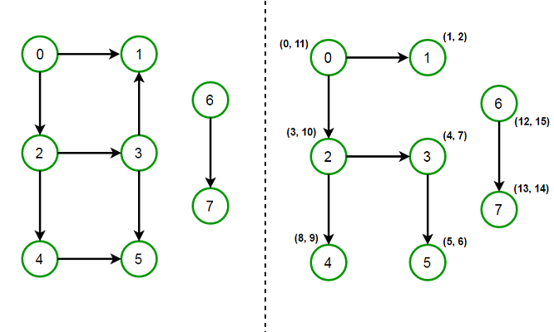

Solution:

// A class to store a graph edge
class Edge
{
int source, dest;

public Edge(int source, int dest)
{
this.source = source;
this.dest = dest;
}
}

// A class to represent a graph object
class Graph
{
// A list of lists to represent an adjacency list
List<List<Integer>> adjList = null;

// Constructor
Graph(List<Edge> edges, int n)
{
adjList = new ArrayList<>();

for (int i = 0; i < n; i++) {
adjList.add(new ArrayList<>());
}

// add edges to the directed graph
for (Edge edge: edges) {
adjList.get(edge.source).add(edge.dest);
}
}
}

class Main
{
// Function to perform DFS traversal on the graph on a graph
public static int DFS(Graph graph, int v, boolean[] discovered,
int[] arrival, int[] departure, int time)
{
// set the arrival time of vertex `v`
arrival[v] = ++time;

// mark vertex as discovered
discovered[v] = true;

for (int i: graph.adjList.get(v))
{
if (!discovered[i]) {
time = DFS(graph, i, discovered, arrival, departure, time);
}
}

// set departure time of vertex `v`
departure[v] = ++time;

return time;
}

public static void main(String[] args)
{
// List of graph edges as per the above diagram
List<Edge> edges = Arrays.asList(
new Edge(0, 1), new Edge(0, 2), new Edge(2, 3), new Edge(2, 4),
new Edge(3, 1), new Edge(3, 5), new Edge(4, 5), new Edge(6, 7)
);

// total number of nodes in the graph (labelled from 0 to 7)
int n = 8;

// build a graph from the given edges
Graph graph = new Graph(edges, n);

// array to store the arrival time of vertex
int[] arrival = new int[n];

// array to store the departure time of vertex
int[] departure = new int[n];

// mark all the vertices as not discovered
boolean[] discovered = new boolean[n];
int time = -1;

// Perform DFS traversal from all undiscovered nodes to
// cover all unconnected components of a graph
for (int i = 0; i < n; i++)
{
if (!discovered[i]) {
time = DFS(graph, i, discovered, arrival, departure, time);
}
}

// print arrival and departure time of each vertex in DFS
for (int i = 0; i < n; i++)
{
System.out.println("Vertex " + i + " (" + arrival[i] + ", " +
departure[i] + ")");
}
}
}

TC: O(V+E)
SC: O(V)

- Given a Directed Acyclic Graph (DAG), print it in topological order using topological sort algorithm. If the graph has more than one topological ordering, output any of them. Assume valid Directed Acyclic Graph (DAG).

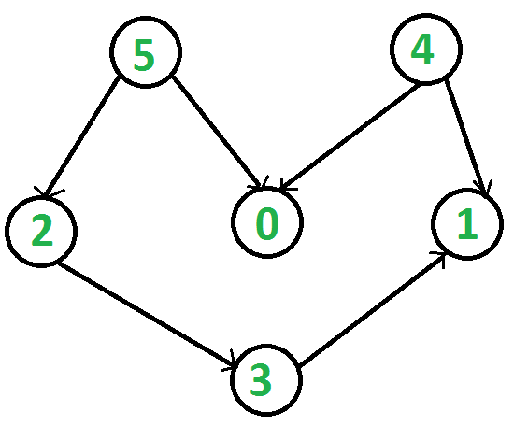

Following is a Topological Sort of the given graph
5 4 2 3 1 0

Solution:

class Edge
{
int source, dest;

public Edge(int source, int dest)
{
this.source = source;
this.dest = dest;
}
}

// A class to represent a graph object
class Graph
{
// A list of lists to represent an adjacency list
List<List<Integer>> adjList = null;

// Constructor
Graph(List<Edge> edges, int n)
{
// allocate memory
adjList = new ArrayList<>();
for (int i = 0; i < n; i++) {
adjList.add(new ArrayList<>());
}

// add edges to the directed graph
for (Edge edge: edges)
{
int src = edge.source;
int dest = edge.dest;

// add an edge from source to destination
adjList.get(src).add(dest);
}
}
}

class Main
{
// Perform DFS on the graph and set the departure time of all
// vertices of the graph
static int DFS(Graph graph, int v, boolean[] discovered,
int[] departure, int time)
{
// mark the current node as discovered
discovered[v] = true;

// set the arrival time of vertex `v`
time++;

// do for every edge (v, u)
for (int u: graph.adjList.get(v))
{
// if `u` is not yet discovered
if (!discovered[u]) {
time = DFS(graph, u, discovered, departure, time);
}
}

// ready to backtrack
// set departure time of vertex `v`
departure[time] = v;
time++;

return time;
}

// Function to perform a topological sort on a given DAG
public static void doTopologicalSort(Graph graph, int n)
{
// departure[] stores the vertex number using departure time as an index
int[] departure = new int[2*n];
Arrays.fill(departure, -1);

/* If we had done it the other way around, i.e., fill the array
with departure time using vertex number as an index, we would
need to sort it later */

// to keep track of whether a vertex is discovered or not
boolean[] discovered = new boolean[n];
int time = 0;

// perform DFS on all undiscovered vertices
for (int i = 0; i < n; i++)
{
if (!discovered[i]) {
time = DFS(graph, i, discovered, departure, time);
}
}

// Print the vertices in order of their decreasing
// departure time in DFS, i.e., in topological order
for (int i = 2*n - 1; i >= 0; i--)
{
if (departure[i] != -1) {
System.out.print(departure[i] + " ");
}
}
}

public static void main(String[] args)
{
// List of graph edges as per the above diagram
List<Edge> edges = Arrays.asList(
new Edge(0, 6), new Edge(1, 2), new Edge(1, 4),
new Edge(1, 6), new Edge(3, 0), new Edge(3, 4),
new Edge(5, 1), new Edge(7, 0), new Edge(7, 1)
);

// total number of nodes in the graph (labelled from 0 to 7)
int n = 8;

// build a graph from the given edges
Graph graph = new Graph(edges, n);

// perform topological sort
doTopologicalSort(graph, n);
}
}

TC: O(V+E)
SC: O(V)
- Given an undirected graph, determine whether it is bipartite using DFS. A bipartite graph (or bigraph) is a graph whose vertices can be divided into two disjoint sets U and V such that every edge connects a vertex in U to one in V. The following is a bipartite graph as we can divide it into two sets, U and V, with every edge having one endpoint in set U and the other in set V:
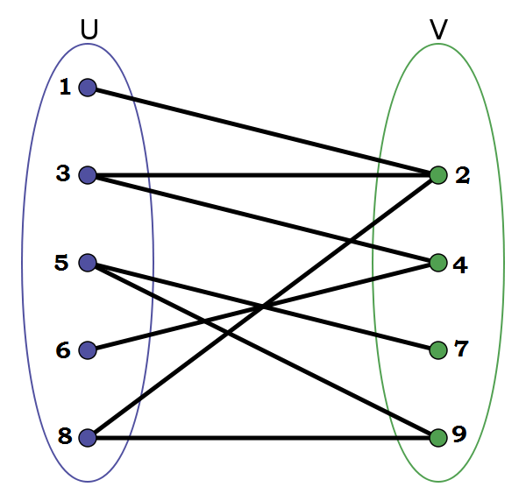

Solution:

class Edge
{
int source, dest;

public Edge(int source, int dest)
{
this.source = source;
this.dest = dest;
}
}

// A class to represent a graph object
class Graph
{
// A list of lists to represent an adjacency list
List<List<Integer>> adjList = null;

// Total number of nodes in the graph
int n;

// Constructor
Graph(List<Edge> edges, int n)
{
this.adjList = new ArrayList<>();
this.n = n;

for (int i = 0; i < n; i++) {
adjList.add(new ArrayList<>());
}

// add edges to the undirected graph
for (Edge edge: edges)
{
int src = edge.source;
int dest = edge.dest;

adjList.get(src).add(dest);
adjList.get(dest).add(src);
}
}
}

class Main
{
// Perform DFS on the graph starting from vertex `v`
public static boolean DFS(Graph graph, int v, boolean[] discovered,
boolean[] color)
{
// do for every edge (v, u)
for (int u: graph.adjList.get(v))
{
// if vertex `u` is explored for the first time
if (discovered[u] == false)
{
// mark the current node as discovered
discovered[u] = true;
// current node has the opposite color of that its parent
color[u] = !color[v];

// if DFS on any subtree rooted at `v` returns false
if (DFS(graph, u, discovered, color) == false) {
return false;
}
}
// if the vertex has already been discovered and
// the color of vertex `u` and `v` are the same, then
// the graph is not bipartite
else if (color[v] == color[u]) {
return false;
}
}

return true;
}

// Function to check if a graph is Bipartite using DFS
public static boolean isBipartite(Graph graph)
{
int n = graph.n;

// to keep track of whether a vertex is discovered or not
boolean[] discovered = new boolean[n];

// keep track of the color assigned (0 or 1) to each vertex in DFS
boolean[] color = new boolean[n];

// start from any node as the graph is connected and undirected
int src = 0;

// mark the source vertex as discovered and set its color to 0
discovered[src] = true;
color[src] = false;

// call DFS procedure
return DFS(graph, src, discovered, color);
}

public static void main(String[] args)
{
// List of graph edges
List<Edge> edges = Arrays.asList(
new Edge(0, 1), new Edge(1, 2), new Edge(1, 7),
new Edge(2, 3), new Edge(3, 5), new Edge(4, 6),
new Edge(4, 8), new Edge(7, 8), new Edge(1, 3)
// if we remove (1, 3) edge, the graph becomes bipartite
);

// total number of nodes in the graph (0 to 8)
int n = 9;

// build a graph from the given edges
Graph graph = new Graph(edges, n);

if (isBipartite(graph)) {
System.out.println("Graph is bipartite");
}
else {
System.out.println("Graph is not bipartite");
}
}
}

TC: O(V+E)
SC: O(V)

- Given a weighted undirected graph, find the maximum cost path from a given source to any other vertex in the graph which is greater than a given cost. The path should not contain any cycles. For example, consider the following graph,
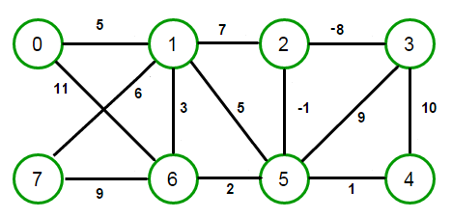
Let source = 0 and cost = 50.
The maximum cost route from source vertex 0 is 0—6—7—1—2—5—3—4, having cost 51, which is more than cost 50. The solution should return 51.
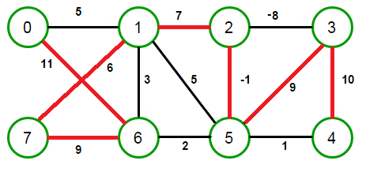
Solution:

// Perform BFS on graph `graph` starting from vertex `v`
int findMaxCost(Graph const &graph, int src, int k)
{
// create a queue for doing BFS
queue<Node> q;

// add source vertex to set and enqueue it
set<int> vertices;
vertices.insert(src);
q.push({src, 0, vertices});

// stores maximum cost of a path from the source
int maxCost = INT_MIN;

// loop till queue is empty
while (!q.empty())
{
// dequeue front node
Node node = q.front();
q.pop();
// v is the current vertex number
int v = node.vertex;
// cost of the current path chosen so far
int cost = node.weight;
// set of nodes visited so far in the current path
vertices = node.s;

// if the destination is reached and BFS depth is equal to `m`,
// update the maximum cost calculated so far
if (cost > k) {
maxCost = max(maxCost, cost);
}

// do for every adjacent edge of `v`
for (Edge edge: graph.adjList[v])
{
// check for a cycle
if (vertices.find(edge.dest) == vertices.end())
{
// add current node to the path
set<int> s = vertices;
s.insert(edge.dest);

// push every vertex (discovered or undiscovered) into
// the queue with a cost equal to the
// parent's cost plus the current edge's weight
q.push({edge.dest, cost + edge.weight, s});
}
}
}

// return max-cost
return maxCost;
}

TC: O(V.E)

- Given a directed graph, check if it is strongly connected or not. A directed graph is said to be strongly connected if every vertex is reachable from every other vertex.
For example, the following graph is strongly connected as a path exists between all pairs of vertices:

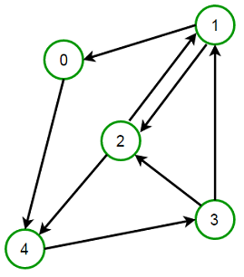

Solution:

// Function to perform DFS traversal on the graph on a graph
void DFS(Graph const &graph, int v, vector<bool> &visited)
{
// mark current node as visited
visited[v] = true;

// do for every edge (v, u)
for (int u: graph.adjList[v])
{
// `u` is not visited
if (!visited[u]) {
DFS(graph, u, visited);
}
}
}

// Function to check if the graph is strongly connected or not
bool isStronglyConnected(Graph const &graph, int n)
{
// do for every vertex
for (int i = 0; i < n; i++)
{
// to keep track of whether a vertex is visited or not
vector<bool> visited(n);

// start DFS from the first vertex
DFS(graph, i, visited);

// If DFS traversal doesn't visit all vertices,
// then the graph is not strongly connected
if (find(visited.begin(), visited.end(), false) != visited.end()) {
return false;
}
}//for loop closed

return true;
}

TC: O(V × (V + E))

