Salesforce Configuration for VTP

Creating the Connected App
Setup/Build/Create/Apps
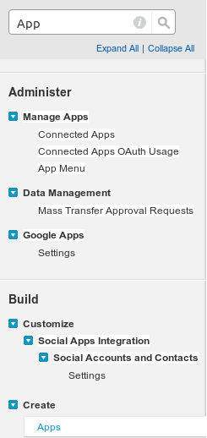
API (Enable OAuth Settings)
Add: api, refresh_token, offline_access
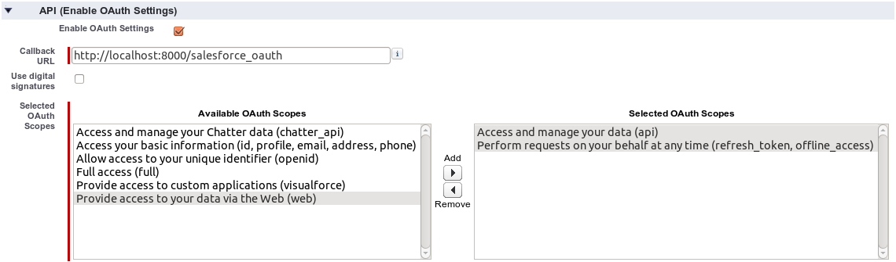
Manage/Edit: OAuth Policies
Permitted Users: Admin approved users are pre-authorized
(except Professional Edition doesn't have Profiles or Permission Sets, so use “All Users instead.”)

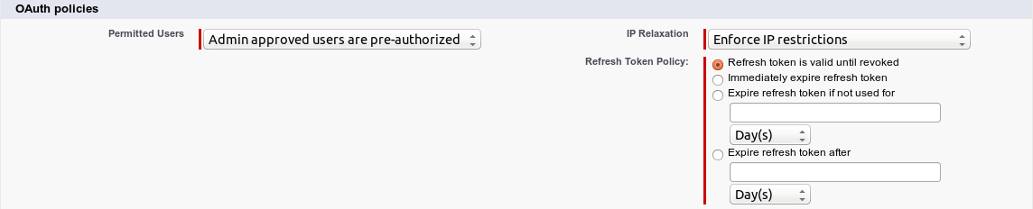

Consumer Key and Consumer Secret
Once the app is created, note these two values.

In VTP environment (developer's local environment or on Heroku), set them in environment variables:
- SALESFORCE_CONSUMER_KEY
- SALESFORCE_CONSUMER_SECRET

Creating the Permission Set

Professional Edition does not have access to create Permission Sets.

Manage Users/Permission Sets
Assigned Connected Apps, Edit

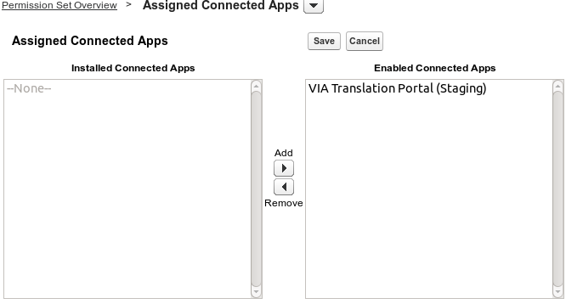

Creating the User
Currently, django-salesforce only supports the “password” OAuth flow. This means we'd like a user who is not a System Administrator for VTP to use. (While VTP will only be able to do things the Connected App is allowed to do over the API, as long as we have a password, we could steal it to do whatever non-API actions we want.)

Setup/Administer/Manage Users/Users/New User
User License: Salesforce
Profile: Standard User
(unless/until we discover Standard User isn't right for the VTP user and create a new Profile for it.)
Role: CEO (or whatever is at the top of the hierarchy over which VTP should be able to modify.)

uncheck Salesforce CRM Content User
uncheck CRM Content Email Alerts
uncheck Newsletter Settings

do Generate new password

After Created
Assign to this user the Permission Set created earlier.

Security Token
Log in as the new user.
My Settings/Personal/Reset My Security Token

The security token will be emailed to the account's email address.

Set VTP environment variables for
- SALESFORCE_USER
- SALESFORCE_PASSWORD – user password + security token

