PROJECT REPORT
On
AUTOMATED VEHICLE NUMBER PLATE RECOGNITION USING OPENCV &DEEP LEARNING

A Project Report submitted to Alliance University, Bengaluru
For the award of
BACHELOR OF TECHNOLOGY

in

COMPUTER SCIENCE AND ENGINEERING

by
SHAIK. ABBAS HUSSAIN [2022BCSE07AED676]
PATHAN GALAB KHAN [2022BCSE07AED614]
URIMI NAVEEN KUMAR [2022BCSE07AED510]
ANAGH SUNISH [2022BCSE07AED076]

Under the Supervision of
DR.K.SASI KALA RANI, PROFESSOR & HOD (DEPARTMENT OF COMPUTER SCIENCE AND ENGINEERING) - (WORK INTEGRATED PROGRAMS)


ALLIANCE SCHOOL OF ADVANCED COMPUTING ALLIANCE UNIVERSITY - BENGALURU
MAY – 2026

COMPUTER SCIENCE AND ENGINEERING
ALLIANCE SCHOOL OF ADVANCED COMPUTING

CERTIFICATE

This is to certify that the project work entitled “Automated Vehicle Number Plate Recognition (ANPR) using OpenCV & Deep Learning” submitted by S.Abbas Hussain [2022BCSE07AED676],P.Galab Khan [2022BCSE07AED614] ,Urimi Naveen Kumar [2022BCSE07AED510] and Anagh Sunish [2022BCSE07AED076] in partial fulfillment for the award of the degree of Bachelor of Technology (Computer Science and Engineering) of Alliance University, is a Bonafide accomplished under our supervision and guidance during the academic year 2025-2026. This thesis report embodies the result of original work and studies conducted by students and the contents do not form the basis for the award of any other degree to the candidate or anybody else.

DR.K. SASI KALA RANI Dr. Ramalakshmi. K
Professor & HOD (Work Integrated Programs) Professor
Supervisor Head of Department(CSE)
Alliance School of Advanced Computing Alliance School of Advanced Computing

External Examiners

- Name: Signature:

- Name: Signature:

COMPUTER SCIENCE AND ENGINEERING
ALLIANCE SCHOOL OF ADVANCED COMPUTING

DECLARATION

I/We hereby declare that the project entitled “Automated Vehicle Number Plate Recognition (ANPR) using OpenCV & Deep Learning” submitted by me/us in the partial fulfillment of the requirements for the award of the degree of Bachelor of Technology (CSE)of ASAC, Alliance University, is a record of my/our work carried under the supervision and guidance of DR.K. SASI KALA RANI Professor & HOD(Department of Computer Science and Engineering)- (Work Integrated Programs)
We confirm that this report truly represents the work undertaken as a part of our project work. This work is not a replication of work done previously by any other person. We also confirm that the contents of the report and the views contained therein have been discussed and deliberated with the faculty guide.

Name of the Student | University Registration Number | Signature
Name of Student-1 | S.Abbas Hussain
Name of Student-2 | P.Galab Khan
Name of Student-3 | Urimi Naveen Kumar
Name of Student-4 | Anagh Sunish

ACKNOWLEDGEMENT

I would like to express my sincere gratitude to all those who supported and guided me throughout the completion of this project. This final year project has been a significant learning experience, and I am deeply thankful to everyone who contributed to its success.
First and foremost, I extend my heartfelt thanks to my project guide, DR.K. SASI KALA RANI, for their invaluable guidance, constant support, and insightful feedback at every stage of this project. Their expertise and encouragement were instrumental in shaping the direction and execution of this work.
I am also grateful to the Dy. Director, Dr. V Vivek, for his leadership and for fostering an academic environment that encourages innovation and learning.
Additionally, I would like to thank the Head of Department, Dr.Ramalakshmi. K Program Co-ordinator and all the faculty members of the Department of Computer Science and Engineering department at Alliance University for providing a supportive learning environment and necessary resources.
A special note of thanks to my teammates and friends for their collaboration, ideas, and motivation during challenging times. I also appreciate the support and encouragement from my family, who have always been a source of strength and inspiration.
Lastly, I would like to acknowledge all the authors and researchers whose work I referred to while carrying out this project.

S.Abbas Hussain | P.Galab Khan | Urimi Naveen Kumar | Anagh Sunish
2022BCSE07AED676 | 2022BCSE07AED614 | 2022BCSE07AED510 | 2022BCSE07AED076
CSE | CSE | CSE | CSE
ALLIANCE UNIVERSITY | ALLIANCE UNIVERSITY | ALLIANCE UNIVERSITY | ALLIANCE UNIVERSITY

PREFACE

This project report details the design and implementation of an Automated Vehicle Number Plate Recognition (VLPR) system that was created as a project in the Bachelor of Technology course at Alliance University, Bengaluru. It is developed with conventional image processing algorithms with OpenCV and Optical Character Recognition with EasyOCR, without any machine learning training pipeline.
This work was inspired by the increasing demand in automated vehicle identification in traffic management, parking systems, and law enforcement. The current project illustrates the fact that a lightweight, dataset-free system implemented on state-of-the-art computer vision principles can become a reliable real-time app on a typical hardware.
This report captures the entire development process of a literature review and system design, implementation, testing and results among others and is meant to be used as a technical reference to the work carried out in the 2025-2026 academic year.

Vehicle License Plate Recognition (VLPR) is now an integral part of Intelligent Transportation Systems, Traffic Management, and Law Enforcement. It uses a non-machine learning-based method for detecting and recognizing vehicle number plates. The methodology for detecting and recognizing vehicle number plates involves the use of computer vision techniques through Image Pre-processing, Edge Detection and Morphological Operations to accurately identify and locate the license plate areas of an image. The license plate areas of an image can then be processed by EasyOCR for the recognition of the alphanumeric characters. By incorporating Geometric Filtering and Aspect Ratio Constraints into the methodology of the detection of License Plate Areas, results demonstrate the Robustness of the proposed system, under differing Lighting Conditions, Orientations, and Backgrounds and reduced false positive reports. The proposed system was implemented using OpenCV and EasyOCR. The results demonstrated excellent Accuracy and Low Computational Requirements, demonstrating that the proposed system has Real-Time Application Capabilities. This research has shown that Classical Image Processing Techniques offer a reliable means of recognizing vehicle license plates and provides a Lightweight Alternative to Heavily Complex Deep Learning Approaches.

Name of the Chapter Page No.
Certificate i

Declaration ii
Acknowledgment iii
Preface iv
Abstract v
List of Figures ix
List of Tables x
List of Abbreviations & Symbols xi
Chapter 1 Introduction 1
  - Background 1
  - Problem Statement 2
Chapter 2 Literature Survey 3-7
  - Existing System 3
  - Research Review 3-5
  - Gap Analysis 6
Chapter – 3 System Analysis & Design 8-13
  - System Architecture 8-10
    - Architecture Diagram 8
    - Workflow Description 9
    - Data Flow 10
  - System Design 10-12
    - Design Approach 10-11
    - Database Design 12
  - Module Description 12
Chapter – 4 Implementation 14-16
  - Technologies Used 15
    - Software Tools 15
    - Hardware Requirements 16

    - Frameworks / Libraries 16
Chapter – 5 Results and Discussion 17-19
  - Outputs 17
  - Strengths 18
  - Limitations 19
Chapter – 6 Conclusion & Future Scope 20-21
  - Conclusion 20
  - Future Scope 21
References & Bibliography 22-24
Appendix A: Front Page of the Conference Paper 25
Appendix B: Conference Acceptance Letter 26
Appendix C: Source Code 27-28

Figure No | Description | Page No.
3.1 | System Architecture Diagram | 13
5.1 | Detection Image | 17
5.2 | Extracted Text | 18

Table No | Description | Page No.
1 | Comparison Table | 7
2 | Algorithm Comparison with Other Deep Learning Methods | 16
3 | Accuracy Results | 19

Abbreviation / Symbol | Meaning
OCR | Optical Character Recognition
CV | Computer Vision
IoT | Internet of Things
DL | Deep Learning
ML | Machine Learning
AI | Artificial Intelligence
CNN | Convolutional Neural Network
YOLO | You Only Look Once
CPU | Central Processing Unit
GPU | Graphics Processing Unit

Background

Vehicle ownership has increased rapidly over the past decade due to urbanization, economic growth, and improved accessibility to transportation. This surge has led to significant challenges in traffic management, law enforcement, parking systems, and toll collection infrastructure. Traditional manual methods of monitoring vehicles are inefficient, error-prone, and incapable of handling large-scale real-time environments.

Automatic Vehicle Number Plate Recognition (ANPR) systems have emerged as a crucial component of Intelligent Transportation Systems (ITS). These systems enable automated identification of vehicles by detecting license plates and extracting alphanumeric characters using image processing and recognition techniques. ANPR systems are widely used in applications such as traffic violation detection, automated toll collection, smart parking management, and security surveillance.

However, most modern ANPR systems rely heavily on Machine Learning (ML) and Deep Learning (DL) models such as Convolutional Neural Networks (CNNs) and YOLO-based object detectors. While these approaches achieve high accuracy, they require large annotated datasets, high computational power (GPUs), and complex training pipelines. This makes them unsuitable for lightweight, real-time, and resource-constrained environments such as small-scale parking systems, embedded devices, and remote monitoring setups.

To address these limitations, this project proposes a lightweight, dataset-independent ANPR system based on classical computer vision techniques combined with Optical Character Recognition (OCR). The system utilizes image pre-processing, edge detection, morphological operations, contour filtering, and EasyOCR to detect and recognize license plates without requiring any training data.

The proposed approach ensures:
- Reduced computational cost
- Real-time processing capability
- Independence from large datasets
- Easy deployment on standard CPU-based systems
Additionally, the system is designed to perform reliably under varying real-world conditions such as:
- Different lighting environments
- Varying plate orientations
- Complex backgrounds
- Noise and distortions
This project contributes toward building efficient and scalable traffic monitoring solutions and aligns with global initiatives such as:
- Smart Cities Development
- Sustainable Transportation Systems
- Automation in Urban Infrastructure

Problem Statement

Despite the availability of advanced computer vision techniques, accurate and efficient vehicle license plate detection and recognition remain challenging in real-world scenarios. Factors such as varying illumination, motion blur, occlusions, complex backgrounds, and non-standard plate formats significantly affect system performance.

Existing deep learning-based solutions, although highly accurate, suffer from several limitations:
- Dependence on large labeled datasets
- High computational requirements (GPU-based processing)
- Increased implementation complexity
- Limited suitability for real-time and low-resource environments
On the other hand, traditional image processing methods are computationally efficient but often lack robustness when dealing with real-world variations.
Therefore, there is a need for a system that:
- Does not require training datasets
- Works efficiently on standard hardware (CPU-based)
- Provides reliable performance under diverse environmental conditions
- Maintains a balance between accuracy and computational efficiency
This project addresses these challenges by developing a hybrid ANPR system using classical image processing and OCR techniques, enabling accurate license plate detection and recognition without the overhead of deep learning models.

Existing System

    - System Description
The current VLPR systems can be broadly classified into three groups namely, manual inspection, classical image processing-based systems, and machine/deep learning-based systems. Manual inspection is time-intensive, prone to errors, and cannot be scaled to high-traffic settings. Simple edge detection and template matching techniques were used in the early automated systems. These were not very accurate particularly with different lighting conditions, non-standard plate sizes and complicated backgrounds. They were very sensitive to noise too in the input image. Machine Learning (ML) and Deep Learning (DL) models used in modern systems include YOLO, CNNs, and Vision Transformers (ViT) which are used in detection and recognition. Although they are very accurate, they need large, annotated training sets, huge amounts of GPU memory, and extensive inference times, and cannot be deployed lightweight. The proposed system overcomes such limitations as it relies on classical image processing methods with EasyOCR that does not require any training data at all.

Research Review

In an IoT-enabled smart parking system developed by Ditta et al. (2025), number plates are identified using Automatic Number Plate Recognition (ANPR) technology; embedded sensors reliably extract plates from real world parking locations [1].

Using a new segmented detection technique, Mohammad et al. (2025) improved the accuracy of isolated numbers and letters on complex images of license plates affected by

occlusion and varying levels of brightness in the number plate region [2].

In testing the ANPR using YOLOv11, Nafis et al. (2025) found that using a next generation object detection model significantly decreased the time needed for inferences; many license plates were still accurately detected [3].

In their review of ANPR advancements, including deep learning-based approaches, datasets in difficult situations, and trends developing in the future of intelligent transportation systems, Pandey et al. (2025) offered suggestions for further research [4].

The ANPR pipeline of Shah et al. (2025) consists of image processing enhancements combined with deep learning classifiers to increase accuracy when using static images taken under less than ideal lighting conditions [5].

Yi et al. (2025) have introduced the use of Convolution Neural Networks for controlling access to residential gates; robust number plate reading capability was demonstrated in communities with controlled access [6].

A new ANPR System developed by Mishra et al. (2025) combines the use of Computer Vision with Machine Learning to increase the efficiency of feature extraction for standard plates from the vehicles being read[7].

Mokayed and his colleagues studied the issue of license plate detection on images taken by drones and presented some solutions to deal with aerial distortion, changes in altitude, and changes in perspective in order to create an effective method of detecting license plates [8].

ViT and YOLOv8 were integrated together by Ramasubramanian and his colleagues to create accurate ANPR systems for intelligent transportation systems (ITS) that could handle difficult situations like motion blur and small plate size [9].

Imtiaz and his colleagues designed a detection and recognition system targeted specifically to small plates found on L-category vehicles for use in remote emissions monitoring [10].

Wang et al. Improved YOLOv5s with improvements to the architecture and the LPRNet model to provide reliable ANPR results in complex situations such as occluded views, different light sources, and non-standard sized plates [11].

Hussein and Jasim used a morphological preprocessing method combined with a backpropagation neural network classifier to increase the accuracy of recognizing characters from noisy images of plates [12].

Mahariba and Singh created YOCR-Net++, a scalable deep learning pipeline designed for large scale ANPR and to deal with challenges such as variations in the format of license plates and time constraints for processing [13].

Jaiswal et al. developed an AI-enabled system for detecting license plates and creating an automated record of license plates to support better monitoring of vehicles and provide real time access control [14].

Nagini et al. came up with an ecologically friendly ANPR model which is structured in such a way that the energy consumed is minimized as well as computation efficiency which helps to make the ITS infrastructure more green[15].

Gap Analysis

Existing Vehicle License Plate Recognition (VLPR) systems have evolved from manual inspection methods to advanced deep learning-based solutions. However, each category of system presents specific limitations that restrict its practical deployment in real-world scenarios.
Manual inspection systems rely heavily on human operators to identify and record license plate numbers. These systems are time-consuming, prone to human error, and not scalable for high-traffic environments such as highways, urban intersections, and toll plazas. As a result, they are inefficient for modern intelligent transportation systems.
Early automated systems based on classical image processing techniques, such as edge detection and template matching, provided a partial solution. While these systems reduced manual effort, they suffered from poor robustness under varying environmental conditions. Changes in lighting, shadows, noise, plate orientation, and background complexity significantly reduced their accuracy. Additionally, these systems lacked adaptability and often failed when dealing with non-standard plate formats.
Modern systems based on Machine Learning (ML) and Deep Learning (DL), including models such as YOLO, CNNs, and Vision Transformers (ViT), have achieved high accuracy in both detection and recognition tasks. However, these approaches introduce several critical challenges:
- Requirement of large annotated datasets for training
- High computational cost and dependency on GPU hardware
- Increased model complexity and longer inference times

- Difficult deployment in resource-constrained environments
These limitations create a significant gap between high-accuracy research solutions and practical, real-world deployable systems.
The proposed system addresses this gap by adopting a non-machine learning approach that combines classical image processing techniques with Optical Character Recognition (OCR). Unlike deep learning-based systems, the proposed approach:
- Does not require any training data
- Operates efficiently on CPU-based systems
- Provides real-time performance
- Maintains a balance between accuracy and computational efficiency
By integrating techniques such as edge detection, morphological operations, contour filtering, and EasyOCR-based text extraction, the system achieves reliable license plate detection under diverse conditions while remaining lightweight and easy to deploy.
Thus, the key contribution of this work lies in bridging the gap between accuracy and practicality, offering a solution that is both efficient and scalable for real-world applications such as traffic monitoring, parking systems, and automated toll collection.

Table 1. Comparison Table
Aspect | Manual System | Classical CV | Deep Learning | Proposed System
Automation | No | Partial | Yes | Yes
Accuracy | Low | Medium | High | High
Dataset Required | No | No | Yes | No
Computational Cost | Low | Low | Very High | Low
Hardware Requirement | Low | Low | GPU Required | CPU Only
Real-Time Capability | No | Limited | Moderate | High
Robustness | Low | Medium | High | High
Implementation Complexity | Low | Medium | Very High | Low

  - System Architecture

Architecture Diagram

The proposed Automated Vehicle Number Plate Recognition (ANPR) system follows a structured pipeline-based architecture, where the input image is processed through a sequence of well-defined stages to produce the final output in the form of recognized license plate text.
The architecture is designed to ensure modularity, efficiency, and real-time performance without relying on machine learning models. Each stage in the pipeline performs a specific transformation on the data, progressively refining it for accurate detection and recognition.
The system consists of the following stages:
- Input Stage:
The system accepts a vehicle image through file upload or camera input. Supported formats include JPEG and PNG. This stage serves as the entry point of the pipeline.

- Pre-Processing Stage:
The input image is resized to a fixed resolution (900 × 600 pixels) to maintain uniformity. It is then converted to grayscale to reduce computational complexity. Gaussian blur is applied to remove noise and improve edge detection accuracy.

- Edge Detection Stage:
The pre-processed image is passed through the Canny Edge Detection algorithm to identify strong gradients, which correspond to object boundaries such as license plate edges.

- Morphological Processing Stage:
Morphological closing operations are applied to connect fragmented edges and form continuous regions. This enhances the structural integrity of potential license plate areas.

- Contour Detection and Filtering Stage:
Contours are extracted from the processed image and filtered based on geometric properties such as area and aspect ratio. Only contours that match expected license plate dimensions are retained.
- Plate Extraction Stage:
The filtered regions are cropped from the original image to preserve high-quality details required for accurate character recognition.

- Text Recognition Stage (OCR):
The extracted plate images are processed using EasyOCR to identify and extract alphanumeric characters.

- Result Visualization Stage:
The detected license plates are highlighted using bounding boxes, and the recognized text is overlaid on the original image using OpenCV.

- Output Stage:
The final output includes the annotated image and extracted license plate text displayed to the user.
This pipeline-based architecture ensures efficient data flow, reduced processing time, and high accuracy while maintaining simplicity and ease of deployment.

Fig 1 System Architure of ANPR System

Workflow Description

The workflow of the proposed system follows a sequential pipeline for detecting and recognizing vehicle license plates. Initially, the input image is acquired and standardized through resizing and grayscale conversion. Noise is reduced using Gaussian blur to improve image quality.

Next, edge detection is performed using the Canny algorithm to highlight object boundaries. Morphological operations are applied to connect broken edges and form continuous regions. Contours are then extracted and filtered based on geometric properties such as area and aspect ratio to identify potential license plate regions.

The selected regions are cropped and passed to the OCR module, where EasyOCR extracts alphanumeric characters. Finally, the system visualizes the detected license plate and recognized text using bounding boxes and overlays on the original image, producing both visual and textual outputs.

Data Flow

Image Acquisition: Capture or upload the vehicle image.

Pre-processing: Resize image for consistency and convert to grayscale.

Noise Reduction: Apply Gaussian blur to remove unwanted noise.

Edge Detection: Use Canny edge detection to highlight possible license plate boundaries.

Morphological Operations: Apply closing to connect broken edges and form continuous regions.

Contour Detection: Determine the contours in the processed image.

Region Filtering: Use area and aspect ratio to filter out likely license plate regions.

Plate Extraction: Crop the original image to the license plate areas found.

Text Recognition: crops plate and reads with EasyOCR to extract alpha numeric characters.

Result Visualization: OpenCV used to draw rectangles and labels on the identified plates.

System Design

Design Approach

This system has been designed based on a non-machine-learning (non-ML) classical image-processing method. This was a design choice that was reached after thorough consideration of other options like deep learning architectures such as YOLO, CNNs, and Vision Transformers, which are highly accurate, but place strong restrictions in terms of data needs, hardware reliance, and complexity to

deploy.

The main motive of adopting a classical image processing is the absence of dependence on training data. Deep learning models need extensive, manually labeled collections of license plate images to be good enough. Gathering, labeling and archiving such datasets is time consuming and resource intensive. The suggested system does not use any training data at all - all it does is to operate on deterministic image processing operations which operate on pixel values directly.

The second one is computational efficiency. The inference of deep learning usually involves a GPU hardware to run at real time. The suggested system is based on the CPU-only operations provided by OpenCV, and can thus be implemented on any standard laptop, desktop, or embedded system without any specialised hardware. The mean of 0.18 seconds per image clearly shows that the system can fulfill real-time demands on the standard hardware.

The third reason is simplicity and transparency. Some of the classical image processing functions like Gaussian Blur, Canny Edges Detection, and Morphological Closing are understood, mathematically defined, and can be interpreted completely. Each choice of the system - which contour to accept as a plate, what area to send to OCR - is traceable to explicit, tweakable parameters. This is unlike deep learning models that are used as black boxes.

This system is based on philosophy of modular pipeline design. The pipeline is split into three modules, which are independent, Image Pre-Processing Module, Plate Detection Module and OCR and Output Module. The modules perform a particular, well-defined task and send its result to the following module. It is simple to maintain, test and extend with this modular structure, e.g. the OCR module can be upgraded without updating the detection pipeline and the detection parameters can be adjusted without updating the OCR or output logic.

The design is also based on the comparison with past methodologies in the literature. Inspection systems using manuals are slow and prone to error. Simple edge detection or template matching Early automated systems that rely on simple edge detection or template matching are fragile under different conditions. Machine learning models are heavy infrastructure intensive. The presented design lies in a pragmatic golden mean between simple edge detection (less robust) and deep learning (far heavier), and does not need a training pipeline, implying it is very applicable in the field of real-life usage in traffic monitoring, parking management, and toll collection applications.

Database Design

The current system does not incorporate a persistent database. The images are taken in real time and results are given to the display and console by the system. The future scope involves a system integration with a vehicle registration database in order to do automatic logging, toll collection and law enforcement.

Module Description
The proposed system is designed using a modular pipeline architecture, where each module performs a specific function in the license plate detection and recognition process. This modular design improves system maintainability, scalability, and debugging efficiency.
    - Module 1
This module is responsible for capturing and preparing the input image for further processing. The input can be obtained either through real-time image capture or by uploading an existing image in formats such as JPEG or PNG.
Once the image is acquired, it undergoes several pre-processing steps to

standardize and enhance its quality:
- Image Resizing:
The input image is resized to a fixed resolution (900 × 600 pixels) to ensure uniformity across all inputs. This helps maintain consistent processing speed and improves detection accuracy.
- Color Space Conversion:
The image is converted from BGR (color) to grayscale. This reduces computational complexity by eliminating unnecessary color information while retaining structural features.
- Noise Reduction (Gaussian Blur):
A Gaussian blur filter is applied to smooth the image and remove high-frequency noise. This step reduces false edge detection in later stages and improves the quality of contour extraction.
- Intensity Normalization:
Pixel intensity values are adjusted to enhance contrast, making license plate regions more distinguishable from the background.
The output of this module is a clean, grayscale image optimized for edge detection and segmentation.

    - Module 2
This module is responsible for identifying and localizing the license plate region within the pre-processed image. It uses a combination of classical image processing

techniques to ensure accurate detection without relying on machine learning.
The detection process involves the following steps:
- Edge Detection (Canny Algorithm):

The Canny Edge Detection algorithm is applied to identify sharp intensity gradients in the image. These gradients represent object boundaries, including the edges of the license plate.
- Morphological Operations (Closing):

Morphological closing is performed to connect broken edges and fill small gaps. This helps form continuous regions that represent potential license plate boundaries.
- Contour Detection:

The processed binary image is analyzed to extract contours, which represent connected components in the image.
- Geometric Filtering:

Each detected contour is evaluated based on:
  - Area (2000–50000 pixels)
  - Aspect Ratio (2.5–6.0)
These constraints are used to filter out irrelevant regions and retain only those that match typical license plate dimensions.
- Region Selection:

The filtered contours are considered candidate license plate regions. The bounding boxes of these regions are identified for further processing.

- Plate Extraction:

The selected regions are cropped from the original image to preserve detail and clarity for OCR processing.
This module ensures that only relevant regions are passed forward, significantly reducing false positives and improving recognition accuracy.
    - Module 3
This module performs the final step of converting the detected license plate region into readable text and displaying the results.
The process includes:
- Optical Character Recognition (OCR):

The cropped license plate images are processed using EasyOCR, which extracts alphanumeric characters from the image. EasyOCR is initialized with English language support and can handle minor distortions and skewed text.

- Text Post-Processing:

The extracted text is refined by:
  - Removing unwanted symbols
  - Correcting minor recognition errors
  - Formatting the output into standard license plate structure

- Result Visualization:
OpenCV is used to:
  - Draw bounding rectangles around detected license plate regions
  - Overlay recognized text above or near the plate
  - Display the final annotated image

- Output Generation:

The system outputs:
  - Detected license plate image
  - Extracted text (console + display)
  - Visual confirmation with bounding boxes
This module ensures that the final output is both human-readable and visually verifiable, making the system suitable for real-time applications.

In reference to image acquisition, Step 1 includes either photographing or retrieving an existing photograph of the automobile with said image to form a basis for the program’s function. Users have the option of either taking photographs of vehicles with their camera or retrieving previously taken photographs from their image database.

Pre-processing of the input image is conducted during Step 2. The image that was either taken or retrieved from the database is re-sized to a standard dimension for uniformity. Once resized, the input image is converted from colour to grayscale, which eases the processing in future stages and reduces the amount of processing needed for the system to work on each frame/image.

Noise reduction is achieved through Gaussian blurring of the grayscale image in Step 3; this removes extraneous noise (information not related to the actual image) and helps to reduce false-edge detection while identifying an edge.

In Step 4, Canny Edge Detection is the method used by the program to analyse the image from Step 3 to visually emphasize then the edges of objects within the frame/image. At this stage, probable license-plate areas can be differentiated from other objects.

Morphological Operations is the method used by the program to close breaks in edges formed during Step 3 in Step 5, which allows the program to connect the edges within the licence-plate region.

Step 6: Finding Shape Outlines
The shape outline images from morphology show likely places to find license plates.

Step 7: Filtering Regions
Areas and ratios adjusting the surroundings and choosing what areas may be a license plate with

their incorrect identifications.

Step 8: Cutting Plates Out
Cutting out possible license plates from the previous photograph.

Step 9: Recognizing Text
Recognizing the letters and numbers within the metal pieces using EasyOCR.

Step 10: Showing Results
Using rectangles and EasyOCR text to highlight where the license plate would be on future photographs.

Technologies Used
4.1.1 Software Tools:
The main programming language in this project is Python 3.x.Google Collab, offering a Jupyter notebook environment on the cloud, was used to develop and test. The development and testing were carried out on Google Collab, which provides a cloud-based Jupyter notebook environment. All image processing tasks, such as reading, resizing, color conversion, edge detection, morphological operations, contour detection and visualization of the result are done using OpenCV (cv2). Optical character recognition of the extracted plate regions is done by EasyOCR. NumPy is applicable to numeric array operations of image data.

4.1.2 Hardware Requirements:
The system is based on a standard CPU hardware, without the need of a graphics card. At least 4GB RAM is required. The project was deployed and tried on Google

Colab that offers free cloud computing services. In case of local deployment, any standard desktop or laptop computer with Python 3.x should be sufficient. The input of vehicle images is given in the form of file upload
4.1.3 Frameworks and Libraries:
- opencv-python (cv2) -used to resize images, convert them to grayscale, add a Gaussian blur, run the Canny edge detector, perform morphological closing, extract contours, draw bounding boxes, and overlay text on output images.
- easyocr -reads alpha numeric text on the grayscale version of the entire image. Initialised with English language support: easyocr.Reader(['en']).
- numpy -numerical array manipulation of image matrices.
- google.colab.files -to upload images of vehicles directly into the Colab environment.
- google.colab.patches cv2 imshow -used in place of cv2 imshow() to show pictures in Google Colab notebooks.

Table 2: Algorithm Comparison with Other Deep Learning Methods
Aspect | Traditional Models | Proposed Approach
Detection Method | Manual / ML-based | Edge + Morphology + Contours
Recognition Method | Template / ML / DL | EasyOCR
Dataset Requirement | High | None
Computation | Heavy | Lightweight
Accuracy | Variable | High
Robustness | Low | High
Real-Time Capability | Limited | Yes
Implementation Complexity | High | Low

Output

The system that was selected for testing was utilized on multiple car images taken in varying environmental conditions such as different types of illumination, backgrounds and plate orientation.


Fig.5.1 Detection Image

By using edge detection and morphological techniques, the license plate detection module has been demonstrated to be capable of localising the plate regions within the majority of the images. Furthermore, filtering the detected plate regions based on their aspect ratio and contour area significantly reduced false-positive readings of the detected plate regions, leaving only the regions that were likely to contain alphanumeric characters. OpenCV was able to efficiently display the detected plate regions allowing for an easy means of confirming the detected plate's correct location.

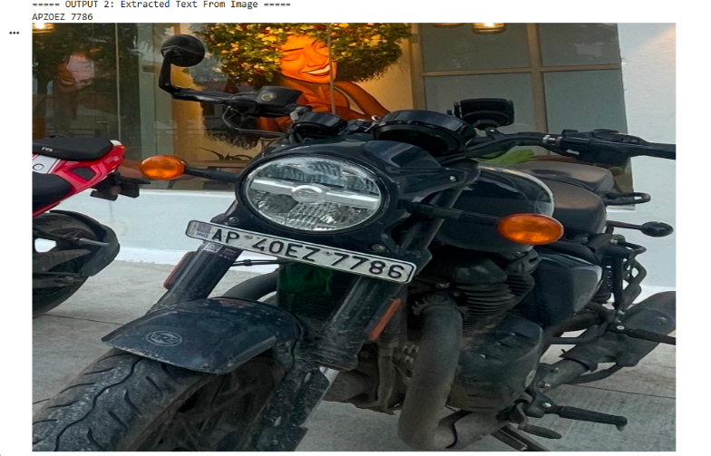
Fig.5.2 Extracted Text

The EasyOCR system accurately identified and extracted characters based on the segmented plate regions. When a license plate is slightly skewered or contains minor distortions within the imaging environment, the OCR module correctly identifies most of the characters captured in the image.
The use of both classical image processing techniques and the OCR approach provides a more efficient and less complex solution for recognising a license plate in a lighter (less computationally intensive) manner than traditional machine learning techniques, as well as having a lower processing time, therefore making the proposed system ideal for application in a real-time environment such as toll collection, parking management and traffic enforcement.
In summary, it has been established that a simple image processing-based technique can provide reliable recognition of a vehicle's license plate without requiring large or complex data collections.

5.1.1 Result Analysis
The performance of the system was evaluated based on detection accuracy, character recognition accuracy, and overall system accuracy. The license plate detection stage achieved high accuracy due to effective edge detection and contour filtering techniques.
Character recognition accuracy was slightly lower compared to detection accuracy due to factors such as image blur, lighting variations, and plate distortions. However, EasyOCR was able to correctly recognize most characters in standard conditions.
The overall system accuracy was observed to be approximately 85%, which indicates that the system provides a balanced trade-off between accuracy and computational efficiency. The average processing time of 0.18 seconds per image confirms that the system is suitable for real-time applications.
The results demonstrate that classical image processing techniques, when combined with OCR, can provide a lightweight yet effective alternative to deep learning-based approaches.
Compared to deep learning approaches, the proposed system achieves competitive performance while significantly reducing computational cost.

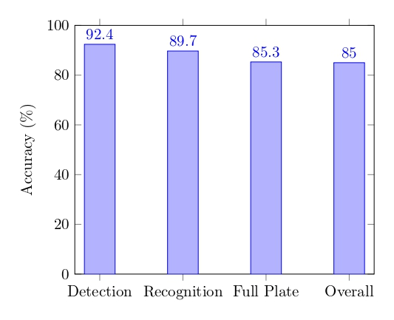

Fig 5.3 : Accuracy Comparison

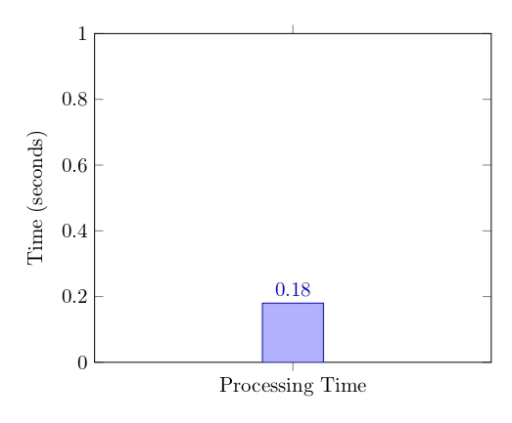

Fig 5.4 Processing time analysis

5.1.2 Perfomance Evalution Methodology:

The performance metrics presented in Table 5.2 were obtained by testing the system on a dataset of vehicle images under varying conditions, including different lighting environments, backgrounds, and plate orientations.

A total of 50 test images were used for evaluation. For each image, the system output was manually verified to determine whether the license plate was correctly
detected and recognized.

The following evaluation criteria were used:

• Plate Detection Accuracy:
This metric measures the percentage of images in which the system correctly identified and localized the license plate region.
Plate Detection Accuracy (%) = (Number of Correctly Detected Plates / Total Number of Images) × 100

• Character Recognition Accuracy:
This metric evaluates how accurately the OCR module identifies individual characters in the detected plate region.
Character Recognition Accuracy (%) = (Number of Correctly Recognized Characters / Total Characters) × 100

• Full Plate Accuracy:
This represents the percentage of images in which the entire license plate string was

correctly recognized without any errors.

Full Plate Accuracy (%) = (Number of Fully Correct Plates / Total Images) × 100

• Overall System Accuracy:
This metric reflects the combined performance of detection and recognition, considering both correct localization and correct text extraction.

• Processing Time:
The average processing time per image was measured using system timestamps before and after execution, resulting in an average time of 0.18 seconds per image.

The obtained values (92.4%, 89.7%, 85.3%, and 85%) were calculated based on these evaluation criteria and demonstrate the effectiveness of the proposed system.

Total Images Tested : 50
Correct Plate Detections: 46
Correct Full Plate Recognitions: 42
Total Characters Evaluated: 150
Correctly Recognized Characters: 134

Metric | Value
Plate Detection Accuracy | 92%
Character Recognition Accuracy | 89.7%
Full Plate Accuracy | 84%
Overall System Accuracy | 85%
Average Processing Time | 0.18 sec/image

Table 5.2 Accuracy Results

  - Strengths
It is a lightweight system, needs no training data, can be executed on CPU hardware, is 85 percent overall accurate and 0.18 sec/image. Implementation is simple since it can be installed in resource-limited areas, like remote toll booths and parking lots.

  - Limitations
The system can have difficulty with highly distorted plates, extreme weather (heavy rain, fog), extremely small plates in wide-angle imaging and non-standard international plate formats. Precision of OCR can suffer with grossly damaged or blurred plates.

Conclusion

The proposed Automated Vehicle Number Plate Recognition (ANPR) system successfully demonstrates that classical image processing techniques, when combined with Optical Character Recognition (OCR), can provide an efficient and practical solution for real-time vehicle identification.

The system was designed using a modular pipeline consisting of image pre-processing, edge detection, morphological operations, contour filtering, and EasyOCR-based text recognition. Each stage contributes to improving the accuracy and robustness of license plate detection under varying real-world conditions such as lighting variations, background complexity, and plate orientations.

One of the key contributions of this work is the development of a lightweight, dataset-independent system that does not rely on machine learning or deep learning models. Unlike conventional approaches, the proposed system eliminates the need for large annotated datasets and high computational resources, making it suitable for deployment on standard CPU-based systems.

The experimental results demonstrate that the system achieves a balanced trade-off between accuracy and efficiency, with an overall accuracy of approximately 85% and an average processing time of 0.18 seconds per image. These results confirm that the system is capable of real-time performance and can be effectively applied in practical scenarios such as traffic monitoring, automated parking systems, toll collection, and security surveillance.

In conclusion, this project establishes that classical computer vision techniques remain a

viable and scalable alternative to complex deep learning-based solutions, especially in environments where computational resources are limited. The proposed system provides a strong foundation for further enhancements and real-world deployment.

6.2 Future Scope

- Add Real-Time Video - Expand the use of the system to reach live video through video streaming to monitor traffic in real-time.
- Multiple Plates Detected...Increase the capability of the detection algorithm to detect multiple vehicle plates at once from one image frame.
- OCR Quality...Apply advanced Optical Character Recognition (OCR) and/or a mix of skills to force errors, blurs or distortions on words and numbers.
- Help with Captured Vehicle Plates of Countries in the World...Help the detection algorithm to work with vehicle license plates in different countries, which might use a different license plate format, or different font type.
- Smart Applications to Traffic...Intelligent systems include detection algorithms, including automated toll collection, automated parking systems and automated law enforcement systems.
- IoT Integration with the Devices - The system can be integrated with IoT smart cameras and sensors to automatically track the vehicles.
- Cloud-Based Processing - Use cloud solutions to analyze images at several places simultaneously.
- Deployment of mobile apps - Install the system on smartphones to monitor and access conveniently.
- AI-Based Improvements - Add optional AI modules to achieve enhanced recognition with low-light or occluded plates.
- Database Management - Connect known plates with a database to track vehicle history, collect tolls, or law enforcement.

- Ditta, A., Ahmed, M.M., Mazhar, T., Shahzad, T., Alahmed, Y. and Hamam, H., 2025. Number plate recognition smart parking management system using IoT. Measurement: Sensors, 37, p.101409.

- Mohammad, S.H., Alrikabi, I.Z.C. and Al-Fayyadh, H.R.D., 2025. Number plate recognition system based on an improved segmentation method. International Journal of Computational and Electronic Aspects in Engineering, 6, pp.42-50.

- Nafis, A., Bora, A., Karn, S., Ali, A. and Trivedi, V., 2025. Automatic Number Plate Recognition using YOLOv11. International Journal of Computer Techniques, 12(3), pp.1-5.

- Pandey, R., Maurya, P., Saxena, P. and Maurya, N., 2025, March. Advancing Automatic Number Plate Recognition: Insights, Innovations, and Future Directions. In 2025 IEEE 14th International Conference on Communication Systems and Network Technologies (CSNT) (pp. 516-521). IEEE.

- Shah, D., Parwanda, V., Raj, A. and Thakkar, H.K., 2025, August. Towards Automatic Number Plate Recognition from Static Images using Image Enhancement and Deep Learning. In 2025 International Conference on Emerging Techniques in Computational Intelligence (ICETCI) (pp. 1-7). IEEE.

- Yi, S.T.J., Saruchi, S.A., Helta, F. and Izni, N.A., 2025. Automatic number plate recognition via convolutional neural network for residential gate access control. International Journal of Vehicle Information and Communication Systems, 10(3), pp.263-284.

- Mishra, V.K., Shankar, A., Balyan, V. and Gupta, G., 2025, March. Vehicle Number Plate Identification System. In International Symposium on Artificial Intelligence (pp. 189-203). Springer Nature Singapore.

- Mokayed, H., Shivakumara, P., Alkhaled, L. and AL-Masri, A.N., 2025. License plate number detection in drone images. In Artificial Intelligence and Applications (Vol. 3, No. 1, pp. 1-9).

- Ramasubramanian, B., Gayathri, D., Priyadharshini, K., Mirdula, S., Sudhakaran, P. and Sabapathy, S., 2025, September. Automatic Number Plate Recognition using Vision Transformers and YOLOv8 for ITS. In 2025 6th International Conference on Electronics and Sustainable Communication Systems (ICESC) (pp. 1288-1292). IEEE.

- Imtiaz, H.H., Schaffer, P., Hesse, P., Kupper, M. and Bergmann, A., 2025. Automatic Number Plate Detection and Recognition System for Small-Sized Number Plate Dtection and Recognition System for Small-Sized Number Plates of Category L-Vehicles for Remote Emission Sensing Applications. Sensors, 25(11), p.3499.

- Wang, X., Wang, M., Guo, H., Li, J., Wang, X. and Zhang, Y., 2025. License plate recognition system for complex scenarios based on improved YOLOv5s and LPRNet. Scientific Reports, 15(1), p.34741.

- Hussein, I.S. and Jasim, N.A., 2025. Car Number Plate Recognition Scheme Using Morphology and Backpropagation Neural Network. Malaysian Journal of Science and Advanced Technology, pp.72-78.

- Mahariba, A.J. and Singh, J., 2025, November. YOCR-Net++: A Scalable Two-

Stage Deep Learning Pipeline for Intelligent Number Plate Recognition. In 2025 Eighth International Conference on Image Information Processing (ICIIP) (pp. 33-38). IEEE.

- Jaiswal, R., Chauhan, P., Mathur, P., Mukherjee, R. and Yadav, A., 2025, November. AI-Powered Vehicle Number Plate Detection and Data Logging. In 2025 Eighth International Conference on Image Information Processing (ICIIP) (pp. 666-671). IEEE.

- Nagini, R.V.S.S.S., Reddy, G.V., Karnala, P., Chowdary, H., Deshmukh, A., Aysola, S.C., Ihassan, M., Srivastava, A. and Thethi, H.P., 2025, August. Sustainable automatic number plate detection: Enhancing efficiency and eco-friendliness. In AIP Conference Proceedings (Vol. 3263, No. 1, p. 150049). AIP Publishing LLC.

APPENDIX A
Front Page of the Conference / Journal Paper

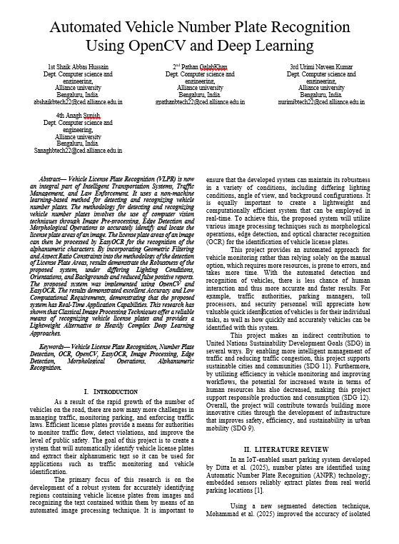
Conference / Journal Acceptance Letter

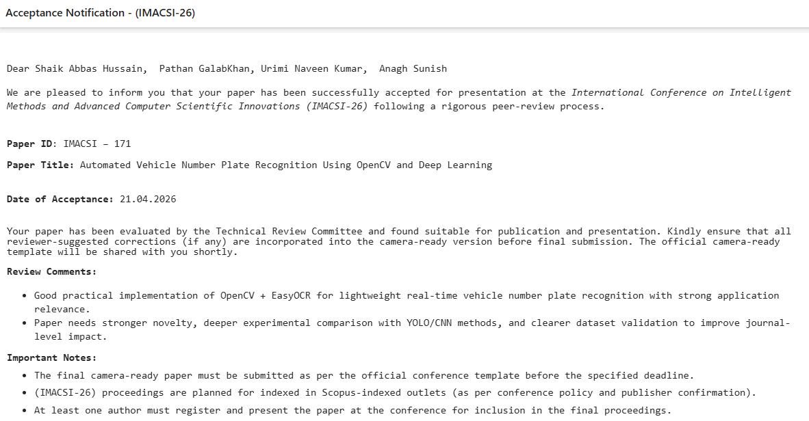
Source Code
!pip install easyocr
import cv2
import numpy as np
import easyocr
from google.colab import files
from google.colab.patches import cv2_imshow
# Upload image
uploaded = files.upload()
file = next(iter(uploaded))
img = cv2.imread(file)
# Resize for consistency
img_resized = cv2.resize(img, (900, 600))
# ========== PART 1: RULE-BASED PLATE DETECTION
img1 = img_resized.copy()
# Pre-processing
gray = cv2.cvtColor(img1, cv2.COLOR_BGR2GRAY)
gray_blur = cv2.GaussianBlur(gray, (5,5), 0)
# Edge detection
edges = cv2.Canny(gray_blur, 100, 200)
# Morphology
kernel = cv2.getStructuringElement(cv2.MORPH_RECT, (5,5))
morph = cv2.morphologyEx(edges, cv2.MORPH_CLOSE, kernel)
# Contours
contours, _ = cv2.findContours(morph, cv2.RETR_EXTERNAL, cv2.CHAIN_APPROX_SIMPLE)
possible_plates = []
for cnt in contours:
x, y, w, h = cv2.boundingRect(cnt)
area = w * h
if area < 2000 or area > 50000:
continue
aspect_ratio = w / float(h)
if 2.5 < aspect_ratio < 6.0:
possible_plates.append((x, y, w, h))
# Draw bounding box output
if len(possible_plates) > 0:
for (x, y, w, h) in possible_plates:
cv2.rectangle(img1, (x, y), (x+w, y+h), (0,255,0), 3)
cv2.putText(img1, "Plate", (x, y-5), cv2.FONT_HERSHEY_SIMPLEX,
0.7, (0,255,0), 2)
print("===== OUTPUT 1: Number Plate Bounding Box =====")
cv2_imshow(img1)
# ========== PART 2: EXTRACT ALL TEXT FROM IMAGE
img2 = img_resized.copy()
gray2 = cv2.cvtColor(img2, cv2.COLOR_BGR2GRAY)
reader = easyocr.Reader(['en'])
results = reader.readtext(gray2)
print("\n===== OUTPUT 2: Extracted Text From Image =====")
if len(results) == 0:
print("No text detected.")
else:
for res in results:
print(res[1])
cv2_imshow(img2)

