**What is Cloud Computing?**

Cloud Computing is software infrastructure that store huge data on remote serves, which can be accessed through Internet.

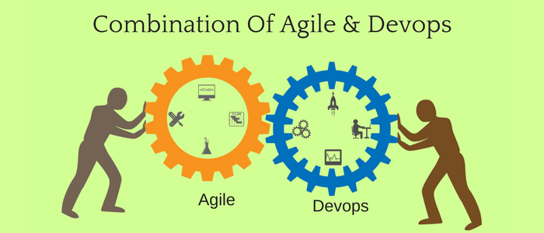

**What is Microsoft Azure used for**

**Azure** is a universal cloud computing platform, consists of solutions as IaaS (Infrastructure as a Service), PaaS (Platform as a Service), SaaS (Software as a Service) which can be used for services. These services are like virtual computing, storage, analytics, networking and many others.

**Application of Microsoft Azure:**

* Backup can be easily automated.
* It provides a platform to build applications using technologies and programming languages.

**Microsoft Azure DevOps Server** is a collective software development tool for whole team. Earlier it is called as TFS (Team Foundation Server). It integrates with your editor or current IDE (Integrated Development Environment), allow your cross-functional team to work efficiently in all sizes of projects.

**Azure DevOps Services**

Azure

Boards

Azure

Pipelines

Azure

Repos

Azure Test Plans

Extensions

Market Place

Artifacts

**Azure**

**DevOps Services are:**

* Azure Boards
* Azure Pipelines
* Azure Repos
* Azure Test Plans
* Azure Artifacts
* Extensions Marketplace

**Reasons why we choose Microsoft Azure?**

* Azure attracts towards IaaS (Infrastructure as a service) and PaaS (platform as a service).
* Azure comprises security as its core and private data & services stay safe. Thus, Microsoft guarantees the best in term of security.
* Azure provides a safe, ductile, secure and efficient storage services in cloud.
* Azure has a hybrid capability that it makes unique. It provides broad range of hybrid connections including cache, Virtual Private Networks and content delivery networks to improve reliability, usability and performance.
* Azure provides SQL and NoSQL services. Azure is the only cloud platform that provide Machine Learning concepts, Block chain service and Bots capabilities.
* With the help of Microsoft Azure many tools such as ASP.NET, C#, C++ etc. are used to develop cloud applications.

**Agile Methodology**

Agile methodology is a process which states that development and testing activities simultaneous throughout the software development lifecycle of the project.

**The agile software development focuses on four core values:**

* Team & individual interactions over tools and procedures.
* Customer alliance over contract negotiation.
* Working software over whole documentation.
* Acknowledging to change over following a plan.

**DevOps vs Agile**

DevOps and Agile are two different software development methodologies with alike aims. Even though agile and DevOps are different, we can use them together. When we use them together, both the methodologies take to greater structured and more genuine results.

**How DevOps and Agile will work together**

Both Microsoft DevOps server and Agile provide a structure and framework that can pace software delivery. You do not require to pick from DevOps or agile. Rather you can make use of both methodologies. When using both methodologies together we can configure that which are the featured to be used to get best of DevOps and agile. Here are some top feature from DevOps and Agile:

**Features from DevOps:**

* Broader scope, wider reach.
* Inter-department collaboration.
* Efficiency from automation.

**Features from Agile:**

* Workflow productivity tools.
* Incremental progress.
* Needs of the customer.